**BBMA Strategy in English**

The Bollinger Bands measure is a method for technical research that illustrates total assets price volatility (in example a commodity , currency or share). According to the standard deviation of the rolling average, the Bollinger Bands were measured. Typically, it is represented on the price dynamics map. Close to the Envelopes, the Bollinger Bands were. The distinction between these two measures is that at a given distance, which is represented in percentages, the boundaries of the boxes are placed above and below the moving average, while the boundaries of the Bollinger bands are constructed at a length equivalent to the total of standard deviations. Since the value of a standard deviation relies upon volatility, the Bollinger Bands control their internal width: whenever the market is competitive, it expands; and in calm times it gets smaller.  
  
**Bollinger Bands Indicator in Forex**  
  
In general, the **Bollinger Bands** are displayed on a price map, but also can be added on a predictor graph. The Bollinger Bands were centered, such as the Envelopes, on the principle that prices continue to be kept between the bands' thresholds. The Bollinger Bands' peculiar trait as a measure is their constant duration, which is due to market fluctuations. The bands expand during times of high uncertainty, creating room for values. The Bollinger Bands narrow the holding values within their ranges during times of low volatility.  
  
**The major characteristics of this measure are:**

1. Sudden price shifts after band narrowing, indicating declining uncertainty.
2. The present trend is anticipated to proceed if rates go past band borders.
3. A pattern reversal is likely if peaks and lows above the bands are accompanied by ups and downs inside the groups.
4. The opposite limit is typically met by a price movement beginning from one of the band limits. For predicting target price, the new observation is valuable.

**Calculation**

* The Bollinger Bands does have three lines to look out for. The middle line (MIDDLE LINE, ML) is a simple moving average.
* ML = SUM [CLOSE, N]/N
* The upper line (TOP LINE, TL) is the middle line moved upwards by a certain number of standard deviations (D).
* TL = ML + (D*StdDev)
* The lower line (BOTTOM LINE, BL) is the middle line moved downwards by the same number of standard deviations.
* BL = ML – (D*StdDev)

**Where:**

* SUM (..., N) – sum for N periods
* CLOSE – closing price
* N – the number of periods used for calculation
* SMA – simple moving average
* SQRT – square root
* StdDev – standard deviation:
* StdDev = SQRT(SUM[(CLOSE – SMA(CLOSE, N))^2, N]/N)

It is recommended to use 20-period simple moving average as the middle line and two standard deviations to determine band boundaries. Besides, moving averages of less than 10 periods are not very efficient.  
  
**MACD indicator formula and settings: description, adjustment and application**

The first phenomenon statistical predictor is the Moving Average Convergence/Divergence (MACD) Technological Indicator. It shows that association between two trend lines of values. The Moving Average Convergence/Divergence Technical Measure is based mostly on discrepancy between both the twenty-sixth and twelfth moving averages. The signaling line (moving average of ninth indicators) is introduced into the MACD to show the most favorable moments. In the wide-swinging trading economy, the MACD is easier to use. Moving Average Convergence/Divergence typically provides signals where there is crossing or separation and in the case of massively oversold.  
  
**Crossing**  
The simple MACD exchanging position is based on passing the hunted line with the predictor. It is time to sell when MACD sinks far below the signal line, and it is ideal to purchase when MACD grows above its signal line. Whenever the MACD goes higher or lower zero, purchase or sell.  
  
**Overbought/oversold conditions**  
Average Convergence/Divergence is also helpful for signaling oversold conditions status. When the MACD increases, it means that the market is grossly undervalued and the more rational prices will return quickly.

[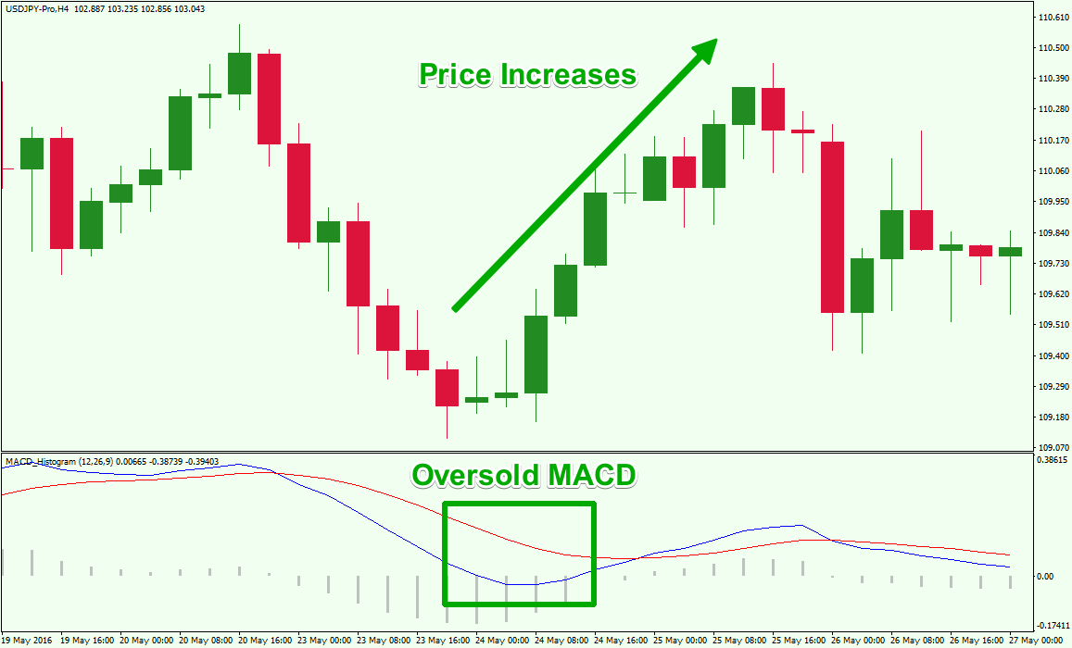](https://forum.mt5.com/customavatars/742020999.png)

**Divergence**  
Where the MACD diverges from the value, an indicator that the present pattern is supposed to be completed exists. Because when price hits new upper limits, a defining aspect takes place as well as the Moving Average Convergence/Divergence measure struggles to hit new peaks at the same period. When the price creates a new low and the MACD struggles to do so, a bearish convergence is created. If both exist in the oversold conditions region, all forms of variance are very significant.  
  
The **Oscillator Moving Average Technical Indicator** (OsMA) is a distinction among input signal smoothing or oscillator blotting. In this scenario, the MACD main line is used as the oscillator as well as the signal line as the filtering of the input signal.

**MACD calculation**  
By deducting the meaning of the twenty-sixth period exponential moving average from its twelfth period simple moving average, the MACD is determined. Along the edge of a MACD, a ninth period marked simple moving average of the MACD (the signaling section) can then be displayed.

* MACD = EMA(CLOSE, 12)-EMA(CLOSE, 26)
* SIGNAL = SMA(MACD, 9)
* Where:
* EMA - the Exponential Moving Average;
* SMA - the Simple Moving Average;
* SIGNAL - the signal line of the indicator.

**Advantages of using Indicator in Forex Trading**  
  
The key value of indicators would be that they clarify market fluctuations. Forex investors can find an indicator's complex techniques **simpler to read**than the price chart's complicated contortions. Notice that "fairly easy" doesn't imply more efficiency in this situation. However, metrics are an exceptional instrument for studying how to detect market volatility or power, such as where a pattern is strengthening. This may have been difficult for such a novice trader to determine on a price map, and they are also kept informed of small shifts with the assistance of certain measures that they have not yet educated ourselves to see on the price graph.

[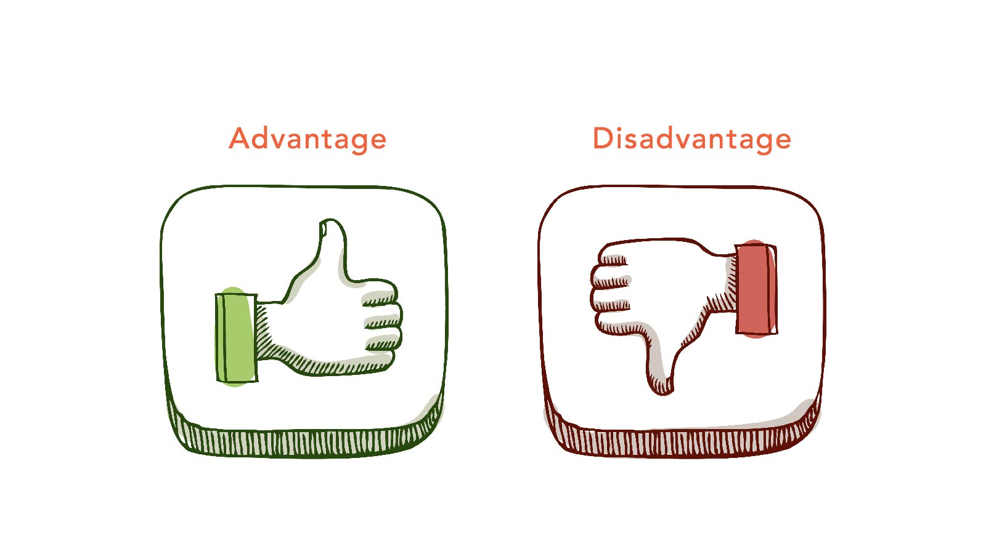](https://forum.mt5.com/customavatars/358876549.jpg)

**Limitations of using Indicator in Forex Trading**  
  
A detailed summary of the mathematical equation and price outputs is seen on the predictor. An indicator also won't even show far more than is obvious to a professional graph reader or investor only by observing the market chart (or quantity) without even any markers.  
  
There is a vulnerability in any index; something which supports the theory to provide process modification also at the wrong time it wasn't at the right moment to provide a trade signal. Research the math beneath it whether you use a predictor. You will figure out the weaknesses this direction. Often, do not only look at the dates when the indicator told the reader to do it and then you expected to win, but also look at occasions when the predictor failed to inform you about going into or out of a transaction.  
  
A further downside to metrics is that they usually **only display what's going on on the price table**, although in a various image manner. Price action investors claim that metrics are obsolete and not relevant because they can only provide details that price (and quantity) charts still provide. They seem to lag after whatever the market does, because indices are measured on the basis of price (or amount, or even both).  
  
**Top 3 Best Brokers of 2021**

[](https://forum.mt5.com/customavatars/1097654401.png)

* **Instaforex: Best Broker for All Level**  
  InstaForex is one of the leading trading platforms that enables the selling of spread betting. To validate their prestige and performance, more than 30 finance awards were received by InstaForex. In particular, on the platform, different experts are available to even provide you with their insights and analysis of the current trends of the market to guide you effectively in your trade. InstaForex treats the site traders well by having a prize pool and giveaways regularly as well as annually. The 24-hour accessibility of InstaForex around the globe is due to its investment in its I.T. framework by offering multiple servers in various nationalities.
* **Binary.com: Best for sellers who are amateurs**  
  Since 1999, Binary.com has been propelling binary alternatives trades. It has in excess of 100 tradable business areas through its binary alternatives and MetaTrader 5 organizations, including Forex, encryption, CFDs, and metals. For its validity, usability, and straightforward passage, the stage has obtained different distinctions. At just $5, it has a humble least store than various puts on our overview, making it more open to new and accommodating shippers. Many store and withdrawal frameworks are maintained by the site, including Visa and Mastercard Mastercards, Bitcoin, and that is only the start. The program isn't accessible to monetary sponsors in the U.S. or of course Canada at this moment. Binary.com was named the Best Broker of Binary Options in 2019 by Global Brands Magazine.
* **RaceOption: Best Bonuses for Registration**  
  With 100+ asset alternatives going from stocks to crypto to commodities, RaceOption supports more than 10,000 trades each day. The base store required for RaceOption is $250 and the base withdrawal entirety is $50. Vendors that are new to trading binary alternatives will abuse the copying handiness of Race Choice. In the United States, the race elective isn't as of now oversaw and doesn't have an unquestionable managerial license outside the United States, despite the way that it is regarded by various merchants to be a secured binary trading stage. You will gain extra income by insinuating companions to the site, and when you sign them up for the race choice, you can make 20% back from their stores.

**Ending Thoughts**  
  
No smart hypothesis stays at all. Numerous individuals are searching for an unmistakable answer for the topic of how to acquire advantage in Forex?, just as the mind-boggling measure of them winds up utilizing Forex signal suppliers. It is a simple method to begin exchanging Forex, and it's far from whether it gives off an impression of being a decent one, particularly as time goes on. The greatest worry to note currently is that you can basically have undeniably more effective business sectors to be productive in the Foreign trade market than losing ones. Clearly, if your sign level is equivalent to your log jam sum, this is all stuff. They may say this to be helpful in Forex, you should make many proper strides than wrong ones to place this word into different phrasing and power them to work all the more effectively into your trade system.  
  
There is no splendid standard here. Various people are looking for a direct answer to the subject of how to obtain advantage in Forex?, and by far most of them end up using Forex signal providers. This is a straightforward technique to start trading Forex, yet it's outlandish in regards to whether it will in general be a beneficial one, especially as time goes on. The essential worry to remember here is that to be gainful in the Forex market, you should mostly have more winning trades than losing ones. This, clearly, is simply material if your take-advantage level is comparable to the level of your stop-setback. To put this message into various words and make them fit even more successfully into your trading technique, we can say that to be useful in Forex, you need to make more right moves than erroneous ones.