**Binary Options Strategy Forum**

**What is Binary Option?**  
  
A financial method with a set price and a predetermined profit is a binary alternative. In all other terms, people gamble while buying an alternative. They anticipate the dollar-yen pairing, for instance, to rise or Tesla stocks to slide over the next 10 minutes. People get income if your suspicions are correct, and if they're not, instead you just take a loss you invested on purchasing an option. A binary choice then offers you the chance to earn an opportunity to make predictions on some asset's price fluctuations. Binary options may not entail high costs, notwithstanding some investors' fears, and this trading conditions is as stable as trading currencies. In comparison, the value of binary options would be that you realize in advance just what you are at danger as well as how much you can profit.  
  
  
**Significance of Binary Option in Forex**  
  
It's essential to get forex practice to trade effectively. A significant amount of useful forex details can be found here at the Instaforex. Invest certain resources to figure out, so once again, why forex trading works, make forex exchanges, competitive forex trading hours, and monitoring risks. Hardly anything beats perspective, as you will learn over the long run, and in the circumstance that you'll have to practice forex exchange, knowledge is the best teacher. It will provide you with a good professional institution on the logistics of producing forex transactions and getting acclimatized to dealing with a specific process of trade.

[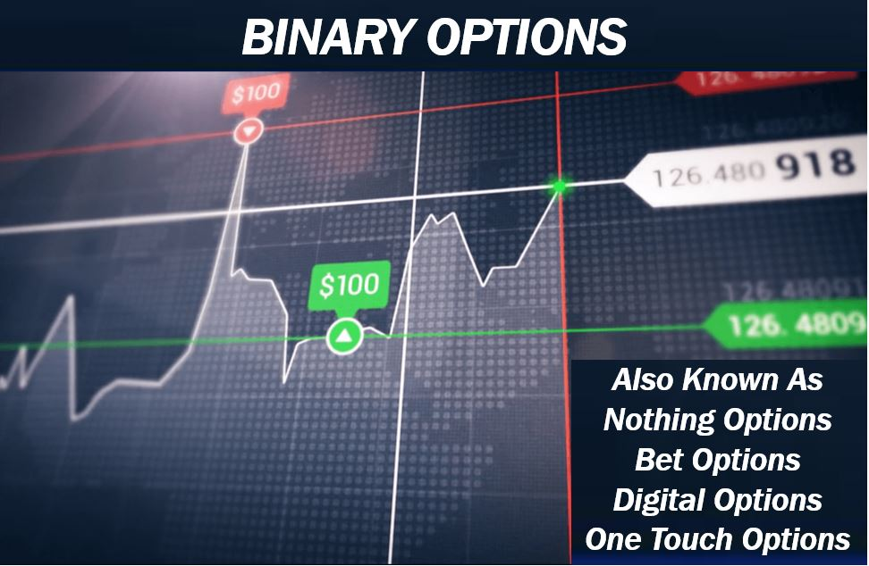](https://forum.mt5.com/customavatars/827919423.jpg)

The advantage of closing down your trade and exiting the market once your target is lessened after going into a market is just something important that you can gain by knowledge that no calculation of books or interacting with multiple vendors can teach. In order to support oneself, it is easy for dealers to figure that the demand will return. If the number of financial institutions fall victim to this snare but are amazed and grieved as the demand only pushes harder toward the impact of specific trade, you must be amazed.  
  
  
**Types of Binary Trading Options**  
  
Including its convenience, options trading is already drawing financial institutions. Low costs, earnings known afterwards, and multiple terms of performance are the main benefits of it. Zero options, premiums, or fees are yet another bonus. One needs to accurately predict where a stock value would go in order to benefit from purchasing financial products. Unless the price goes in line with both the prediction, even though the adjustment is small, the offer will be effective. There have been three kinds of trading with spread betting: Bollinger bands, brief, and lengthy. InstaForex supplies binary futures for intraday expiry as well as provides access to different exchange commodities including such silver and gold, 21 money markets, including 49 portfolio Currency swaps.

* **Intraday binary options**  
  People can evaluate a time period for purchasing the option on the following day, predict where the commodity price would go, and acquire a call and put option of that certain price in order to buy another intraday binary choice.  
    
  **Advantages of trading intraday binary options with InstaForex**
  + Quick increment: 5 minute stage (M5 time frame), 1 minute stage for the first thirty minutes.
* **Expiry binary options**  
  They are fixed deals with a defined salary that are restricted to 4 weeks during their period. Because once assumption for a cost path turns out to be true, the alternative would carry profits. Should one bear in mind that they'll be acquired in preparation when acquiring expiry rights, inside 7 days from the latest date; for just a purchase, up to four weeks from the point of purchase.  
    
  **Advantages of trading expiry binary options**
  + Significantly increase short: phase in 5 minutes.
  + Purchasing an alternative may be delayed for 7 days.
  + An choice can be bought 3 minutes before the scheduled option activating period.

**STRATEGIES FOR BINARY OPTIONS TRADING**

[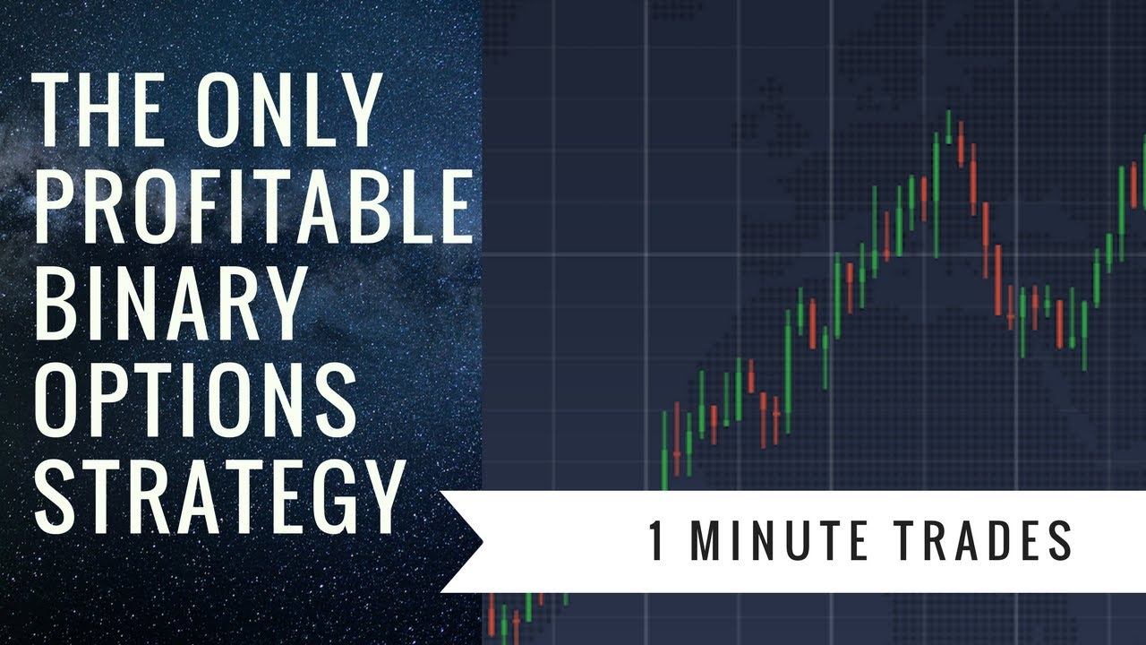](https://forum.mt5.com/customavatars/941521859.jpg)

1. Simple strategies  
   Easy binary choice trading techniques are useful not just for newcomers, but for seasoned traders as well. In tough conditions in the business, experts use simple tactics. These techniques require limited skills. Rapid Fire, Martingale, Doji Muster, Strangle, 60 Seconds are by far the most common of all. Successful investors created these easy and comprehensible techniques. They may not need deep business expertise. It can be used to raise deposits by beginner traders.
2. Strategies based on indicators  
   All such methods are focused on metrics that measure binary option price volatility. If an indicator reacts in that certain manner, the trader gets a warning. Puria Process , No Touch, Breakout, and performance depends mostly on trend lines: RSI, EMA, and MACD are perhaps the most appropriate practices for the simple indicators. It's extremely lucrative to trade on those tactics. Moreover, certain tactics, such as on trend lines, offer the ability to exchange several tools simultaneously.
3. Graphic strategies  
   This style of strategy is meant for forex industry practitioners because components of technical research are used in the graphic techniques. It needs dealing with stock prices for this method. Traders must assess the direction model to make a pattern-based forecast. When he or her has had expertise in the market, recognizes trading procedures, and recognizes how the real world works, a trader should apply graphical techniques. Pattern Reversal , Bottom - Top, Triangle and many others are common graphic techniques for options trading.

**How People Make Money From Binary Options Trading**  
  
But we'll get to wherein the asphalt hits the turnpike: by trade tactics, generating money. In such a single acquisition, designers are not worried about making a return. We are interested in building a secure handling process that helps you to produce a reasonable return over even a prolonged period of time. We're going to give everybody some other ideas to get you moving.

* **Learn and grasp diagrams of candlesticks.** By analyzing past market patterns, a lot of the pricing activity seen around binaries can be modelled. Practically, that's what line graphs represent. Initially, the diagrams themselves might seem complicated, but once you grasp the basics and the common candlestick pattern, they are pretty easy to follow.
* **Study your chosen fundamental products and past business actions.**Trading for profit on financial products is not at all like gambling. It was not a die toss, but a flip of the both quarters. To pick binaries that are far more likely to expire in the market, a smart trader can use knowledge and documents. The new price of the transaction contains some of the most critical information.

[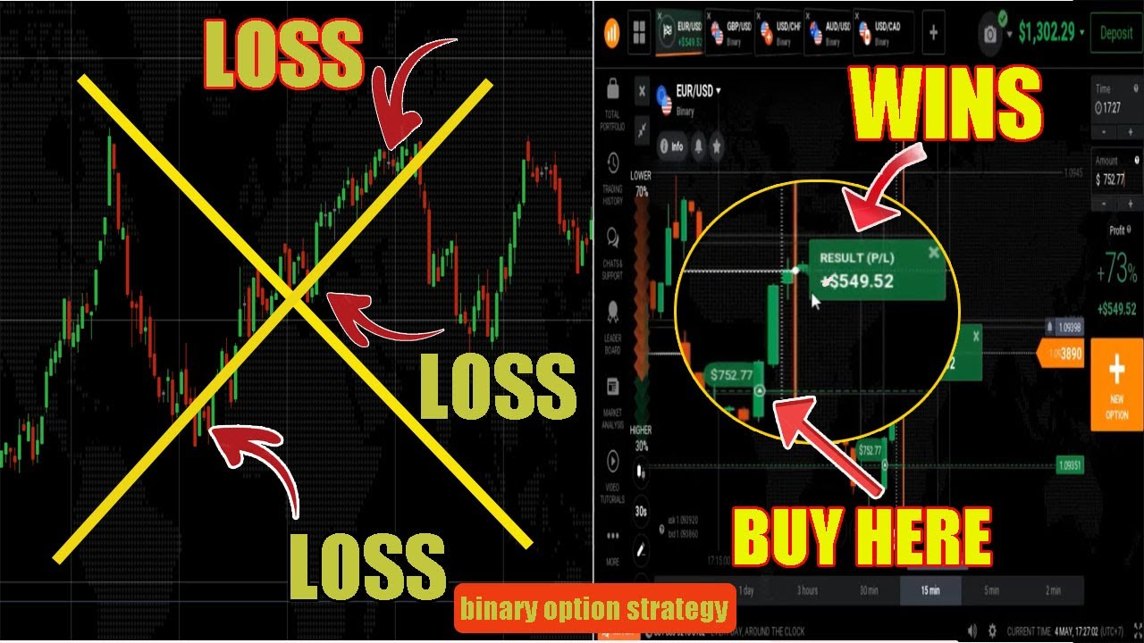](https://forum.mt5.com/customavatars/1685906435.jpg)

* **Marketing trends monitor and analyze.**Fight the temptation to bet on a rebound if the valuation of gold is only that for the last 3 hours. Likewise, if IBM shares have already fallen and are beginning to slide, a purchase market would unexpectedly actually occur and push the stock upwards. Placing a bet on trends when marketing basic plugins for terms is a good strategy. Betting on movements is like asking for trouble.
* **Don't use your annual salary to gamble.** And if you're absolutely certain a binary decision can't lose, cling onto the whole salary, that it's likely to go the distance but keep you prosperous throughout the aftermath. There has been substantial risk applied to the sale of this form of measure. Even if a deep assumption or a buddy's suggestion turns out to be correct, it will do so beyond the company's lifespan. Be vigilant of your money. Hey, be smart.
* **Until sacrificing a large portion of the working capital, earn some practice.** Sample investments are sold by too many traders. In both of these funds, customers can perform transactions while placing their own money at risk. Users have the capacity to get used to the platform with credit products operated by investors.

**Binary Options Top 4 Best Brokers of 2021**

1. **Instaforex**: **Best Broker Overall**

InstaForex is among the leading stock exchanges that allowed Binary Options to be traded. More than 30 financial awards have been won by InstaForex to justify their reputation and success. In addition, various analysts are available on the website to provide you with their observations and interpretation of the latest industry dynamics to guide you efficiently in your trade. By offering a prize pool and giveaways weekly as well as yearly, InstaForex handles the platform traders well. InstaForex's 24/7 connectivity around the world is due to its expenditure in its I.T. structure by providing several servers in distinct nations.

1. Binary.com: **Best for dealers who are novices**

Since 1999, Binary.com has been advancing binary options exchanges. It has more than 100 tradable business sectors through its binary options and MetaTrader 5 administrations, including Forex, encryption, CFDs, and metals. For its genuineness, ease of use, and simple entry, the stage has acquired various honors. At just $5, it has a modest least store than different puts on our rundown, making it more accessible to new and easygoing merchants. Many store and withdrawal systems are upheld by the site, including Visa and Mastercard Mastercards, Bitcoin, and that's just the beginning. The program isn't available to financial backers in the U.S. or then again Canada right now. Binary.com was named the Best Broker of Binary Options in 2019 by Global Brands Magazine.

1. RaceOption: **Best Bonuses for Registration**  
   With 100+ resource options going from stocks to crypto to commodities, RaceOption bolsters in excess of 10,000 exchanges every day. The base store needed for RaceOption is $250 and the base withdrawal sum is $50. Merchants that are new to exchanging binary options will exploit the duplicating usefulness of Race Choice. In the United States, the race elective isn't presently managed and doesn't have an unmistakable administrative permit outside the United States, in spite of the fact that it is respected by numerous brokers to be a protected binary exchanging stage. You will acquire additional income by alluding companions to the site, and when you sign them up for the race option, you can make 20% back from their stores.
2. IQ Option: **Better for merchants with experience**  
   250 separate monetary instruments are given by IQ Option, including Forex exchanging, CFD stocks, commodities, and that's just the beginning. The fundamental and innovative survey of the stage would be valued by genuine brokers. The site permits new clients to assemble a preliminary record with training cash of $10,000 so you can figure out how to explore the foundation of IQ Option prior to putting genuine cash on the line. This representative site, which is administered under the Cyprus Securities and Exchange Commission, is accessible in 189 nations. Windows, MacBooks, internet browsers and handheld gadgets are compliant with the organization, engaging you to exchange wherever you go. You would have to send a base store of $10 and a base commercial measure of $1 and a base withdrawal of $2 to begin on the stage. IQ Option could be the best intermediary for you in the event that you are looking for a significant level web based exchanging stage.

**Ending Thoughts**  
  
No clever theory remains whatsoever. Many people are looking for a clear solution to the question of how to gain advantage in Forex?, as well as the overwhelming amount of them end up using Forex signal providers. It is an easy way to start trading Forex, and it's far about whether it appears to be a good one, especially over the long run. The biggest concern to note now is that you can primarily have far more successful markets to be profitable in the Foreign exchange market than losing ones. Evidently, if your sign level is equal to your slow down amount, this is all stuff. They may say all this to be useful in Forex, you ought to take many appropriate steps than erroneous ones in order to put this word into various terminology and force them to work more easily into your exchange mechanism.