**Great Benefits of AF Global Expert**

Some indicators and trading systems specialized only on certain aspects of the trade, whether be in the stock market, forex trading, or cryptocurrency. One must know the relative strengths and weaknesses of those programs. Failure to do so might spell success or failure in engaging in whatever trade.  
  
Some, however, will offer you a whole package. This is especially true of some automated trading systems, who offer almost everything, from plans and strategies, timing, and even decision making. Such trading systems are of great help, especially to those who are just new in the trade and do not know the ins and outs of the trading.  
  
One such trading system is the AF Global Expert. AF Global Expert has been around for some time and has been in use for half a decade. Several versions of this trading system have been available on the net for quite some time, and the latest installment promises a lot, both to the experts as well as to those who are new and want to try forex trading.  
  
  
What is AF Global Expert?  
  
[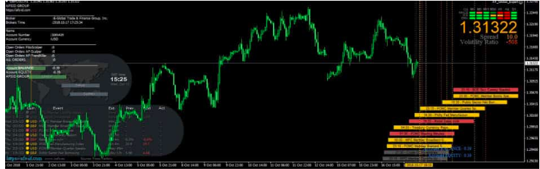](https://forum.mt5.com/attachment.php?attachmentid=370368&d=1620045059)  
  
AF Global Expert, as an automated trading system, is the culmination of other trading systems that have been around and offering their services for quite some time. The three are AF Scalper, AF-Fibo Scalper, and AF-Trendkiller, The three had great advantages against other trading systems, for they were developed by experts who have in their minds the needs of traders engaging in forex trading.  
The three previous installments were expert trading systems used for scalping in forex trading. AF Global Expert, the updated and, what promises to be, the final version, will be an optimized, better version. AF Global Expert has some features previously unavailable to three and has updated algorithms for better calculations, all for great profit and minimizing losses.

Trading styles for AF Global Expert  
  
As an automated trading system, it can be used both for scalping and day trading. It is great for scalping because its algorithms are perfectly suited for that kind of trading. It can review both the long history of a particular currency, pair it with another, then make valuable calculations which cannot usually be done even by experts or those who had a knowledgeable and great experience.  
  
What you then lacked in experience and skill will be offset by AF Global Expert’s calculations and analysis And, as you go on trading, using AF Global Expert, you will also learn, have a feel, and develop the necessary insights that will help you dealing with the forex trading.  
If you have already gained enough experience, or have gained quite a handsome profit, you can also try day trading, which is also available on AF Global Expert. You can also switch on both styles, depending on your mood or sentiment.  
  
The algorithms of the three trading systems were combined and incorporated into the AF Global Expert. The result is more efficiency. It has far greater predictive power, for the algorithms were more advanced compared to the previous three incarnations of the system. It reduced risks on the part of the user, for its calculations are much better than the previous ones. It allows, then, for a better engagement in forex trading.  
  
  
Currency Pairs

The best and the most profitable currency pairs are the most ideal ones to use in AF Global Expert. AF Global Expert will suggest to you those currency pairs, so you need not worry. It will tell you what pairs are hot, or where the possibility of greater profit lies with regards to currency pairs.  
Using this, then, will give you knowledge as to the in-demand, sought-after currency pairs in the market. It will give knowledge that will enhance your understanding of forex in general, all while making some profit out of your engagement in the forex.  
Reduced possibility of loss, increased possibility of profit  
  
AF Global Expert has some features which allow for minimization of risk as well as losses. It has a hidden stop loss feature, which will mean that the AF Global Forex will move or transact for you to be able to avoid losses. It can do so because its algorithms are configured in a way that will compute those possibilities, even before they occur.  
  
Consequently, the algorithms also perform the same with regards to profit. AF Global Expert will know if a particular currency pair is already ending its run or nearing the end. It has a hidden stop take profit feature, which allows you to have profit, at the least possible risk.  
AF Global Expert, compared to other trading systems or indicators, is not that complicated, and very easy to use. You can just download it and install it on your MT4 platform. It has a user-guide manual that allows you to easily engage in forex trading.  
  
You do not need to be an expert or have an in-depth knowledge of forex trading to use AF Global Expert. This automated trading system is designed specifically to allow every layman to participate and engage in forex. No deep knowledge about forex or its intricacies, just simple knowledge of how to install programs and use of the computer. AF Global Forex can be run on your MT4 platform just like any other program on your computer.  
  
  
Assessing AF Global Expert

There are some indicators and automated trading systems that are perfect and suitable for an expert. Others are more suitable to laymen and new to forex trading. AF Global Expert certainly belongs to the latter category. Easily operable, user-friendly, with features that allow you to profit as well as to minimize losses. All in the language that perfectly suits ordinary people.  
  
Overall, AF Global Expert allows ordinary people who want to engage in forex trading while avoiding all the jargon, technicalities, and other nuances that might be incomprehensible to most of us. It allows them to participate in an otherwise difficult and intricate world of forex trading, using just basic knowledge and computer skills. Even greater, they do participate with minimal risks, or with almost no possibilities of losses at all.  
  
Knowledge and skill, ultimately, are important in engaging in the stock market, forex trading, and cryptocurrency. For news, updates, as well as the latest in indicators, trading systems, and the like, visit <https://www.instaforex.com/>. They can be of great and invaluable help.