**Why And When To Decompile Ex4 Files**

Indicators and automated trading systems are available in the internet, either for a fee or for free. Some work just fine, with no problems, and can be operated easily in an MT4 or MT5 platform. Some, however, for reasons unknown, will not work and had become inoperable.  
  
In this case, you might need to decompile Ex4 files to make it operable on your MT4 platform Decompiling is the process by which you make a certain program run or operable by conducting some kind of “reverse engineering.”  
  
  
Why decompile?  
  
  
You need to decompile because either the original source code is already lost, or it has been modified. In both cases, the basic goal is to make the program rendered inoperable run again in an MT4 platform. In decompiling, information will be processed and organized in order to make it operable, even in the absence of a source code. Since the program is still in your computer, chances are it still contains relevant information that can be used to trace and be organized in a manner that will make the program operable again.  
  
Another reason why some decompile is also to modify the program, in your case, an indicator or an automated trading system, making it more efficient and effective. You must remember, however, that modifying source code is usually subject to restrictions by the owner or author of the source code, and in some cases, might be prohibited or illegal. Modification of programs through decompiling, however, is usually allowed and can be done as long as done in accordance with any agreement, or the law.  
  
  
Is there an alternative to decompiling?

The most effective alternative to decompiling is to reach out to the owner of the program, or author of the source code. All programs have source code, and if the problem is that your program has lost the source code, it is better that you ask them for help. Especially so if your program lost the source code because of unforeseen events or untoward incidents, like a computer crash or virus. There is also no problem asking the owner for the source code, especially if you buy the program from them.  
  
Sometimes, the programs, indicators, or automated trading systems suffer from some glitches inherent in the programming itself. If your Ex4 file were suddenly rendered inoperable due to the glitches in the program, it is only appropriate that you ask the owner of the program or the author of the code, to provide you the necessary source code to make the program run again. You are well within your right to do so.  
  
  
When do I need to decompile?  
  
  
There are some situations, however, when even the source code is no longer available. This is due to several reasons. One of them is that the program may have already been obsolete, and has been superseded by other programs that are far superior to the previous one, in that case, the source may have already been modified by the author or the owner.  
  
Some programs have copyright and terms of use. There is the possibility that you are no longer allowed to access the improved version of a particular program. This is what usually happens in a free version of a particular program. A free version, as we know, is usually subject to limitations and restrictions, which are usually not found in a paid one. In this case, the source code may not be available, or not available for free.  
  
Finally, you need to decompile if you really can no longer reach out to the author of the source code, or the owner of the program. Since all avenues of reaching out to them are no longer available, it is obvious that you have to decompile, for it is the only way for you to make the program operable again.

Can I do the decompiling myself?  
  
  
You can. Some decompilers are available on the internet. Some are for free, others are for a fee. Instructions on how to use it are available, and you can run it the way you run install and run and install Ex4 file in your MT4 platform. There might be problems with regards to the true effectiveness of a decompiler, whether it can deliver on what it promised.  
  
[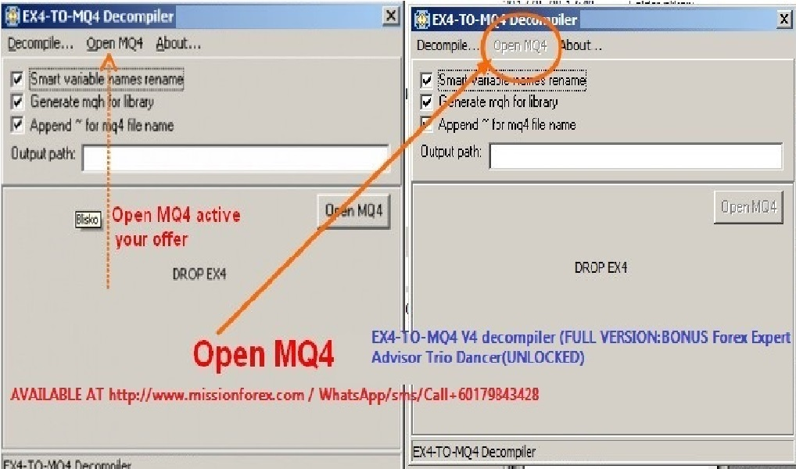](https://forum.mt5.com/attachment.php?attachmentid=366722&d=1619347442)  
  
The reason may not lie with the decompiler, but with the Ex4 file in MT4 that needs to be decompiled. Not all programs are the same, and they are programmed differently from each other. Some may easily be decompiled, while others may not be decompiled at all. It varies from program to program, and probably, from indicator to indicator, and on automated trading systems as well.  
  
You can hire an expert too. Some offer their services on the net. Some even offer it for free and are willing to teach others. But the same problem will also arise. The nature of the Ex4 file will determine whether the decompiling process will be successful, or whether it will be truly possible at all.  
In the end, though, there is nothing wrong with trying it. Especially so if the Ex4 file you want to decompile and run in your MT4 platform is truly effective and efficient, at least before it becomes inoperable.  
  
  
Is decompiling effective?  
  
Some attest that decompiling really works. When we say it works, we mean that it can be operable again. How effective and efficient, however, depends on the information retained. Remember that when you decompile, you are only gathering previous data and try to run a program based on this information. Information loss is unavoidable. Besides, a decompiled Ex4 converted to run again is different from an original one, which has the source code. But again, you can always try.  
  
In the end, the choice to decompile or not depends on what options you have with regards to a particular indicator or automated operating system. If you want that program that truly works for you before, which, for some reason, no longer runs, you can try decompiling. You have nothing to lose, but you have to do it within the bounds of what is ethically allowed and appropriate.  
  
If you want to be more knowledgeable and skilled in forex trading, the stock market, and cryptocurrency, and want to know the latest about indicators and automated trading systems, go and visit <https://www.instaforex.com/>. They can be of great and invaluable help.  
To those who want to know more about installing indicators and other programs in MT4 and MT5 platform visit <https://www.earnforex.com/guides/how...in-metatrader/>