**Installing and Using the FX NUKE**

A lot of indicators and some automated trading systems require considerable knowledge and skill on the part of the trader. There are some, however, that you can use despite being new to the trade. It can do everything for you, from planning and strategizing to buying and selling. These kinds of trading systems or expert advisors will need minimal or almost no supervision from you. Others need some kind of supervision, or planning and strategizing from your part. Be as it may, however, you really do not need that great amount of expertise to run them. Among these is the forex nuke, or better known as the FX Nuke.  
  
  
What is FX NUKE?  
  
  
FX Nuke is a trading system best suited for trading in currencies. It will show you different strengths of currencies and will show you what are the best currency pairs that you can trade, buy, or sell. FX Nuke shows you all the signals, and when to do those transactions. It will indicate to you the best time or the best opportunity to do the trading. It thus allows you to cash in on whatever opportunities the forex market can offer.  
  
  
FX NUKE can do this because it is based on algorithms that measure both the current strength and past performances of any given currency. As such, it can do predictions as to the directions a particular currency will take, whether it will continue its upward surge, or will eventually decline. Based on this information and calculations, the FX Nuke will guide you in making decisions concerning the most profitable currency pair.  
  
  
How to install FX Nuke

You can install the FX Nuke on your MT4 platform. To install it, open MT4, then click the “File”, then click on the open data folder.  
Then copy templates files to the templates folder.  
Copy indicator files to the MQL4 indicators folder.  
Then restart your MT4.  
  
Strategies in using FX NUKE  
  
  
You can use FX NUKE in trading in different currency pairs. There are 28 currency pairs available for you to trade, and you can decide on whatever currency pair you want to trade or engage. The CS dashboard will indicate to you all the best possible currency pairs available. Based on the data indicated on the CS dashboard, you can decide about the currency pair that will give you great profit.  
  
  
The usual strategy is to look for the strongest currency and the weakest currency. Volatility and movement are common in these kinds of pairing, so a chance for profit can be maximized by having this pairing. Having said this, you can still use the currency pairing of which you are most familiar, most convenient, and most knowledgeable. Having knowledge and familiarity is certainly a great advantage.  
The movement or direction of the currency pair will be indicated by lines moving snake-like. A blue dot indicates an entry signal It will be followed by a blue line, again moving snake-like, indicating the direction of the currency pair. The appearance of a red dot is an indication that you have to exit. It will be followed by an orange line.  
  
[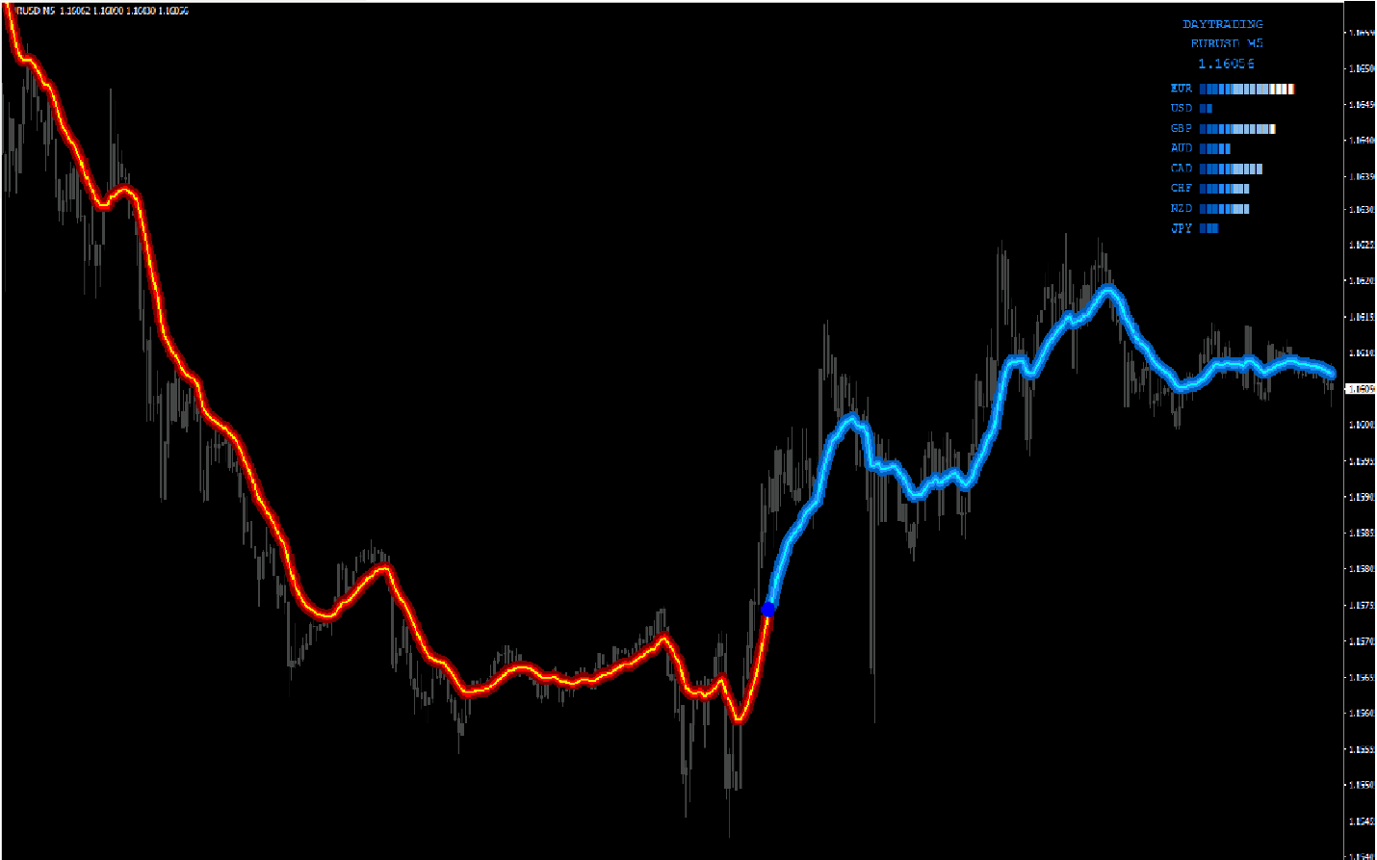](https://forum.mt5.com/attachment.php?attachmentid=364164&d=1618822986)

You can trade any time of the day. There are three trading styles available; scalping, day trading, and swing trading. You use the trading style that suits you, your strategy and philosophy in trading, or your temperament. This will allow you to maximize the FX Nuke as a trading system, for you will have the necessary familiarity and knowledge in using a style of trade that you are comfortable with. It will give you a better chance of maximizing profit.  
  
Based on the style, you can decide on the time frame that you will use. A particular trading style suits a particular time frame. Scalping, for instance, you have to use short time frames, m1-m5, because it is more effective using time frames, and more suited for quick decision making and quick profit. Swing trading requires longer time frames, usually H1 or even higher. Day trading is just about between those scalping and swing trade time frames.  
  
Deciding on time frames depend on your strategy, as well as on your decision to quickly cash in, or wait longer, a few hours, or even a day, for instance. Again, it depends on your temperament, as well as your overall approach and strategy in forex trading.  
  
  
Some Issues in using FX NUKE  
  
  
As mentioned, there are three trading strategies available using the FX NUKE. Of the three, it is the scalping strategy that can best maximize the FX NUKE trading system. It measures minute fluctuations and can calculate immediately based on these fluctuations and movement. There, it can register quickly when to buy, trade, or sell.  
  
As such, the FX NUKE trading system usually suits those who want shorter time frames and those who have a short-term plan or are engaged in quick, short-term strategizing. Ironically, it suits those who have little patience or do not want to wait longer to enter or to exit. It is safe and effective, however, using all of the three strategies.

Knowledge in forex trading is a must. One advantage, however, of using FX NUKE is that you can learn from all the intricacies of forex trading while using FX NUKE. By looking at how it works and using it, you can learn about currencies in general, how they behave in the long term and the short term. Aside from this, you can learn strategizing itself. Though you will decide eventually based on movements and the dots, it can give you that “gut feel” as to when a run will finally end.  
  
More than making money, using FX NUKE will give you the necessary knowledge and experience in forex trading, as well as other related fields like the stock market and cryptocurrency. Having FX NUKE in your MT4 platform is a great plus, especially if you are new to forex trading. It will allow you to have a better feel and, will make you feel comfortable in dealing with the intricate world of forex. Once comfortable, you can deal and trade in other related fields, such as the stock market and cryptocurrencies.  
  
  
Having FX NUKE is great. It is still important, however, to have knowledge and skill, and educate yourself about the complexities of forex trading, the stock market, and cryptocurrencies. For knowledge, skills, and availabilities of other indicators and trading systems, visit the <https://www.instaforex.com/>. They can be of great and invaluable help.  
  
To those who want to know more about installing indicators and other programs in MT4 and MT5 platform visit <https://www.earnforex.com/guides/how...in-metatrader/>