**Some Free EA Available for Download on the Net**

Expert Advisors or EA are trading software that can be used by any user or trader for Forex Trading. Most of it is automatic and can be used with minimal, and sometimes, no supervision at all from the user. It is capable of planning, strategizing and decision-making, and can make profits for the user. Expert Advisors use algorithms that allow them to make calculations and make decisions based on those calculations. It can help both those who are already experts in the field, as well as those who are just new in the trade and are willing to make profits on the market or at least give the forex trading a try.  
  
A lot of Expert Advisors or EA are available on the internet for a fee. Some of them, of course, perform better than others. There are also some Expert Advisors that can be availed for free and be used instantly by those who wanted to trade on forex. Here are some of those free EA or Expert Advisors that are available on the internet and can be downloaded anytime.  
  
Free EA For Dowonload  
  
Here are some of the free Expert Advisors available for download. You can scour the internet looking for these. Let us discuss some of them and take a look at what they can offer.  
  
Swiss Army EA  
  
[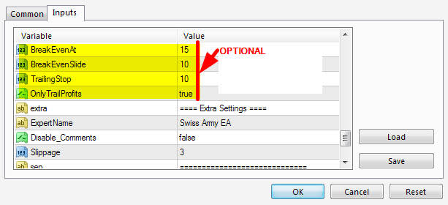](https://forum.mt5.com/attachment.php?attachmentid=350700&d=1616668217)  
  
A lot of options are available and can be done using this EA. You can apply this to the MT4 platform. Just adjust the settings for breakevens and trailing stops, as well as in taking profits and stop losses. The Swiss Army EA will show to the screen precisely what it is doing so that you will know what is happening. You have to take action based specifically on what is shown on the screen. Unlike other EA, it still needs supervision and specification from the user. It can manage the accounts of the user, but ultimately, the decision will be up to the user, for the Swiss Army EA does not trade.

E-Trailing  
  
[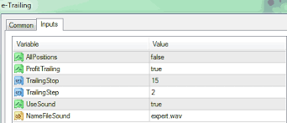](https://forum.mt5.com/attachment.php?attachmentid=350706&d=1616668299)  
  
Only works at a particular currency chart at a time, so you need to attach it to all charts that have an open trade. It has an automatic feature for trailing stops for all the trades that are open, as well as those that will be opened in the future. Features include AllPositions which applies trailing stops for all the positions that are indicated, Profit Trailing which is used to make and lock profits as well as to start a new position, and Trailing Stop which is used for pips.  
  
Blessing EA  
  
[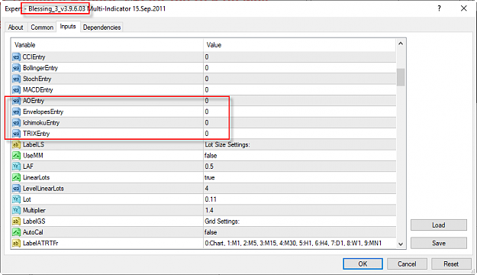](https://forum.mt5.com/attachment.php?attachmentid=350712&d=1616668469)  
  
Unlike the Swiss Army EA and the E-Trailing, the Blessing EA is also a buy or sell EA. It computes the profitability of the market by analyzing the price direction as well as through computations of StopLoss and TakeProfit. By putting it into the Buy-Sell setting, you can either buy or sell depending on what the Blessing EA indicates. One can buy when the direction is long, and sell when the direction is short, and one can eventually maximize profit by observing trend reversals when TakeProfit is indicated on the EA.

Super Forex Expert Advisor  
  
As an EA, the Super Forex Expert Advisor uses the relative-strength index that is set on high and low. It is then applied to a trailing stop. It is usually at best using JPY or USD and can be maximized by using it as a long-term scalping strategy. It must be optimized every once in a while, usually on a monthly basis, and if done, can be maximized, very effective, and can yield great profits.  
  
As one can see, every free EA tackled and discussed is different from each other. One is more efficient in the buy and sell strategy, others are more effective in stop and taking profits. Others work only on a particular currency chart at a time, while others can be optimized precisely by using a particular currency pair or chart. One can decide as to what free Expert Advisor he/she will use depending on his style, temperament, or particular plan or strategy one has in mind. It also depends on what kind of knowledge or skill level one has, for an expert advisor, even though automated, sometimes needs to be supervised, at least minimally, by its user. And as we saw, a particular Expert Advisor has a particular mode of expertise and thus may be more suited to a particular user or trader, than the others. All, of course, can be used for forex trading and for maximizing profit.  
  
Limitations of Free Expert Advisors  
  
Just like other products that are free, and by its very nature, free EA might be limited in its features. The first limitation, of course, is that for some, it is only available on trial for other, more advanced features of the product. Some glitches can be expected along the way, either upon installing or while using it.  
  
There is also the possibility that the free version or free EA itself may no longer be available on the internet, or that there may be some updated versions of it but the previous version can no longer be used, and one has to download it again. If the free EA is no longer available, one may need to resort to decompiling to make the software run again.  
  
Another limitation usually associated with free EA is the lack or the unavailability of support or help mechanism for those who have trouble running it. Just like what was mentioned above, since free EA are very numerous, often updated, and are available only in some versions, there are really few who can troubleshoot it when it malfunctions, and oftentimes, one resorts to downloading another EA instead of trying to fix the one that was malfunctioning.

Overall, one can always use some tools or programs that are available on the internet, especially if it is free and of great benefit to the user. There is really no harm in trying or downloading profitable free EA on the internet. Any user can always use whatever it is that is available, free or otherwise. All of those mentioned above are worthy of trying, and all of them can be installed on the MT4 platform.  
  
Anyone needs help as far as trading in forex is concerned, whether expert or otherwise. For those who want to acquire knowledge and/or skill in trading, and want to acquire and learn about software apps, programs, indicators, and expert advisors, try visiting <https://www.instaforex.com/> to learn more about forex trading, stock market, and cryptocurrency. The website is of great and invaluable help.  
  
To those who want to know more about installing indicators and other programs in MT4 and MT5 platforms, visit the website <https://www.earnforex.com/guides/how...in-metatrader/>