**Using RCI Indicator in MT4**

USING RCI INDICATOR ON MT4  
  
Most trend and channel indicators have specific purposes that help a user or trader in planning, strategizing, or dealing with forex trading in **general**. Some indicators will suit the style of the trader, and so will be of more value to the user compared to others. Some are directly related to strategizing and planning, and their appeal is their easy applicability to trading. Some indicators, however, require deep knowledge of the user of the workings of the forex trading or at least have knowledge and familiarity of other indicators and strategies to be maximized and used efficiently as an indicator. To this last category belongs the RCI Indicator.  
  
WHAT IS AN RCI INDICATOR?  
  
RCI Indicator uses Rank Correlation Index or RCI to determine possible changes in a price or commodity. Rank Correlation Index is a formula that uses data from price changes or price fluctuations across a certain time frame. All the data gathered are stored and analyzed in RCI Indicator. The RCI Indicator, using all the stored data, will make analysis and will indicate possible changes regarding markets and the prices, allowing the user or trader to make plans and strategies based on what the RCI Indicator shows or indicates. Since it relies on accumulated data across time, it is very sensitive to market changes and fluctuations. It can detect those possible minute changes in prices which other technical indicators may not detect, and thus cannot be subject to analysis or scrutiny. It also displays and indicates all the correlation between prices and time frames, so it can give a user or a trader added advantage when it comes to strategizing or planning, either long-term or short-term. Though it can show a lot of information and is helpful in analysis, the overall effectiveness of the RCI Indicator still relies on the trader’s ability to make connections between the available data and his /her strategy. It ultimately depends on the user how to maximize the RCI Indicator as a technical indicator and as a tool in forex trading.  
  
INSTALLING RCI INDICATOR  
  
As a technical indicator, RCI Indicator is not included in the usual technical indicators available in the MT4 platform. The RCI Indicator itself, however, as well as versions of it, are available throughout the internet and can easily be downloaded. Fortunately, it is easy to download and install, and here are the steps:  
  
· Download the RCI Indicator on your desktop, laptop, or mobile phone

· Copy the RCI Indicator to your MT4 directory or MT4 Indicators as shown in your PC or mobile phone  
· Restart your MT4 platform  
· Select the chart where your MT4 Indicators are located  
· Look for Custom Indicators on your MT4 platform  
· Right Click on RCI Indicator at your MT4 platform  
· Look for the chart, attach it then press “Ok”  
  
It is that simple. The RCI Indicator on MT4 is now available for use by any trader.  
  
  
USING RCI INDICATOR IN MT4  
  
[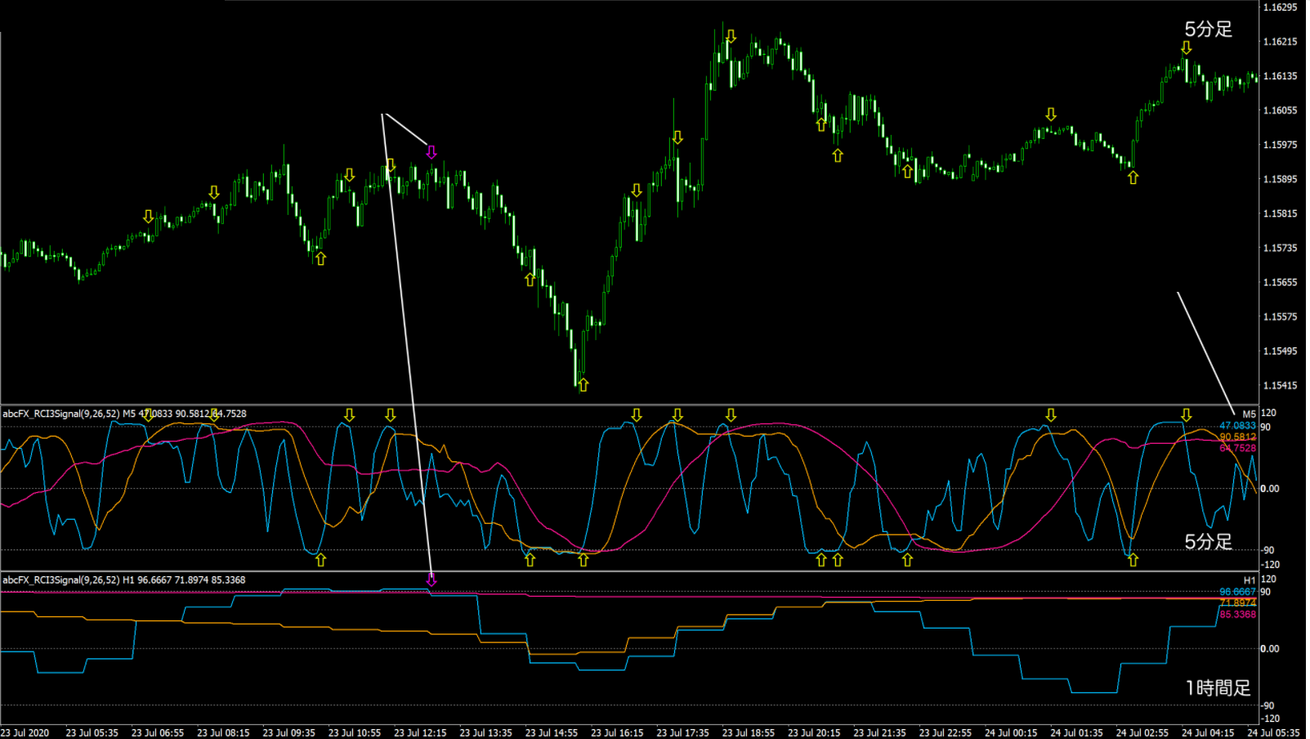](https://forum.mt5.com/attachment.php?attachmentid=348478&d=1616338738)

RCI Indicator can be used in multiple time frames, meaning it can show data and work on all timeframes, and the data that you need depending on what particular timeframe a user or trader wants to use will be available. The chart of RCI Indicator will show both the uptrend and the downtrend, as well as the trading signal. The uptrend is those that show +100, while the downtrend is those that show -100. Any line close to +100 or -100 is a trend that is close to reversing, so a trader or user must pay attention to the lines carefully. If the lines cross the 0, it is a good indication, a signal to trade, buy or sell. If the line hovers around 90-95, plus-minus, one can expect a change in the trend. Ultimately, if it does not reach 100, it means the end of the run, and the move towards the opposite direction can be expected. Needless to say, whatever decision regarding prices, stocks, whether to trade, buy or sell, lies with the user/trader.  
  
Here are, however, some helpful strategies in using RCI Indicator;  
  
· Set the parameters first  
· If lines cross 0, either buy or sell  
· The price is bullish if lines are mostly in the same direction  
  
RCI Indicator in MT4 supports all time frames, so one is at liberty to adjust it to suit one’s style, plan, or strategy.  
  
DRAWBACK  
  
RCI Indicator is a great technical indicator, but there are some difficulties associated with its use. The first difficulty is that ultimately, the decision to trade, whether to buy or sell, lies with the trader or user. Great as it is, it can only indicate the direction, but the timing itself is left to the user, and one must really have the proper sense of timing to capitalize on the information that RCI Indicator gives, so as to maximize profit or minimize losses. One must really have the necessary experience, knowledge, and skill relevant in forex trading, to be able to make such kinds of decisions. Those things can only be gained through a time of wheeling and dealing in the forex trading, one who is really new to the business must really have gained proper acumen so as to maximize the RCI Indicator, and capitalize on the information that it can relay to the user or trader.

One must also have knowledge of other strategies to be able to maximize the RCI Indicator. RCI Indicator shows information that may be relevant or helpful for short-term strategy, and sometimes, long-term strategy. One must really know how to use those kinds of strategies, for there are times for sure, that a particular strategy will be more appropriate, given the information that RCI Indicator will show. One who is only biased to a particular kind of strategy would not be able to maximize the RCI Indicator. Finally, those who use the RCI Indicator must already be familiar with other technical indicators as well, for it can be maximized even more by using it in tandem or in combination with other technical indicators. The more information and data will be analyzed, the more efficient the analysis of the RCI Indicator, the better for the user.  
  
One can gain more experience, knowledge, and skill in forex trading as time goes by. One can also have knowledge of other software apps, programs, and technical indicators, for these are available throughout the internet. If you want to know more about these things, one can visit Instaforex and their website. They will be of great and invaluable help.  
  
To those who want to know more about installing indicators and other programs in MT4 and MT5 platforms, visit the website <https://www.earnforex.com/guides/how...in-metatrader/>