**The Idea of Decompiling MT4 Ex4 Files**

Some programs or software apps may no longer be available for use if the source code is no longer available. Source code is used for “compiling”, a process that allows the computer to read the files and execute them in a manner needed by the user. For various reasons, source code may be lost, either due to a computer crash or limitations inherent in the use of software, for instance, if it has no longer a license or no longer even exists as a program. The failure to execute “compiling” due to these reasons is a problem that most computer users face every now and then.

One can, however, still use the program despite the absence of a source code. This method is known as “decompiling.” In forex, for instance, one can decompile mt4 ex4 files to make a program run again and be used in forex trading. Since the computer has already used the program before when it was used, there is the possibility to use it again by obtaining the code, not from the source itself, but from the computer itself which has executed and used the program before. The method itself is quite tricky and needs deep knowledge of the workings of the computer itself. Easier to do, according to some, is to download some programs that can “decompile” the files to make it readable as a computer program. In short, one can use a “decompiler.”  
  
How Does a “Decompiler” Work?

In the MT4 platform, an indicator or expert advisor installed still has the necessary Ex4 files in it though it may no longer have the source code. A “decompiler” is a program that gathers information from all those previous programs and executes files that a user wants to use. In MT4 for instance, all the relevant files are still in existence, provided they were not erased or deleted. All except the source code. The “decompiler” will try to read all the relevant information from the files, and hopefully, can reconstruct the code to make the program run again. Sounds good enough. The word “try” however, was used, for using “decompilers” to crack a code is a bit tricky. All programs are written differently and have different degrees of difficulty. That the “decompiler” can really crack the code to make the program usable is not a sure thing. This is especially true of MT4 and MT5 platforms and all the programs that are installed in them. Theirs are the most difficult ones to crack. “Decompilers”, both free and otherwise, are available all over the internet. Remember, however, that the picture shown below is a real possibility with regards to “decompilers.”  
  
[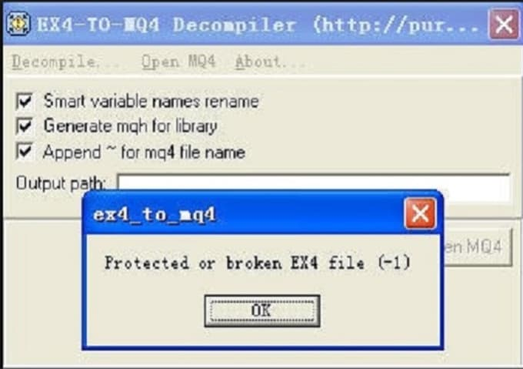](https://forum.mt5.com/attachment.php?attachmentid=346251&d=1615971646)  
  
Some Issues in Decompiling

To decompile MT4 Ex4 files to make it an executable program, as mentioned above, is difficult, but one can at least try. There are some people of course, who claim that they can do decompiling, or that they can make the program run again despite the absence of a source code. By now it is quite obvious that the source code is the ultimate key to running a program, compiling, or decompiling. Some programs, however, can really run even without the source code, as long as they are programmed to do so, and as long as the relevant information in the MT4 Ex4 files is still there. In itself, decompiling MT4 Ex4 files and make them executable is not that impossible. But one really has to try first in order to know whether a program in MT4, indicators or expert advisors, can be decompiled, either by a decompiler or by someone who claims he/she can crack the code. Ultimately, the use of “decompiler”, or hiring someone who can do the job, is an article of faith. One either has to trust the decompiler program or trust the person to do the job. It is safe to say though, that most programs, especially those used in MT4 platforms such as most indicators and expert advisors, do really have a source code. It is a matter of security both for the creator of the program and the user, to have such a feature.  
  
There are also some legal issues and complications that may arise from the process of decompiling. Most programs are copyrighted, and the source code is one of the security features of the program, protection for both the creator and the user. Thus, to decompile MT4 Ex4 files into a usable program is to thread dangerous grounds. In itself, though it is not that a big deal. Forex trading is a serious business, and one will not surely jeopardize his trading and participation in it by his desire simply to run a particular program. Programs such as indicators and expert advisors are all means or tools to help a user in forex trading. It is safe to say that they have all the means to secure their product and protect the interest of both its creators and users. The best thing to do, therefore, is to contact the provider in case of malfunction or failure to run a program. Also. Decompiling itself is not prohibited by law, one can use a ”decompiler” or hire someone to do the decompiling as long as it is within the bounds of the law.  
  
“Decompilers”, and those who are in the business of decompiling, are there precisely because there is the need by most people to use programs that for some reason, no longer run or are not executable in MT4 or MT5 platform, desktop or mobile phones. To use available tools, or ask help from some people to decompile MT4 Ex4 files to MQL4 and make it executable is only normal in the light of the need to use a program immediately in order to participate and cash in on forex trading. Just like in all things there are inadvertent risks, and one must always be truly aware of those things.

If one needs help with regards to the use of programs such as indicators and/or expert advisors and has some questions regarding its applicability, one can always pay a visit to instaforex.com to have more information. They are of great help in providing knowledge, skill, and sufficient information relevant in forex trading and cryptocurrency. They are for sure, of great and invaluable help.