**Installing and Using Raff Channel Indicator**

INSTALLING AND USING RAFF CHANNEL INDICATOR  
  
WHAT IS RAFF CHANNEL INDICATOR?  
  
[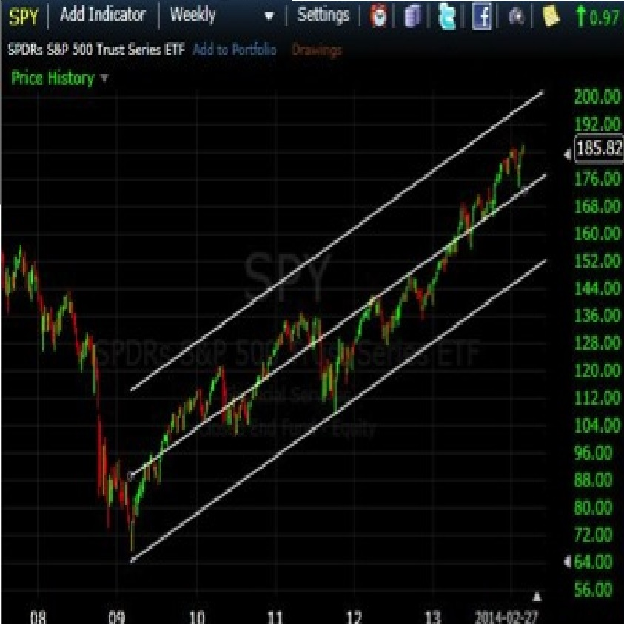](https://forum.mt5.com/attachment.php?attachmentid=344341&d=1615715577)  
  
Raff Channel Indicator is an indicator developed by Gilbert Raff. It is a tool that allows the user to spot active trends, whether those trends may continue or may go in the opposite direction. It tells the user where the activities occur in the chart, indicated by lines or trends, its movement, and its trajectory. The user then can make appropriate analysis and strategy based on trend movements, whether it is moving steadily or fluctuating wildly as it moves towards a certain trajectory.  
  
HOW TO INSTALL RAFF CHANNEL INDICATOR  
  
First, one has to download it and install it on the MT4 platform. To install the Raff Channel Indicator, click on the file menu, then click on ‘Open Data Folder’. Open the MQL4 folder, then copy the Raff Channel Indicator into the Indicators folder. After that restart your MT4, open it again and you can find the Raff Channel Indicator in the MT4 folders.  
  
USING RAFF CHANNEL INDICATOR

In using the Raff Channel Indicator, the user has to look at the trends, the movement, and all the swings. Raff Channel Indicator will show you the width by having the deepest downswing from the steepest upswing, meaning how far the regression of a trend (hence the Raff Channel Indicator is one of those “linear regression” indicators). It then again will make an upswing, from the steepest, it may go down again to its deepest, or modest downswing, depending on the price activity. The swings will be dependent on how far the price can go, (how high or how low) as well as the pace or how quickly it goes in that direction. If a downswing is far deeper than the previous, deepest one, one can expect a reversal in a trend and it will probably go upward again. Usually, it is better if you apply the Raff Channel Indicator after several trend reversals, or after it has made several downswing trends. You always have to look for the deeper ones. The reason for this is that the channel can be broken after it made several, deep downswings. It means that a new, particular trend may be starting again. In this case, you need the chart to be redrawn.  
  
A user or trader can use a particular strategy, though it is recommended that the trends exhibit several downswing-upswing activities to have a better picture or to make better predictions. One does not necessarily have to follow the recommendation to the letter. Some traders who strategize short-term, for instance, can decide on whether to make their move even if the Raff Channel Indicator exhibits short, but several modest swings on the chart. For those who want to have a clear, better picture of trends for planning or strategizing, waiting for the “great swing” is advisable  
  
RAFF CHANNEL INDICATOR: AN ILLUSTRATIVE GUIDE  
  
[](https://forum.mt5.com/attachment.php?attachmentid=344341&d=1615715577)  
  
Here is an illustration of the Raff Channel Indicator and all the points mentioned above. This is the Raff Channel Indicator showing the high points and the low points in the chart. The white two white lines above and under indicate the possible range of activity involving price action. The middle white line indicates where the greatest possible trajectory of the price activity will occur.  
  
In the figure below, the first low point and first high point are indicated by two green arrows. The distance between them shows the first upswing in price activity. Again, the upper white line and the lower white line show the possible range of movement, while the middle white line indicates just the exact trajectory and movement of the price.  
  
[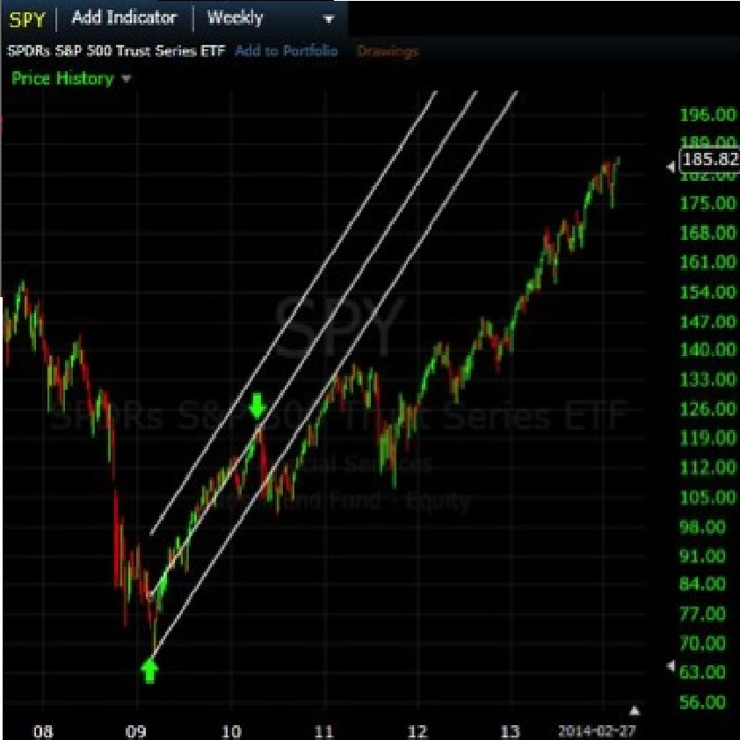](https://forum.mt5.com/attachment.php?attachmentid=344346&d=1615715841)

OTHER THINGS TO CONSIDER USING RAFF CHANNEL INDICATOR  
  
The accumulation of data across time is what makes the Raff Channel Indicator reliable. For those who want to use the Raff Channel Indicator in planning or strategizing short-term, one has to contend with lesser information, but it is effective still nonetheless, as long as the user adjusts the time frame to his/her style or temperament. The user must also be familiar with the trade, whether stocks, forex or cryptocurrency. Since timing and decision making is important, one must already possess the knowledge and skill necessary to make proper decisions, and also to make accurate forecast and prediction. Raff Channel Indicator will teach the user and advise the user with regards to the steps or direction that can be taken, but it is not a method in itself. Whatever steps may be taken will ultimately depend on the user, trader or analyst. Finally, Raff Channel Indicator can be used in tandem or along with other indicators, for better efficiency. If one is skilled, knowledgeable with the trade, and has knowledge of other tools or indicators, one can maximize the Raff Channel Indicator for better profit.  
  
As indicated above, it is important to have the necessary knowledge and skill aside from having tools, software programs, and other technology. For those who want to add knowledge and skill in trading to their repertoire, one can pay a visit to Instaforex and their website. They can be of invaluable help.

OTHER THINGS TO CONSIDER USING RAFF CHANNEL INDICATOR  
  
The accumulation of data across time is what makes the Raff Channel Indicator reliable. For those who want to use the Raff Channel Indicator in planning or strategizing short-term, one has to contend with lesser information, but it is effective still nonetheless, as long as the user adjusts the time frame to his/her style or temperament. The user must also be familiar with the trade, whether stocks, forex or cryptocurrency. Since timing and decision making is important, one must already possess the knowledge and skill necessary to make proper decisions, and also to make accurate forecast and prediction. Raff Channel Indicator will teach the user and advise the user with regards to the steps or direction that can be taken, but it is not a method in itself. Whatever steps may be taken will ultimately depend on the user, trader or analyst. Finally, Raff Channel Indicator can be used in tandem or along with other indicators, for better efficiency. If one is skilled, knowledgeable with the trade, and has knowledge of other tools or indicators, one can maximize the Raff Channel Indicator for better profit.  
  
As indicated above, it is important to have the necessary knowledge and skill aside from having tools, software programs, and other technology. For those who want to add knowledge and skill in trading to their repertoire, one can pay a visit to Instaforex and their website. They can be of invaluable help.