**Strategy in Using Aroon Indicator**

In 1995, Tushar Chande developed an indicator that has been in demand and in use for more than two decades. It is called the Aroon Indicator. The Aroon Indicator is used to detect trend changes in the market, whether stock market or foreign exchange trading. It shows two curves that will help the user to identify the changes in the market. As an indicator, it shows both the prevailing changes in the market as well as the strength of the two curves. It allows the user to plot or strategize with regards to the strength or weakness of a trend. Aroon Indicator shows two trends represented by two lines: the Aroon Up and Aroon Down. The two measure the trends of a particular price, stock, or value, whether they are up or down. The line above zero is the uptrend, and below it is the downtrend. An uptrend line is indicated by those who go above zero, while a downtrend line is indicated by the opposite.  
  
USING THE AROON INDICATOR  
  
The lines that do fluctuate between zero and 100 are the ones that will indicate to the user the information needed in order to plan or strategize using Aroon Indicator. If the lines fluctuate close to 100, it indicates a strong trend. On the other hand, if the line or trend tends to go towards or near-zero level, it indicates a weak signal or trend. Depending on how often the lines or trends fluctuate towards zero or 100 is a solid indication of a strong or a weak trend. If it fluctuates often to 100, it is a signal that a trend is on the whole, strong, fluctuating often towards to or near zero is, of course, an indication of a far, weaker signal or trend.  
  
CALCULATION USING THE AROON INDICATOR  
  
Now how to make calculations using the Aroon Indicator? One can use 14 to 25 as the base for calculation. It really depends on whether one is new in the trade, or already experienced and knowledgeable. It also depends on what kind of strategy one wants to use, or what kind of trader he/she is. One can easily adjust the settings depending on the style or temperament of the trader.  
  
The calculation is quite simple. For the strong, upward trend, one has to count the number of upward movements of the trend, if you use 25, then divide it by 25 and multiply it by 100. For a downward trend, one has to count the number of downward movements, divide it by 25 then multiply it by 100. Those are the percentages. The result of those calculations will tell you whether the trend will strengthen or weaken.  
  
INSTALLING THE AROON INDICATOR  
  
Though it is not available on the MT4 platform, you can download it and install it on your PC and use it in your MT4 platform. You can also use it in tandem with other channels and indicators. How to install it? First, you just have to download the Aroon Indicator on the internet.

DIFFERENT STRATEGIES USING AROON INDICATOR  
  
The Aroon Up and Aroon Down indicates the movement of the market, price, or stock. It tells you whether the price is going to be bullish or bearish. If it crosses the Aroon Up, it means that it is going to be bullish, and bearish if it crosses the Aroon Down. One, however, must be careful in making moves, since it only indicates the current direction. The possibility that it might reverse is there. It is important to look at the range of the trend before making any moves, whether buy or sell.  
  
If it hovers near the 100 level, it indicates a strong trend, and if it hovers near the zero levels, it indicates a weak trend. In making decisions it is important to use Aroon Indicator with others, such as the RSI Indicator, so as to really gauge how strong or weak the trend is, for the possibility of a price being overbought or oversold is there, and as such, the Aroon Indicator may not be enough to give the user the proper signal or the actual situation with regards to price.  
  
TRADING EXAMPLES  
  
Below is a buy and sell example. The first figure is with regards to buy strategy for NZDUSD, 60-minute time frame. Once the Aroon Up crosses the Aroon down and the RSI Indicator reversed from oversold, take the buy strategy. You can then profit once the RSI Indicator shows or reaches the overbought area.  
  
[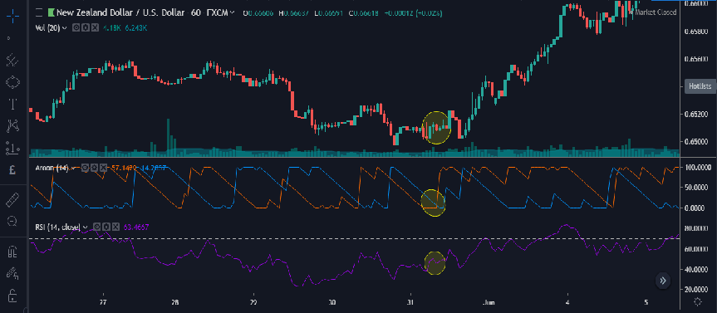](https://forum.mt5.com/attachment.php?attachmentid=342428&d=1615393664)  
Below is an example of a sell strategy, with CADJPY 60 minute time frame. The Aroon down crosses the Aroon Up and the RSI Indicator shows a reversal from the overbought area, then that is the opportune time to sell.  
  
[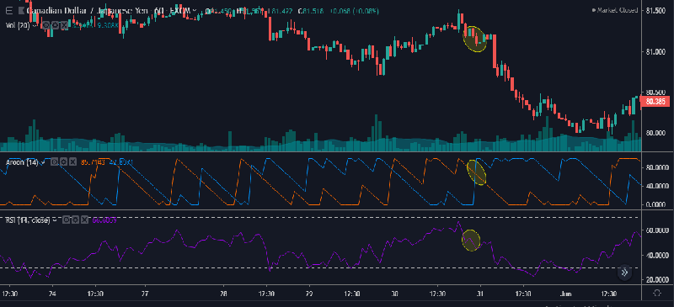](https://forum.mt5.com/attachment.php?attachmentid=342430&d=1615394004)

DIFFERENT STRATEGIES USING AROON INDICATOR  
  
The Aroon Up and Aroon Down indicates the movement of the market, price, or stock. It tells you whether the price is going to be bullish or bearish. If it crosses the Aroon Up, it means that it is going to be bullish, and bearish if it crosses the Aroon Down. One, however, must be careful in making moves, since it only indicates the current direction. The possibility that it might reverse is there. It is important to look at the range of the trend before making any moves, whether buy or sell.  
  
If it hovers near the 100 level, it indicates a strong trend, and if it hovers near the zero levels, it indicates a weak trend. In making decisions it is important to use Aroon Indicator with others, such as the RSI Indicator, so as to really gauge how strong or weak the trend is, for the possibility of a price being overbought or oversold is there, and as such, the Aroon Indicator may not be enough to give the user the proper signal or the actual situation with regards to price.  
  
TRADING EXAMPLES  
  
Below is a buy and sell example. The first figure is with regards to buy strategy for NZDUSD, 60-minute time frame. Once the Aroon Up crosses the Aroon down and the RSI Indicator reversed from oversold, take the buy strategy. You can then profit once the RSI Indicator shows or reaches the overbought area.  
  
[](https://forum.mt5.com/attachment.php?attachmentid=342428&d=1615393664)  
Below is an example of a sell strategy, with CADJPY 60 minute time frame. The Aroon down crosses the Aroon Up and the RSI Indicator shows a reversal from the overbought area, then that is the opportune time to sell.  
  
[](https://forum.mt5.com/attachment.php?attachmentid=342430&d=1615394004)

Strategies like this are common among traders around the world. If you are placed in the right position and have a proper sense of timing, there is no reason why you will not profit using the Aroon Indicator.  
  
DRAWBACK  
  
Using a lower setting will put severe limitations on the Aroon Indicator, as it will be prone and susceptible to false signals. Crossovers also do not mean that one can make a killing, for proper timing is imperative and needed to maximize the Aroon Indicator. The greatest advantage of Aroon Indicator is its ability to predict future trends and direction, but one must really have a sense of timing as well as knowledge, skill, and expertise in order to maximize its use. Better also if one uses the Aroon Indicator in tandem, partner, or along with other indicators, such as RSI Indicator.  
Whether one is new, beginner or already experienced and skilled in the stock market, foreign exchange trading, or cryptocurrency, one can always improve even more and add knowledge, skill, and expertise to his/her arsenal. One can make a profit and have an enjoyable experience participating and engaging in the market. For those who want to know more about trade, indicators, programs, and the like, one can always go to the Instaforex website. They can give invaluable help to anyone who is willing and initiated.