**The pros and cons of Quantum VPOC Indicator**

Technical indicators help the trader, analyst, or even financial experts in analyzing trends and predicting outcomes in trade, whether it may be stocks, foreign exchange, or cryptocurrency. Some indicators and trading systems are easy to use and can be appropriated even by those who are new in the field. There are some, however, that require greater knowledge, skill, and experience to be able to maximize efficiency for trade and for profit. As such, those indicators are only for those who already have knowledge of using other indicators, as well as have a deeper knowledge of the intricacies and complexities of the market and commodities.  
  
One such indicator is the Quantum Volume Point of Control Indicator or Quantum VPOC. Indicator. The value and volume of a particular price or commodity is one that has been analyzed in greater detail by most experts and analysts. As such, most analysis, strategizing, and predictions have the value and volume as the primary and most of the time, the only focus of analysis. Whether strength, fluctuation, or volatility, it is the two that stand as the locus and where everyone, human analysts or technical indicators, concentrates. Quantum VPOC Indicator, unlike others, introduces the variable of time to the system and analysis. The factor of time is included in the analysis of value and volume and thus allows for a far, deeper, and incisive analysis of a price, commodity, or currency.  
  
In looking at the market, there are always high points and low points of congestion involving certain prices and commodities. It was these points of congestion that usually, a trader analyst or expert will look at and then try to make some sense out of it. One always has to look back at the previous charts shown by indicators to make some sense out of it, and thus allow one to map out, plan or strategize. The Quantum VPOC Indicator allows one to take a look at periods of congestion and thus make appropriate plans or strategies. This is so because the VPOC Indicator makes a deeper analysis of the relationship between volume and value (or price). Simply put, the VPOC Indicator analyzes the volume and the density of transactions and its relation to value or price, over certain periods of time. The analysis allows the indicator to make projections with regards to periods of congestion, which will then allow the trader to make appropriate strategies, whether to enter or exit, and when.

How does the Quantum VPOC Indicator do it? The Quantum VPOC Indicator has a Volume Profile, sets of bars indicating the quantity, from past to present. Then it will show a vertical histogram, showing bars of different lengths which indicates the amount, density, and intensity of activity, or volume. Then the indicator will analyze the different congestion or peaks, represented by long bars. The peaks are points of congestion where most traders agree about the value or price of a stock or commodity. Most trading and activity occur during these periods, precisely because both the seller and the buyer, in short, the market sentiment, on the whole, is in agreement. Those points in the chart that indicate periods of great density and high activity are called the High-Value Nodes or HVN. Consequently, as the activity decreases, there will be points where the line will dip, indicated by short bars. Those points are known as Low-Value Nodes of LVN. The HVN that is at its highest or at its best is known as the Volume Point of Control (hence the term for the indicator), will be the focal point of the indicator and will make its calculations after it has been reached, updating the chart till the emergence of a new quantity bar.  
  
To summarize, those who use the Quantum VPOC Indicator must strictly pay attention at the High Volume Nodes and the Low Volume Nodes to make plans, strategize or make the proper adjustment. Those nodes, peaks and congestion, and all the activities about prices and trading are all shown in the chart, as well as the support and resistance zones that highlight the range and varied activities concerning HVN and LVN.  
  
[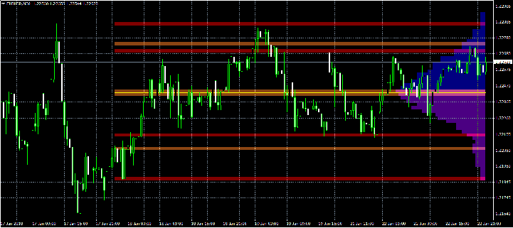](https://forum.mt5.com/attachment.php?attachmentid=338211&d=1614687973)

Quantum VPOC Indicator is a great indicator, but nevertheless a complex one. One must be truly familiar with other indicators and of indicators in general, to be able to use it and/or maximize its efficiency for trade or profit. Knowledge and skill in trading and other indicators are a prerequisite, and one who has it is presupposed to already possess adequate knowledge in dealing with the intricacies of stocks, foreign exchange, and cryptocurrency, as well as of different indicators.  
  
Time is also a tricky proposition. Though lethal and very efficient especially if combined with other indicators and other strategies, Quantum VPOC Indicator helps those who strategize and plan for the long term. It is of great advantage to those who are conservative in their approach to the market and those who prefer long-term engagement with a particular price, currency or commodity, or the trading market in general. The volume-value relationship across time is its most important aspect, and one who is looking far, far ahead, having this tool is the one who stands to benefit the most using this indicator. One who is for the quick fix, or moving to cash in quickly, or those who favor short-term strategizing and short runs may use the indicator and maximize its advantage, provided they are willing to factor in the variable of time and apply it to their strategizing.  
  
Ultimately, the Quantum VPOC Indicator favors and can be maximized by those who are really in the trade, have participated in it for some time, and has a knack for a different experience or a different feel in dealing with the stock market, foreign exchange, or cryptocurrency. Though in general, it favors those who are conservative, the Quantum VPOC Indicator can be enjoyed by those who see the market as a game, which must be solved or unlocked in order to have access to its secrets and thus rake some gains or profit. Knowledge and skills however are imperative. The Quantum VPOC Indicator is not just any like any other indicator, and one must be adept at using it and applying it in order to maximize its efficiency and thus make some gains or profit in the trade. To those who are willing, it might prove to be a great experience. A great tool to have in the complex world of the finance market.

One may be skilled and knowledgeable enough, but there is always enough room for someone to acquire even more knowledge and skill, and acquire even greater tools, software, and programs to be used in participating and engaging in stocks, foreign exchange, and cryptocurrency. If one wants to have more knowledge and wants to have some indicators and trading systems, Instaforex is more than willing to help, and it will never hurt to visit their website.