**The case for VPOC Indicator**

Different types of indicators are available for almost every need a trader has in order to engage better in market, whether be it stock market, forex or cryptocurrency. It is a basic tool one must have, and depending on one’s preference, style or strategy, one may choose a particular indicator or indicators. One may also choose an indicator depending on specific aspects of which the trader needs help or improvement. Simply put, a trader must have the appropriate indicator for specific needs and purposes.  
Different indicators for different aspects of trade, for different needs and purposes. Some are good at analyzing prices and its fluctuations, some are good in measuring trends, and everything concerning about it. In some instances, there are different indicators that can be used with regards to the same specific aspects one wants to measure and analyze. There are some indicators, however, that specifically caters to a particular aspect of the trade, and that aspect can be regarded as the sole specialization of that particular indicator. If a trader wants to analyze that particular aspect of which other indicators are usually silent or non-reliable, it certainly helps to have this particular indicator in a trader’s arsenal. One such indicator is the Volume Point of Control, better known as the VPOC Indicator.

As the name suggest and unlike most indicators, the VPOC indicator has, as its main focus of data analysis, volume, or the intensity of activity related to price, stock or asset, instead of prices as such and its fluctuations, or trends and anything related to it. But like other indicators, VPOC indicator also take into account the prices. Though normally, the idea of volume and its relation to prices (i.e., the law of supply and demand and all its other components) is well taken by observers, traders, financial advisers, in the case of VPOC the relationship is even more scrutinized by focusing on where the high volume, that is, where the frenetic, fast paced activity is occurring with regards to prices, assets or stocks, and connecting it with another important variable: time. It analyzes where the intense activity or ‘congestion” occurred in a given time frame across the chart, as well as the duration of that congestion, how intense and heavy, or how low it is. The VPOC indicator allows the user to view and examine those congestions and relate it to the prices, whether it will increase or not, and thus predict the likely direction the prices, stock or asset will take.

[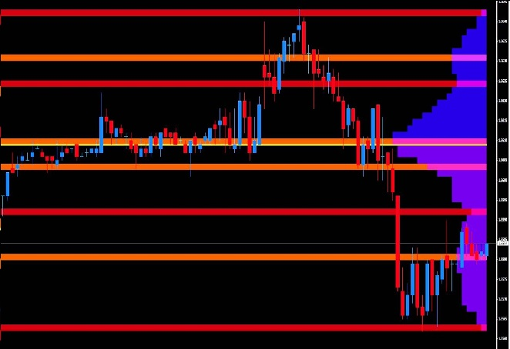](https://forum.mt5.com/attachment.php?attachmentid=320095&d=1610880848)  
How can the VPOC indicator do this exactly? The VPOC Indicator has a volume profile which allows the trader to view the amount of activity (that is, volume) occurring at a price during a certain period of time. The volume of which the activity is the highest is regarded as the high volume node or HVN. It will be indicated in the chart as something with the highest or greatest level of congestion which signifies high-level activity. It means that a lot of trading is occurring at this level. Conversely, low or little activity will be indicated by having little or low congestion in the indicator. It means that there are little or low trading that is occurring at this level. This is called the low volume node or LVN. The series of HVN and LVN in a certain time period or frame will be indicated in the chart. Indicated also are the so-called support and resistance zones which indicate various HVN and LVN for certain time frames. Finally, the Volume point of control line (VPOC line) will indicate the highest point in the high volume node, the highest point of congestion in the indicator. These is where the highest point of activity occurred and as such, the greatest indicator of what will be the market sentiment, the highest “point of agreement” among the traders with regards to the price. Eventually disagreement in prices will occur, and it will be indicated by how the trend moves with regards to the VPOC line. It can either again move towards a HVN or LVN. Based on this, a trader can plot his next move and strategize, or decide whether to buy, sell or trade.

A trader can use and apply a VPOC Indicator, in this case, the VPOC Indicator to the MT4 platform. It can easily be configured in the PC along with other indicators. All the features and the files needed to run the VPOC Indicator must be allowed in order for the indicator to operate smoothly. Some VPOC indicators will require you to register or have an account email, either for verification purposes or for FAQs or troubleshooting in case something goes wrong or the indicator malfunctions, or if you have trouble running the indicator. One must acquire VPOC indicator (or any indicators for that matter) from legitimate sources so as to avoid complications or any legal implications that may arise.

Once you have the VPOC indicator, you must have the following features or at least exhibit in the charts the following in order to analyze data and plot long or short-term strategies for trading, whether stocks, forex or cryptocurrency. The VPOC indicator is exhibited overall using a volume profile. The volume profile, as discussed above, will indicate the HVN or LVN for a certain time period. However, one may choose as to adjust the volume profile relative to the preference of the trader. The so-called Volume profile bar can be adjusted, depending on the preference of the trader. The same thing with the support and resistance line, counts which can be adjusted by 2s (2, 4, 6, 8…). All of this allows the trader to make a closer., more introspective analysis which he thinks a “normal” VPOC indicator cannot give or at least, has limited capacity to make. It allows the trader to have an even more leeway in examining the data and the trend exhibited in the VPOC indicator which then allows him/her to plot various strategies which a normal version of VPOC indicator might not suggest or indicate. Simply put, controlling the various features of the VPOC indicator allows for an in-depth, closer analysis of the data which may not be visible or obvious in a “normal” VPOC indicator at first glance. As mentioned also above, the indicator will show the VPOC line. One can either display or hide it. Finally, but certainly not the least important, the VPOC Indicator allows one to adjust the time frame. Time frames are important in analysis, especially in planning strategies. It allows for a better “timing” compared to other indicators and/or oscillators. If one can factor in accurate analysis using time frames, one can have a more accurate picture and representation, one that is more susceptible to accurate analysis, all the better for planning, strategizing, and eventually, predicting and decision-making for the trader.

Overall, the greatest advantage of having a VPOC Indicator is that you have an indicator which focuses more on the rather not usual aspects of the trade. More than data on prices and the rate and others, it focuses more on the traffic, the intensity of activity or the lack thereof, and thus focuses more on the unseen aspect of trade itself, which is market behavior. More than the data indicated by the usual suspects when it comes to certain aspects of stock, forex or cryptocurrency, the data that is exhibited in the VPOC Indicator lies behind the scenes, and sometimes, really more indicative of the real behavior of the price, stock or asset than what most or other indicators might suggest. In this regard, the VPOC Indicator is of invaluable help when in comes to planning, strategizing, predicting and decision-making.

As I mentioned above, there are different indicators available for different aspects of stock market, forex and cryptocurrency. Any trader, adviser or analyst can choose among different indicators and competing programs and software, depending on one’s style, philosophy or even preference. The different styles and preferences are ultimately tied to any planned strategies either long term or short term. It is thus important that a trader, adviser or analyst choose what he thinks is the best and appropriate indicator/s. There are some indicators however, that are more helpful and can build and improve one’s capacity for plotting and building strategies, and VPOC Indicator is one of them. VPOC Indicator however, can offer those things that other indicators do not or may have overlooked. It is in this regard that VPOC Indicator has that distinct advantage over the others. It allows for both short-term and long-term planning and strategizing. It allows for an in-depth analysis of data across time frames. It gives the trader, analyst and adviser insights into market behavior, how strong it is, how long may it last and the directions it will take. It even allows for a closer scrutiny of the market behavior by having the indicator, if one wants to, to focus on the HVN and LVN by adjusting volume profile features as well as the support and resistance lines of VPOC Indicator. Though all traders must eventually rely on their knowledge and skill, having indicators, and having indicators that have really a certain kind of specialization, will be of great and invaluable help.