**Aroon Indicator and FX**

THE AROON INDICATOR  
  
Indicators are an important tool for any trader. There are however, many indicators that are available for any trader, and not all indicators are the same. All of them have their own strengths and weaknesses. There are indicators that are good in analyzing long term trends, and thus are best suited for long term strategies, and there are those that are suited in analyzing emerging trends and thus can be considered best in strategizing on a short-term basis. A trader must be careful in choosing a particular indicator. A trader can use a particular indicator that suits his style, philosophy, temperament, or strategies that he/she is planning to develop. This insight might be the key, the eventual difference-maker between having a profit or taking a loss in trading.

The Aroon indicator is an indicator that has been around for quite some time. Developed by Tushar Chande in 1995, it has been in use for the last 25 years as an indicator, mainly for emerging trends. This indicator is best at analyzing how vulnerable the prices are to fluctuations, or how stable it is. The Aroon indicator will show whether the prices are rising steadily, wildly fluctuating, or remains relatively stable.  
There are two lines which consist the Aroon indicator. The first one is called the Aroon “upline.”

It measures how strong the price or the asset when moving upward. The other one, its exact converse and opposite, is called the Aroon “downline.” Looking at the two lines, one can easily see whether an asset or security is bullish or bearish. An upline above the downline means that the asset is bullish, while a downline above the upline is considered bearish. Looking at the lines for a period of time, one can see a pattern, whether a peak or trough is being formed, in each highs and lows. Fluctuations can also be seen looking at the lines. One therefore can easily see a trend as with regards to price behavior, security or asset by looking at the crossover lines being formed in the indicator. In a nutshell the Aroon indicator indicates to the trader the momentum, fluctuations and the direction that the price, stock, asset or security is moving, that is, whether it is rising, declining, or remains stable.  
[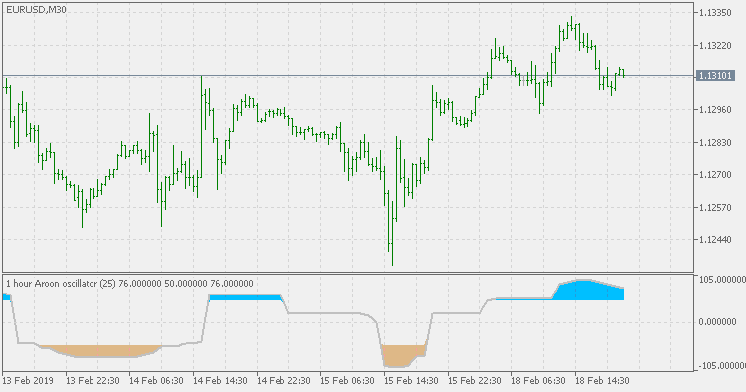](https://forum.mt5.com/attachment.php?attachmentid=318604&d=1610527624)  
Since the Aroon indicator has been around for more than two decades, most charts and platforms actually calculate Aroon indicator. It is important though, for traders, to know by themselves how to calculate the Aroon indicator. The trader will have a better understanding of the indicator, and this will be of invaluable help in conducting technical analysis.  
The calculation is as follows:  
• You have a chart, numbered from zero to 100  
• The indicator moves from between these number  
• For Aroon upline, 25 - Number of days up since Recent 25 day high/25 x 100

• For Aroon downline, 25 – Number of days down since recent 25 day low/25 x 100  
  
  
On the basis of the data that will figure on the Aroon indicator, any trader can gauge what directions any asset, stock, security or price is going. The two lines (upline and downline) will tend to fluctuate according to whether it will go up, down, sometimes steadily, sometimes it will exhibit volatility. All of these will be shown in an Aroon indicator for a fixed, certain periods (25 days). Based on this, the trader can make an assessment or conclusion as to whether the price, asset, security or stock is exhibiting an upward or downward trend.  
  
The trends however, that the Aroon indicator exhibits can be interpreted by the trader in a number of ways, and decisions about these can vary widely. Since it can track the performance of an asset and the fluctuations, and compute it based on the Aroon indicator, a trader can surmise whether the price, asset or security can continue its rise or the decline. After reading the numerous highs and lows for a certain number of period or days, taking into account all the fluctuations and volatility involved, the trader then can make the assessment as to whether the asset has already reached its peak, whether high or low. In other words, the trader can now make the assessment as to whether the trend will eventually continue or not. Based on these assumptions, the trader then can make the appropriate decision with regards to the asset, to sell it or to trade it.  
  
Some traders and users of Aroon indicator suggest that these might as well be the greatest strength of the indicator. It can give signals to the trader as to whether a trend is ending and a new trend in emerging or forming. The intersecting multiple lines of Arron upline and downline will suggest this to the trader. The momentum will indicate whether a trend is upward or downward. A succession of higher highs may indicate an upward trend. Conversely, a succession of lower lows for a certain period or days may indicate a downward trend. A sudden, abrupt change or halt in the momentum, or a steady reversal, with the momentum going in opposite direction, may suggest that a trend is reversed and a new one might be suddenly emerging.  
  
The advantage of Aroon indicator is it can signal and indicate to the trader whether an asset can continue its good performance or not based on the trend that is emerging, whether it will continue the upward trend or the downward trend. The drawback of this however, is that one must really depend on the trend, and since it takes some time to realize where the trend is going, the decision when to buy, sell or trade may be harder to reach. Predicting outcomes, therefore, are not the strength of the Aroon indicator, for it is ultimately reliant on the succession or prevalence of highs and lows in an emerging or ongoing trend and thus one basically loses valuable time in waiting for some trends to emerge. Coupled with other indicators and oscillators however, the Aroon indicator is of great help and will allow the trader to gain some insights as to the actual strength or weakness of a trend across certain periods.

A trader can use the Aroon indicator for MT4 and forex trading. It can be reconfigured in your computer along with other indicators. Once included in the MT4, it can now be used along with other indicators. You can navigate using the Aroon indicator and start using it. There are issues, however. The use of Aroon indicator in MT4 is severely limited. Only the lookback period is available in the configuration settings. Aroon indicator is also very sensitive to price fluctuations. Its ability to predict is severely limited. If a trader decides to use larger values, (in the case for Aroon indicator, 25 days or period), it becomes less sensitive. It is advisable to use smaller values to make it then more sensitive, but it might affect the strategy any trader has on mind. A trader must bear in mind this severe limitation of Aroon indicator if ever he/she wants to use it in MT4 trade platform. One can also decide to use Aroon indicator in conjunction with other indicators and oscillators so as to make it more effective in planning a strategy, either long-term or short term. This might as well be the best way to use and maximize the Aroon indicator in an MT4 trade platform.  
  
A trader can use the Aroon indicator in forex trading analysis. The preceding paragraphs already mentioned the various strengths of this indicator, namely, momentum analysis and trend analysis of a security or an asset, and this is a big help in analyzing some trends in forex trading. But again, there are some limitations with regards to the use of Aroon indicator in forex trading. Most commentators observed that Aroon indicator cannot be used in trade divergence. Though trade divergence is common among most oscillators, it is not possible using Aroon indicator. The best way therefore, is to use the Aroon indicator together with other indicators that are proven to be excellent with trade divergence. It will maximize the trader’s ability, especially in Forex, to make analysis and decisions because the Aroon indicator is proven to be most efficient in determining the strength of a trend. Combining the use of Aroon indicator with other indicators is then an imperative if one must really want to maximize the use of Aroon indicator. But again, coupled with other indicators, the Aroon gives a trader, especially in forex, added tool for analysis which will eventually help him/her in decision making, whether to buy, sell, or trade.  
  
The Aroon indicator has its strengths and weaknesses. It can be used in analyzing the trends; how strong or weak it is, how likely it is to last. It can give insights to traders, whether trading in securities, stocks or forex, as to the directions the trend will take. It can also give insights to traders as to whether a trend is coming to an end, or whether a new trend is emerging or forming. Overall, these insights are of invaluable help for any trader. On the other hand, there are some limitations with regards to the efficiency of Aroon indicator in some areas. Among this is over reliance on trends which makes one lost the sense of timing in whether to trade, buy or sell. In forex, the Aroon indicator is more accurate when using smaller values compared to larger ones. Since this is the case, one must be quick in making decisions as to whether to buy trade or sell. Larger values make up also for more lag, which makes the indicator less sensitive and therefore, less accurate. Since accuracy is important, the trader must play up to the strengths of the Aroon indicator so as to make it more efficient. Aside from this, a trader can also use other indicators to counterbalance the weaknesses of the Aroon indicator. All of this will allow the trader to be more efficient in analysis and in decision making. It will ultimately allow the trader to maximize possibilities of profit, on one hand, and minimize all the possible losses, on the other.  
  
Aroon indicator is just one of the many possible indicators that one can use in analyzing and trading for securities, stocks, assets and forex. It is one of the most popular indicators around, having been around for more than two decades and developed by one of the most renowned figures in the world of finance. Be as it may however, it has limitations and one must also rely on other indicators to maximize the use of Aroon indicator. Playing through the strengths of Aroon indicator as well as of that of other indicators, the trader must also, ultimately, have the knowledge, skill, proper training, and sense of timing in order to fully engage in the world of stock market and forex trading. The use of available technology and methods is a must, but ultimately, one must also have what it takes in order to maximize all the advantages the technology and methods offer. Combining all of these will make one an able, efficient trader that can maximize possibilities of profits and eventually minimize losses.  
  
Knowledge and training, however, does not come easily, and however great one is, however knowledgeable, any trader still will need all the help he/she can get in order to maximize everything the stock market and forex trading offers. In this regard, it will not be too much to ask the help of certain experts and brokers in the financial world, stock market and forex to be able to increase the probability of success. Instaforex is one of the best in the business. It offers expert guidance, analysis and trading tools which will make one an even more efficient trader. It will not hurt if one avails of any help that is available either through the use of method, technology, program, software and/or knowledge. One can easily pay them a visit through their website.