**Raff Channel Indicator: An Assessment**

Trend channel is an important tool in forex trading and analysis. It allows you to track the price of the asset and thereby allows one to make decisions regarding the assets one holds. To have a program, method or software that allows you to track accurately and on a regular basis different prices, price fluctuations and price behavior is imperative if one wants to make a profit out of forex trading.  
  
[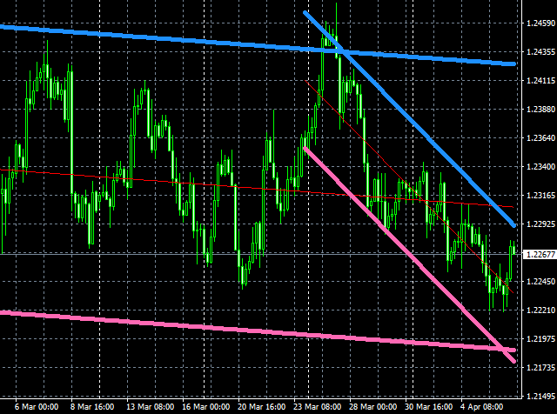](https://forum.mt5.com/attachment.php?attachmentid=317792&d=1610268164)  
  
One can either rely on their own knowledge and analysis in making decisions regarding the information available through a trend channel. One can either buy, sell or trade. One can also rely on various methods that will help someone in assessing and analyzing the different data available. The methods vary and aside from relying on tools and software available for data analysis, one must eventually rely on his/her own skill in making decisions in forex, stocks or cryptocurrency trading.

One way of helping traders is through the use of certain “indicators” that will allow them to plot, create or predict trend channels, predicting some outcomes by looking at the prices and price behavior and analyzing the data that comes from it. The use of “indicators” allows the trader to see predictive patterns and certain tendencies that data prices and its behavior exhibit, thus allow for a more informed, educated appropriate decisions regarding the assets and allow someone to make profits out of those trade decisions.

Raff Channel Indicator is one of the indicators available for any trader to use. It was a technique developed by Gilbert Raff. Strictly speaking, what does a Raff Channel Indicator do and how does it help a trader? First, it allows the trader to know whether prices are rising or not. It allows one to track whether prices are bullish or bearish. One can do this using Raff Channel Indicator by tracking accurately the regression by looking at the resistance and support lines exhibited by prices. One then can make decisions, either to gain profit or avoid losses depending on the data or trends available at the Raff Channel.

The repainting features of Raff Channel allows one to look at specific periods to track trends and make data analysis, assessment, and prediction regarding those trends. It allows the trader to closely scrutinize the price behavior and thus allow for a more in-depth study and analysis of prices and price behavior.

Other features are available in the Raff Channel Indicator. The data series included in the RAFF Channel Indicator is a great help for any trader. Among the most important features, of course, are the ones that allow you to draw the Raff Channel as well as to develop strategies one can use in buying, selling or trading. One feature allows you to measure the greatest deviation in the prices and price behavior for certain periods. By looking at this, one can measure the fluctuations and actual volatility of the prices. One can then develop strategies, create or plot trend channels, which will eventually help the client or its user to decide whether to buy, sell or trade, depending on how one assessed those deviations and fluctuations and strategies developed as suggested by the data indicated in a trend channel.  
It also allows one to have a look at regression and measure its actual strength by accurately looking at the resistance and support lines through various times and period. By looking at the strength, one can then decide either to have a short-term strategy for certain prices, or dig in for the long run, depending eventually of course, on the analysis of the trader.

Aside from measuring deviations both small and great, one can also derive through the use of Raf Channel Indicator through the “normalized slope”, the average, normal or median value of prices. If one can measure deviations and make assessments based on all the intangibles associated with it, one can also measure stability of a price or how stable or unstable it is based on its behavior. A trader can therefore have both features of the price behavior and have a larger, more accurate picture of the price behavior. It will certainly help those who are plotting trend channels, which will eventually help traders on whether they will buy, sell, or trade.

The Raff Channel Indicator also has features that allow the user or client to view all those features mentioned with it being displayed on different columns. It allows someone to have a comparative analysis for a more accurate plotting and creation of trend channels. It then allows for a more in-depth analysis, and whatever decisions a trader will eventually take, one is rest assured that the decision is an informed one.

Overall, these features mentioned are up to date and among the most efficient when compared to other channel indicators. It makes Raff Channel Indicator one of the best in the market today. It allows a trader to have a more balanced, accurate picture of prices or price behavior. It allows him/her to make comparative analysis of deviations, fluctuations, and its rate, as well as its stability, across certain periods. It allows one to plot and develop certain strategies that will further enhance the knowledge of the trader in dealing with stock market and forex trading. These strategies will be of invaluable help, it will allow someone to maximize profits or minimize losses in an increasingly lucrative but volatile world of stock market, forex and cryptocurrency trading.

Though ultimately one must rely on knowledge, skill and training in order to participate in stock market, forex and cryptocurrency trading, it will certainly help if one must also acquire technology, knowledge, competence and skills which are available either as a strategy, method or software. Having Raff Channel Indicator is certainly a welcome development in helping us plot strategies in the intricate world of stock market and forex trading. Combine Raff Channel Indicator with other tools, and/or indicators, as well as the trader/user’s great knowledge and skill of stock market and forex trading, one can certainly maximize the possibilities for profit and also greatly minimize the losses associated with volatility unforeseen developments both in stock market and forex trading.