**FX Agency Advisor 3**

For the past couple of years, a sea of change has occurred both in financial capitals as well as different stock markets around the world. The availability of new technologies and the increasing connectivity brought about by innovations in communications allow an increasing number of people to participate in what was, just a few decades ago, a still complicated financial world. With development in techniques in different fields of business and science, with different tools, programs, and applications now available, and with the internet becoming available to more and more people, many can now participate in the business of stock market and foreign exchange. Whereas before people need financial and forex advisors, the availability of tools and programs allows one to participate and examine the fluctuations in the market based on available data, through the use of tools available online. It flattened the field and allowed for the increasing number of ordinary men and women to participate and reap the benefits of engaging in stock market and forex. The use and availability of tools and technique, however, varies, and the difference between the different tools, techniques and applications or programs may, in the end, spell boom or disaster to those who are participating in it.

Among the different tools and programs available on the internet, the FX AGENCY ADVISOR is one of the leaders and probably the best available in the market. Now on its third version, the FX AGENCY ADVISOR is easy to operate but more sophisticated in its function, it allows you to make decisions based on data analysis that could only be given usually by an expert. FX AGENCY ADVISOR can do this because the system was developed by those who were known experts in the field of forex trading throughout the world. They knew the intricacies of forex trading so well, and the knowledge that could only be imparted by an expert can be imparted to the individual through the use of the FX AGENCY ADVISOR. It was developed by the best and the brightest in the field, and using FX AGENCY ADVISOR allows you to maximize all the available data that will eventually of great help in your decision to buy, trade or sell.

FX AGENCY ADVISOR is a lot way better than your traditional, expert financial or stockbroker adviser. It is easy to use and allows you to follow the fluctuations in real time by analyzing different time frames. It was made possible due to the algorithms that can provide the exact information given in a specific time frame and thus allows the individual to follow different fluctuations in different time frames. This new version allows you to observe four different time frames, which makes it way better than the older versions. One can choose which time frame to follow and observe and thus allows one to maximize the profit using this system. The FX AGENCY ADVISOR is so easy to use, the calculations are going to be performed by the system, one only has to look at the monitor to decide what steps one needs to take in order to have a profit.

How easy to use the FX AGENCY ADVISOR? Look closely at the picture below. The smaller box contained all the relevant information you will need in order to trade, buy or sell. All the fluctuations will be recorded on the graph. Outside the smaller box is the graph that will allow you to track all the relevant information contained in the smaller box. The difference between making a higher or lower profit is entirely left to your decision making, all the computations and analysis will be performed by the system.

[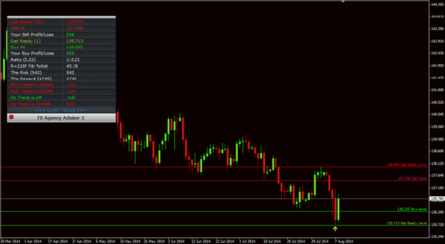](https://forum.mt5.com/attachment.php?attachmentid=317393&d=1610088579)  
  
FX AGENCY ADVISOR allows you to use whatever time frames that you want in order to maximize profit. But it is not the only thing the system can do for you. The system allows for available currency pairs. FX AGENCY ADVISOR also has a mechanism to allow you to rake in smaller profits at several intervals during a day and at different currencies available, or what they call to be “scalping.” It ultimately depends however as to what kind of trader you are, but whatever kind of trader, the software will be able to help you to track, analyze and capitalize on all available data and turn all those data into profits. The software allows you to trade and profit on whatever the stock market offers: binary options, currency trading, foreign exchange, index futures and others.

FX AGENCY ADVISOR is a powerful tool a software that will enhance your capability to trade in an increasingly changing world of finance and stock market. But powerful as it is, it offers even more. The software can be updated on a regular basis so as to be in line with future developments and innovations, and all of this for free. This will give any trader or participant in the world of stock market a vast, powerful tool to be used in order to make a steady, sure profit.

The world of finance and stock market is increasingly evolving, some modes of trading, innovations, and techniques go obsolete as the days, months, years go by. Other tools became available that will enhance the power of the individual trader to participate in an increasingly volatile but still and more than ever, profitable world of stock market. A trader who wants to make and maximize profits in participating in a very complicated world of finance and stock market must have all the necessary skill, tool, program, software and application which in turn can give him the necessary knowledge in order to trade, buy and sell in the stock market. FX AGENCY ADVISOR is such a tool, in fact, the only tool available to any trader that can do all of this in an instant. A powerful, vast tool, the only tool that can handle intricate, sophisticated data but at the same time so easy and handy to use, certainly a big help for any trader or player in the stock market. Making money has never been so easy and has never been so fun.