**Crude Oil Trading: A Basic Guide for Beginners 2021**

Ever watched the oil price fluctuate and wished to be a part of the action? How does one go about trading crude oil on worldwide markets? Technology has transformed away from coal and oil as its primary energy source for more than a century. The commodity is utilized in a wide range of products, including gasoline, plastics, and medications. As a result, it is highly prized, and price fluctuations are closely monitored around the world.  
  
Oil's volatility provides traders with a plethora of trading opportunities. It can also diversify portfolios, hedge other asset investments, and take positions on geopolitical problems. The good news is that trading oil is easier than ever before, as it is available online 24 hours a day, five days a week.  
  
So, how to get started with oil trading? This article will examine how and why oil prices fluctuate, what factors influence oil prices, how traders can trade oil, and the best crude oil trading for brokers.  
  
**What Is Crude Oil?**

[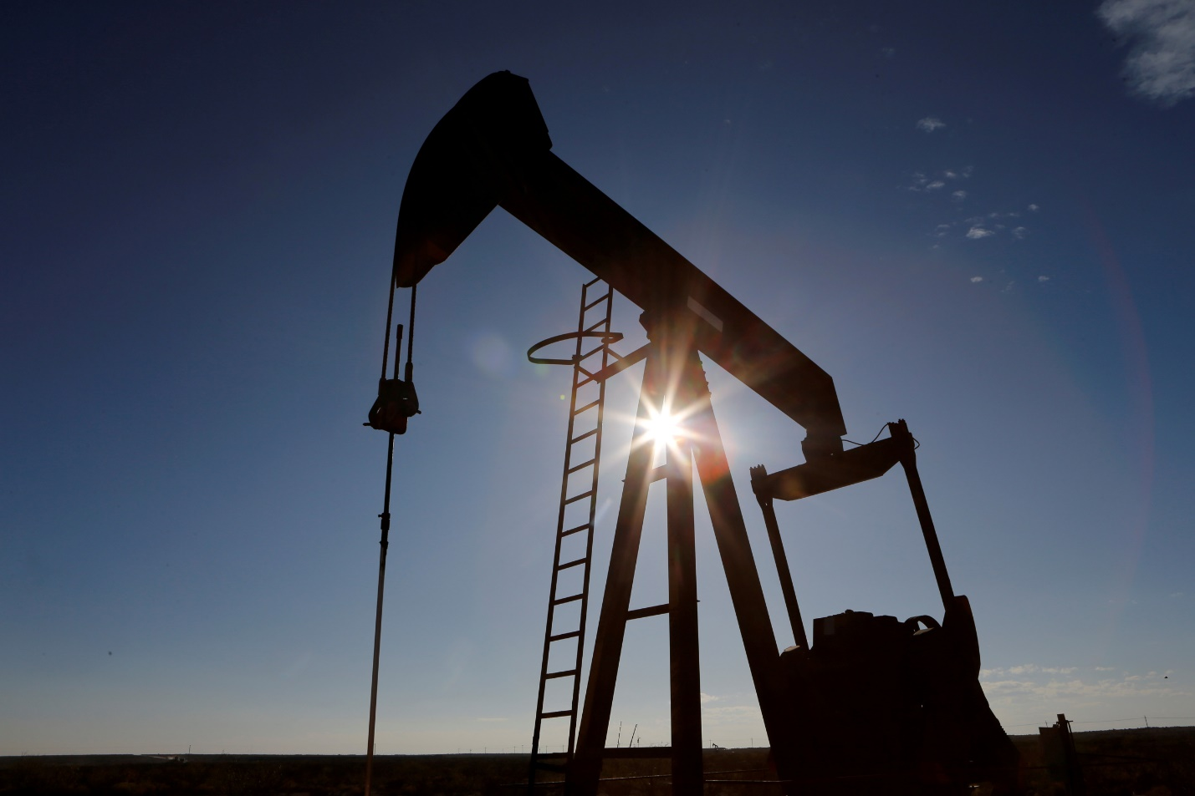](https://forum.mt5.com/customavatars/434479236.jpg)

Crude oil is a worldwide commodity that trades as spot oil and through derivatives contracts in marketplaces all over the world. The enormous number of products made from unrefined crude oil has earned it the nickname "black gold." According to the International Energy Agency (IEA), oil is an essential and vital component of the world economy, with total global use of 93 million barrels per day, according to International Energy Agency (IEA). Unsurprisingly, this commodity has a significant impact on daily lives, and economists, entrepreneurs, and traders all keep a close eye on it. Crude oil is one of the most traded commodities in the world, and it is used for a variety of purposes, including speculation, investment, hedging, diversification, and more.  
  
**WTI Crude Oil: What Is It?**  
  
With over 1 million contracts traded every day, WTI Crude Oil futures (ticker symbol CL) is the most actively traded crude oil futures contract. The term WTI refers to the West Texas Intermediate. On MetaTrader 4 and MetaTrader 5, this is one of the two most popular and well-known benchmarks for trading oil. Brent Crude is the other.  
  
WTI is a light, sweet crude oil with a low density and sulfur content commonly utilized in gasoline and diesel fuel production. Even though WTI is priced in Cushing, Oklahoma, it is linked to energy markets worldwide. As a result, trading WTI is a cost-effective strategy to speculate on crude oil events in the United States and worldwide. WTI is also an oil benchmark, which means that its price is used as a guide for buyers and sellers of crude oil and is mentioned in the media as oil price.  
  
**What Is Brent Crude Oil?**  
  
Brent Crude, like WTI, is used as a benchmark for oil prices. This type of oil is commonly utilized because it is sweet and light, making it simple to refine into diesel and gasoline. The majority of it comes from the North Sea and is refined in Northwest Europe. Brent is the most common type of oil in Europe and North Africa.  
  
**Brent vs. WTI Crude Oil Comparison**

[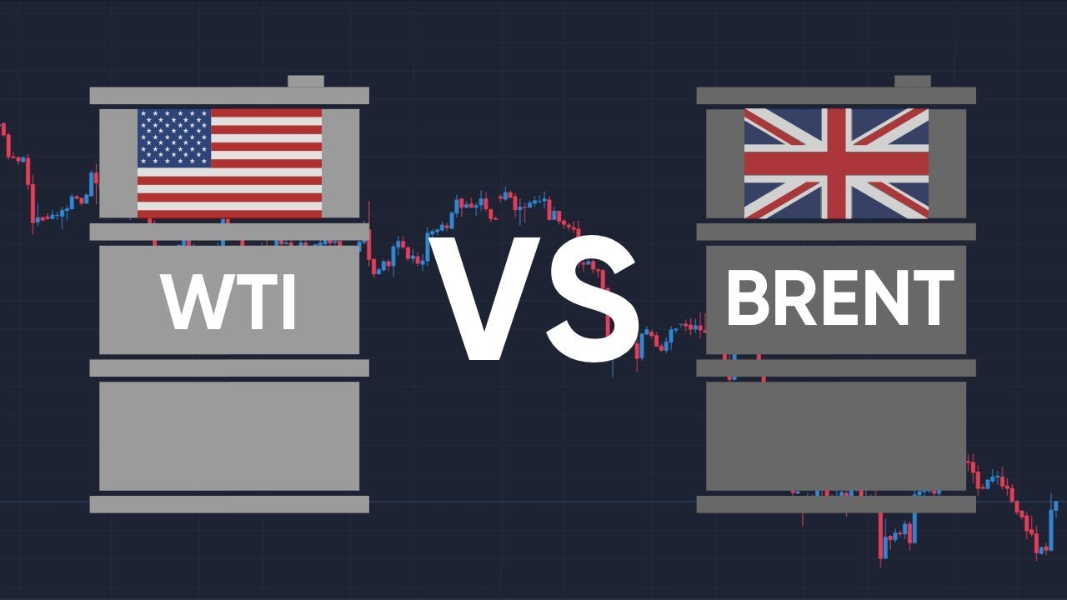](https://forum.mt5.com/customavatars/1850646835.jpg)

While both Brent and WTI crude oil are popular trading instruments, there are five significant distinctions between the two:

* **Extraction.**

WTI crude oil is extracted and produced mainly in Texas, North Dakota, and Louisiana in the United States. Meanwhile, Brent crude is primarily extracted from North Sea oil fields.

* **Political differences.**

Political activity frequently influences oil prices, which means that the political situation in countries where oil is extracted can impact pricing and oil trade activity. This is more important for OPEC oil now than Brent or WTI.

* **Oil composition and content.**

API (American Petroleum Institute) gravity, which measures how heavy the oil is compared to water, and sulfur content are two factors that influence the price of WTI and Brent. WTI has a sulfur content of 0.2%, while Brent has a sulfur content of 0.37%. Sulfur content is lower, resulting in a sweeter, easier-to-refine oil.

* **Oil trading options.**

Futures contracts and CFDs are available for Brent and WTI, respectively. Futures contracts for each oil are managed on different markets, but many CFD brokers will sell both through the same broker and platform.

* **Prices.**

WTI crude should theoretically trade at a premium to Brent crude, but this isn't always the case. This is because the price of oil is influenced by various factors other than the quality of the oil itself. One is supply and demand; for example, during the Shale Revolution in the early 2000s, when supply surged, the price of oil fell.  
  
**What Factors Influence Oil Prices?**  
  
Oil price fluctuations are significant for traders, investors, and worldwide economies. When oil prices rise, it affects customers both directly (at the gas station) and indirectly (at home) (products made with oil or the fuel used by companies to produce). Ultimately, reduced oil prices mean lower consumer costs.  
  
Crude oil prices are determined by supply and demand on a worldwide scale. One of the most important elements influencing petroleum products—and thus crude oil—demand is economic growth. Energy consumption rises as economies grow, particularly for transporting commodities and materials from producers to consumers.  
  
*Here is the long-term impact:*

* Higher oil prices tend to make items more expensive, which suppresses economic growth by raising the risk of inflation and interest rate hikes.
* Lower oil prices tend to make items more accessible, stimulating economic growth by lowering the risk of inflation and interest rate hikes.
* Low oil prices may cause producers to reduce current production or halt new oil projects, resulting in a reduction in supply.

Day by day, minute by minute, oil prices fluctuate dramatically. A variety of factors have an impact on costs. Consider the following:

* Subsidies for oil businesses or other energy corporations.
* International politics.
* Increase or reduction in supply by oil producers.
* Increase or decrease in demand by oil users and importers (agreements made between countries).
* Competition from other energy sources.
* Internal politics of an oil producer.
* Insecurity and geopolitical conflicts (tends to increase prices).
* The use of oil and its long-term prospects.

Traders might be curious about how supply and demand affect the price. In general, lesser stores and higher demand lower costs, while higher supply and more robust demand raise prices. However, supply and demand are influenced by two major causes. Let's go over them again.  
  
**Oil Production Levels: Oil Supply**  
  
Because oil is a resource that is not found in every country, production is concentrated. Oil is produced in 100 countries or almost half of the world's population. Five of these countries account for 49.6 percent of global crude oil output. This gives oil-producing governments and oil-producing organizations (such as OPEC) additional power oversupply and pricing. They can cut back on oil output to keep prices from falling or help them rise. They can raise their oil output if they believe the price is high enough to sell and profit.  
  
**Oil Demand Determines the Health of the Global Economy.**  
  
When the global economy is doing well, demand for oil rises because consumers buy more products, corporations ship and move more commodities (owing to increased demand), companies invest more (to develop enough capacity). People travel more for business and pleasure. The opposite impact of a weakened global economy is a reduction in oil demand.