**Drone Stocks: Top 5 to Watch and Invest in 2021**

Those who have a keen interest in history may think of war when you first hear the word drone. In the 21st century, however, drones became much more common than in previous centuries, infiltration into the market and association with the idea of war. By January 2021, for example, the FAA recorded more than 1.78 million drones in the USA alone. As a result, companies and consumers alike are becoming part of each day.  
  
In business, civic and military affairs, drones are predicted to play an important role. Drones are a leading technological transformation of the intelligent generation. It captures the imagination of many, from hobbyists to surveyors, technology managers, technologically knowledgeable enthusiasts, technology investors, and business leaders around the globe. The drones market is expected to reach $58.4 billion by 2026, according to Bloomberg. From 2021 to 2026, a CAGR of 16.4% is expected. In addition, it is likely that by 2026, the global size of the small drone market alone is $22.55 billion.  
  
Drones will remain integrated into everyday life in the future. While military drones remain a helpful contributor to the drone industry's growth even today, estimated to make a contribution to the drone industry in general of up to $19.6 million by 2026, the military drones will certainly not continue to play their role alone. With battery-powered commercial drones taking over the market, the idea that drones can only be used in war and perhaps even in business is quickly changing. It is estimated that the use of commercial drones on the market alone will increase by CAGR by 28% by 2026, the highest growth rate among all drone sectors, including government, law enforcement, military, and consumer sectors.  
  
**Are Drone Companies a Good Investment?**  
  
The only reason for this unprecedented future growth is developments in drone technology. For example, artificial intelligence is now integrated into drones to carry out additional tasks without having a human being direct them. After analyzes and all-alone deliveries, drones can now take off, navigate, collect and transmit data. That's also why they become a popular supply tool, especially during the coronavirus pandemic, in the medical supply. The value of delivery drones was about 2 billion dollars by 2020 and was projected to increase by 14% in CAGR by 2026 to 5.6 billion dollars.  
  
In that context, it is more profitable and unprecedented in the drone industry. Alphabet Inc Class A (NASDAQ: GOOGL), Boeing Company (NYSE: B.A.), NVIDIA Company (NASDAQ: NVDA), and Amazon.com, Inc. are among the most successful drones producers or companies in the manufacture and use of drones (NASDAQ: AMZN). These names are also generally regarded as popular investor stocks. The list below is the compilation of the ten best drone stocks to invest in.  
  
**Top 5 Drone Stocks Companies to Invest in 2021**  
  
Would you like to invest in drones? These ten drone stocks should follow the market.  
  
1. **Amazon.com, Inc. (Hedge Fund Holders: 243)**

[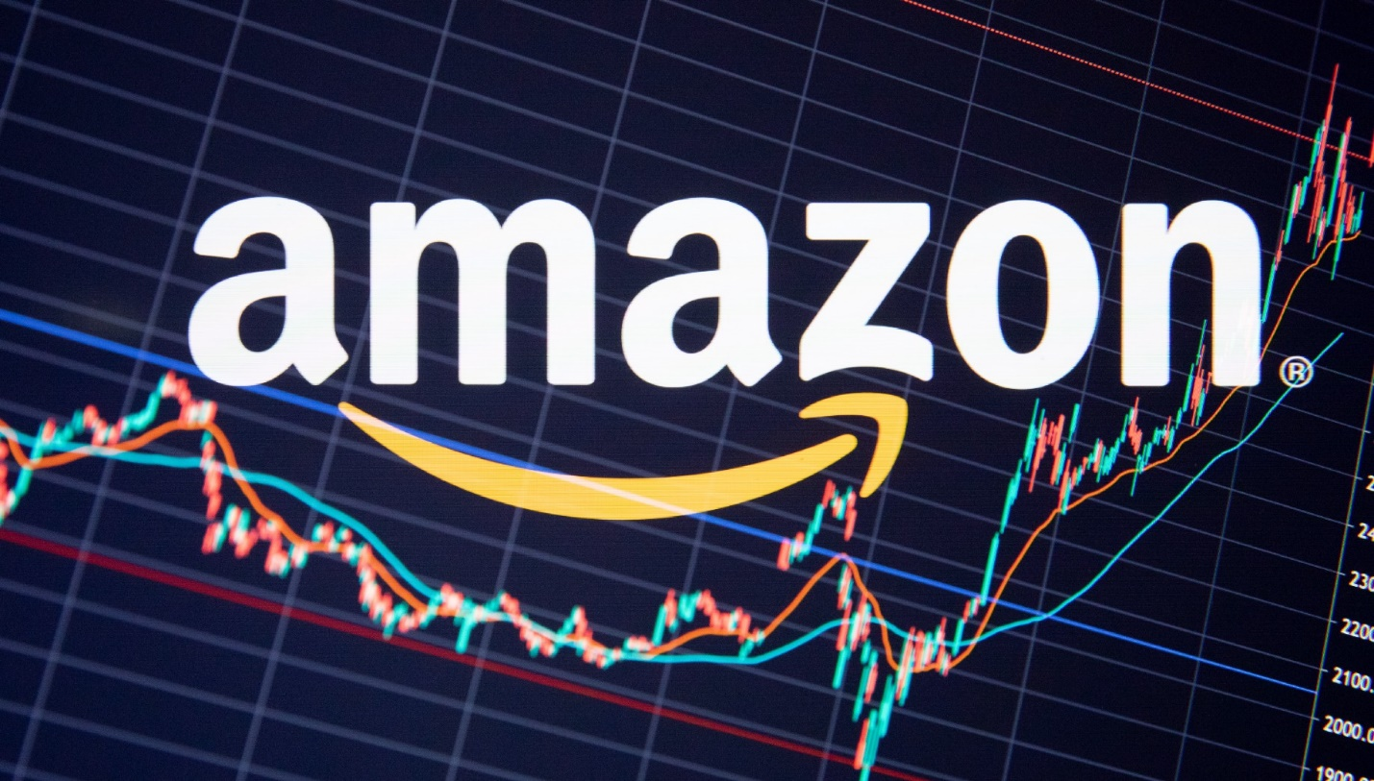](https://forum.mt5.com/customavatars/629783957.jpe)

Amazon Inc. produces and sells electronic devices such as Kindle, Fire T.V., Fire TV, Echocarbons, Rings, and other devices. It operates in three sectors: North America, International Web Services, and Amazonia (AWS).  
  
In the first quarter of 2021, EPS reported revenues of $108.5 billion, which accounted for 41.47% growth over the year, at $9:64 with its $15.79 EPS value. The company also has an income margin of 8.98% in the previous six months and a profit margin of 9.5% to date, increasing 40.48%. From 866 tracked by Insider Monkey, 243 hedge funds had stakes in Amazon.com, Inc. (NASDAQ: AMZN) worth around 50.4 billion dollars by the end of the first quarter of this year. The share value is approximately $51.5 billion compared to 273 hedge funds holders in the previous quarter.

2. **NVIDIA Corporation (Hedge Fund Holders: 80)**

[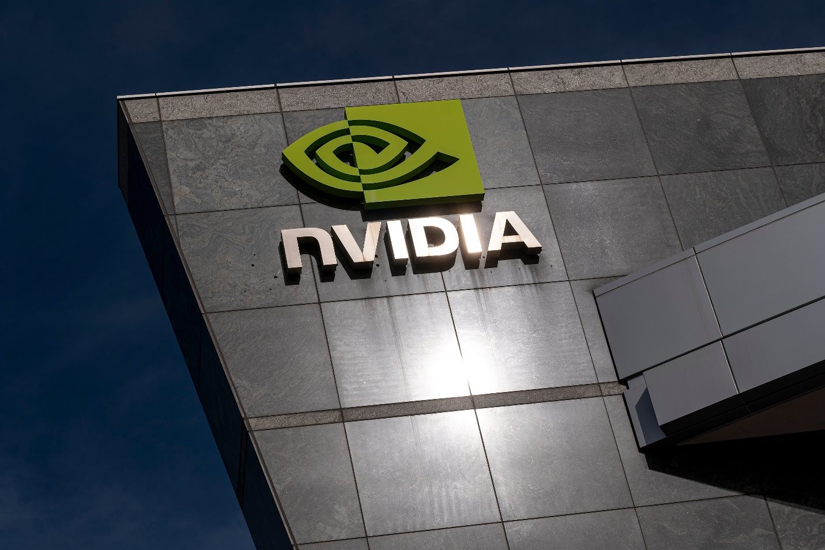](https://forum.mt5.com/customavatars/131578240.jpe)

The company is a leading producer of high-end graphics units (GPUs). NVIDIA is based in California, Santa Clara. With the launch of the RIVA series of graphics processors in 1997, NVIDIA became a significant force in the computer gaming industry.

See also: Get a chance to win luxury car. [Join now](https://www.instaforex.com/ferrari?x=MBZKY&uifd=657)!

NVIDIA (NASDAQ: NVDA) agreed on July 11 to acquire DeepMap, an autonomous vehicle start-up H.D. mapping system. A few days later, on June 15, a delayed filing of the $40 billion deal for the Softbank-owned chipmaker ARM was also reported. The delays are due to the participation of the E.U. in the agreement. Wells Fargo recently reiterated its Nvidia Overweight (NASDAQ: NVDA) rating and increased its inventory price target from $715 to $875. The company cited the expansion of the company's rating action A.I. platform.  
  
The 866 insider Monkey hedge funds held about USD 6.2 billion stakes in the NVIDIA Corporation (NASDAQ: NVDA) at the end of the first quarter of this year. The figure was 88 hedge fund holders compared to around $8.69 billion in the previous quarter.

3. **The Boeing Company (Hedge Fund Holders: 59)**

[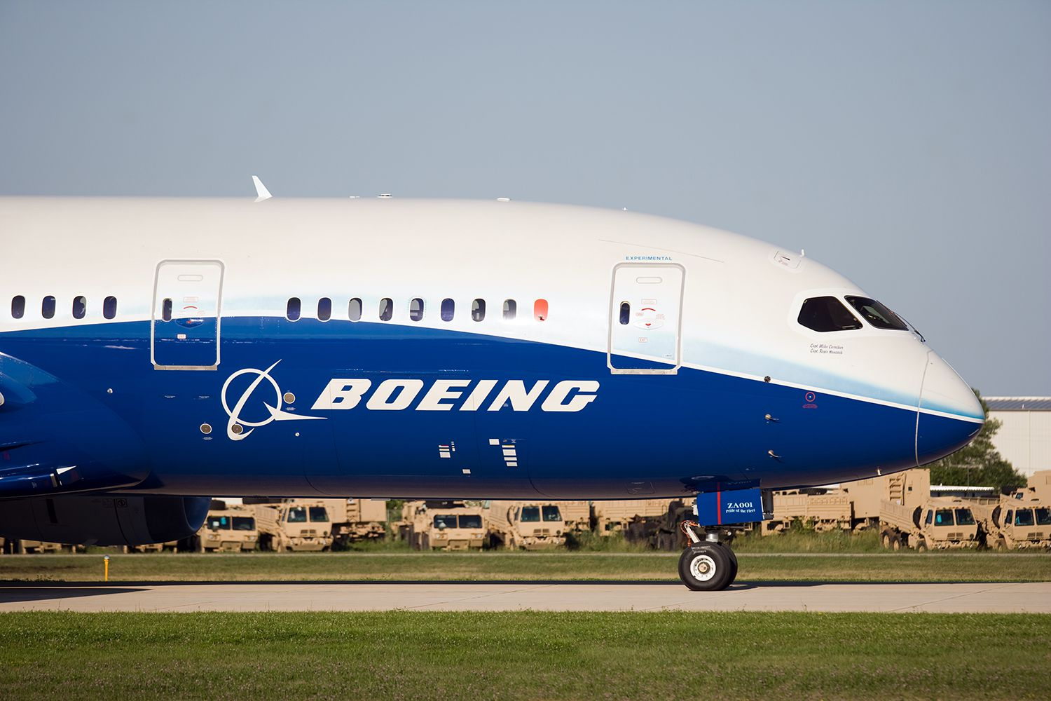](https://forum.mt5.com/customavatars/245799318.jpg)

Boeing is a manufacturing company of commercial and military aircraft, arms and strategic intelligence and defense systems. Commercial aircraft have overtaken Boeing as its primary source of revenue for Defence, Space & Security.  
  
In its first-quarter report, the Boeing Company (NYSE: B.A.) announced -$1.59 in EPS versus -$1.09 in the quarter estimate. The company also gained 8.86 percent in the past six months and 18.01% in 2014. First-quarter sales amounted to $15,22 billion.  
  
At the end of this year's first quarter, 59 hedge funds of the $1.44 billion worth of 866 were tracked by Insider Monkey in The Boeing Company (NYSE: B.A.). This is comparable to 55 hedge fund holders in the last quarter, with approximately $1,05 billion lower stakes.

4. **Alphabet Inc. (Hedge Fund Holders: 159)**

[](https://forum.mt5.com/customavatars/2037548217.jpg)

In 2015, after Google had restructured its operations to "cleaner and more accountable," Alphabet Inc. was founded. Google itself became an Alphabet subsidiary with products like Search, Maps, YouTube, Chrome, and the Android mobile phone platform being looked after.  
  
On June 24, Google Cloud and Jio of India partnered with 5G solutions from Alphabet Inc. (NASDAQ: GOOG). The cloud offering for fully automated lifecycle management of Google Cloud's 5G network is expected. In the first quarter of 2021, EPS (GOOG) was 26.29 dollars, with a peak figure estimated at 10.63 dollars and revenues of 55.31 billion dollars, an increase of 34.39% annually and an overall trend estimate of 3.62 milliards. Alphabet Inc. In the last six months, the stock has grown by 43.33% and, to date, by 47.3%.  
  
By the end of this year's first quarter, 159 of the insider monkey's 866 hedge funds had stakes in Alphabet Inc.

5. **AeroVironment, Inc. (Hedge Fund Holders: 16)**

AeroVironment, Inc. is the designer, developing, and manufacturer of small uncrewed aircraft and fast-charge battery charging systems. The company offers antenna, sensors, and missile systems for extended range tracking. In the United States, AeroVironment markets its products.  
  
A $7 million tasking order from U.S. Special Operations Command has received this March by AeroVironment, Inc. subsidiary (NASDAQ: AV AVAV), Arcturus A.V. (USSOCOM). The task is to last one year and is designed to provide USSOCOM with mid-length USSOCOM programs. The company has also entered into multiple dealings with the Puma 3 A.E. statistic UAS and initial spares packages this April with a total potential of $80 million and a further $44.9 million increase to the deal through the U.S. Armed Forces contract exercise this year, including multi-year orders worth approximately $11.53 million.  
  
From 866 trackings by Insider Monkey, 16 hedge funds held stakes in AeroVerrment, Inc. (NASDAQ: AVAV, for more than 137 million USD) by the end of the 1st quarter of this year.

**Conclusion**  
  
The stocks of drones are becoming very trendy. The demand for them is growing rapidly due to technological advances and the ways that the technology is eloquent and sophisticated. Many drone companies offer ultra-modern technologies to customers. For multiple purposes, customers can use drones. As the world is running on automated systems and almost everything is being operated automatically, drone companies' inventories can be one of the best investments. Due to the fairly realistic market price potential, now is the time to invest in the stocks of drone companies.  
  
Which of the drone companies mentioned above do you think is the best? Comment down your pick!