**Top 4 Most Powerful Candlestick Patterns to Use in 2021**

Technical analysis in the form of candlestick charts is a sort of technical analysis in which data from multiple time frames is combined into a single price bar. This sets them apart from traditional open-high, low-close bars or simply lines connecting closing price points. Candlesticks generate patterns that predict price direction if they are finished. This colourful technical instrument, which dates back to 18th-century Japanese rice dealers, gains depth with proper colour coding. Steve Nison introduced candlestick patterns to the Western market in his famous 1991 book "Japanese Candlestick Charting Techniques." Hundreds of these patterns are now recognized by many traders, with names such as bearish dark cloud cover, evening star, and three black crows. Single-bar patterns like the Doji and the hammer have been used in a variety of long- and short-side trading strategies.  
  
**Reliability of Candlestick Patterns**  
  
All candlestick patterns aren't created equal. Because hedge funds and their algorithms have evaluated them, their enormous popularity has diminished their reliability. To compete against regular investors and traditional fund managers who use technical analysis tactics accessible in popular texts, these well-heeled competitors rely on lightning-quick action. To put it another way, hedge fund managers use software to entice investors to search for high-odds bullish or bearish outcomes. On the other hand, Reliable patterns continue to emerge, allowing both short- and long-term earning opportunities to be available.  
  
Four candlestick patterns that can be used to predict price direction and momentum are listed below. Each one makes a prediction of more excellent or lower prices in the context of the surrounding price bars. They are also time-sensitive in two respects.

1. They are only able to work within the bounds of the chart they're looking at, whether that chart is intraday, daily, weekly, or monthly.
2. Their power rapidly declines three to five bars after the pattern is completed.

**Performance with a Candlestick**  
  
These findings are based on Thomas Bulkowski's 2008 book "Encyclopedia of Candlestick Charts," which featured candlestick pattern performance rankings. Bulkowski presents statistics for two categories of expected pattern outcomes:

1. **Reversal.** Candlestick reversal patterns signal a price move ahead.
2. **Persistence.** Persistence patterns indicate that the current price trend will persist.

In the following circumstances, the hollow white candlestick denotes a closing pattern that is higher than the starting point, while the black candlestick suggests a closing pattern that is lower than the beginning print.  
  
**Are Technical Trading Tactics Based on Candlesticks Profitable?**  
  
The purpose of a candlestick is to perform precisely what it says on the tin. It takes a set of events and summarizes them. The open, high, low, and close are the four key information in summary. Furthermore, Japanese candlesticks provide a visual cue in colour to indicate whether the market moved up or down between the open and closing. As a result, a candlestick only reveals two things about the market:

1. The price range that existed during the historical period.
2. How prices changed over time. (High/low/open/close).

This is precisely what it does, and it does it perfectly. If there's anything else traders can make of it, it's entirely up to their imagination and interpretation. Most people, unfortunately, assume that these candlesticks represent the entire market. Even though it is a crude representation, it leaves out a lot of information:

* It doesn't reveal how much activity took place throughout the period.
* It does not indicate if the majority of the persons were buying or selling.
* It does not reveal the type of market participants who were buying or selling. (Was the price manipulated by a few market makers, floor traders, or outside speculators/investors?)
* It does not reveal how much was purchased by whom.
* The market is represented not just by activity during the day or within a specific time frame but also by who is holding long or short positions in the market. This information is also not received from the candlesticks.
* Traders can't get statistical probability from a candlestick chart.
* It does not reflect psychological data, the intensity of long/short holders' convictions, or when and at what price they would liquidate.
* Candlestick charts don't tell traders how many market participants and how much money they're putting into the market at any particular time.

**Top 4 Candlestick Patterns 2021**  
  
**1. Strike in Three Lines**

[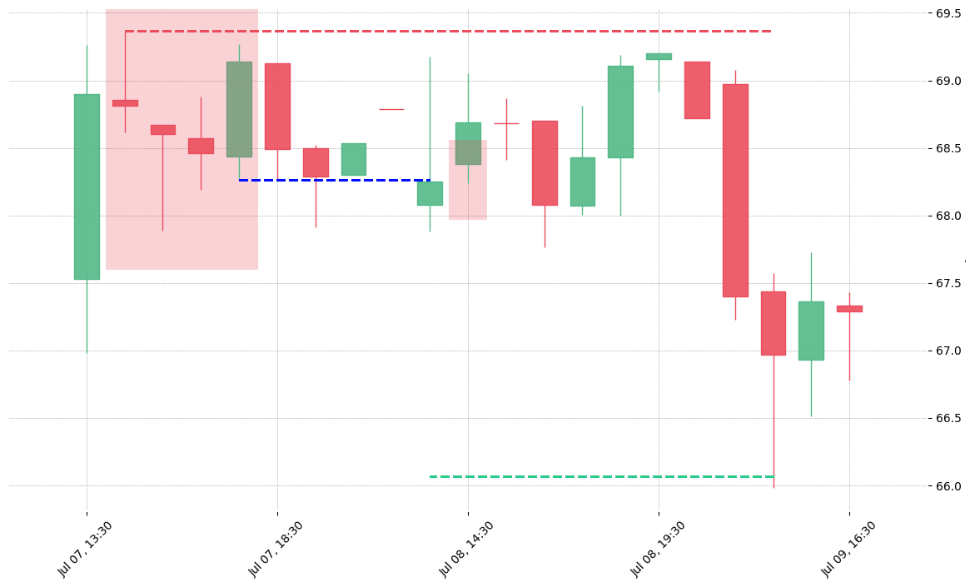](https://forum.mt5.com/customavatars/392794626.png)

Within a downtrend, the bullish three-line strike reversal pattern carves out three black candles. Each bar is a separate entity that has a low that is lower than the intrabar common and a close that is close to it. The fourth bar starts lower than the others, but quickly reverses into a wide-range outer bar that closes above the series' original height. The first print also denotes the end of the fourth bar's silence. According to Bulkowski, this reversal predicts rising prices with an 83% accuracy rate.

**2. Two Black Gapping**

[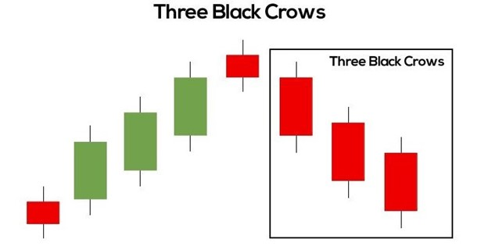](https://forum.mt5.com/customavatars/1123316414.jpg)

After a significant top in an uptrend, the bearish two black gapping continuation pattern occurs, with a gap down gives two black bars posting lows that are lower this pattern suggests that the drop will continue to lower lows, potentially resulting in a broader-scale downturn. According to Bulkowski, this pattern forecasts lower pricing with a 68% accuracy rate.

**3. Evening Star**

[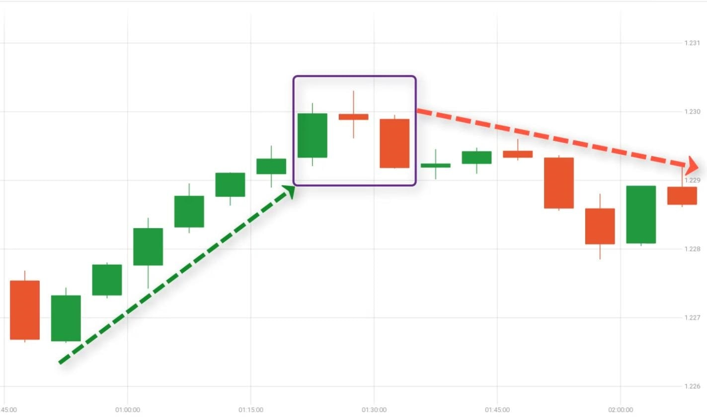](https://forum.mt5.com/customavatars/978663031.jpg)

The bearish evening star reversal pattern, which carries an uptrend to a new high, is initiated by a massive white bar. The market gaps higher on the next bar, but no fresh buyers appear, resulting in a tight range candlestick. The pattern is completed by a crackdown on the third bar, indicating that the slide will continue to lower lows, possibly sparking a broader-scale slump. According to Bulkowski, this pattern has a 72% accuracy record in predicting decreased pricing.

**4. Abandoned Baby**

[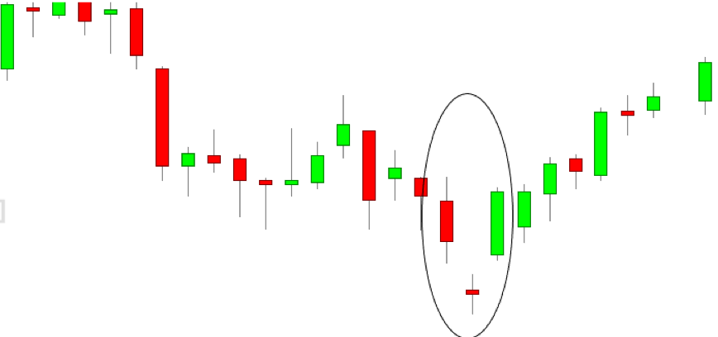](https://forum.mt5.com/customavatars/2123405208.png)

After a sequence of black candles prints lower lows, the bullish abandoned baby reversal pattern develops at the bottom of a downtrend. On the next bar, the market gaps more inferior, but no new sellers materialize, resulting in a narrow range of Doji candlestick with identical opening and closing prices. A bullish gap on the third bar completes the pattern, indicating that the recovery will continue to higher highs, possibly triggering a broader-scale upswing. According to Bulkowski, this pattern has a 49.73% accuracy rate in predicting increased prices.  
  
**Conclusion**  
  
Market participants are drawn to candlestick patterns; however, many of the reversal and continuation signals provided by these patterns do not work dependably in today's computerized environment. Fortunately, statistics by Thomas Bulkowski demonstrate that a small subset of these patterns has extraordinary accuracy, providing traders with meaningful buy and sell recommendations. A [brokerage account](https://forum.mt5.com/showthread.php?327483-Brokerage-Fee-in-Share-Market-and-Forex-Guide-2021&highlight=brokerage+account) is required to put the knowledge gained from candlestick patterns to use and invest in an asset-based on them.