**Three Moving Average Crossover EA: Strategy to trade with this EA**

A solid EA trading system will not lose its effectiveness over time and should perform consistently for several years. It is also another average trading method with a high consistency over time. Today's discussion is about the Metatrader 4 program that uses an MA crossover to produce alerts and trades.  
  
**Trading with 3 EMA Crossovers**  
  
The three-moving average crossover strategy is a trading method that employs three different length exponential moving averages. Moving averages are all trailing indicators, but they can assist a trader in framing the market when applied appropriately. Traders can set in on a specific chart location using moving averages instead of buying and selling at random points on the chart. Traders can also then choose a trading opportunity based on a variety of simple price action patterns.

**Parameters:**

* Lots
* TakeProfit
* StopLoss
* Ma1Period - The period for Ma1 calculation
* Ma1Shift - The shift for Ma1
* Ma1_Method - The method for Ma1 calculation
* Ma1_AppliedPrice - The applied price for Ma1 calculation
* Ma2Period - The period for Ma2 calculation
* Ma2Shift - The change for Ma2
* Ma2_Method - The technique for Ma2 calculation
* Ma2_AppliedPrice - The used price for Ma2 calculation
* MagicNumber

**Why Use Three Moving Averages in Your Strategy?**  
  
Moving averages are not magical, but they can create a simple trading technique that works. These tactics seem to appeal to Forex traders in particular. Moving averages develop various trading methods, but keep in mind that complex trading techniques aren't necessarily the best. Do less when you're unsure.  
  
**Benefits of employing a three-moving-average strategy?**

1. Indicates the direction of the longer-term trend and whether the shorter-term trend is favorable.
2. Traders can look at a shorter-term trend to evaluate whether they should trade with or against it.

It's important to remember that moving averages, even EMAs, are lagging indicators that won't help to predict peaks and bottoms. This isn't necessarily bad, as trading conditions might be sloppy when the trend is changing. The critical difference between utilizing two moving averages, as in the Golden Cross technique, and utilizing three averages is that the Golden Cross technique has a longer-term trend direction.  
  
**What Do The Triple Moving Averages Represent?**

* 9-period exponential moving average.
* EMA of 21 periods.
* 55-period exponential moving average. (Some people will use the 50 EMA moving average, but it makes no difference).

*The 55 EMA will use to determine the longer-term trend direction:*

* Traders consider the trend to be up when the 55 EMA is below the nine and the 21.
* Traders will consider the longer-term trend down if the indicator is above the shorter-term moving averages.

*The 21-day exponential moving average (EMA) regards as a medium-term trend indicator:*

* For an uptrend, the 21 must be below the 9 and above the 55.
* For a downtrend, the 21 should be above the 9 and below the 55.

*More commonly than the 55, the 9 periods will pass over and under the 21 period.*

* 9 EMA has crossed above the 21 and is now above the 55, indicating an uptrend and potential for a buy trade.
* If it falls below the 21 while already below the 55, it is in a downtrend and sells trade.

Many times the 9 EMA may cross the 21 periods, reversing the short-term trend and turning it against the longer-term trend. There may be trading opportunities in the direction of the shorter-term trend as well as the longer-term trend. When there is a mix of trend directions, traders are cautious with profit targets and must quit when price action is terrible.  
  
**The Strategy of Trading With Three Moving Averages**  
  
While trading the crossovers is an option, it is not the most excellent method to use the three EMAs. If it opts to sell only based on a crossing, be prepared for a lot of whipsaws. The condition of the moving averages can reveal a lot about the market:

* Consider the market to be in a trading range when the indicators are jumbled together.
* Consider momentum entering the market when the quicker moving average starts to pull away from the others.
* We're looking at a trending market because the 9 and 21 EMAs have crossed and separated.
* A strong trend is in play when all of the averages line up.

It can assess what type of trading setups needs to join the market based on those four items.  
  
**Buy Setup**  
  
Although this one-hour price chart is for a Forex currency pair, it may be used on any instrument.

1. Traders want the moving averages to line up in the same direction in the following order: 9, 21, 55.
2. Traders look left for a swing high 3 after the final cross, in this case, the 21 crossing the 55. We are on the close of the [candlestick](https://forum.mt5.com/showthread.php?325048-Best-Candlestick-Pattern-Indicator&highlight=candlestick) — observe the green arrow – if that swing high has been wiped out.

**Short Setup**

* To examine shorts, it utilizes the range's lowest swing low as the area that has to break.
* The 21 EMA has crossed the 9 and the 55 EMA, establishing a short.
* Sell the candlestick closure that caused the moving average crossing.

The short setup is the polar opposite of the buy setup, and they both require the same crucial factor: a pivot low or high must be breached before entering the trade.  
  
**Stop-Loss + Profit Taking + Trailing Stop**

See also: [Wide range of InstaForex technical indicators](https://www.instaforex.com/forex_indicators?x=MBZKY&uifd=657).

On this kind of transactions, there are a few things to keep in mind when deciding where to place your stop loss:

* Allow for price movement to avoid a tight stop loss.
* Be dependable.
* Using the 2 X ATR, you can keep your stop outside of expected volatility and let the price vary.
* Using previous swing highs or lows is a straightforward visual area, but the pivots may be far from price due to the lagging nature of moving averages.

[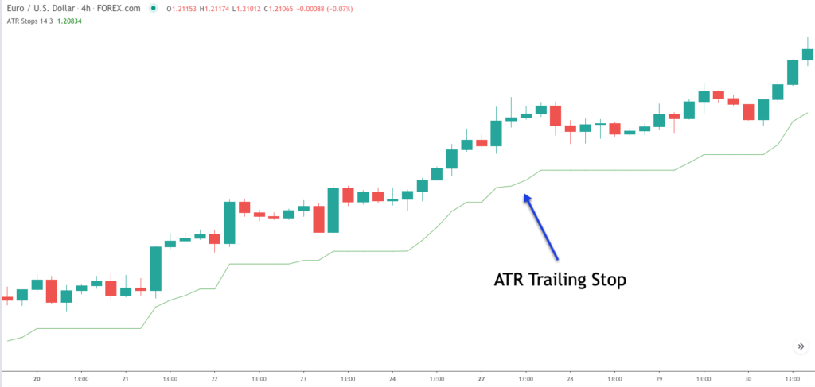](https://forum.mt5.com/customavatars/1026575306.png)

The downside of this crude oil futures chart and the candlestick that would short is marked. Choose the swing high or set the stop to 2 X ATR. They are stopped out in this example, but it could trace the 55 EMA, 21 EMA or create profit goals based on risk multiples if they weren't. This is also a good idea to aim for past swing low zones.  
  
**Second Example of a Continuation Trade**  
  
We could use the shorter moving average crossings for continuation trades, as previously indicated, but keep in mind what a crossover represents: A shift in the trend's direction, either short or long term, suggests that you may be dealing with a weakening market. Using our rule of requiring removing a swing high or low before entering a trade can help us avoid losing transactions.  
  
*But what about a market that is strongly trending?*  
  
**Returning to the crude oil chart**

[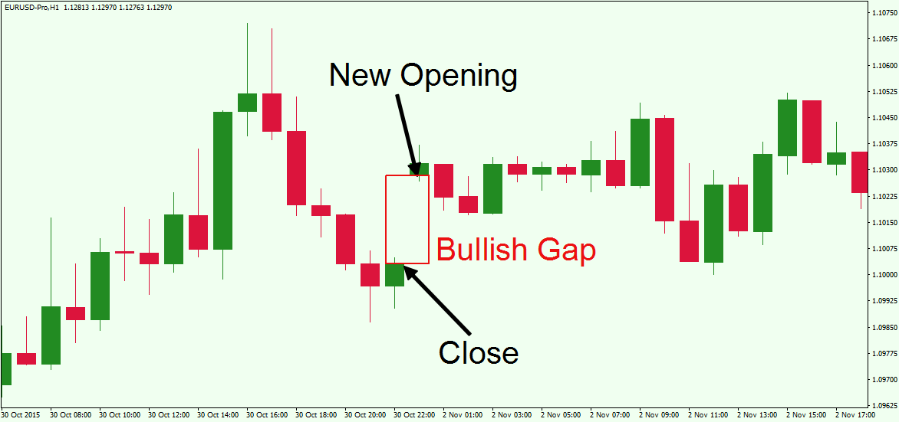](https://forum.mt5.com/customavatars/1728678050.png)

It highlighted a gap in the averages and how far the price has deviated from them. Price has declined due to momentum, and though the cross of the averages is a trade, it may have trading plan rules that require traders to take a break.  
  
*What is the reason for this? Due to the recent momentum, traders anticipate a price rebound.*  
 *This is where the continuation trade will be used.*

* Price returns to the 9/21 EMA.
* A trade trigger is a reversal pattern, reversal candlestick, or simple trend line break.
* Stops can be placed above the last high candlestick.
* Profit-taking follows the same rules as the other techniques.

**What about Bitcoin?**

[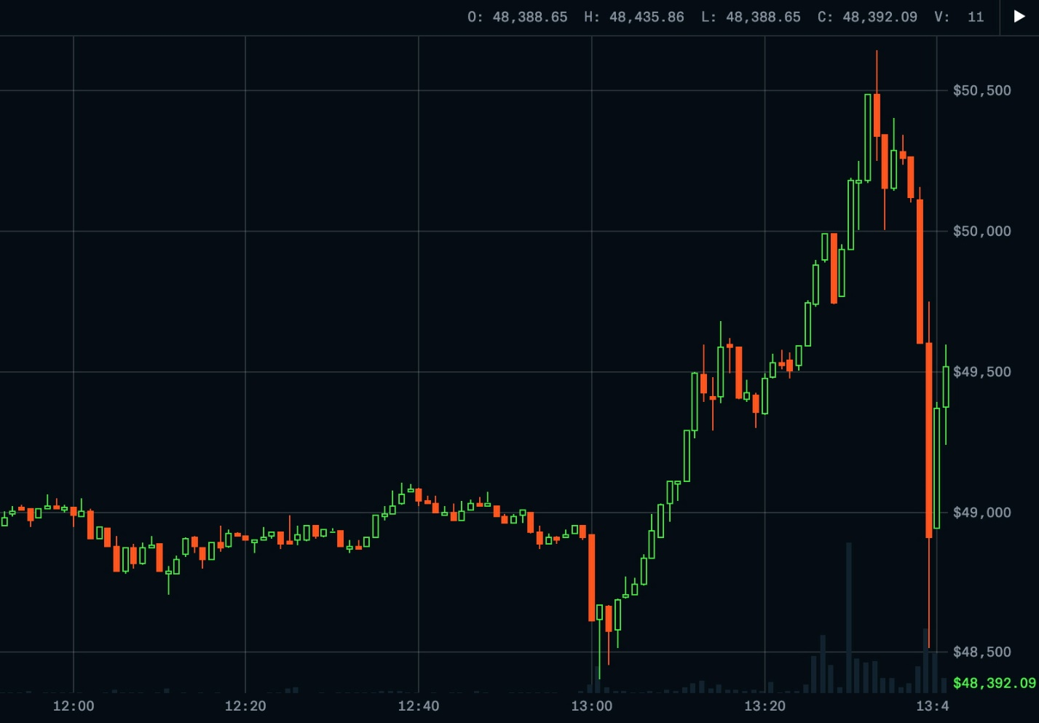](https://forum.mt5.com/customavatars/2008846753.jpg)

1. Price pulls back, and a massive momentum candle to the upside wipes off the preceding four hours.
2. The market has a pullback and momentum stride.
3. Pullback into the EMAs and within candle (lower time frame range) or 4. Breaking the trend line and entering the market.

*The following are the main points:*

* Price pulls back between the 9/21 moving averages, indicating that the market is trending and has upward (downside) momentum.
* Back-test your rules and create a trading plan encompassing everything from markets to risk tolerance, just as you would with any other trading strategy.

**Thoughts on the Triple EMA Trading Strategy**  
  
With moving averages, the lagging issue can cause issues such as price moving too far too fast. This may lead to us entering a trade exactly when the price returns to its average level. The good news is that we can determine momentum based on the averages' separation and the price's distance from the averages. In all trades except the continuation, two approaches, including the required swing level breaks, assures that price action is providing us a trending price pattern. Three moving averages make it easy to determine whether a market is trending or range.

* They have a trend if the averages are apart.
* They have a range if price swings back and forth around the averages.

Suppose traders don't trade the 3 EMA crosses mindlessly. In that case, they might be able to get an advantage with this technique, which takes advantage of the trend, momentum, and essential trade management and profit-taking procedure.