**Shved Supply and Demand – How to Trade with this Indicator?**

The Shved Supply and Demand Indicator for MT4 designed to assist traders in determining supply and demand zones. The definition of Shved supply and demand zones differs slightly from those of the support and resistance zones. At price levels where a previous price rally (strong upward move) began, demand zones (often equated with support) form. According to supply and demand theory, there must be many unfilled buy orders in the market where the rally began. As a result, if the price returns to the demand zone, there is a greater risk that it will be rejected from the demand zone and move upward again.  
  
On the other hand, supply zones (often equated with resistance) form at price levels where a previous rapid downward step began. According to supply and demand theory, there must be many unfilled sell orders in that region. Should the price shift upward into the supply zone again, the price, according to the theory, has a higher chance of being rejected to the downside. Demand zones and support zones were equated by the creator of the Shved Supply and Demand Indicator for MT4. In addition, he equated supply and resistance areas.  
  
**Trading with Shved Supply and Demand Indicator MT4**  
Without proof, the Shved Supply and Demand Indicator for MT4 boxes should not be exchanged. Meaning, traders shouldn't put a limit sell order at any box that's drawn above the current price. Those boxes do not reflect high price resistance levels. On the other hand, Traders could see in the strategy tester's visual mode that the Shved Supply and Demand Indicator for MT4 is very profitable if they wait for a confirmed supply (resistance) zone. This indicates that the indicator has begun to draw a supply (resistance) line, and traders can wait until the price moves back into that zone and is rejected downward once more. If that happens, traders should take advantage of a high-probability downward trend.  
  
One good sell trade and one sell trade in progress are depicted in the figure below. Traders will see the first (completed and successful) transaction in the upper part of the chart. They can see where the Shved Supply and Demand Indicator drew the red supply (resistance) zone for MT4. The price then dropped before beginning to rise again into the supply (resistance) zone. The Shved Supply and Demand Indicator for MT4 renamed the box as "Verified Res)" after the price was rejected downward. The downward rejection gives the traders the sell entry signal. This sell trade was a great way to keep the momentum going.

[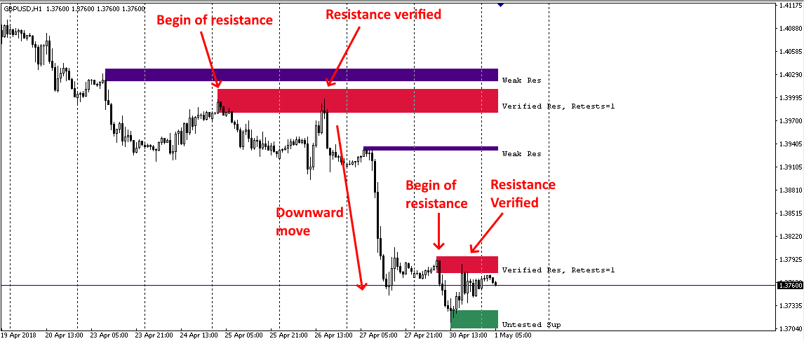](https://forum.mt5.com/customavatars/172166249.png)

The second trade is seen in the lower part of the figure above. The sell entry should now be made because the upside pullback appears to be complete, and the downward move could now begin. The outcome of the second trade (again, a winner as shown by Shved Supply and Demand Indicator MT4) is shown below:

[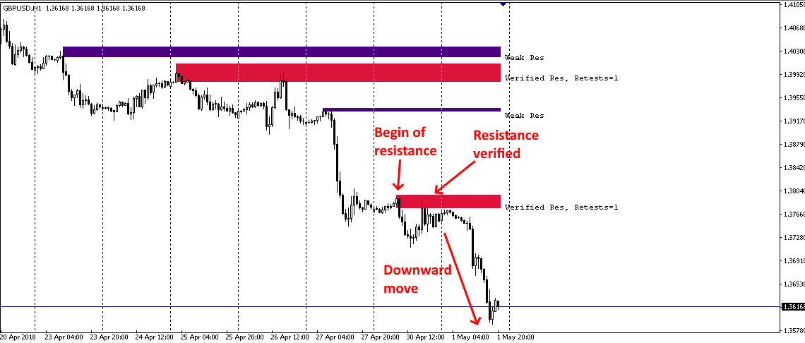](https://forum.mt5.com/customavatars/1142025195.png)

For buy trades, the same principle can be applied, but in the opposite direction. The Shved Supply and Demand Indicator draws a demand (support) zone for MT4. The price rises briefly before falling back into the demand (support) zone. It's critical now that an upside rejection happens once more. Traders will then enter a buy trade during the first pullback after the rejection, for example.  
The illustration below depicts the point at which traders may have joined the exchange. It's possible because the stop was put below the demand (support) zone:

[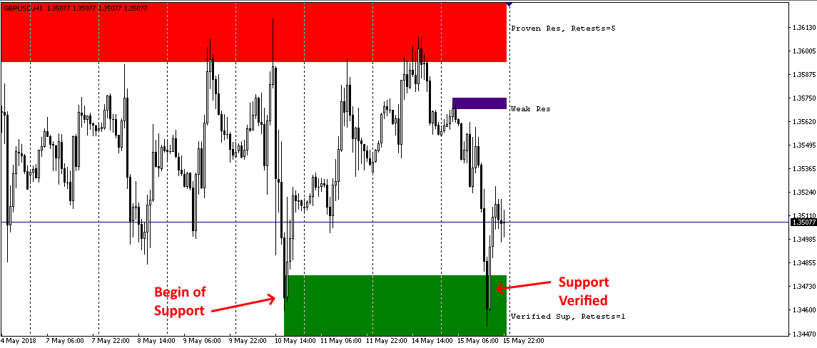](https://forum.mt5.com/customavatars/864403463.png)

The following figure depicts the outcome of this exchange, which was a good winner on the subsequent upward move:

[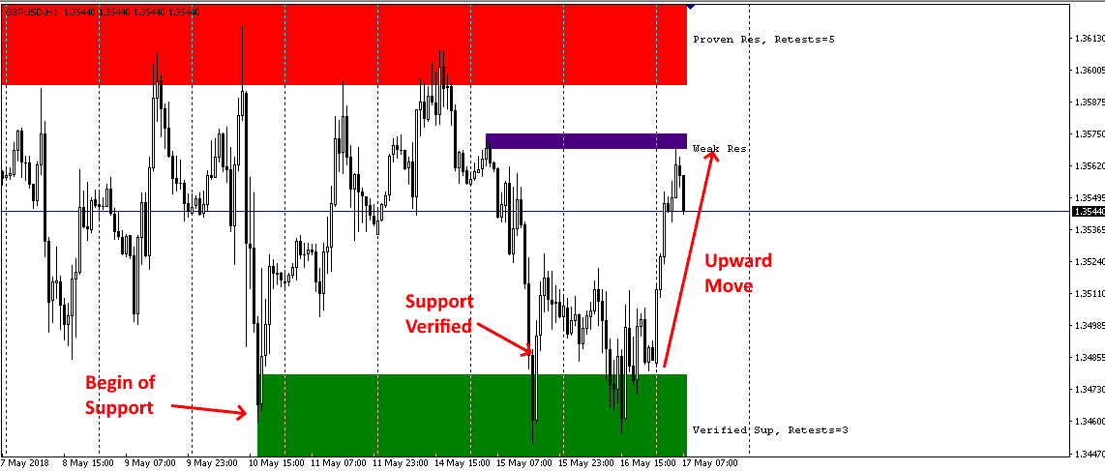](https://forum.mt5.com/customavatars/1156948327.png)

**What Types of Zones Does the Shved Supply & Demand Plot?**  
  
This indicator highlights five different styles of levels:

1. **Weak zone** – this is a weak zone. There is no surplus supply or demand near these values. As a result, a trader can either stop trading with them or do so with caution.
2. **Region that has not yet been checked** - They have supply and demand areas where the price has made a powerful and targeted change in the past.
3. **Verified zone**– a standard that has already been checked (verified). These are the values that have ignited new trading interests two or more times. On the chart, the indicator shows the number of times such formations have been retested. The zone becomes more vital as the number of retests increases.
4. **Validated zone** – a trend that has been consistently checked (proven). Trading activity almost often returns from these levels, even though a level is disrupted and the pattern shifts.
5. **The so-called "mirror" levels of the turncoat zone** - Initially, such zones serve as sources of resistance or support. The levels are broken out and used to trade in the opposite direction regarding fluctuations in supply and demand.

**How to Download the Shved Supply and Demand Indicator?**

**Step 1: Download Indicator**

* Click this File to download the [Shved Supply and Demand Indicator installer.](https://indicatorspot.com/?download=1&kcccount=https://indicatorspot.com/wp-content/uploads/2020/12/shved_supply_and_demand.ex4)

**Step 2: Open MT4 Data Folder**

* Next, go to the MT4 terminal root directory and open it. To do so, click File then open Data Folder.

[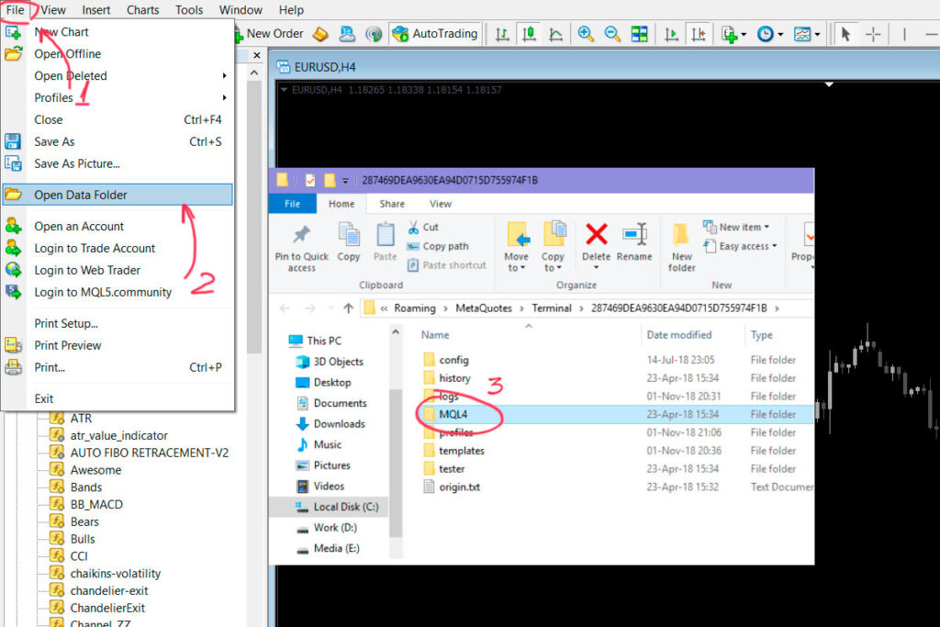](https://forum.mt5.com/customavatars/2039919295.jpg)

**Step 3 – Distribute the indicator to the MQL4 Folder**

* Open the "Indicators" folder by double-clicking on the "MQL4" folder.

**Step 4 – Restart or Refresh MT4**

* To see the indications in the Navigator window after installation, restart the terminal or right-click – Refresh.
* Use the Ctrl + N shortcut to locate the Navigator window if a trader can't find it.

[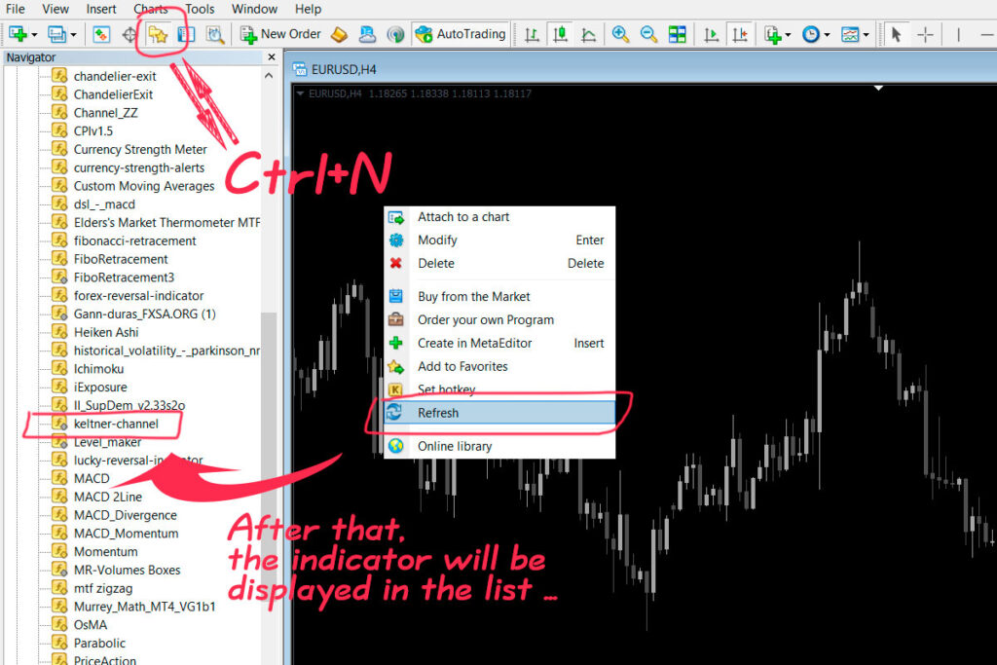](https://forum.mt5.com/customavatars/828503179.jpg)

**STEP 5 - Enable DLL Imports to Run Indicators**

[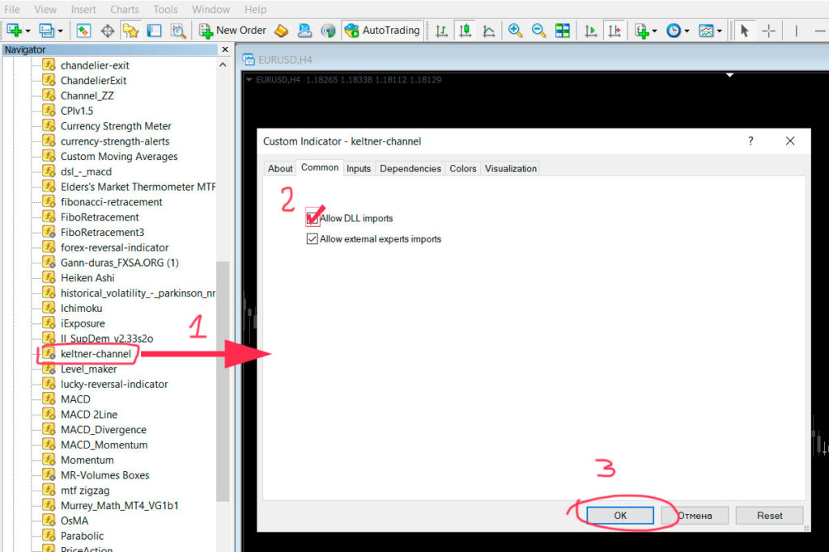](https://forum.mt5.com/customavatars/498739401.jpg)

* Move the indicator onto the graph. Common tab in the new window > check the Allow DLL imports box.
* After that, press OK.

The indicator should appear on the chart and work properly.

**Final thoughts**  
  
Traders can have a profitable trading strategy by waiting for checked supply/demand zones indicated by the Shved Supply and Demand Indicator for MT4. To improve the consistency of trades, keep an eye on the bigger picture (higher time frames) as always in trading.