**Money Flow Index – How to Trade with this Indicator?**

What causes markets to fluctuate? It's a fundamental question that any experienced trader should think about, and the answer can be as complicated as it to be. The most straightforward response is probably supply and demand. If there is a strong demand for an instrument but a limited supply, the price will naturally increase. The cost will decline if the opposite is true. Isn't it simple? But how to tell what's going on in terms of supply and demand? Especially in the Forex sector, which is decentralized and, as a result, not particularly clear. We can use price data to figure out how much money is moving in and out of a particular instrument.

[](https://forum.mt5.com/customavatars/2090398035.png)

The Money Flow Index indicator is one of the most widely used methods (MFI indicator). It measures the amount of money flowing into and out of a particular asset. Also, MFI is a valuable method for determining a trend's growth prospects. It's easy to use and doesn't have a lot of redundant detail. It also considers price fluctuations and tick volume when determining whether the flow is positive or negative. In several cases, it resembles the Accumulation Distribution Indicator. The main problem for traders who want to use the Money Flow Index predictor is to have to do all their calculations. The ultimate price spot with the best market entry or exit location is not just a point or a line. The good news is that the calculation is pretty straightforward. Let's start by looking at how the index's values are determined.  
  
**Money Flow Index Calculations**  
  
*There are several stages to the Money Flow Indicator process.*

1. First, we'll need to figure out the period's typical price (TP).
2. Next, we must determine the Money Flow (MF) number. If the current price is higher than the previous day's top, the outcome is positive. The M is considered harmful if the price is lower. Both values apply to the same period.
3. The final step is to measure the money ratio. To calculate MR, divide the positive sum of the MF by the negative sum.

**Money Flow Index Indicator in MetaTrader 4**  
  
The Money Flow Index in MT4 indicator is one of the tools that come standard with the platform, so you won't have to download it separately if you want to use it. Look in the list of indicators instead for it in the volumes folder, as seen in the image below:

[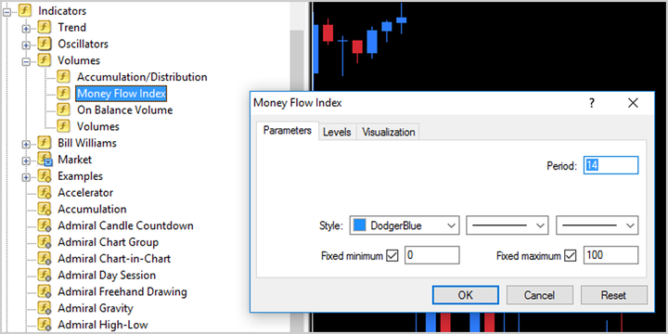](https://forum.mt5.com/customavatars/2026434072.png)

When you open the indicator, you'll see a dialogue box (as seen in the screenshot above) where you can customize the parameters to your liking. The key settings are 'Period,' 'Fixed Minimum,' and 'Fixed Maximum,' in addition to the visual aspects of color and line thickness. The duration is the N value in the above equations that determines the period over which the positive and negative money flows are calculated. 14 is the default value. The indicator's fixed minimum and maximum determine the extremes in which it will oscillate. Respectively, the values are 0 and 100 are default, and it is recommended that you use these values.

**How to Download the MFI Indicator for Metatrader 4?**  
  
The tool is not allowed by default on the trading platform. The good news is that the MFI indicator for MT4 is simple to download and install with only a few clicks. The process is the same as any other technical oscillator you might use to fit your trading style. The indicator must then be integrated with the trading platform and mounted in a few simple steps:

1. [*Download MFI Indicator for MT4*](https://storage.googleapis.com/fxtr-static/forex-indicators-robots/money-flow-index-mfi-mt4-indicator-evaluate-trends-and-confirm-reversals/MFI.zip)
2. Open the RAR file we just downloaded and extract it.
3. Open MT4 and select File Menu.
4. Locate Data Folder and double-click it to open it.
5. Then, look for and open the MQL4 folder.
6. Copy and paste the extracted file into the Indicators folder.
7. Open MT4 and select Insert -> Indicators -> Custom -> MFI.

**Conclusions**  
  
The MFI indicator, as we've shown, is a valuable tool for gauging buying and selling pressure generated by money flows into and out of a market. The indicator may use to detect possible reversals when oversold or overbought values are shown. Checking for divergent behavior between the price and the indicator will make this even more accurate.  
  
The best way to figure out the best for you is to experiment with different strategies in a risk-free setting, such as a [demo trading account](https://forum.mt5.com/showthread.php?321840-5-Best-Forex-Demo-Account-for-Beginners-2021&highlight=demo+account+forex). That way, you can see what works with real-time pricing without risking losing money as you get your bearings. This indicator will serve you well when you begin your trading career full-time.