**How to become a Successful Trader with POC Forex Strategy**

[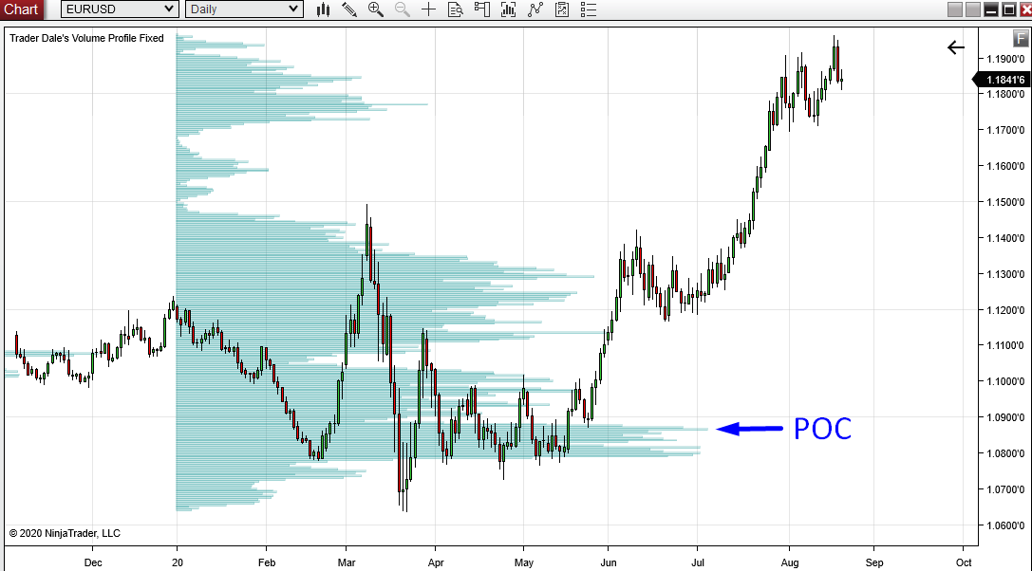](https://forum.mt5.com/customavatars/155451156.png)

In the chart above, do you see the trading opportunity offered by Point of Control? You owe it to yourself to understand Point of Control (POC) and how to apply it to your market whether you trade Forex, Stocks, or CFDs. Besides, Point of Control is the only order flow that works well in Forex, Stocks, and CFDs. In order flow, the price level with the highest volume in a bar is known as the POC. Point of Control is better understood in terms of value, which means we think about it daily without even realizing it. We either accept or reject the price, just like whether we're buying vegetables at the supermarket or the new Samsung smartphone. The only difference is that costs are approved or rejected much more quickly and several times a day in the markets. From the standpoint of market structure, a Point of Control in a bar is critical. When you see it in the light of the economy, it becomes more straightforward. A market should find help after a downward step. The market should have moved higher to encounter resistance.  
  
The market's goal is to make trade more accessible, but how does that happen? The market looks for value and shifts from one value zone to the next. It goes from the point of Control to the Point of Control in the case of individual bars. When market participants agree on a price, they continue to exchange, forming a Point of Control in a bar. When market participants disagree on a price, they reject it, and the market moves on to the next price acceptance stage.  
  
You're probably thinking to yourself, why would the consumer support a price level to reject it later? In comparison to long-term traders, short-term traders have different ideas about what meaning is it.  
  
**How to Trade with Point Of Control (POC)?**  
  
The Point of Control (POC) is a price level where the most significant trading volumes occurred. The POC is the essential thing that the Volume Profile indicator displays. I'd venture to suggest that if you just used Volume Profile to classify the POC, you'd be a much better trader than 99 per cent of retail traders. Regardless of the trading technique, you use. Point of Control is so relevant that it indicates where the most activity took place – where the most prominent trading positions are acquired.  
  
Who acquired these massive trading positions? - Large financial companies such as hedge funds, mutual funds, large banks, and so on. Big institutions are the ones that switch and control stocks, amassing massive trading positions. Isn't it a big help to know where they put the majority of their works? The good news is that we already have it, and what you only need is the [Volume Profile indicator!](https://forum.mt5.com/showthread.php?314731-Strategies-in-Volume-Profile-Indicator-MT4-Download&highlight=Volume+Profile+indicator) to see the POC. The majority of their places were assigned to POC. The best part is that those institutions will never hide from us, as they will still be visible on the Volume Profile.  
  
You may have had some suggestions about how to benefit from trading the POC from the example above. This step is the simplest way to construct your plan around:  
  
**Step 1**: Determine a point of contact for your desired period.  
**Step 2**: Keep an eye on the price as it moves away from the POC (up or down).  
**Step 3**: Place this POC on your chart and wait for the price to return to it.  
**Step 4**: Place a trade-dependent on the price's initial movement from the POC.

[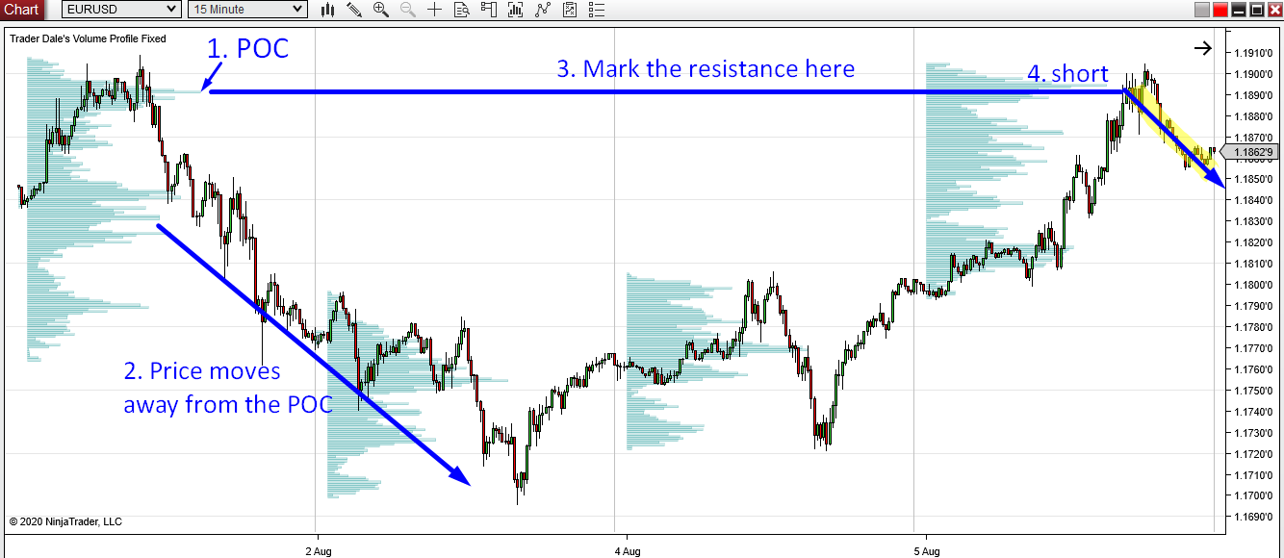](https://forum.mt5.com/customavatars/1364949228.png)

**Timeframes of POC**

* **POC Daily.**

Perfect for intraday trading. Point Of Control can find in a variety of time frames. If you use the Daily Volume Profile (which shows how volumes are distributed each day), each day would have its POC. Daily Volume Profiles are printed on a 60 Minute chart in the image below. Every day, a new Daily profile is published, along with a new Daily POC.

[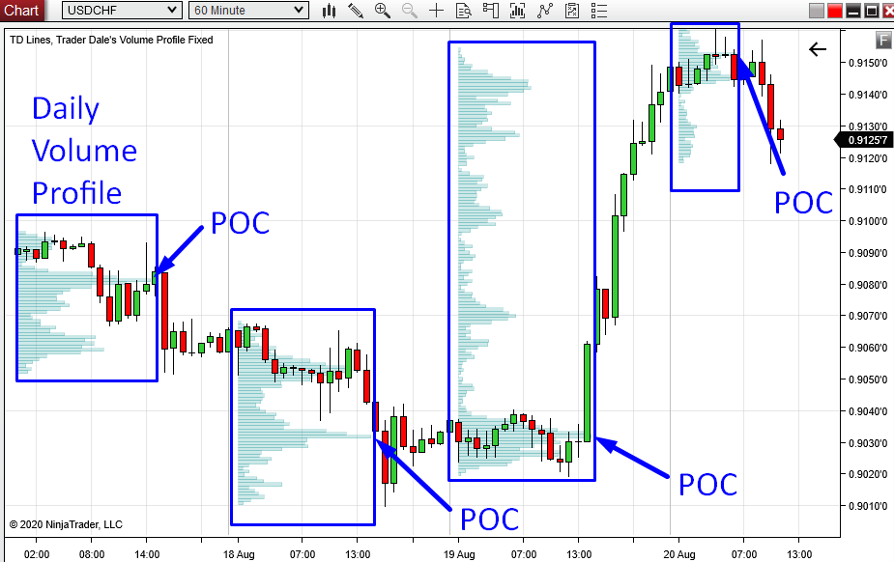](https://forum.mt5.com/customavatars/1499108566.png)

* **POC Weekly.**

Perfect for intraday trading. Weekly Volume Profiles are depicted in the diagram below. This timeframe means that a new profile is created every week. Each of those profiles has its point of contact (POC). Those POCs are the most crucial aspects of each profile!

[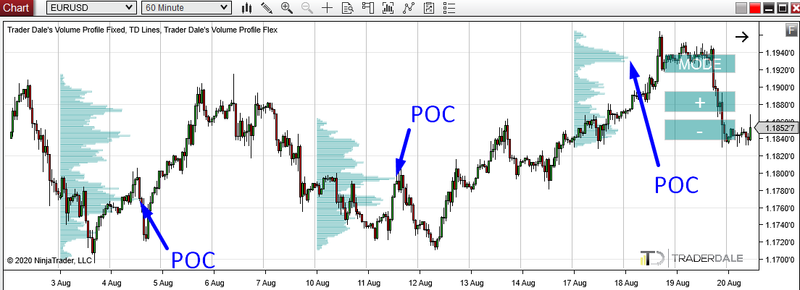](https://forum.mt5.com/customavatars/1314959747.png)

* **POC Monthly.**

Great for swing trading. The Monthly POC, like the previous two examples, shows where the highest volumes exchange each month. On a Monthly Volume Profile, a Monthly POC appears, which is helpful for swing trading. Monthly Profiles on a Regular Time Frame are depicted in the diagram below.

[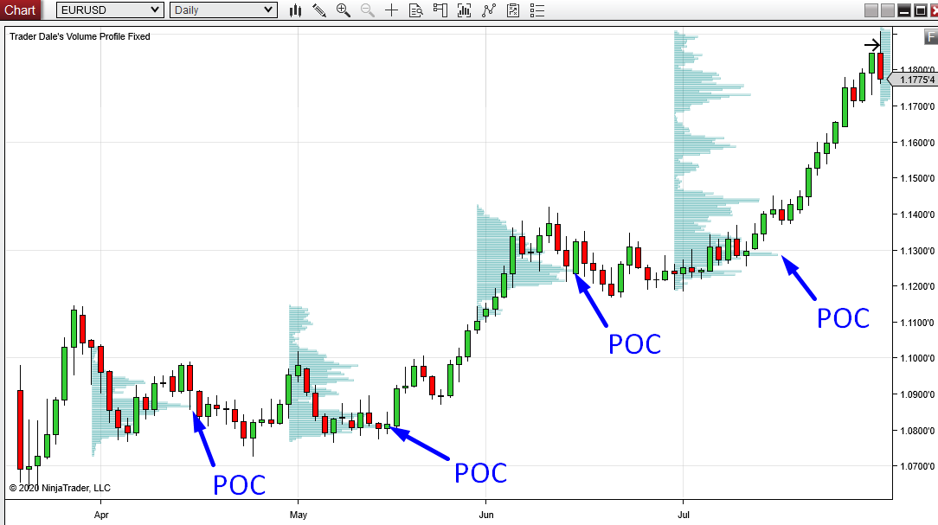](https://forum.mt5.com/customavatars/1158093265.png)

* **POC Yearly.**

Perfect also for swing trading. The Yearly POC is the location where the highest amounts are exchanged during the year. It is also the location where the most elevated amounts exchange during the year and – is best used for swing trading. The image shows the Yearly Volume Profile on EUR/USD with POC at 1.0866 is shown below. This trading is the most necessary amount this year for traders who trade long-term trades!

[](https://forum.mt5.com/customavatars/1118554258.png)

Notice that the large organizations we're monitoring with the POC operate on a variety of time frames. If you're an intraday investor, you'll want to keep an eye on the Daily POC or Weekly POC. Also, if you're trading swings, you can aim for Monthly POC or Yearly POC.

**POCs in Combination**  
  
When two or more POCs converge at the same price level, it can create a nice confluence. This combination may be a Daily POC or a Weekly POC, for example. In this situation, the heaviest volumes exchanged on a given day were also the most severe volumes traded in the preceding week.  
  
On the EUR/USD, the example below shows a confluence of Weekly POC and Daily POC. They are both at 1.1934. As a result, this price level is highly significant, as it is where the majority of the big institutions' volumes are exchanged. * Weekly Volume Profiles are shown in green, while Daily Volume Profiles are shown in grey.

[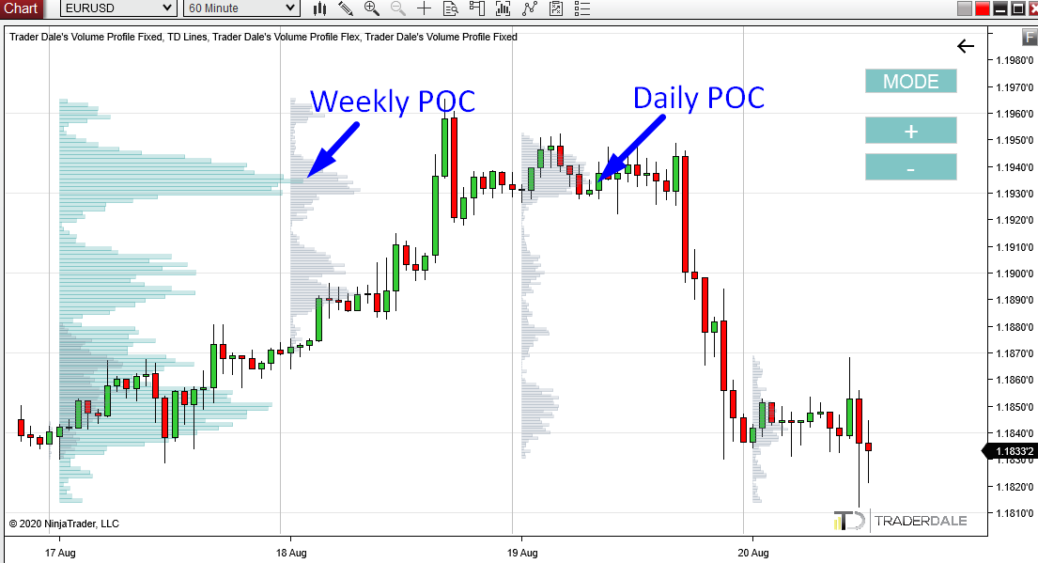](https://forum.mt5.com/customavatars/495732254.png)

**What Causes the Price to Respond to POC?**

You'll find that the price responds to POCs if you look at the charts. It is sometimes used as a powerful Support or Resistance. Let's take a look at the image below:

[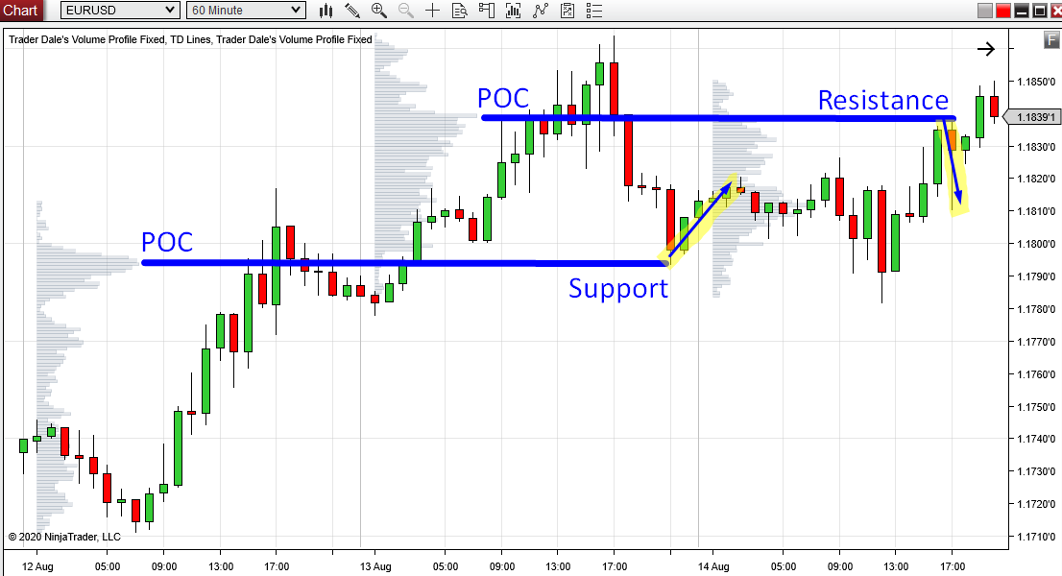](https://forum.mt5.com/customavatars/1092208472.png)

But why does the price change in response to POC? What is the aim of the POC as a Support/Resistance zone? Big trading institutions can't easily click one button to join their trading positions as we can. They deal with enormous sums of money, and entering their trades takes time. They often join exchanges in a rotation (in the volume accumulation area) and then begin a pattern. To put it another way, you look for a POC (that is, the place where they accrued their positions) and then watch the price move upwards or downwards from it.

* If the price moves upwards from the POC, then the heavy volumes accumulated hidden volumes of solid buyers.
* If the price falls from POC, the rich books indicate potent sellers.

Those trading institutions also defend their prominent trading positions, which they have carefully prepared and entered over a long time. As a result, when the price falls back into the POC region, those organizations become more aggressive and defend their positions.