**Installing and Trading Strategy with Buy-Sell Secret Forex**

[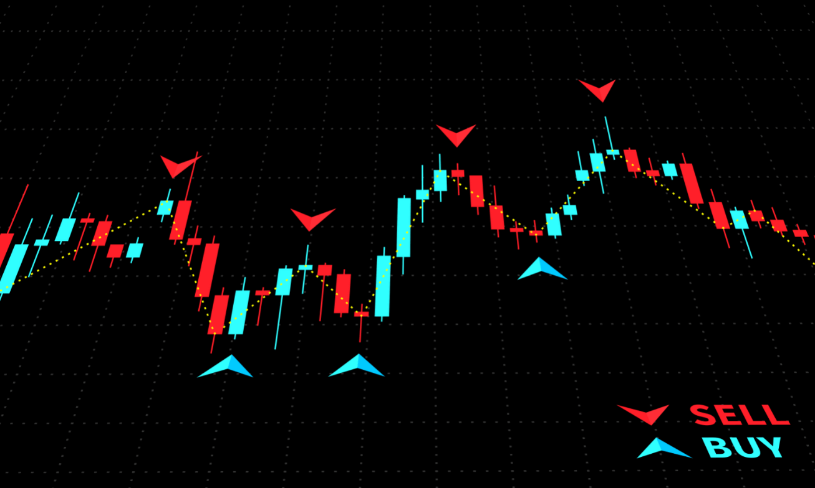](https://forum.mt5.com/customavatars/1990438321.png)

Karl Dittmann's ultimate buy sell secret forex indicator is a trading method that can be loaded into any forex chart and time frame. This indicator system includes entry signals, stop-loss guidelines, and take-profit goals. According to Karl, this measure has a hit rate of up to 85% profitable trades!  
  
Buy-Sell Forex Secret uses an entirely unique technique to predict market reversals, reducing the number of false trading signals that sabotage profitable trading to a bare minimum. Trading with this indicator will also help to boost trading on a consistent basis. Since Buy Sell Forex Secret is well-versed in all aspects of the market, it basically predicts where the price will go at all times. If traders use several pairs, this indicator will provide a reliable income of at least 150 pips to 200 pips. The indicator also sends out signals, such as stop loss and take benefit amounts, to the inbox.  
  
Buy-Sell Forex Secret is a reliable indicator that does not need to be repainted. However, it can only be used during a strong trend and not on a flat market. As a result, in the European and US sessions, trading with the Buy Sell Forex Secret indicator is recommended.    
**Installing the Indicator**  
  
**Step 1:**

* Open your MT4 platform and login.
* Select File, then Open Data Folder from the drop-down menu. You'll notice a folder named MQL4 here; this is the new "home" for all your .ex4 and.mq4 files.
* Go to the MQL4 folder and open it. The Indicators folder can be found here. In the MQL4/Indicators folder, copy your indicator (ex4 or.mq4) files. To do so, right-click the file and pick "copy" and then "paste."
* Restart your MT4 program.

**Step 2:** Open the MetaTrader® platform and select View Navigator from the drop-down menu. CTRL+N is another choice.  
  
**Step 3:**The 'Navigator' window will appear. Then pick 'Indicators'.  
  
**Step 4:** Look in the Indicators folder for the BuySellForexSecret folder To load the BuySellForexSecret file onto your chart, double-click it and select OK.  
  
**Rules on Using Buy/Sell Forex Secret Signals**  
  
**Rule #1:**Never use the indicator on a market that is flat. Just use the indicator during active market hours, such as the London and US sessions. On a weak market (nighttime, Christmas season, other holidays, etc...), the pattern will not be apparent.  
  
**Rule #2:** Determine whether there is a current pattern. (Keep in mind that trend is your friend!). Ignore all warning signs that point to a new GLOBAL trend. Also, use the informer to assess the frequency of the new pattern.

**Options in Exiting Trades with Buy/Sell Forex Secret Indicator**  
  
**Option 1:** When the Buy Sell Forex Secret issues the opposite trading signal, exit your trades. This means that you sell for full advantage and leave just as the market expected to reverse.

* If you enter on a Buy (blue) signal, exit as soon as a Sell (red) signal appears (pink).
* If you enter on a pink sell signal, exit as soon as a green buy signal appears (blue).

**Option 2:**

* Exit trades based on the Take-profit (TP) number shown in the Popup Warning.
* Remark: TP and SL levels can be adjusted to fit your trading style. This can be accomplished via the indicator inputs.

**Option 3:**

* Another highly efficient exit mechanism is to exit near strong support or resistance levels.
* It's a strategy that creates earlier exits, allowing you to benefit sooner.

**Why Should You Buy and Sell Forex Secret?**

Buy-Sell Forex Secret has been checked and proven to provide at least 150-200 pips on a daily basis, with approximately 80% of trades winning if the program is used correctly. Regardless of the ups and downs in the Forex market, you can benefit easily. This indicator directs traders to trade during the best market session, ensuring that only high-probability trades are taken.  
  
It's a unique chance to trade with this powerful indicator, where the trades are reliably profitable. Traders would certainly find Buy Sell Forex Hidden Indicator to be incredibly simple and easy to use, with a 60-day money-back guarantee.  
  
**How to trade with Buy Sell Forex Secret?**  
  
Buy-Sell Forex Secret displays UP Arrows for Buy Long entries and DOWN Arrows for Sell Short entries to show the exact profitable entry points. It guides me in making the best decisions at the right time. The Indicator is actually very simple to understand and use. Traders who use Buy Sell Forex Secret do not need to use any robots.