**Trading Strategy with Gann HiLo Activator MT5**

The Gann High Low Activator Indicator for MT5 creates a chart band used to trade trends. A simple moving average based on the high candle data and another SMA based on the low candle data is used to build the band. Grey color occupies the gap between these basic moving averages. There is one more line that detects the trend's course. When there are upward trends, green is used, and when there are downward trends, orange is used.  
  
Robert Krausz creates the Gann HiLo Activator. This indicator is a trend-following technical indicator that assesses trend direction and generates with-trend entry signals. As part of a trading system known as the "New Gann Swing Chartist Scheme," it works better when paired with the Gann Swing Indicator and the Gann Trend Indicator. The Gann HiLo Activator also is a simple moving average of the peaks and lows from the previous three cycles. It is a trend-following measure based on the logic of moving averages and is used to represent the market's direction of movement.  
  
The Gann HiLo activator not only generates entry signals but also aids in the determination of stop-loss levels. It enables the detection of various anomalies and trends in price dynamics that are otherwise undetectable to the naked eye. Traders will predict future market action based on this knowledge and change their strategy accordingly.  
  
This is how it will appear on a trading platform

[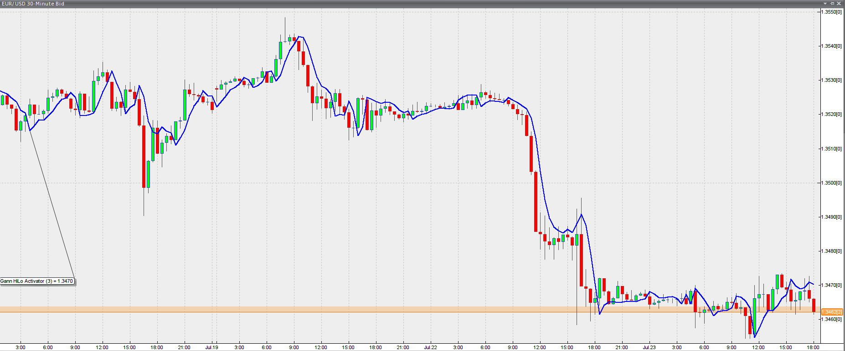](https://forum.mt5.com/customavatars/475947296.png)

The following is how its readings can be perceived. A bull trend is in effect when the price action is above the Gann Activator, which means that only long entries should be made. During an uptrend, the predictor is measured using the lowest three periods of the previous three periods.  
  
In contrast, if the Indicator is plotted above the price, it indicates that the market is in a bear trend, and you can only trade short positions. Activator measurements are made using the previous period's peaks during a downtrend. To get a complete picture of this trading scheme, read the following two parts.  
  
**Gann Swing Oscillator**  
  
The Gann Swing Oscillator, designed by Robert Krausz, works in conjunction with the Gann HiLo Activator and the Gann Trend Oscillator to help traders define market swings and make better decisions. The Gann Swing Oscillator will show whether the market is in an uptrend or downtrend. Its outcomes are represented on a scale ranging from +1 to -1. Two higher highs characterize an upswing, which is indicated by the Indicator having a value of +1. On the other hand, a downswing is represented by two lower lows and the oscillator reaching a value of -1. This is how a trading site shows the Indicator.

[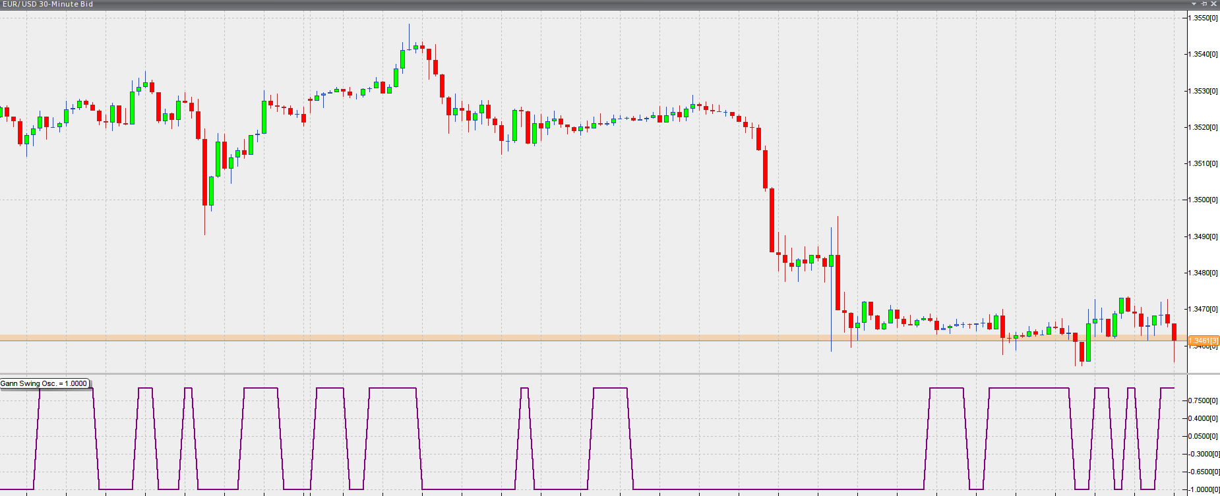](https://forum.mt5.com/customavatars/2108645232.png)

The Gann HiLo Activator, Gann Swing Oscillator, and Gann Trend Oscillator are combined in the so-called "New Gann Swing Chartist Scheme" strategy previously mentioned. The Gann Trend Oscillator, in particular, decides long-term trends, while the Swing Oscillator describes short-term movements. Convergences between them are shared in their favor. For more detail and examples of combined use, see the following article about the Gann Trend Oscillator.  
  
**Gann Trend Oscillator**  
  
The Gann Trend Oscillator, which was also created by Robert Krausz, is a trend-following predictor that is used to evaluate the long-term price trajectory of financial instruments. Like the Gann Swing Oscillator, the Trend Oscillator shows when a market is uptrending and when it is downtrending, and vice versa. The values of the indicators are again shown on a scale ranging from +1 to -1.  
A market trending up is characterized by a value of +1. Whereas a market trending down is defined by a value of -1. The Gann Trend Oscillator is represented in a trading network like this.

[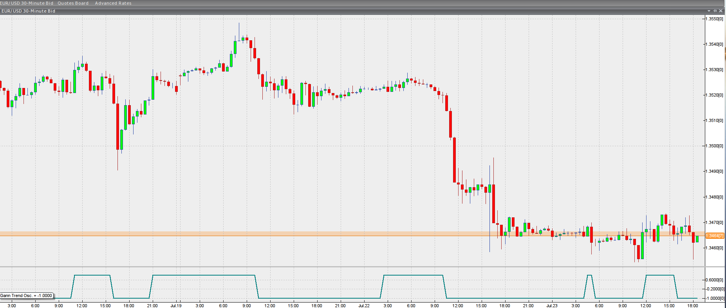](https://forum.mt5.com/customavatars/844477504.png)

The Gann Swing Oscillator is used to identify short-term patterns as the market swings and thus pinpoint precisely market entry points, as we mentioned in the previous article. It is supplemented by the Gann Trend Oscillator, which decides the long-term market direction. When the Gann Trend and Swing Oscillators converge, entry signals appear on the screen. When the Trend Oscillator rises from -1 to +1 and matches the Swing oscillator's value, a buy signal is produced. When the Trend Oscillator falls from + 1 to -1 while its counterpart is already at -1, it means the primary trend has turned bearish, and you can only trade short. The Gann HiLo activator defines precise entry points as well as stop-loss thresholds. Here's how the three look when paired together.

[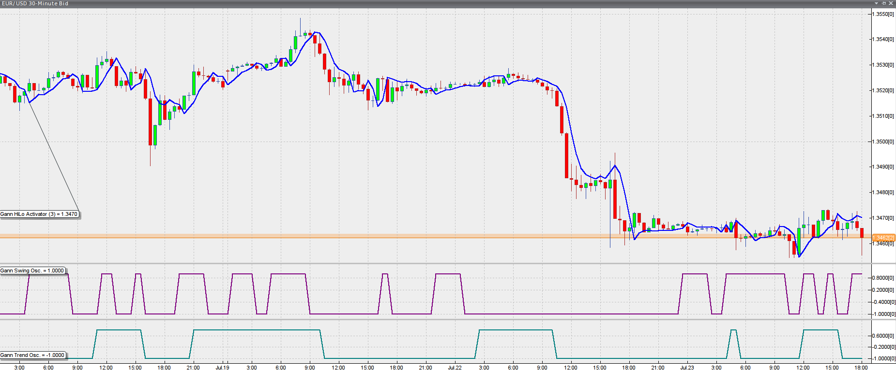](https://forum.mt5.com/customavatars/1057697940.png)

**Steps to install Gann High Low Activator in MT5 Indicator**  
  
1. Download Gann High Low Activator – mt5 Indicator.mq5  
  
<https://www.mql5.com/en/code/download/1496.zip> (download file)

2. Position Gann High Low Activator – mt5 indicator.mq5 in your Metatrader 5 Experts / Indicators / Gann High Low Activator – mt5 indicator.mq5 directory.  
3. Open or restart the Metatrader 5 Client.  
4. Choose a chart and time frame to measure the MT5 indicators.  
5. Go to your Metatrader 5 Client's Navigator and look for "Custom Indicators."  
6. Right-click Gann High Low Activator – mt5 indicator.mq5 and select Properties.  
7. Attach to a chart  
8. Make adjustments to the settings or click OK.  
9. The Gann High Low Activator – mt5 Indicator.mq5 Indicator is available on your Chart.  
  
**How do you uninstall Gann High Low Activator – mt5 Indicator.mq4 from your Metatrader Chart?**  
  
1. In your Metatrader 5 Client, go to the Chart where the Indicator is running.  
2. Choose the Chart by right-clicking on it.  
3. "List of Indicators."  
4. Then delete the Indicator from the list.  
  
Suppose the MT5 forex technical indicator you want to add to the MT5 charts is a custom MT5 forex technical indicator, such as the Gann HiLo Activator forex technical indicator. In that case, you must first add the custom Gann HiLo Activator MT5 forex technical indicator to the MT5 trading forex platform and then compile the custom GANN HiLo Activator MT5 forex technical indicator.

**Generating the Buy and Sell Trading Forex Signals**  
  
When the forex price is above the Gann HiLo Activator forex indicator, it means that the forex trend is bullish and upwards, and only buy forex trades should be opened. The Gann HiLo Activator forex predictor measures the previous forex price periods lows in a bullish forex upwards trend.  
  
When the forex price falls below the Gann HiLo Activator forex indicator, the forex trend is bearish downwards, and only sell forex trades should be opened. The Gann HiLo Activator forex indicator calculates the previous forex price periods highs in a bearish forex downwards trend.  
  
**Conclusion**  
  
Robert Krausz's Gann HiLo Activator is a primary but powerful trading method for determining the market's trend. It is easy to measure and comprehend. This Indicator's reliability, however, can be improved. As a result, technical analysts and experts recommend using the Gann HiLo indicator combined with the Gann Swing and Gann Trend indicators. The New Gann Swing Chartist Plan is a Forex trading scheme based on this combination.