**Anton Kreil – Here's Why You Should Know Him and His Courses.**

[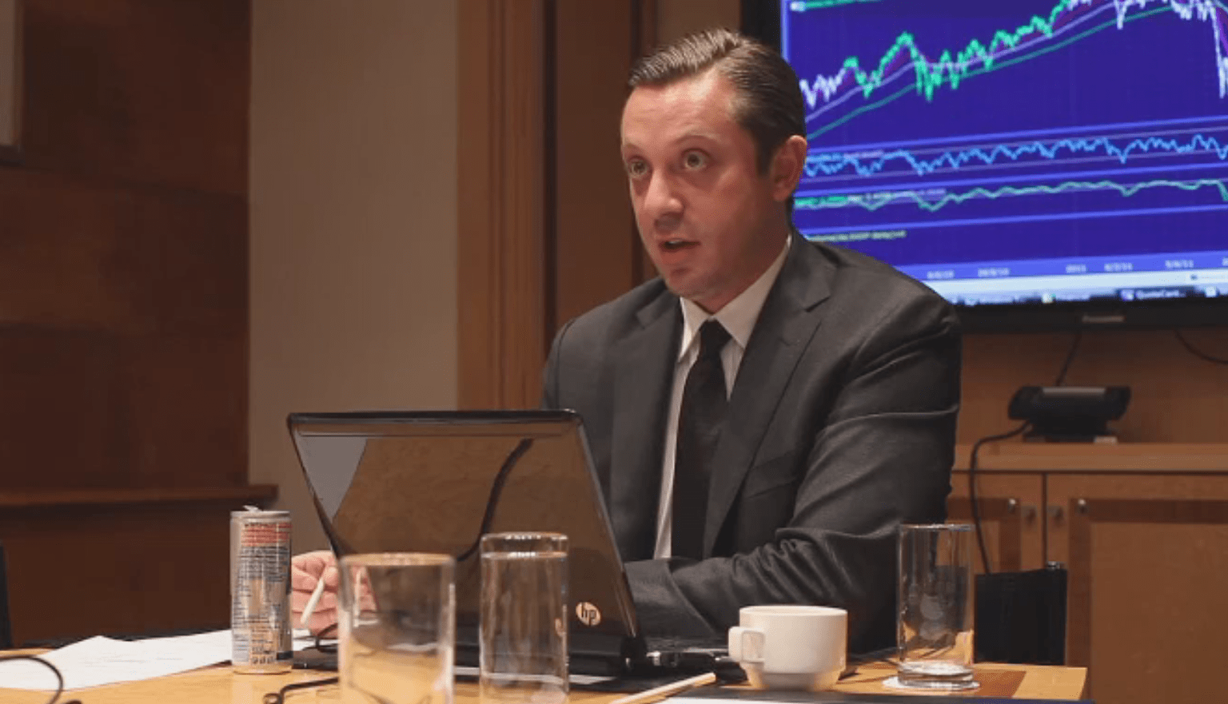](https://forum.mt5.com/customavatars/963429274.png)

Get any poverty to newfound wealth story, and you'd find one common element in all, strong determination and desire to try to do well. The story of Anton Kreil is not any different. Born in 1979 to a low-income family, Anton decided that he had had enough of his low environment and decided to form it big. He pursued economics at the University of Manchester at 18 years old and graduated at 21. He took a stab at exchanging and progressed nicely thereupon. Anton built a robust and profitable portfolio for himself. Seeing his impressive documentation, Goldman Sachs give him a suggestion to affix them. Anton Kreil spent the subsequent few years working his way through as an institutional trader. Anton has traded for firms like Goldman Sachs, Lehman Brothers, and JP Morgan. Anton continued his stellar run within the corporate world still and has become VP of European Equities for JP Morgan at the young age of 26. Effectively a mogul, Anton Kreil chose to hold up his boots at 28 from the investment banking sector. Post-retirement, he went on a world tour in seek of peace and soul. However, it had been only after his journey that he saw his most significant rise to fame.  
  
Riding on the eye he had garnered, he created the Institute of Trading and Portfolio Management. One of the first reasons behind opening the institute was teaching people to trade the correct way. in keeping with him, most of the instructions and education provided by brokers and educators was so-called "hogwash." The Course was designed so that even the most critical amateur could come to know the sport. After spending it slow with those that took the Course, it was evident that the Course almost entirely might be devoured by anybody. It was really at that time that he selected some more people to be a part of his organization. Anton Kreil has been ready to reach bent 4500 people along with his training, of which 1100 went ahead for advanced level courses. In the long run, 85 of them proceeded to become institutional brokers.  
  
**What Amount is Anton Kreil Worth? How Could He Construct His Riches?**  
  
Anton Kreil is assessed to be worth about $10 million starting in 2017. Of Course, he has had quite twenty years, thanks to his early start within the trading world. But being an effective broker, highlighting Million Dollar Traders likewise helped fill his pockets. As we referenced before, he procures from his curated exchanging Course for laypeople, the Professional Trading Masterclass.

**What is Inside on Kreil's Programs?**  
  
The Professional Trading Masterclass and Professional Forex Trading Masterclass, like the Institute of Trading and Portfolio Management, offer courses. You'll always opt to take the web version of the Course additionally. Several seminars are organized in numerous corners of the globe so people worldwide can take an interest. One of the more well-known courses selected by individuals is the Vacation Mentoring Program. The program ordinarily continues for 14 weeks. The primary ten days are spent vacationing and training in five-star hotels and includes one to at least one training by the person himself. He also incorporates a group of senior trading mentors who help individuals during the program. Once the holiday and training are over, everyone returns, and therefore the remaining 12 weeks of the Course takes place over Skype.  
  
**How Are You Able to Get Familiar with His Subtle Strategies?**

[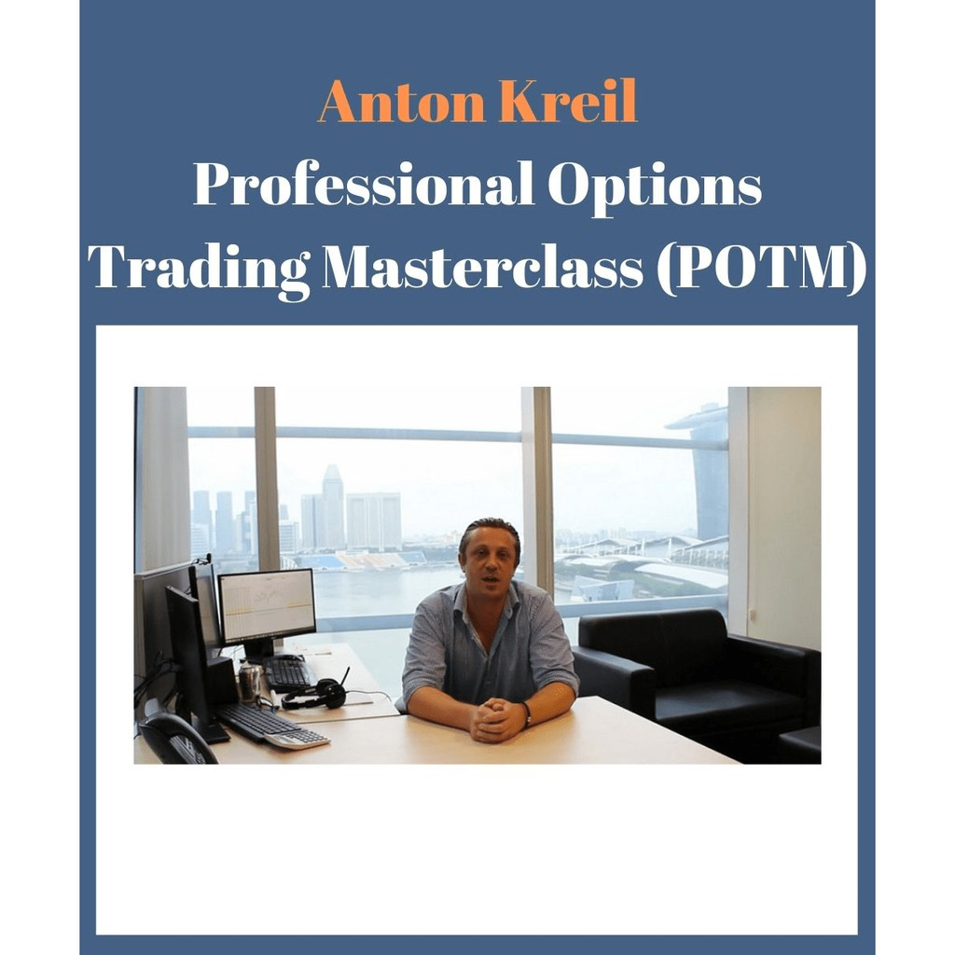](https://forum.mt5.com/customavatars/371317777.png)

Like most other expert merchants who stay quiet, Anton Kreil imparts his thorough information to other people. Anton has planned courses that catch the entirety of his learning over his profession. Where his courses shine is that he's able to present them within the simplest form possible. If you would like to learn from Anton's success, you don't need to sweat it out plenty. You'll be able to get on to the Institute of Trading and Portfolio Management to induce started. During Goldman Sachs and JP Morgan's days, his experience has been rolled in very carefully into these courses.

In 2013, Anton Kreil decided to create his courses even more accessible and thus launched a video series of his Professional Trading Masterclass. Between 2010 and 2013, he spent lots of his time on the street talking about individuals and sharing their prosperity mantra. He presently flaunts the Professional Trading Masterclass course to be the  
only comprehensive trading course online.  
  
**Why Do I've Got to Require an Examination for Every Course?**  
  
You do not have to take the examinations if you are doing not want to. The examinations are primarily designed so you'll be able to test your knowledge on all of the data that you have learned in each video series and from the resources provided. The examination is optional and may be taken by clicking on the "Take Exam" button at the underside of the most page of every Video Series. There's nothing in each examination that you simply may be questioned on it isn't included in each corresponding Video Series' and, therefore, the supporting resources.  
  
In terms of grading, if your percentage mark is below 50%, this is often a "Fail" grade, 50%-59% may be a "Pass" grade, 60%-69% could be a "Merit" grade, and 70% and above is classed as a "Distinction" grade. 95% of our delegates pass the exam just because there isn't anything you are tested on. It isn't within the Videos. You'll be able to rewind the Videos as persistently as you wish for self-study before you are taking the exam. You'll automatically receive a color certificate from the Institute of Trading and Portfolio Management after taking the exam to your email. The certificate includes your name, percentage mark, and your grade, with certification to manage your own money in a very professional trading capacity via your account subject to local regulatory parameters globally. Institute Managing Partner Anton Kreil personally signs each certificate.

**Finalization**  
  
Anton Kreil has had a distinguished lifetime. Having a fruitful merchant (as confirmed by the BBC) instructing you contributing abilities may be a godsend. Anton has always been known within the Industry for his obsession with Financial Markets, his insane work ethic, and his ability to show up and coming new talent within the Industry. However, irrespective of which Course you are taking or the professional you speak, there's a risk of losing money. What do you think about Anton Kreil? Are his courses legit? Tell us through the remark segment beneath. Thank you!