**How the Image Watermark with Timeframe Indicator Works?**

A watermark on the graph is seen by several experienced experimental importance maps. It does not only increase the obvious appeal of the chart; however, some data that merchants may use may well be provided in addition. A personalized technical indicator that gives a noticeable adjustment to the value chart is the Image Watermark with Timeframe indicator. In addition to the foreign money pair or tradeable instrument picture, it offers a watermark on the value chart showing the timeframe. In addition, it offers another area of textual material that is labelled here with Your Title Right.  
  
On our previous article, we discussed about the [Basic guide on symbol watermark timeframe indicator](https://forum.mt5.com/showthread.php?314835-Basic-Guide-on-Symbol-Watermark-Timeframe-Indicator&p=15180225&highlight=#post15180225). Now, allow us to talk about how the image watermark with timeframe indicator works to enhance the visible aesthetics of our value charts in forex trade.  
  
**Work of Image Watermark with Timeframe Indicator in Forex Chart**  
  
Based mainly on the Image Watermark code with Timeframe indicator, the data relating to the timeframe and the image form will only be obtained from the dealer's feed. It then locates a textual material that displays each timeline and image as a context. Font settings allow merchants to switch between Font Dimension (sidFontSize) and Font Type (sidFontName). It also helps merchants to use the sidXPos for the x-axis and the sidYPos for the y-axis to adjust the position of the watermark.

[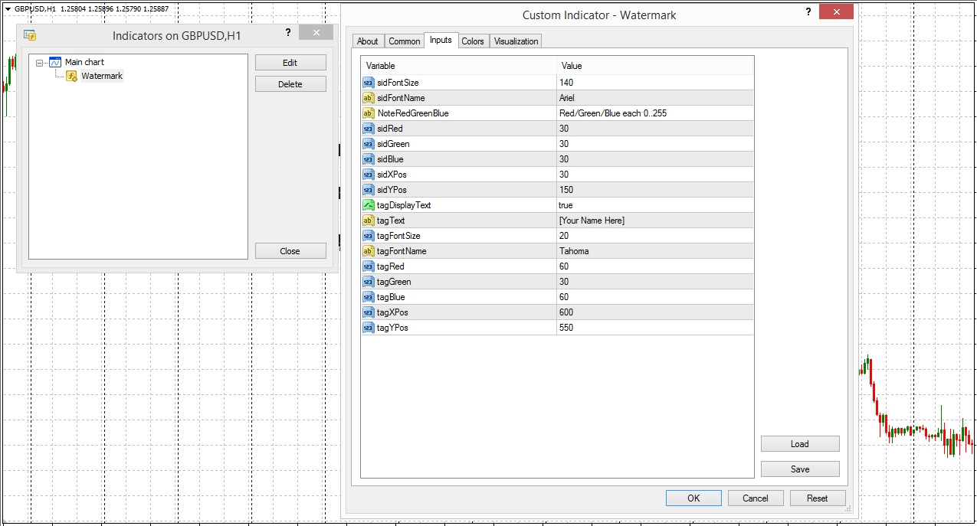](https://forum.mt5.com/customavatars/909697517.PNG)

Using the sidRed, sidGreen, and sidBlue variables, merchants may change the color of textual material. Nonetheless, in order to arrive at the color that you would like, you would need to google the mixture of those hues. The purple hue on sidRed, the novice hue on sidGreen, and the blue hue on sidBlue should be mounted.

[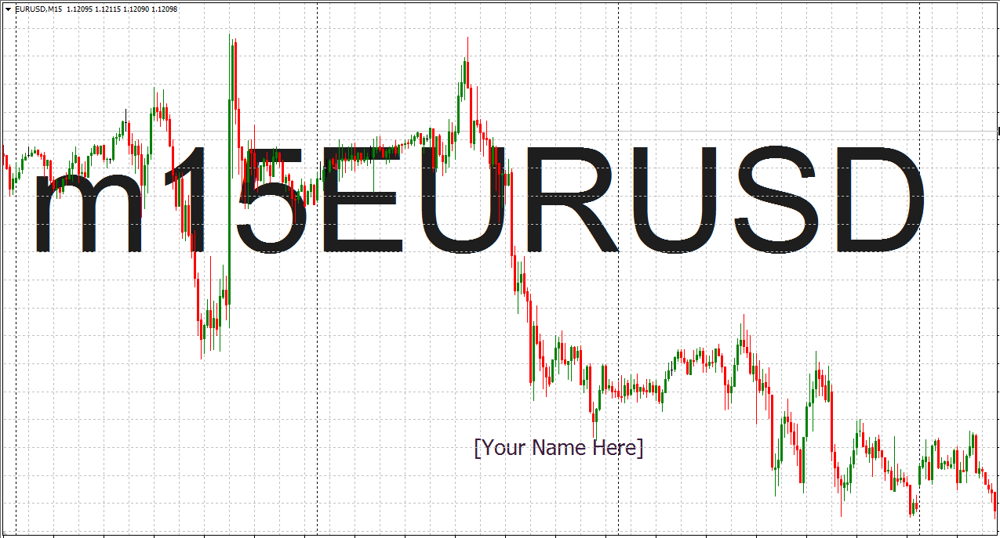](https://forum.mt5.com/customavatars/1414565368.PNG)

The Image Watermark with Timeframe indicator also allows merchants to display a "Tag Textual Content" with the exception of the timeframe and image, which would show "Your Title Right Here" by default. By changing the tagDisplayText variable to false, merchants may decide to take the Tag Textual content away. Merchants can adjust the content of the Tag Text by changing the tagText variable to show on the chart no matter what you need. Merchants can change the location, color, font, and font measurement of the Tag Text content, just as with the previous textual content.  
  
**The Proper Way to Use the Timeframe Indicator Image Watermark for MT4**  
  
The Image Watermark with Timeframe indicator is clearly not the type of indicator that would provide a sign of the position the market is transferring to merchants. Technical assessment data corresponding to the trend course, momentum, overbought or oversold value ranges, uncertainty, and so on are not provided. As such, it does not provide details to merchants that could help sort out any trade setup. This indicator is aesthetic only. Merchants may use this metric to help them assess the picture of the chart and the period at which they purchase and sell at extra short notice. It can be used to mark with the Tag Textual content the type of trade setup they have recognized.  
  
**The Proper Way to Set Up the Timeline Indicator Image Watermark for MT4**

* Obtain Picture Watermark for MT4.mq4 with Timeframe Indicator.
* Copy Picture Watermark to your Metatrader Listing with Timeline Indicator for MT4.mq4 / specialists / indicators / indicators /.
* Start or restart your Four Shopper Metatrader.
* Pick the chart and timeframe where you need to look at your MT4 metrics.
* Search "Customized Indicators" largely left in your Metatrader Four Shopper in your Navigator.
* Click correctly on the Picture Watermark with the MT4.mq44 Timeline Indicator.
* Link to a Graph.
* Modify configurations or click okay.
* Image Watermark Indicator with Timeframe Indicator for MT4.mq4 can be found in your graph.

**The Proper Way to Delete the Timeframe Indicator Image Watermark for MT4 from your Metatrader Chart.**

* Choose the chart where the indicator in your Metatrader Four Shopper is running.
* Appropriate click on the map.
* Record indicators.
* Select and remove the Indicator.

**Conclusion**  
  
The Timeframe indicator image watermark for MT4 is a Metatrader 4 (MT4) indicator and the essence of this technical indicator is to remodel the historical past data accrued. The Timeframe Indicator Picture Watermark for MT4 offers an opportunity to detect numerous peculiarities and trends in value dynamics that are invisible to the naked eye.