**Basic Guide on Symbol Watermark Timeframe Indicator**

[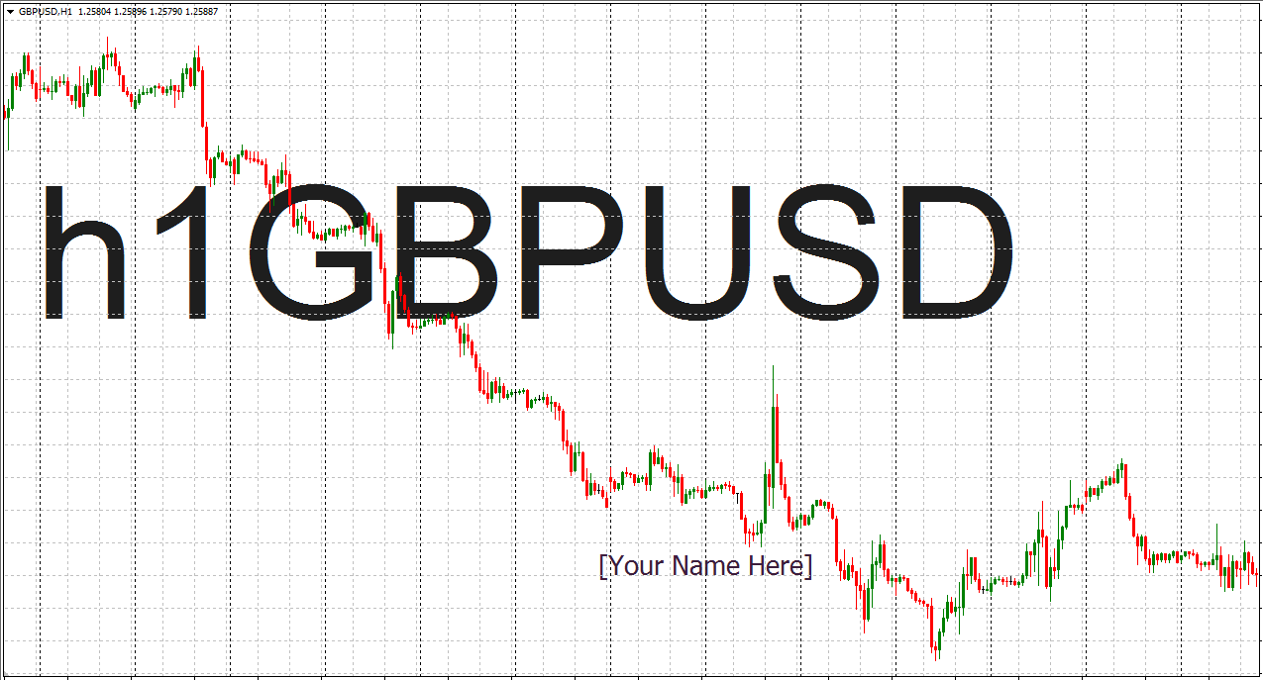](https://forum.mt5.com/customavatars/1071801248.PNG)

The Symbol Watermark Timeframe Indicator for MT4 is an indicator designed for traders using the MetaTrader 4 charting platform to take trades, do their charting, and conduct their technical analysis. This Indicator is straightforward, very light, but very precise to do what it intends to accomplish. The Indicator's primary purpose is to print the name of the current currency pair in the chart and the current timeframe from which the trader operates. The traders who use this are very particular and will probably gain some advantages from using it to work. Some of the benefits of using this Indicator are outlining and thoroughly discussed below.  
  
**How to Download the Timeframe-MT4 Indicator Symbol Watermark?**

1. Download Watermark Symbol With Timeframe.mq4.
2. Copy Symbol Watermark .mq4 to your Metatrader Directory with Timeframe / Experts / Indicators /.
3. Start or restart your Client Metatrader 4.
4. Choose a time frame and map where you want to test your MT4 indicators.
5. Search for Custom Indicators frequently left in your Navigator in your Metatrader 4 Client.
6. Right-click on the Watermark Symbol with Timeframe.mq4.
7. Attach to a Diagram.
8. Modify Configurations or Click OK.
9. Watermark Indicator Symbol With Timeline.mq4 is accessible on your map.

[B]How to Uninstall the Timeframe.mq4 Symbol Watermark from your Chart

1. Choose the chart in which the Indicator is running in your Metatrader 4 client.
2. Right-click in the Diagram.
3. List indicators.
4. Pick and uninstall the Indicator.

**Advantage of using the Timeframe Indicator Symbol Watermark For MT4**

* One of the first significant benefits of using the Symbol Watermark With Timeframe Indicator For MT4 is that it will allow the trader who monitors several graphs to precisely understand which map they are looking at even from a mile away. This process means the trader can quickly watch all of the trading charts from any distance for traders who typically need to track many maps. Without needing to come closer to the trading charts to look before they can quickly realize what chart or which currency pair they are searching.
* The Symbol Watermark With Timeline Indicator For MT4 makes it very convenient to observe all of the trader's charts. The reason is that traders will then be able to take trades and keep the maps without the requisite stress of continually looking very closely to see what is happening in a particular chart and exactly what currency it belongs to.
* The Symbol Watermark With TimeFrame Indicator For MT4 would also help forex instructors who usually deal with many students and visuals during public meetings such as seminars and conferences with other people and need to share some of their trading charts. This process means that when trying to educate these people, a trader who can also teach many people how to make money from the stock markets will also need to exchange charts. These charts will immediately suggest that any of his trading screens will have to be shared by the trader. The traders who are watching him can see and understand what they are saying or explain to them immediately.
* Also, for those visually impaired traders, the Symbol Watermark with TimeFrame Indicator for MT4 can be very helpful. As it would allow those traders to easily track their trading charts and make all the required technical analysis or trading decisions they need to make without stressing themselves too much.
* This process is quickly allowing more senior traders who need glasses to trade to be still able to see clearly, particularly when they need to make quick trading decisions based on what is currently happening in the price. Along with that, they do not need to keep trying to concentrate on figuring out precisely what is going on with the trading charts before making the trading decision or she wants to make. For the trader who uses it, this will inevitably make the exchange far less stressful.

**Completion**  
  
This Indicator is not only a technical assessment sort of Indicator but is slightly additional to an indicator type of aesthetic alteration. This metric can use by merchants who choose to have a watermark on their value charts for an extra professional look.