**The How-to’s in using MetaTrader 4**

A custom indicator is a software that has been developed independently by the user in MetaQuotes Language 4 and acts as a technical indicator. A mathematical transformation of security price and volume to forecast future price changes is a technical indicator. The use of metrics helps one address when and when the current pattern will remain the same. The metrics intend for the relative simplification of the dynamic trading decision-making process. Indicator algorithms use as well to establish trading strategies and to provide expert advisors.  
  
This article will discuss the different steps of using MetaTrader 4, compose installing, using charts, and setting up channels in the trader.  
  
**Installing Custom Indicators in MetaTrader 4**

1. Locate the MT4 custom indicator file on your computer and copy it. These are the files with the MT4 indicator you must have downloaded.
2. Open a folder of info.

[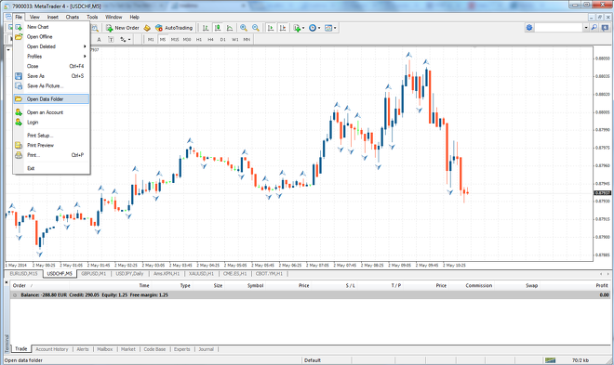](https://forum.mt5.com/customavatars/1264964471.png)

1. Open File MQL4.
2. Open the folder indicators.
3. Paste some files.
4. MetaTrader 4 Restart.

**Using a Custom Indicator on Charts**

1. Open up your network with MetaTrader 4.
2. Locate, as below, the Navigator panel.
3. Find the Custom Indicators on the navigator.

[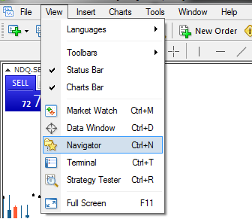](https://forum.mt5.com/customavatars/2072602451.png)

1. Click Custom Indicators, and your newly built indicator should be visible.
2. Double-click the indicator, and the Properties of the indicator window appears.

[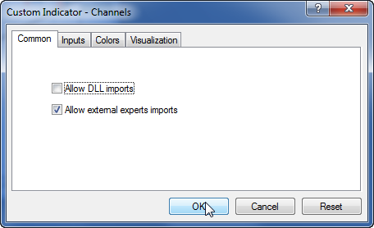](https://forum.mt5.com/customavatars/440344689.png)

1. Click OK.

**Setting Up Channels in MetaTrader 4**

* **Adding a Standard Channel for Deviation**

1. Click Insert and switch to Channels, then click.
2. Click Standard Deviation.

[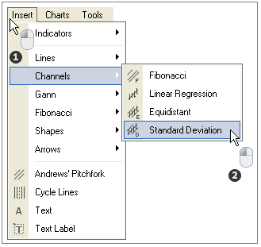](https://forum.mt5.com/customavatars/468300957.png)

1. Where you want the channel to start, click.
2. At the end of the channel, shift the mouse and release the mouse.

[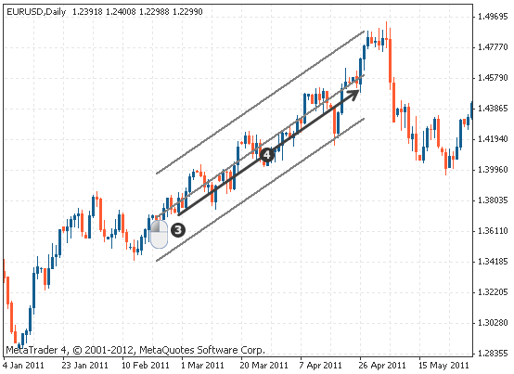](https://forum.mt5.com/customavatars/581795691.png)

1. Changing parameters at a later time.

*To change the indicator's settings at a later date:*

* Right-clicking anywhere in the region of the map
* Tap on the List of Objects
* Pick the channel to change.
* Click Alter.
* The menu for the parameters appears. You can change the channel here.
* Several parameters can influence most artifacts.
* Two types of parameters exist:

**a. Object calculations.** for example, where the channel begins, finishes, and the angle it has.  
**b. Visuals of an object.**e.g., how it appears, the lines' color and thickness, etc.

* **Adding a Channel of Linear Regression**

1. Click Insert and switch to Channels, then click
2. Linear regression is clicked
3. Where you want the channel to start, click
4. Shift the mouse and release the mouse at the end of the medium.

* **Adding a channel equidistant**

1. Click Insert and switch to Channels, then click
2. On Equidistant, click.
3. Where you want the channel to start, click
4. Shift the mouse and release the mouse at the end of the medium.

* **Adding a channel with Fibonacci**

1. Click Insert and switch to Channels, then click
2. On Fibonacci, click
3. Where you want the channel to start, click
4. Shift the mouse and release the mouse at the end of the track.

* **Delete a channel in MetaTrader 4**

*To remove a channel (or a different object):*

1. Right-clicking anywhere in the region of the map
2. Click on a list of items.
3. Then, select your desired channel to delete from.
4. On Delete, click.

**The indicator is on the zip file. What to do?**

1. Some hosting platforms that we use include zipping of the MT4 indicator. This hosting means that a quicker download compress by the indicator.
2. Via looking at the file name you downloaded, you will determine if your indicator is zip. The file is zip if it ends with .zip.
3. Double click on the file to open the file, and it will be unzipped file ex4. This process works on both macOS and Windows.
4. When you've got it, the Ex4 format is now ready for installation.