**Things you should know about MT4 Stop Loss EA**

[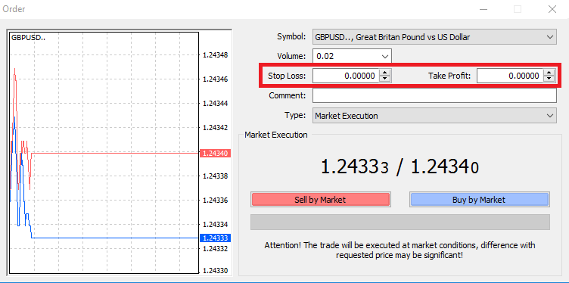](https://forum.mt5.com/customavatars/1451007086.png)

The EA immediately avoids losses and takes benefit for each new order (also pending ones). In the options, the SL (stop loss) values and TP (Take Profit) orders sets. This EA works on the platform for all orders, so there is no need to bind it to each chart. It is beneficial for pending orders because you can transfer SL and TP directly from your map in the same manner as you do for market orders.  
On our last topic, we talk about the [setting up of Stop Loss and Take Profit](https://forum.mt5.com/showthread.php?312791-How-to-set-Stop-Loss-and-Take-Profit&highlight=) on our trade. Now we will proceed with the things you should know about using this EA. Read on!  
  
**How is Stop Loss Operating?**  
  
The stop loss level on her trade is allocated beforehand by an intraday trader. The transaction automatically closes when the cost exceeds the predetermined stop-loss stage. The trader is willing to save the majority of the money that she has spent. One may begin to prepare a plan for the return of the missing funds. Essentially, opting for a stop-loss order stops, in terms of money lost, a bad trade from getting worse.  
  
**How to Calculate Stop Loss?**

The stop loss level on her trade is allocated beforehand by an intraday trader. The transaction automatically closes when the cost exceeds the predetermined stop-loss stage. The trader is willing to save the majority of the money that she has spent. One may begin to prepare a plan for the return of the missing funds. Essentially, opting for a stop-loss order stops, in terms of money lost, a bad trade from getting worse.  
Let's take an example to understand how trade will show stop loss. If you want to buy a stock currently trading at $100, you must now decide where you want your stop loss to put. Holding the stop loss at 98 dollars below 100 dollars is a reasonable number to go. This process means that you are cool with losing $6 on this particular trade, but any more than that would result in the transaction's termination. Additionally, the goal number should be 1.5 times the percentage of stop failure. In this situation, the stop loss was $6, which you're okay with losing. Therefore, your minimum benefit should be $9, which would place you at $104 + $9 = 113 dollars.  
  
**Where Should Stop Loss Level Be Set?**  
  
Most beginner traders are struggling to decide where to set the levels of a stop loss. Whenever one sets too much of her stop loss level high, if the stock goes in the wrong direction, she runs the risk of losing a lot of money. Alternatively, traders who set their stop loss amount too close to the selling price lose cash when deducted too quickly from their trades. There are different techniques that you can use to measure the sum of stop loss for each exchange. These techniques can water down into three approaches that you can use to assess to set your stop loss:

* Method for Percentage
* Method for Help
* Method of Moving Average

**Using the Percentage form to measure Stop Loss**

Intraday traders commonly use the percentage method to measure stop loss. All one has to do in the percentage system is assign the percentage of the stock price they are willing to lose before leaving the trade. E.g., assume that you are comfortable with your stock losing 10% of its value before you exit your business. Also, let's take your own 50 dollars a share in stock trading. Your stop loss will then set at $45-$5 under the stock's current market value ($50 x 10 percent = $5). Your stop loss will therefore set at $45-$5.  
  
**Using the Support process, measure Stop Loss.**  
  
The estimation of stop loss using the support system is somewhat complicated for intraday traders than the percentage method. Seasoned intraday traders, however, are understood to use it. You need to find out the most recent support level of your stock to use this tool. A region of stability is where the stock price mostly stops falling, and the stock price also stops falling; where the stock price usually stops rising is an area of resistance. You have to put your stop-loss price point below the support level until it calculates your support level. Suppose your stock is currently trading at $500 per share, and $440 is the new funding level you can identify. It is recommended that your stop loss become slightly below 440.  
  
There are rarely reliable levels of both support and resistance. It is useful to allow your stock some space to come down and then bounce back off of the support stage before pulling the trigger on it by exiting. Setting the standard slightly underneath the level of support helps you offer some wiggle room to your stock before you want to leave your trade.  
  
**Calculate Stop Loss using the form of Moving Averages**

Compared to the support method, the moving average approach is more straightforward for intraday traders to decide where their stop loss create. First, there is a need to add a moving average to the stock map. As it avoids holding your stop loss too close to the stock price and being withdrawn from your trade too fast, a longer-term moving average is better. Set your stop-loss slightly under the satisfying average level once it adds the moving average, as it has more wiggle room to shift direction.  
  
**Benefits of this Forex Advisor Expert**  
  
When you enter the trade, benefit & stop loss will appear automatically at that moment. Then you can quickly move those lines as you wish. No need to think about loss stems & benefit taking. The Expert Advisor will look after your trade after you enter the profession. The work will close automatically when the price touches the take-profit goal line. Otherwise, the business would close with a loss if the price touches the stop-loss goal line. The forex specialist advisor can, however, help to carry out your trades quickly. It can, on the other hand, dominate you. If not, you would be an unsuccessful dealer since we can't always forecast the future demand. It relies on countries' economic & political choices.