**How to set Stop Loss and Take Profit?**

Stop-loss is a metric that tells you how much you're losing on a specific trade. It is necessary to measure the stop loss beforehand to prepare if a business changes its course. A stop-loss order helps mitigate the loss if the stock price goes in the opposite direction from the planned movement, rendering the transaction unprofitable. Furthermore, the EA immediately prevents losses and benefits with any new order (also pending ones). SL and TP order sets in the choices. This EA works on the platform for all orders, so there is no need to bind it to each chart. It is beneficial for pending orders because you can then transfer SL and TP directly from your map in the same manner as you do for market orders.  
  
In this article, we will talk about how to set stop loss and take profit. Are you excited to find out? Read on!  
  
**Setting Stop Loss and Take Profit**  
  
When placing new orders, the first and most straightforward way to add Stop Loss or Take Benefit to your trade is by doing it right away.

[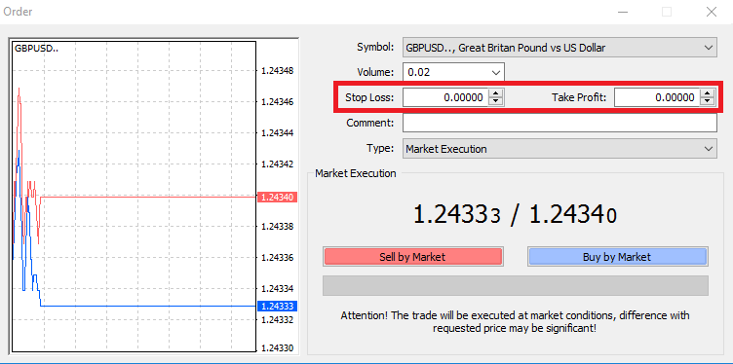](https://forum.mt5.com/customavatars/1965838538.png)

Insert your unique price level in the Stop Loss or Take Benefit fields to do this. Note that when the market moves against your position (hence the name: stop losses), Stop Loss is executed automatically, and Take Profit levels runs automatically when the price hits your defined profit goal. This process means you can set the amount of Stop Loss below the current market price and the level of taking Benefit above the current market price.

It's important to note that an open position or a pending order is link often to a Stop Loss (SL) or a Take Benefit (TP). When your trade has opened, and you're watching the demand, you can change both. Your marketplace is a defensive order, so they don't need to open up a new position, of course. Users could always attach them afterward. However, we strongly recommend that your posts are always protected*.  
  
**Adding amounts of Stop Loss and Benefit**  
  
Using a tradeline on the map is the best way to add SL/TP levels to your already open place. Click and drag up or down the line of trade to a specified stage to do so.

[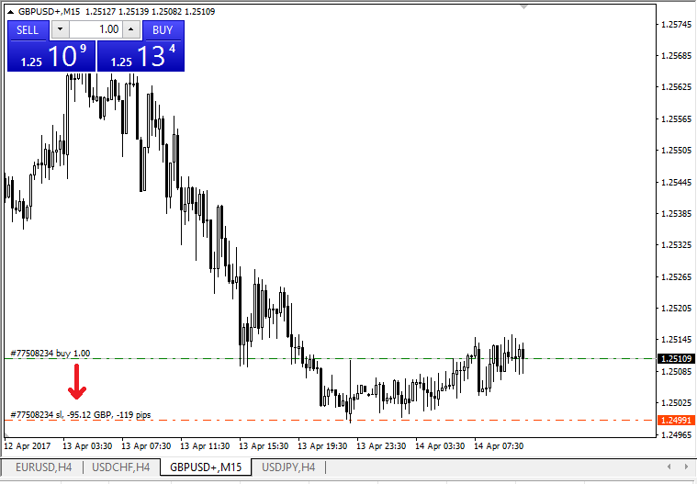](https://forum.mt5.com/customavatars/2030654999.png)

The lines of the TP/SL will appear on the map once you have reached their levels. You can also easily and quickly change SL/TP levels in this way. You can also do so from the 'Terminal' module at the right. Click-right on your accessible place or your order pending to add or change SL/TP levels and select 'Modify or remove the order.'

[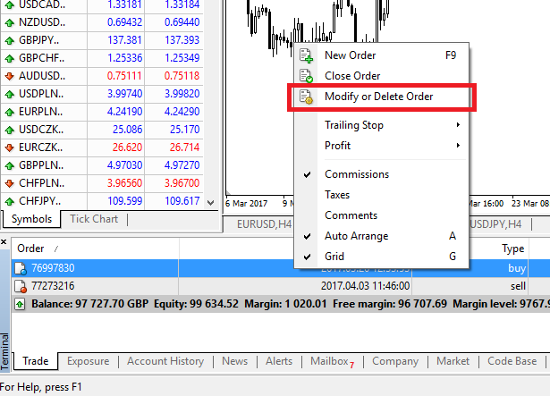](https://forum.mt5.com/customavatars/700083547.png)

You will be able to enter/modify SL/TP by the exact market cost or by specifying the points range from the current market price; the order modification window will appear.

[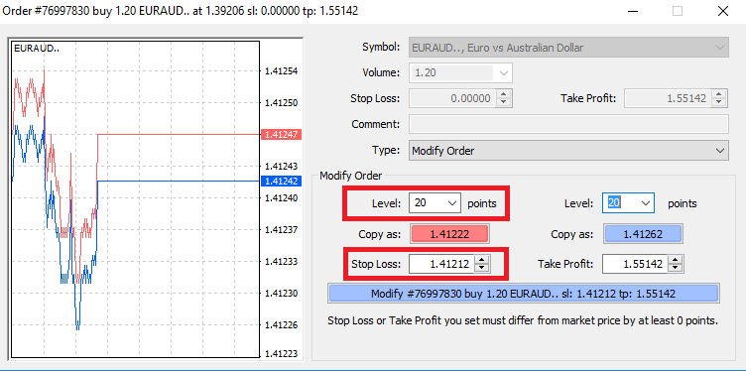](https://forum.mt5.com/customavatars/759057213.png)

**Trailing Stop**  
  
Stop Losses intends when the market moves against your position to minimize losses, but they can also help you lock in your earnings. While at first, that can sound a little counterintuitive, it's quite simple to understand and master. Let's assume that you have opened up a long place, and the market is heading in the right direction, currently making your trade a profitable one. You can now move your original Stop Loss, which puts below your open price, to your free price (so that you can break even) or above the available price (so you are guaranteed a profit).  
  
You may use a Trailing Stop to render this process automatic. This Tracking stop can be a handy risk management tool, mainly when price increases are rapid or unable to track the market regularly. Your Trailing Stop will immediately follow the price as soon as the place turns profitable, preserving the previously defined gap. Trailing Stops (TS) connects to your open positions, but it is important to note that you need to have the platform available if you have a trailing stop on MT4 for it to perform successfully. It's worth remembering that if you're using station instead of MT4, your trailing stops stay in place even if you log out. To set a trailing visit, right-click the open location in the 'Terminal' window, and in the Trailing Stop menu, enter your desired pip value for the distance between the TP level and the current price.

[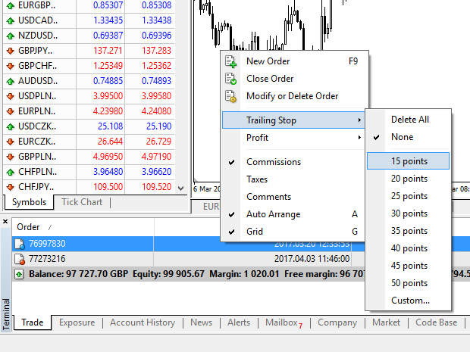](https://forum.mt5.com/customavatars/329543938.png)

Your Trailing Stop is active right now. This process ensures that TS would provide the stop loss level follows the price automatically if prices shift to the profitable business side. You can quickly disable your Trailing Stop by configuring 'None' in the Trailing Stop menu. If you want to deactivate it easily in all open positions, click 'Delete All.'

MT4 offers you plenty of ways to defend your places in just a few seconds, as you can see. Although Stop Loss orders are one of the best ways to make sure that the risk is on care and that future loss preserves at reasonable levels, they do not provide 100% protection. It is free to use Stop Losses, and they cover your account against adverse market fluctuations, but please be mindful that your position can not guarantee at all times. If the market unexpectedly becomes volatile and there are differences above the amount of your stop, you might be able to close your place at a lower level than requested. This process regards as slippage in rates.  
Guaranteed stop losses that have no chance of slippage and ensure that the place is closed at the level of stop-loss you requested, even if a market moves against you, are accessible with a simple account free of charge.  
  
What are your thoughts about Stop Loss EA? Share your thoughts in the comment box below! Thank you!