**Top 4 Best Indicators Available in MT4**

The foreign exchange market is the world's biggest. It has a regular volume estimated at $2 trillion and is continually evolving, as with any other market. A trader must learn how to predict price motions, future market directions, and actions to succeed in Forex. Currency traders need to use multiple review forms to do this. Technical analysis, which focuses on analyzing past market data to identify potential upcoming market activity, is most common and useful. The use of different tools needs for technical analysis, and it is also often associated with the application of indicators, primarily the Forex MetaTrader 4 (MT4) indicator.  
  
**Technical Metrics**  
  
An enormous number of custom indicators are also available for MetaTrader 4. Technical metrics characterize the fact that no fundamental components, such as sales, earnings, and profit margins, are explicitly analyzed. The most extensive use of technical indicators is made by active Forex traders on the market, developing mainly to analyze short-term price movements. For a lengthy investor or trader, most technical measures are mostly irrelevant because they do not generally shed light on the effectiveness of fundamental factors driving market movements. By examining the long-term trend, long-term traders will also benefit from technical indicators to identify good entry and exit points.  
  
**How to Add Custom Indicators in MetaTrader 4?**  
  
Compared to a primary download method, the process of installing custom indicators on your trading platform is much simpler. What you need to do is comply with these straightforward steps:

1. Copy the Custom Indicator Indicator
2. Open the folder for data
3. Open the file MQL4
4. Open file for indicators
5. Paste the copied information
6. Restart Platform MetaTrader 4

**How MetaTrader 4 Custom Indicators Install for Charts?**  
  
Some traders may get confused since they do not know how to apply indicators to MetaTrader 4 maps. This MetaTrader is much better at present than uploading indicators. All you need to do is find the hand from the Navigator window that you want to use these three steps and then execute them:

1. Left-click and hold down
2. Drag the Custom Indicator to the Diagram
3. To add the indicator to your map, release your mouse

**List of the best available indicators in MetaTrader 4**  
  
These indicators will improve your negotiating expertise and foster your technological study.  
  
1. **MACD**

[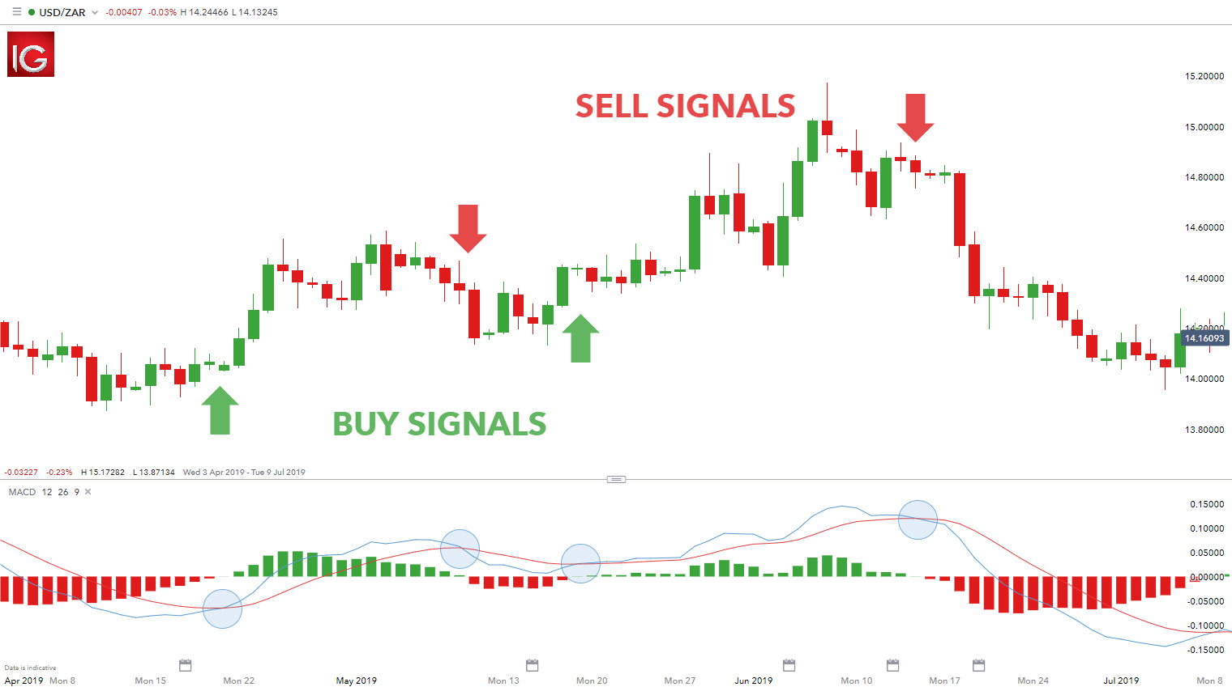](https://forum.mt5.com/customavatars/318327417.png)

The Moving Average Convergence Divergence (MACD) indicator indicates MT4 patterns - to be exact, a trend-following momentum indicator. This indicator shows the relation between two moving averages of prices. The MACD statistical technique is fast - you subtract the 26-day Exponential Moving Average from the 12-day. Furthermore, on top of the MACD, a nine-day EMA of the MACD (known as the signal line) is plotted, acting as a sell and buy signal trigger. There are theoretically three ways to interpret MACD:

* **'Crossovers'** is the first one. It represents a bearish signal when the MACD falls under the signal line that means that it may be time to sell. Alternatively, your indicator presents a bullish sign when the MACD rises above the signal line, which means that the particular asset's price is most likely to experience upward momentum. To avoid being fooled out or entering into a position prematurely, most FX traders, until entering, wait for a reported cross out over the signal line a place.
* To evaluate the MetaTrader 4 indicators listed, we will add the second method,' **Divergence.'** This indicator is when the security price, which implies the end of the current trend, actually diverges from the MACD.
* A **'Dramatic Rise'** is the last technique. This indicator is when the MACD severely increases. The lesser moving average pulls out of the longer-term MA, indicating overbought protection and returning to normal levels.

As this shows the direction of the short-term average concerning the long-term average, traders are waiting for a leap or zero axes. Additionally, the short-term average is above the long-term average while the MACD is above zero, which implies upward momentum. The zero lines for this FX indicator also acts as a support and resistance field.  
  
2. **MFI or Money Flow Index**

[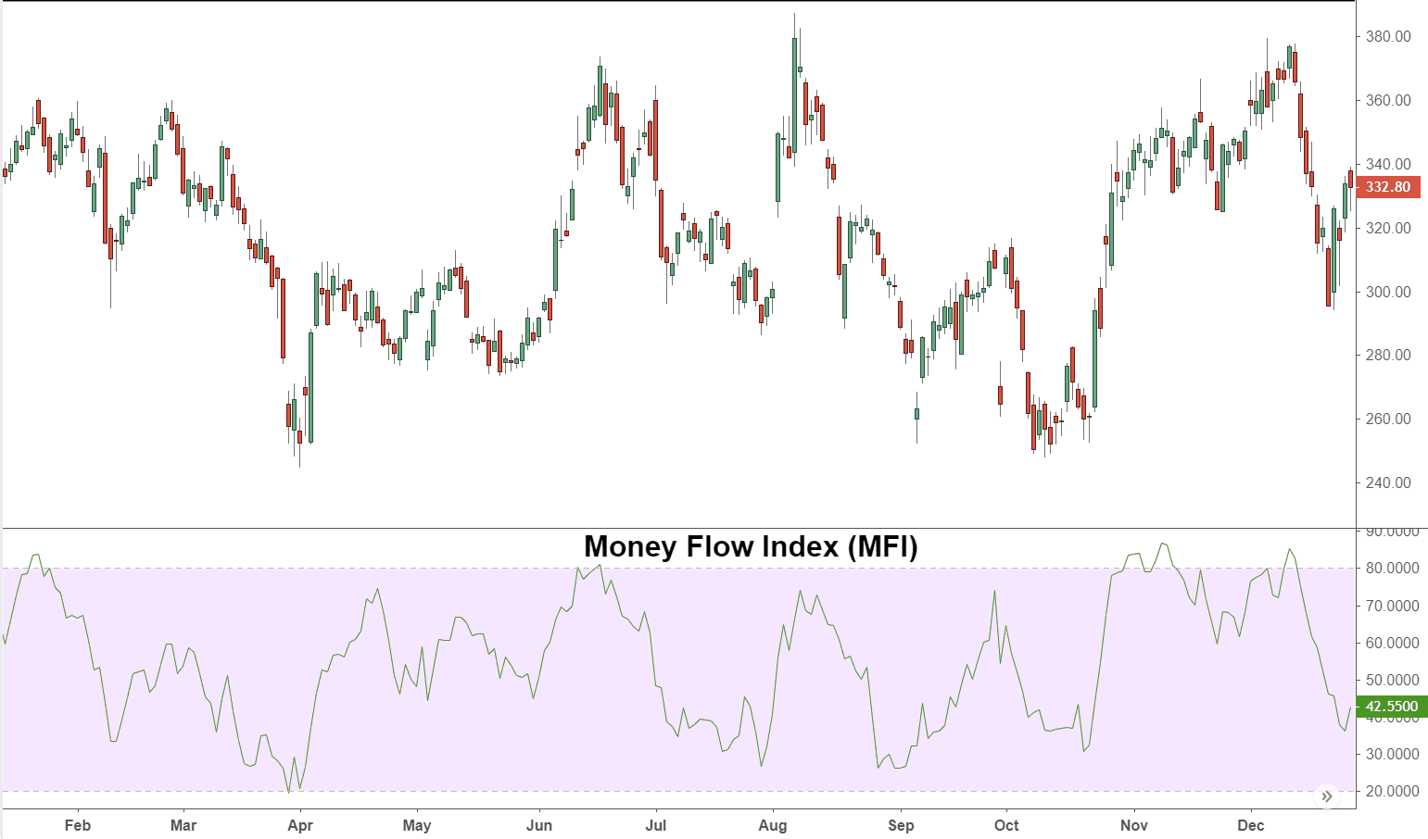](https://forum.mt5.com/customavatars/1078751301.png)

The Money Flow Index (MFI) is an impulse measure that utilizes an instrument's price and volume to forecast the current trend's reliability. The Money Flow Index adds trading volume to the Relative Strength Index since it is also a volume-weighted (RSI). To reach the index number, it takes certain steps. For your calculations, it recommends by different skilled traders to use a 14-day duration. In the first step, the typical price defines as follows:

* (Low+High+Close) / 3
* The Raw Money Flow measurement is the next step:
* Volume x Typical Price
* To quantify the money flow ratio, you then need to complete the following sum:
* (14-period Positive Money Flow) / (14-period Negative Money Flow) When the typical price is greater than the previous typical price value, positive money values produce. The number of good cash over the number of periods is the profit (mainly 14 days). The opposite is true for negative cash flow values.

The Money Flow Index is the final level, one of the MetaTrader 4's best indicators. That is: 100 - [100 / (1 + ratio of money flow)]. It's indeed important to set clear that many traders watch for openings when the MFI moves in the opposite direction of the price. This Divergence may also be a leading indicator of a change in the current pattern.  
  
3. **Amount On-Balance**

[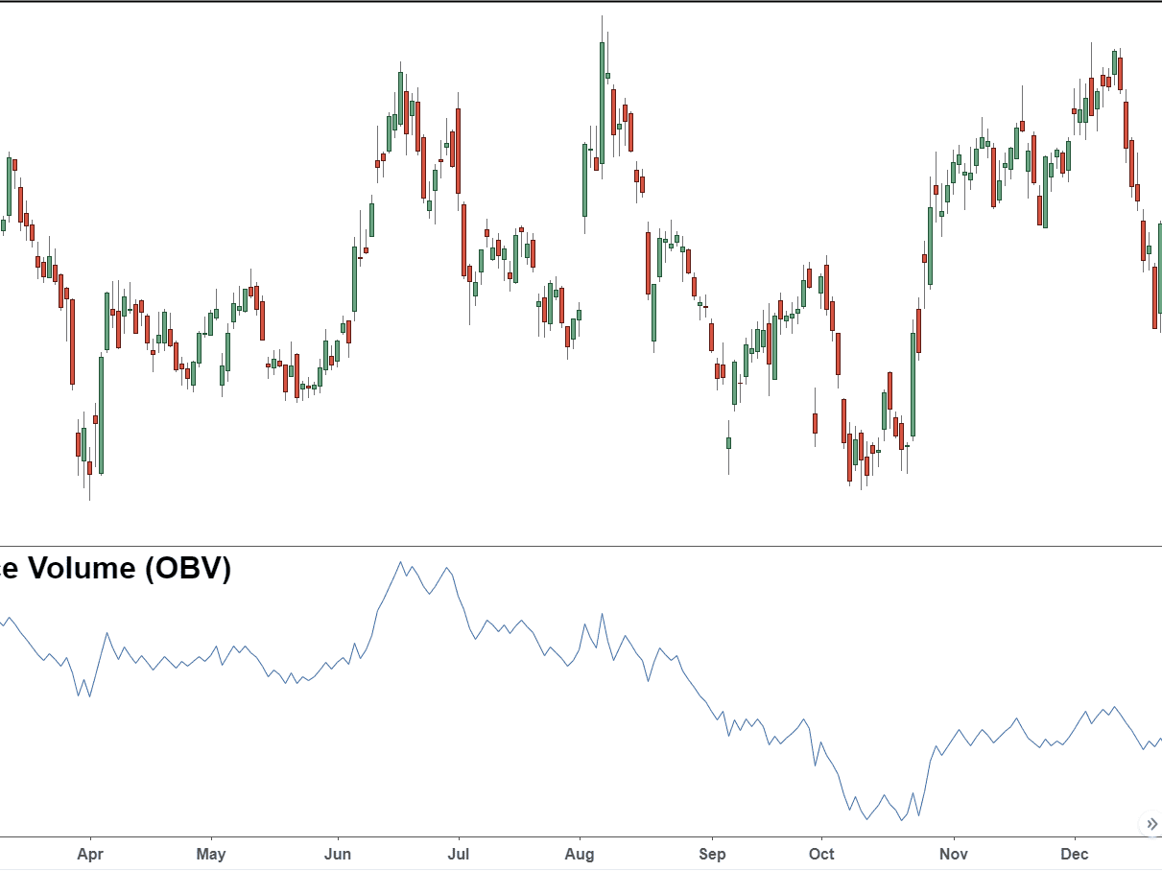](https://forum.mt5.com/customavatars/266675037.png)

The On Balance Volume Indicator (OBV) use to calculate the positive and negative volume flow. It is a simple measure that holds a cumulative total of volume by adding or subtracting each cycle's volume depending on the price movement. Besides, by integrating both price movement and work, this calculation extends to the simple volume measure. This indicator's reasoning is that price change is followed by volume, so if security sees an OBV rise, it is a signal that work is increasing on upward price movements. In essence, price falls imply that the protection is seeing increased volume on down days.

4. **Accumulation/Line of Delivery**

[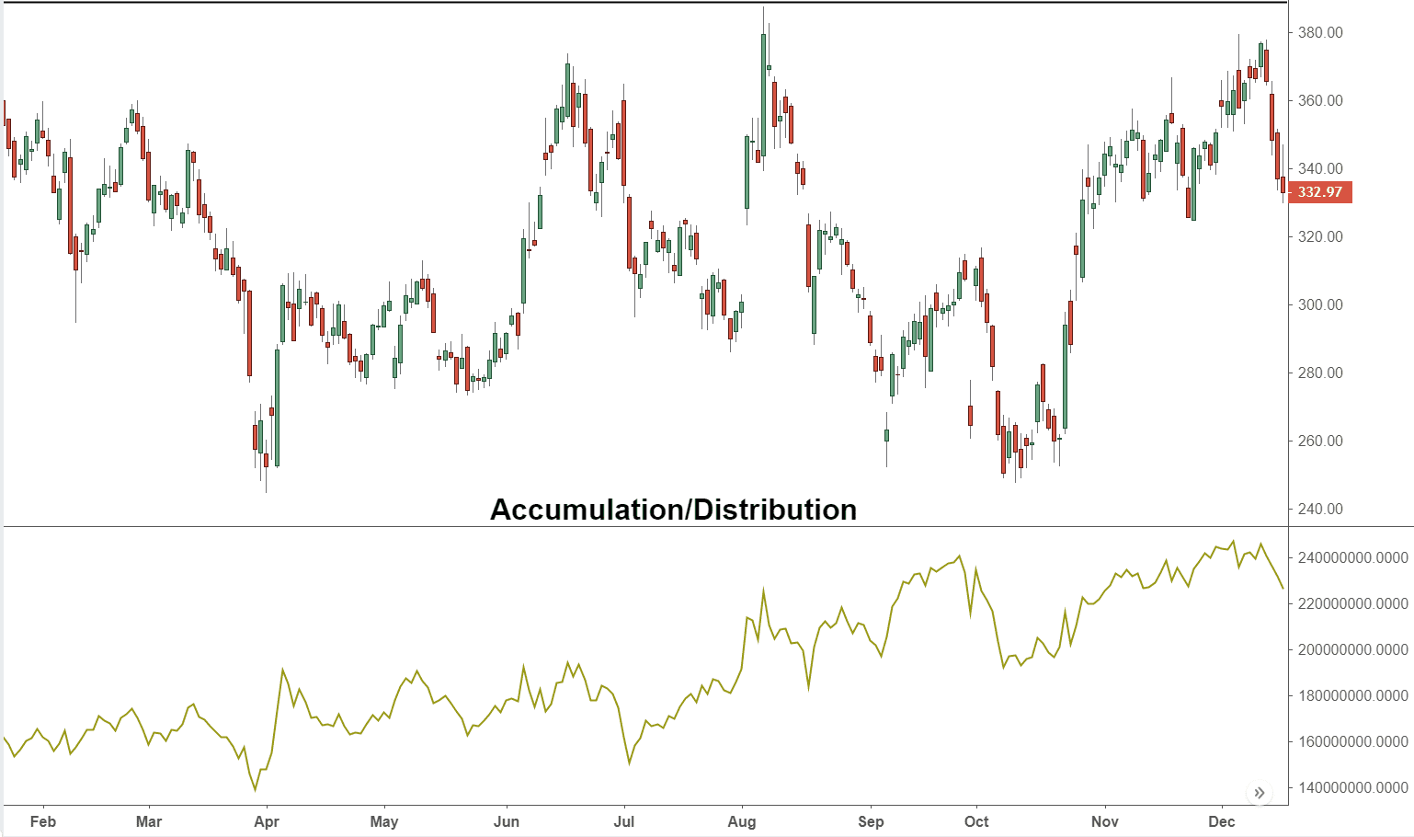](https://forum.mt5.com/customavatars/1068848250.png)

Forex MT4 is one of the common indicators in the Accumulation/Distribution Axis. It resembles, but with one significant difference, the On Balance Volume indicator. Instead of taking the closing price of the security for the duration exclusively into account, the period's trading range often takes into account. Compared to OBV, this is therefore assumed to provide a more accurate depiction of cash inflow. Also, as the instrument closes the halfway point of the concrete range, the line trending up is a sign of rising buying pressure. The downward trend of the line, in turn, is a sign of increased selling pressure within the particular securities.  
  
**Finalization**  
  
The regular practice of most currency traders is the implementation of Forex indicators. They can show essential information that your trading experience is beneficial. MetaTrader 4 is not only because of its essential characteristics, it is the best trading platform, but rather because it facilitates amounts of indicators that may be useful to you. If you want to read more about indicators for the MetaTrader trading platform, why not read our article on [An Ultimate Guide on Mobile trading with MT4 and MT5 App for Android](https://forum.mt5.com/showthread.php?311478-An-Ultimate-Guide-on-Mobile-trading-with-MT4-and-MT5-App-for-Android)