**An Ultimate Guide on Mobile trading with MT4 and MT5 App for Android**

The Android app for MetaTrader 4 and MetaTrader 5 is a robust trading application for mobile devices powered by Android. You can select from hundreds of brokerage firms and thousands of servers through the application. For successful Forex trading, it provides everything you need: a full collection of orders, trading history, interactive charts, technical analysis, and the broadest range of mobile devices supported. Traders using the Android MetaTrader 4 enjoy robust Forex trading features anytime and anywhere in the world. Your Android system now has a complete range of analytics and trading options!  
  
**Mobile trading with features for MT4 and MT5**

[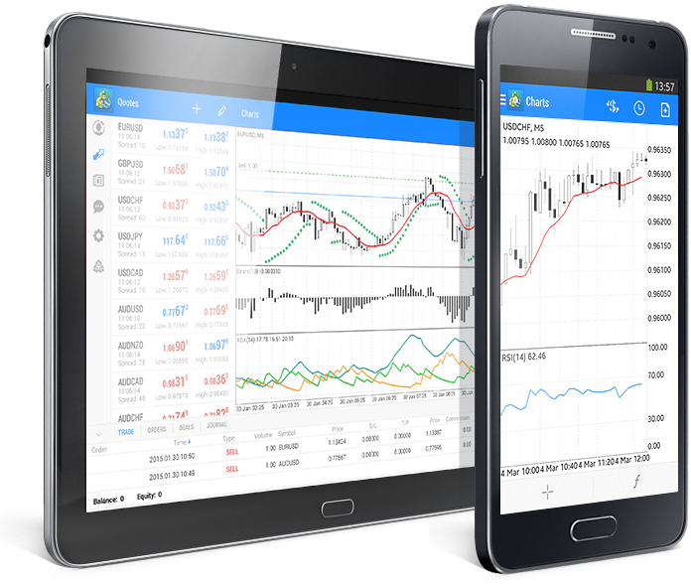](https://forum.mt5.com/customavatars/976738783.png)

The platforms Android MT4 and MT5 come with several features that include;

* **Interactive graphs**

[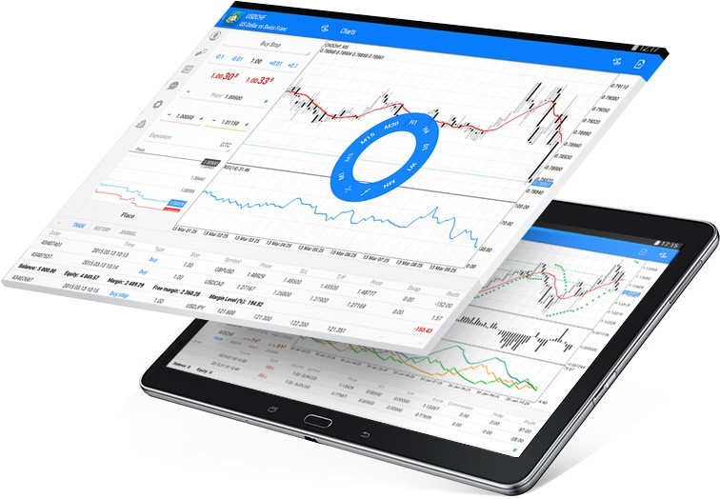](https://forum.mt5.com/customavatars/1647243446.jpg)

In real-time, interactive charts track currency rate changes. There are three types of maps in the application: bars, candlesticks, and lines that allow you to trade directly with them. You can scale and scroll charts quickly and move from one minute to one month between nine timeframes. The Android app for MetaTrader 4 and MetaTrader 5 helps you set up and execute your trading strategy most accurately. The program provides the 30 most essential technical indicators and 24 analytical artifacts: lines, channels, geometric forms, Gann, Fibonacci, and Elliott instruments. These indicators can add to the chart window and each other, although you can also change the color schemes to your liking. You can simultaneously open up to 10 windows with indicators. This way makes it easier for you to have the full benefit of the most detailed review possible. Also, MT4 and MT5 mobile app make mobile trading more intuitive, and analytical capabilities extend greatly.

* **Full collection of orders and trading functions**

[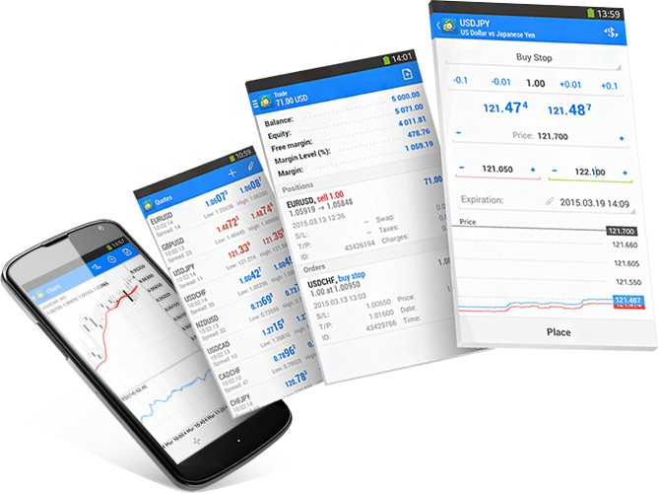](https://forum.mt5.com/customavatars/982962680.jpg)

You need a versatile MetaTrader 4 mobile trading device coupled with a full range of orders and trading functions to execute any strategy. Orders for instant execution allow you to trade Forex on an ongoing basis, while pending ones relieve you of the need to monitor your trading constantly. Even if the application is closed, the request on trading will be executed. Open positions may be changed to set your benefit or minimize your losses by adjusting the order levels of Stop Loss and Take Profit. You can find all the details about the number of orders and open positions, open rates, volumes, and account status in the Trade window. In contrast, the History window allows you to access the full history of all previous trades.  
  
Implement every solution! You will be supported by the versatile MetaTrader 4 trading system for Android.  
  
***Other features included for MT4 and MT5 include:***

* Complete influence over a trading account
* Trading from any position 24/5
* Both order forms and modes of execution
* Trade history
* Interactive maps of symbols
* Three styles of charts: bars, candlesticks from Japan, and split lines
* 9 timeframes: between one minute and one month
* 30 of the most popular technical indicators
* 24 items for study
* Stock market news
* Free mobile chat and electronic mail

**Indicators Available for Android MT4**  
  
On your Android, the MT4 mobile platform gives you a wide range of indicators. These comprise of;

* Oscillator Accelerator
* Accumulation/Distribution
* Alligator
* The average index of directional movement
* True Range average
* Impressive oscillator
* Bears Power
* Bollinger Bands
* Power Bulls
* Commodity Channel Index
* DeMarker
* Envelopes
* Force Index
* Fractals
* Oscillator of Gator
* Ichimoku Kinko Hyo Hyo Hyo
* MACD
* Index of business facilitation
* Momentum
* Index of Money Flow
* Moving Average
* The Oscillator Moving Average
* On Volume of Balance
* Parabolic SAR
* Index of relative strength
* Index of relative vigor
* Standard deviation
* Stochastic Oscillator
* Volumes
* Williams Percent Selection

**Indicators Available on Android MT5**  
  
MT5 provides you with a wide variety of indicators on your Android, similar to MT4. These comprise of:

* Moving Average
* Force Index
* Oscillator Accelerator
* The momentum of Bollinger Bands
* Impressive oscillator
* The average index of directional movement
* The Oscillator Moving Average
* Oscillator of Gator
* Envelopes
* Alligator Relative Strength Index
* Ichimoku Kinko Hyo Hyo Hyo
* Index of relative vigor
* Index of business facilitation
* Standard deviation
* Williams Percent Selection
* Parabolic SAR
* True Range average
* Accumulation/Distribution
* Fractals
* Bears Power
* Index of Money Flow
* MACD
* Power Bulls
* On Volume of Balance
* Stochastic Oscillator
* Commodity Channel Index
* Volumes
* DeMarker

**How to Add Android Indicators?**  
  
You may put an indicator on your chart directly or append it below, similar to using a hand on your Metatrader PC platform (for example, using an indicator oscillator). The first thing you're going to need to do is to create a free account on the mobile platform of Metatrader or connect to your current account.  
  
Follow these instructions to connect to the existing account you created through your broker;

1. Open up your mobile platform for MT4 / MT5.
2. Click on 'Configuration' and 'Manage accounts.'
3. To add an existing account, click on the + symbol.
4. Select 'Current account login.'
5. Search for and select your broker.
6. Enter your password and login, and then sign in.

Follow these instructions to add indicators to your mobile trading platform:

1. Open up your mobile platform on MT4 or MT5.
2. Open the graph to which you wish to apply the indicator.
3. Select the ‘f’ symbol.
4. Then you'll have two options. The indicator can either be added to the main chart or to the indicator window.
5. Please pick the ‘f+’ symbol and choose from the indicator range.
6. Pick the parameters of the metrics you want to use and press to apply them.

**How to Uninstall Mobile Indicators from MetaTrader?**  
  
You no longer want to add the first hit symbol (‘f’) to erase any indicators.  
Click the erase trash bin symbol, and the markers you want to uninstall can be ticked.  
When you have selected the indicators you want to delete, press the delete button again, and they will be deleted.  
  
**How are Indicators Modified?**

1. To adjust and change the parameters for any indicators you have already used, click the indicator button to show the arrows.
2. Pick the indicator you want to customize, and the choices you may alter will be shown to you.
3. Make the modifications and pick 'done.'

**How to Use Android Custom MetaTrader Indicators?**  
  
It is not a built-in feature at this point in time to incorporate or use custom measures like the 1,2,3 or auto Fibonacci indicator pattern indicator. Using either a Microsoft-based tablet or mirroring their device to their phone is the most common solution that traders use to have these types of indicators available. While it is a more comfortable choice to use a Microsoft tablet that enables complete Metatrader functionality, it also defeats the purpose of mobile trading. You can access the full suite of Metatrader software that your machine is running, including all the custom indicators while setting up mirroring.  
  
**Conclusion**  
  
A daily practice of most currency traders is the implementation of Forex metrics. They can explain essential data that can benefit from your trading experience. MetaTrader 4 and MetaTrader 5 is the best trading platform because of its simple features and because it supports masses of indicators that you might find useful. Moreover, as all is quick and intuitive, you do not need to spend a long time learning how to install custom indicators in MT4 and MT5.  
  
Do you have other opinions regarding indicators for the MetaTrader trading platform? We would love to hear the thoughts of yours in the comment section below. Thank you!