**How to Calculate Fibonacci Retracement?**

Fibonacci retracement levels are horizontal lines that show where support and resistance are likely to exist, based on Fibonacci numbers. Each degree is related to its proportion—the proportion of how much the price paid back to the previous move. Traders are waiting for rates to approach these Fibonacci thresholds and to act on their plan. Typically, they're waiting for a reversal signal on these closely watched retracement levels before opening their positions. The three tiers most widely used decks are 0.618 – the reciprocal of the golden ratio (1.618) denoted in mathematics by the Greek letter φ.  
  
The indicator is useful when drawn between two essential price points: the high and the low. The predictor would then establish the thresholds between the two stages. Suppose the stock price is $10 higher and then $2.36 lower. In that case, 23.6 percent, which is the Fibonacci number, has been traced back. Fibonacci numbers are present all over nature. Many traders also conclude that these figures still have significance in capital markets.  
  
Before we proceed to Calculate Fibonacci Retracement, you may also want to read about [Fibonacci Retracements and Ratios of Fibonacci](https://forum.mt5.com/showthread.php?308988-What-are-Fibonacci-Retracements-and-Ratios-of-Fibonacci&p=15157095#post15157095)for a broad introduction of Fibonacci Retracement.  
  
**Calculating Fibonacci Retracement Level**  
  
Fibonacci retracement degree does not include formulas. If these metrics use in a map, the consumer selects two points. When these two points are pick, the lines will represent the percentages of the transfer. Suppose the price falls from $10 to $15, and these two price ranges are the points used to draw the retracement tracker. Then the 23.6 percent level will be $13.82 ($15-($5 x 0.236) = $13.82). The 50 percent level would be $12.50 ($15-$5 x 0.5) = $12.50).  
  
As mentioned above, there is little to measure when it comes to the degree of Fibonacci retracement. The measure is fractions of the price point they want. The root of Fibonacci numbers, though, is intriguing. They are based on something called the Golden Ratio. Start a set of numbers with zero and one. The Fibonacci retracement degree is all extracted from this number series. After the series begins, the measures divide one number by the next number, which yields 0.618, or 61.8 percent. Divide the number by the second number to the right, and the answer is 0.382 or 38.2 percent. All percentages, except for 50 percent (because it is not an official Fibonacci number), are based on a statistical equation involving this number series. Notably, 0.618 or 1.618 is the Fibonacci Sequence uses in sunflowers, galaxy formations, shells, historical objects, and design.  
  
**How to Draw the Fibonacci Retracement Level?**  
  
Drawing Fibonacci retracement level is a simple three-step process:  
  
**For the uptrend:**

[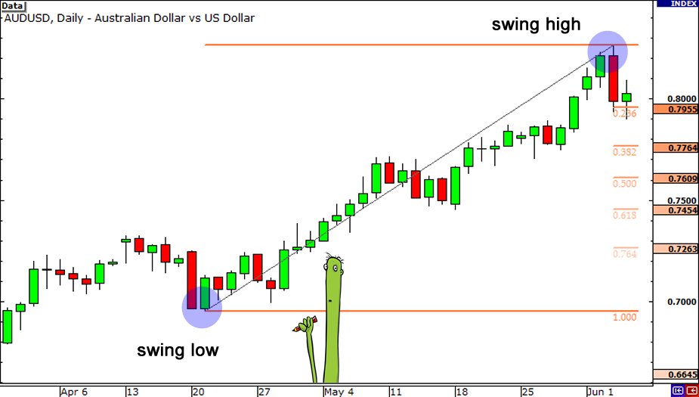](https://forum.mt5.com/customavatars/1223915032.png)

* Step 1 – Define the trajectory of the market: uptrend.
* Step 2 – Connect the Fibonacci Retracement Tool to the bottom and drag it to the right, all the way to the tip.
* Step 3 – Track the three possible assistance levels: 0.236, 0.382, and 0.618.

***For the downward trend:***

[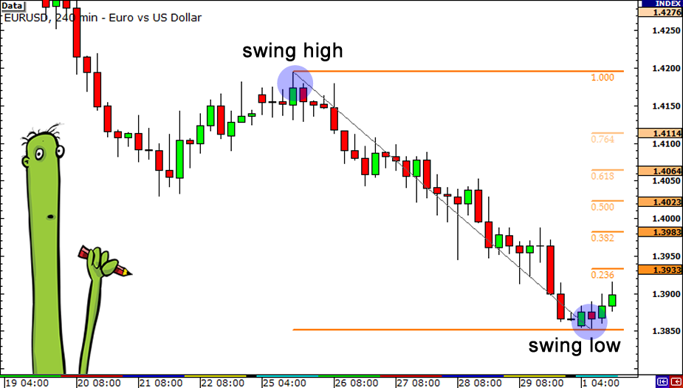](https://forum.mt5.com/customavatars/1310297906.png)

* Step 1 – Define the course of the market:
* Step 2 – Connect the Fibonacci Retracement Tool to the top and drag it to the right, all the way down to the floor.
* Step 3 – Track the three possible resistance levels: 0.236, 0.382, and 0.618.

Of course, aiming for a confluence of signals is more accurate (i.e., more reasons to take action on a position). Don't slip into the pit of thinking that the demand would only immediately reverse because the price hit the Fibonacci stage. Combine Fibonacci levels with Japanese Candlestick shapes, Oscillators, and Markers for better signals. Suppose you can tell from the table below. In that case, the Three White Soldiers trend confirms that rates are above the Moving Average line. In comparison, the MACD (Moving Average/Convergence Divergence) is above the zero lines.  
  
**Trading in Fibonacci Retracements**  
  
Every trader, particularly a beginner, is dreaming of mastering the Fibonacci theory. Many traders use it to define possible support and opposition levels on the price line, which indicates that reversal is probable. Most enter the market merely because the price has hit one of the ratios of Fibonacci on the map. It's not enough! It is best to search for more signs before joining the sector, such as reversing Japanese Candlestick formations or Oscillators crossing the baseline or even a Moving Average confirming your decision.  
  
**What are Fibonacci Retracement Levels Telling You?**  
  
Fibonacci retracements can be used to position entry orders, assess stop-loss levels, or set price goals. E.g., a trader can see a higher movement of stock. It traces back to the 61.8 percent mark after a leap up. Then it's starting to get up again. After the bounce happened at the Fibonacci level during the uptrend, the trader chooses to purchase the bounce. The trader should set a stop loss at a level of 61.8 percent, as a return below that level could suggest that the rally collapsed. Fibonacci levels also appear in other cases in the sense of technical research. For example, Gartley patterns and Elliott Wave theory are prevalent. After significant market changes up or down, technical analysis types have found that reversals appear to occur near some thresholds of Fibonacci.  
  
Fibonacci retracement ratios are steady prices that do not shift, as opposed to moving averages. The static design of the price ranges enables fast and straightforward recognition. This design helps traders and investors to predict and respond prudently when the price conditions check. These thresholds are inflection points where some market movement expects either a turnaround or a split.  
  
**Fibonacci Retracement Parameters**

The parameters of this EA are specifically defined and include the following parameters:

* **Batch Management** – enable/disable batch management.
* **Maximum risk** – maximum risk percentage of the overall margin
* **Decrease factor** – number of consecutive losses to minimize batch size
* **Stop trailing** – the number of pipes to use to enable the trailing stop (pips)
* **Final stage** – stop loss by shifting [x] pipes
* **Stop Losing** - Stop Loss
* **Take profits**– take profits (pips)
* **Make purchase orders**– enable/disable purchase orders;
* **Make sales orders**– enable/disable sales orders;
* **Magic number** – the number for each symbol window and the type of exchange in which the EA works concurrently.
* **Fibonacci parameters**
* **Fib-level filters are available**
* **Level 0.0 percent-200.0 percent** – Enable/Deactivate each Fibonacci level
* **Additional Contact Level Mode** – Open operations when touched before multiple Fibonacci level tubes.
* **Distance for the additional amount**– distance for an additional level of the pips

*Graphical criteria shall include:*

* **Line Style Fibonacci Line Style**
* **Width of line** – width of line Fibonacci
* **Color Line Fibonacci Color Line**

[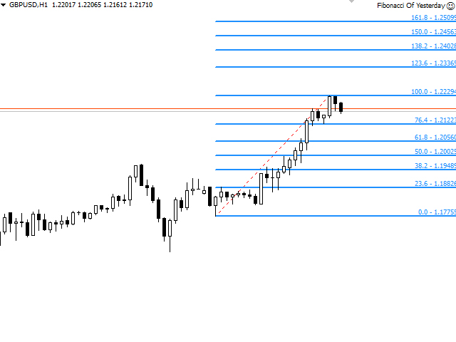](https://forum.mt5.com/customavatars/62463828.jpg)

**Note:**The recommended time frame is 30 minutes and 1 hour. The default configuration for the highest benefit rate does not design, and the user would have to change the settings to make the tool profitable.  
  
In short, we are talking about a device that uses Fibonacci as the basis for its service. This robot is not ideal for all forms of traders since it leaves several parameters open. It is the operator who optimizes the process and makes the machine more or less profitable. Therefore, it may not be the most fitting EA for beginner traders. It is often best for every EA to use dedicated VPS or virtual servers to remain permanently attached to the robot. If we don't have a server, we will not compel to have our machine on 24/7. Another suggested choice is to provide an ECN account in a stable low latency broker such that our orders complete in the shortest possible period.  
  
**Conclusion**  
  
Before investing in the purchasing of the EA, I strongly recommend that you download the free trial edition for a better understanding of the process and familiarize yourself with all the functionality that the user can program, and, if possible, figure out the viability of the robot even in a demo account. Fibonacci Retracement EA is available for sale on the MQL market for USD 30 and can also lease for USD 10 per month.