**Who Accepts Bitcoin? (Full Guide)**

**Who Accepts Bitcoin?**  
  
Cryptocurrency exists so that we can make transfers electronically. The new trend has been adopted by many sectors.  
The day's burning question is:  
  
**Who accepts bitcoin?**  
  
We like to view knowledge in a beautiful way at SpendMeNot. That's why we did a brilliant infographic for this. This highlights some of the most successful businesses that are currently embracing bitcoin.

[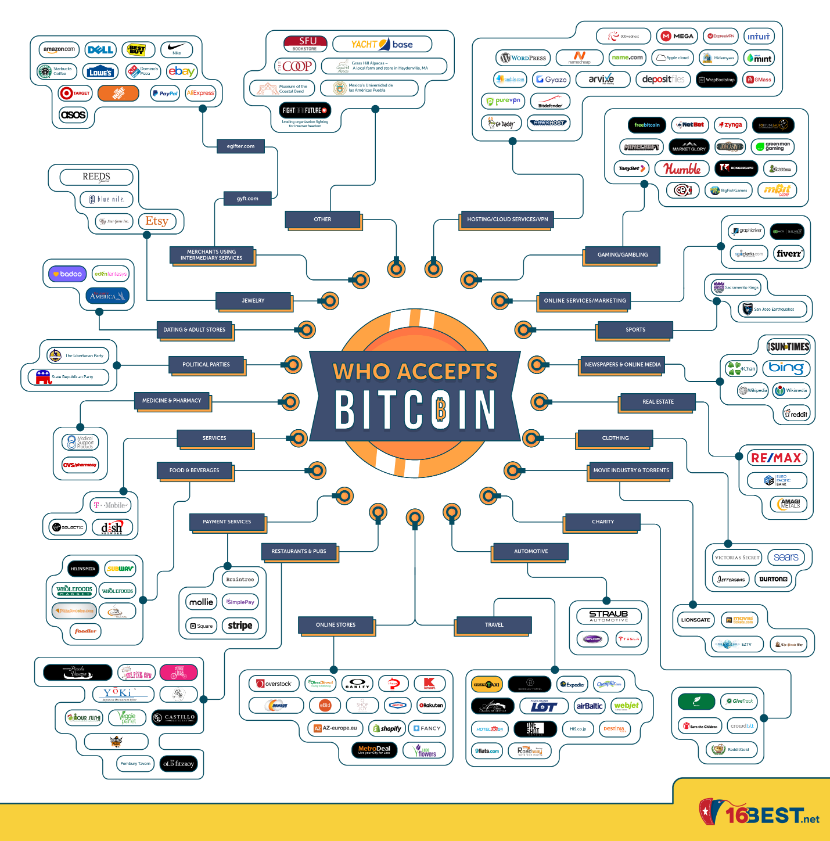](https://forum.mt5.com/customavatars/71467831.png)

**Top Companies Accepting Bitcoin Sorted by Industry**  
  
Cryptocurrency is a type of digital currency that uses encryption and anti-counterfeiting measures using cryptography. It is not regulated, which makes it completely transnational, by any bank, government, or other form of authority. Only in the modern world does this form of currency work, because it can only be used for making online purchases.  
  
Bitcoin, Ethereum, Ripple, Litecoin, and Bitcoin Cash are the most popular crypto-currencies (BTC). For a decade, Bitcoin has been around and is the most popular cryptocurrency. What people need to grasp, though is who supports bitcoin transfers. With this cryptocurrency's rising success, more and more businesses are hopping on the bandwagon and embracing it as a type of payment.  
  
There are markets that are not waiting to become a standard means of payment for cryptocurrencies. Instead as soon as they can, they follow the new fashion.  
  
**1. Jewelry & Watches**  
(Source: Paybis, Paxful)  
  
As with bitcoin transfers, the diamond industry is no stranger. Here are several examples of businesses who would be more than delighted to accept payment from you in the form of cryptocurrency:

* Etsy
* Fancy
* Real Watches
* Ancora1919
* Kobelli
* Saving Pearls
* Domoshop
* Cryptomatic

Notable Example: Etsy  
Etsy is an online store where individuals can sell and purchase products that are exclusive. It is also a spot where you can locate bitcoin accepting merchants. To allow another type of payment option, vendors on Etsy may customize their payment settings. Then a wallet address will be sent to them, and the client will be able to make a payment. And it doesn't just have to be a bitcoin wallet; suppliers can even connect other crypto wallets!  
  
**2. Services & Intermediaries**  
(Source: Paybis, Paxful)  
  
The bitcoin movement has been joined by telecom operators and cable and internet service providers. Here is a list of providers that offer the bitcoin payment option:

* AT&T
* Dish
* Bitrefill
* Ynotek
* Teahouse Transport
* Purse.io
* Gyft
* eGifter

Notable Example: AT&T  
  
AT&T, with a record of 153 million cellular customers in 2018, is a major US telecom service provider. The first telecom provider to accept bitcoin was AT&T in 2019. Customers will have the option to choose BitPay as a payment form when signing in to their accounts online or on the smartphone.  
  
And they aren't by themselves:  
  
Back in 2014, Dish began embracing bitcoin as one of their rivals. Dish is a provider of satellite television and Broadband services, its biggest rival being the satellite channel branded as DirecTV from AT&T.  
  
**3. Food & Beverages**  
(Source: Paybis, Paxful)  
  
Now you can use your hard-mined cash to put food on the table. This is a list of Bitcoin-accepting food and beverage companies:

[](https://forum.mt5.com/customavatars/602589276.jpg)

* Wholesale Roots
* Koyah
* Whisky.de
* Subway
* Lieferando
* Domino’s Pizza
* Burger King
* Crypto Coffee
* Toga
* The Pembury Tavern
* The Block
* Undead Coffee

Notable Example: Domino’s Pizza  
Now you can order Domino's Bitcoin Pizza and it comes with a discount! Lightning pizza is one of the websites that supports bitcoins when ordering Domino's Pizza as a payment form.  
  
**4. Banks & Payment Services**  
(Source: Paybis, Paxful)  
  
Cryptocurrencies tend to be a challenge to banks everywhere with their biggest rival being the blockchain sector. No wonder, since crypto-currency transfers are known to be quicker and simpler. However, there are several banks and payment services that are not opposed to merchants of bitcoin, such as:

[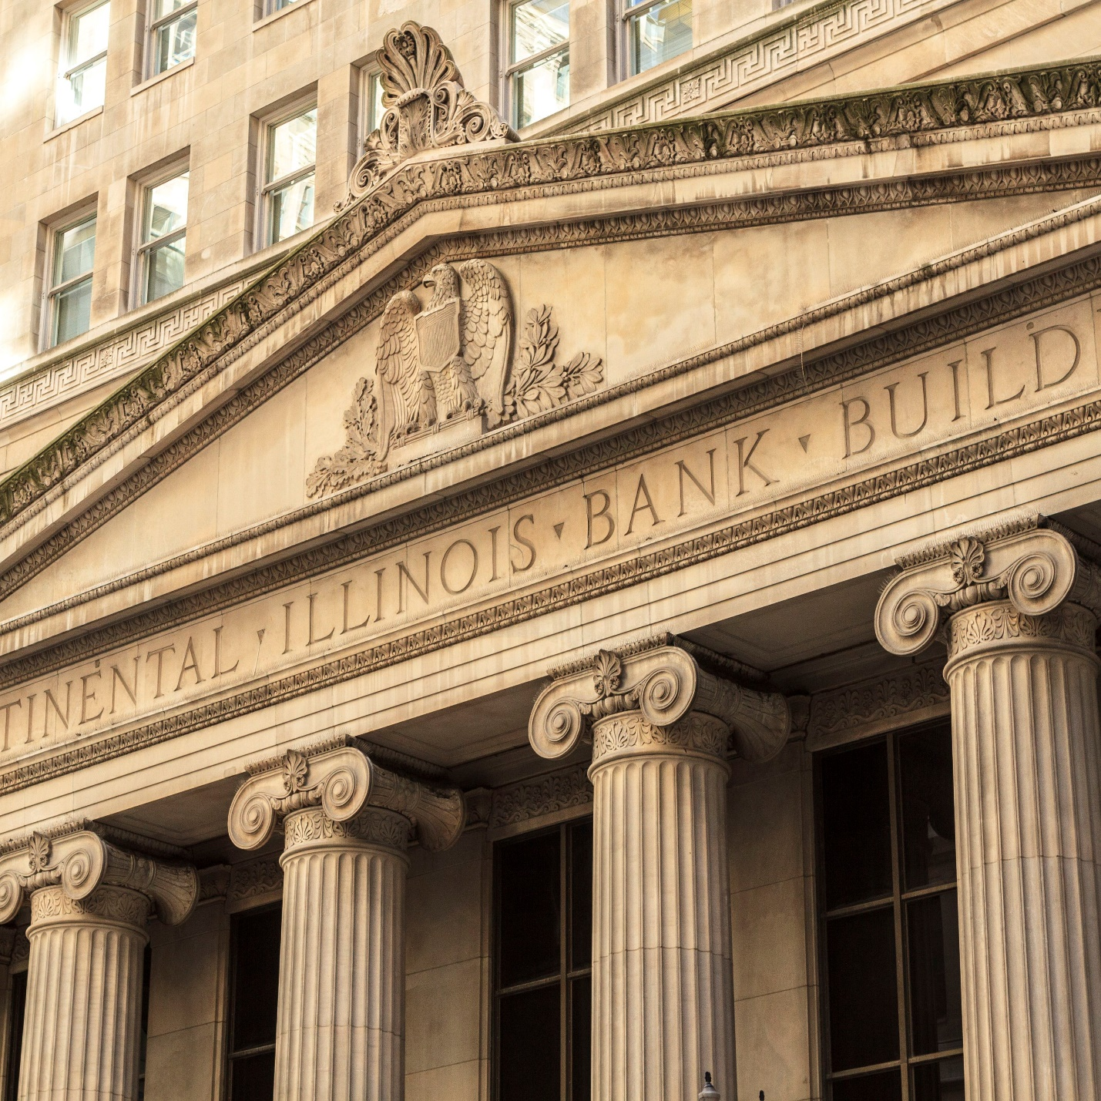](https://forum.mt5.com/customavatars/1390024307.jpg)

* Fidor Bank
* Goldman Sachs
* Royal Bank of Canada
* Worldcore
* Bankera
* Paypal
* Intuit
* Living room of Satoshi
* Bylls
* Vaultoro
* Bitcoin Commodities
* Denarium
* Bitcoin Real Estate

Notable Example: Fidor Bank

Fidor Bank in Germany is now allowing customers to purchase and sell Bitcoin. Let's only hope that in the future, banks can encourage US people to purchase BTC.  
  
**5. Online Shops**  
(Source: Paybis, Paxful)  
  
Internet shopping has become the standard, since it is a more efficient way for most customers to purchase products. And using digital currencies, you can buy items. Here are several bitcoin-accepting online stores:

[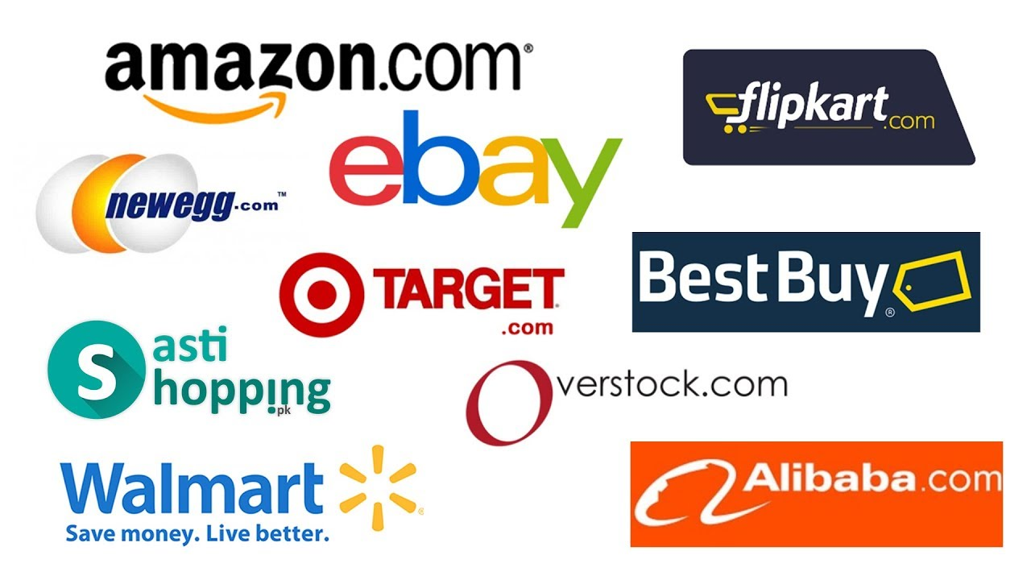](https://forum.mt5.com/customavatars/480625057.jpg)

* Overstock
* Newegg
* Shopify
* Rakuten
* BitPlaza
* SurvivalCampingStore
* Webhallen
* Cryptoshopper
* Something Geeky
* Sugartrends
* Bitshopping
* Mubiz
* Gipsybee
* Minku
* Benny’s Boardroom

Notable Example: Overstock  
Overstock is an Online shopping website based in the state of Utah in the United States. To make Bitcoin purchases on the website, the company collaborated with Coinbase, which is a Bitcoin network. This made Overstock the biggest supermarket online where you can buy stuff with bitcoin. Bitcoin sales accounted for close to 1 percent of their revenue in the year that they approved this payment form.  
  
Customers need to pick Pay with Bitcoin under the Payment Details portion of the checkout page to pay with Bitcoins. Using their Coinbase account or Bitcoin address, they will complete the transaction. However, via their smartphone website, bitcoin payments are not approved yet.  
  
What is more:  
  
Overstock helps other major cryptocurrencies such as Ethereum, Litecoin, Dash, Monero, and the new Bitcoin Cash to be used by customers.  
  
**6. Travel**  
(Source: Paybis, Paxful)  
  
There are also quite a few Bitcoin-accepting travel agencies. To book a reservation with the following travel companies, you may use cryptocurrencies:

* Cheap Air
* Bitcoin.travel
* More Stamps Global
* Travala, Cryptocribs
* AbitSky
* Future Travel
* Airtreks
* TravelByBit
* CheapBizClass
* Destinia
* Greitai
* Privatefly

Notable Example: Cheap Air  
Cheap Ai is a California based American online travel agency that supports cryptocurrency as a payment form. CheapAir has received more than $5,000,000 worth of crypto payments since 2013. CEO Jeff Klee has announced that CheapAir will also begin accepting Ethereum air ticket payments. They are now accepting Bitcoin, Dash, Bitcoin currency, and Litecoin. Cryptocurrencies can be used to book domestic and international flights.  
  
**7. Automotive Manufacturers & Services**  
(Source: Paybis, Paxful)  
  
You can't download your car, but with Bitcoin, you can buy a car. Cryptocurrencies for certain car firms are an agreed payment method:

* Post Oak Motor Cars
* Classic Recreations
* BMW
* Remotes and Keys
* AGU
* Utoky
* Lamborghini Newport Beach
* Spokester

Notable Example: BMW  
One of the few car companies embracing Bitcoin is the Stephen James Corporation, which is an accredited BMW and MINI automotive firm.

**What Places Accept Bitcoin?**  
Cryptocurrencies, both among businesses and customers, are becoming more and more common worldwide. For any country, there are rules for regulating Bitcoin. They allow fast and safe transactions, so it is no surprise that they are favoured by customers who are wary of cyberattacks. Companies will save a lot of banking costs by permitting this payment process.  
  
A organization that accepts Bitcoin will expand their future client base.  
So, cryptocurrencies are no longer just an asset for speculation. You can also use Bitcoin to buy watches, suits, pizza, and many other items.