**Everything You Need To Enable Authy 2FA For Binance Withdrawals**

[](https://forum.mt5.com/customavatars/331331985.png)

You may have learned of Binance if you acquire, sell, or otherwise exchange cyber currencies today. Binance is the fastest growing exchange for trading bitcoin, alt-coin, and other currencies, named by merging the words' binary 'and' finance.' It's famous because it has a clean and intuitive user interface accessible in several languages and handles orders at incredibly high speeds.  
  
Although what we like most is how user protection is embraced by Binance. You must have two-factor authentication (2FA) enabled to make a transaction while you can open an account and make a deal with only a password.  
  
In an attempt not to annoy users during the set-up process, Binance offers two types of 2FA to choose from: SMS-based and software-based authentication systems (specifically, Google Authenticator). The inherent dangers of 2FA focused on SMS will motivate the 2FA app to be chosen by those who want extra strong protection. But what they do not know is that the Authy 2FA software can be used instead, even though Binance promotes Google Authenticator.  
  
**Why Use Authy Instead Of Google Authenticator?**  
  
The same security standards are used by Authy and Google Authenticator, so note that you can use Authy anywhere you are told to download and activate Google Authenticator. And Authy, rich in functionality, includes several benefits that Google Authenticator does not provide, including:

* A simpler-to-use gui
* Synchronization of various devices so that you can use 2FA on iOS or Android devices or from a laptop.
* Cloud-back ups in order to stop account lockouts
* Simple recovery to an account if you forget or change your device. (Restoring Google Authenticator accounts is painful).

**Path to Protecting Your Binance Account with Authy 2FA Step-by-Step**  
  
Second, a pop-up will appear when you initially log into Binance, urging you to allow 2FA with Google Authenticator. Again for the sake of this step-by-step tutorial, instead of Google Auth, we use Authy.

[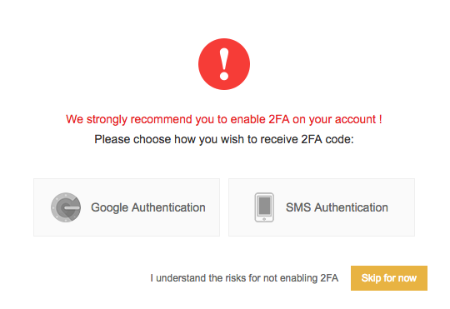](https://forum.mt5.com/customavatars/1916888031.png)

You might see the dashboard itself if you have already opened a Binance account but have not set up 2FA. Take a peek at the bottom right corner if this is the case. That's where the Google Authenticator prompt is shown. Click the 'Activate' button to get started.

[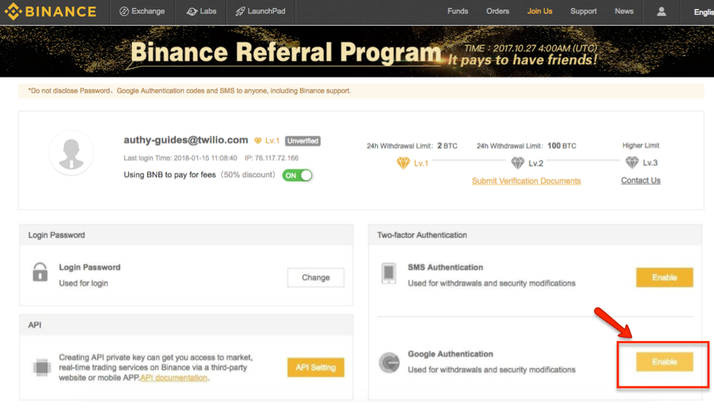](https://forum.mt5.com/customavatars/1212032113.png)

**Downloading Authy**  
  
Next the update will alert you of the 2FA app. You can skip this move if you are already a loyal customer of Authy. Alternatively, for IOS, Android, and tablets, you can find Authy here.

[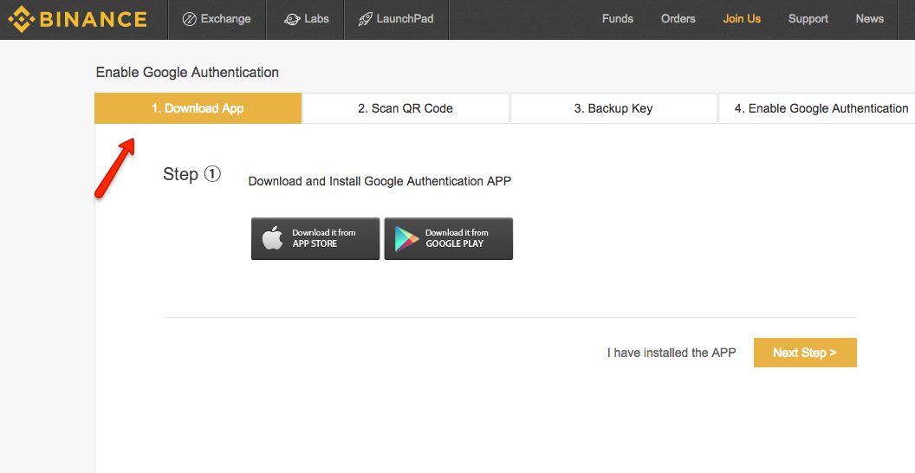](https://forum.mt5.com/customavatars/926981390.png)

**Binance QR Code scanning for the Authy app**  
  
A QR code will be displayed after you have downloaded Authy and pressed 'Next Pass,' which you need to check for the Authy app. On your phone, launch Authy while you keep this page open. Locate and click on the 'Add Account' button on your smartphone on the Authy screen on the right. Point your unit's camera to the QR code seen on your computer when you're through and click "Scan QR Code." A Binance 2FA token is set up by Authy automatically.  
  
Once the QR code has been sufficiently scanned, Authy will ask you to use Binance to name your account. Click Done.' FYI after doing so When a Binance logo is added to Authy, this step will be automated. You will now display a Binance 2FA account and a 6-digit digital token in the Authy app, which refreshes every 30 seconds.

[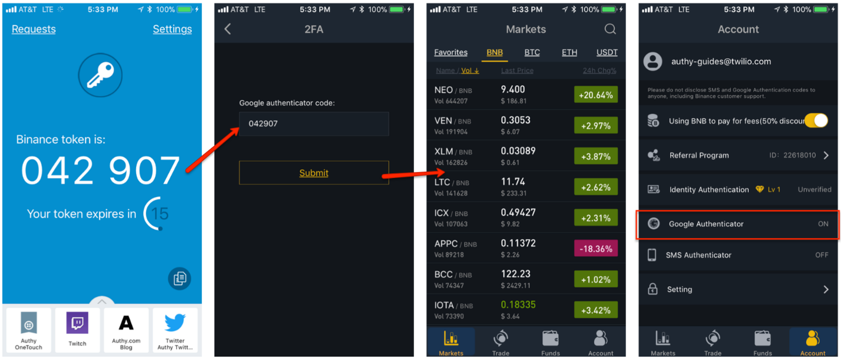](https://forum.mt5.com/customavatars/130857871.png)

**Connecting Authy To The Binance Website**  
  
You'll be asked to record a 16-digit alphanumeric backup key when returning to the Binance website. Copy this down and keep it safe for yourself. In order to check your account, Binance will need this backup number if you ever lose your computer. Click "Next Step" once you have registered the backup key.

[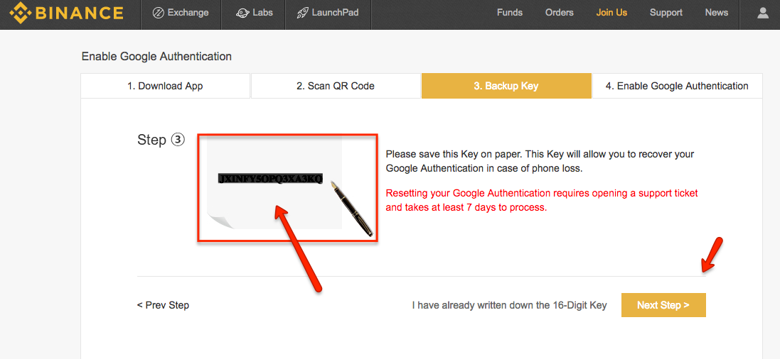](https://forum.mt5.com/customavatars/678126373.png)

In order to complete the 2FA configuration, you must enter the following data in the required fields:

The 16-digit backup key  
Your Log-in password for Binance  
The 6-digit numeric 2FA code as seen on the Authy app for your Binance account

Click on "Enable Google Authentication" when done.  
  
**Logging Into Binance With Authy 2FA**  
  
Now that Authy 2FA is active, any time you sign in, Binance will demand that you enter a 2FA token. They will also order it again to validate withdrawals from Binance. Let's replicate the login experience using the Binance software for iPhone, to show how simple it is. On your smartphone, import and open the Binance app. You will be asked to enter your Authy code (yes, where it says 'Google Authenticator') after entering your email address and password.  
  
Now open the Authy app to get the authentication code for Binance 2FA. Please go back to the Binance app and type the code you have got from Authy. You can land straight into the Binance workspace if approved, so that you can purchase and sell as you prefer.

[](https://forum.mt5.com/customavatars/130857871.png)

**Authy’s Multi-Device Provides Extra Protection**  
  
If you access Binance through its smartphone application or through its website, you may also want to use Authy on many platforms. We are really differentiated from Google Authenticator by our "Multi-Device" feature. This helps you to use Authy from more than one computer and keep synchronized all your Authy accounts. And, Binance and the other Authy-Protected accounts will also be able to login, whether one device is missing or hacked. What the Multi-Device feature does is pretty clear:  
  
Multi-Device helps you to install new applications when activated and add them to your Authy account. You are unable to add another instance of the Authy software for your account while disabled (although any existing devices with Authy installed will remain active).  
We recommend that you first install the Authy app on a device like your mobile phone. Then as a backup on a different device, like a tablet or laptop, install it again. Then on the Authy app, disable 'Allow Multi-Device.' This will mean that if you lose access to one, you will already have access to Authy-protected accounts and give you peace of mind.

**Don’t Forget The Hardware Wallet**  
  
Although 2FA is an excellent way to secure logins and to authenticate transactions or transfers, we would not recommend that you also use a hardware wallet. Your digital coins are only safe from hackers and Ponzi schemers with an air-gapped wallet. Would you want to actually buy the sports car? Return your wallet coins to your Authy-protected Binance account and make the exchange.  
  
**With Authy 2FA, your Binance Trades are now secured**  
Your Binance account and your cryptocurrencies are now considerably safer than a username and password (or even 2FA codes dependent on SMS) would have security. And if you prefer not to use the Authy software, we advise you to use an app-based 2FA such as Google's rather than Binance's SMS-based offering.  
  
Best of all, you now know that wherever Google Authenticator is advertised you can use Authy!