**Bitcoin Transfer: A Convenient Way in Digital Transaction**

[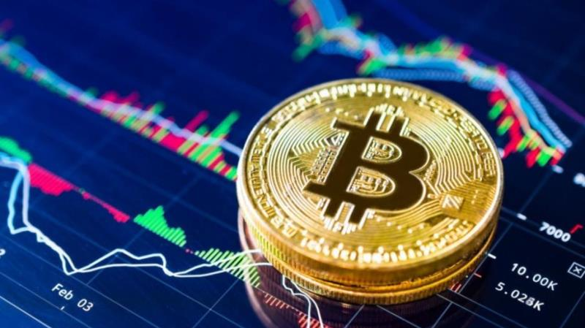](https://forum.mt5.com/customavatars/1443937609.jpe)

Bitcoin, also known as a blockchain, a decentralized currency or a digital currency, is a form of money that is fully decentralized. It's sort of like an online equivalent of currency. You may use it to purchase goods and services, but not many shops besides Bitcoin, and some countries have outlawed it entirely. The actual bitcoins you see in your pictures are a novelty. Without the private codes displayed inside, they will be useless. Bitcoin is one of the first digital currencies to use peer-to - peer infrastructure to make quick transfers simpler. Independent entities and corporations who control the controlling force of computation and invest in the Bitcoin network are made up of nodes or miners. "Miners," or people who process transactions on the blockchain, are inspired by incentives (release of new bitcoin) and transaction fees charged in bitcoin. This miners may be thought of as a consensus authority that enforces the legitimacy of the Bitcoin network. New bitcoin is being issued to miners at a constant but regularly decreasing rate, such that the total supply of bitcoins is close to 21 million. As of July 2020, there are nearly 3 million bitcoins that are yet to be mined.  
  
  
  
**Investing in Bitcoin**

[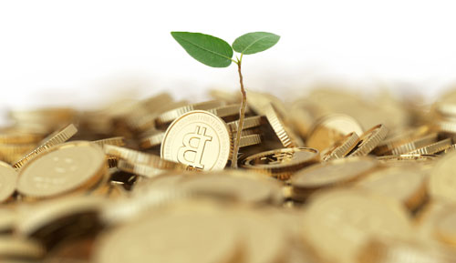](https://forum.mt5.com/customavatars/1193055000.jpg)

We've always written about bitcoin as a means of payment. Bitcoin just needs to be like that. The key objective of Bitcoin is a world without the involvement of banks. Even so, a lot of people don't use Bitcoin as a payment tool, but rather as a savings. Since there is supply and demand across Bitcoin, there is liquidity in the digital currency. These figures are also the statistics you read in the press. One day Bitcoin is worth too much euros, the next day it's even higher or smaller. Bitcoin is rare and has a record of 21 million Bitcoin. Currently there are almost 18.5 million bitcoin in circulation. The last bitcoin is predicted to be mined in 2140. This means that all 21 million Bitcoin will be in circulation in 2040. In all the bitcoin in use, 4-5 million BTCs have been lost. The cause for this may be because people have lost private keys, lost their wallet, forgotten their password, or the BTC has been moved to the wrong account. You're a bank of your own, remember?  
  
**How Bitcoin Transaction Works**

[](https://forum.mt5.com/customavatars/1270848492.png)

At its simplest, a bitcoin exchange operates by granting someone else the balance of the BTC you own. In order for a bitcoin transaction to be considered "valid," there must be at least one input, while several inputs are also possible. The input is a relation to the output of a previous transaction. Notice that any input connected with a bitcoin transaction must be the unused output of a previous transaction. In addition, any bitcoin transaction input must be digitally signed, which happens via the private key associated with the bitcoin address that initiates the BTC switch. If several inputs are connected to a single bitcoin transaction. This means that the payment being submitted comes from different bitcoin wallet addresses. Any Bitcoin consumer can create an almost unlimited number of wallet addresses, each of which can contain any number of BTC addresses.

**Bitcoin Fees**

[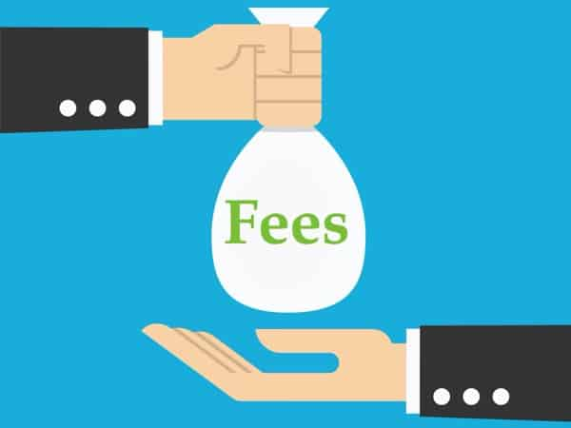](https://forum.mt5.com/customavatars/1744965537.jpg)

Bitcoin is also referred to as a decentralized payment network that does not require transaction costs. That assertion is valid to some degree, but it doesn't tell the whole story. There is no processing charge for the receiver on any bitcoin transaction with another user on the network. But often a processing fee is involved, albeit a very small one. Contract costs in the world of Bitcoin are not used in any contract. In fact, several of the bitcoin wallets allow the user to automatically add a transaction fee in order to speed up the transaction itself. A transaction, with a small charge, would be prioritized by speeding up to be included in the next network block, whilst transactions without payments would have a lower priority. Certain exceptions to the use of processing fees do not affect the speed of the processing.  
  
If these requirements are not fulfilled, a regular processing cost of 0.0001 BTC per 1,000 bytes would be applied. Bitcoin Core Consumer Users will alert each time a transaction charge is used, while the Consumer will ask the User to either approve or deny the transaction fee. Rejecting the request, however, decreases the prioritization and impacts the speed at which network confirmations are implemented. Most bitcoin transactions are roughly 500–600 bytes in size and, based on performance, can or may not be subject to a BTC transaction charge of 0.0001. The inclusion of a transaction in a network block is completely random, but the transaction fee (if required) is affected. After that, transactions subject to a charge of 0.00001 BTC / kilobyte would be added to the block, with the maximum charge-per-kilobyte transactions being listed first. This process is replicated until the size of the block exceeds 750,000 bytes.  
  
**How to Secure Your Mobile Wallets**

[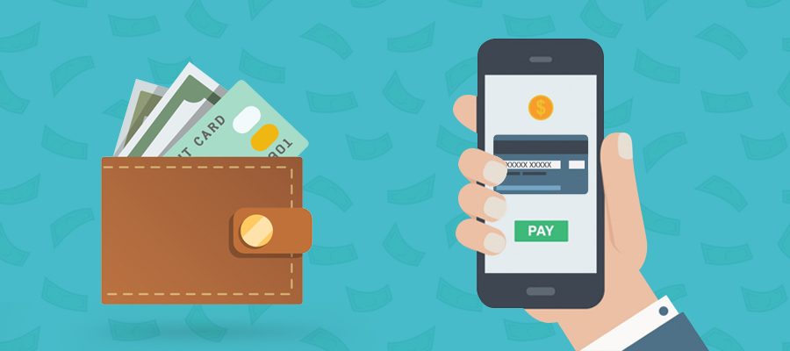](https://forum.mt5.com/customavatars/259812392.jpg)

Just when you don't go around with your actual wallet sticking out of your back pocket, or holding your bank card PIN number on a piece of paper inside the bag, you need to be careful of your bitcoin wallet, too. A mobile bitcoin wallet is easy to use, since it can be mounted on either a tablet or a smartphone. Any of these products is more often than not in close proximity to ordinary customers and does not require users to take specific things with them everywhere they go. Similar to how a laptop wallet operates, getting access to an Internet connection — either by cell phone or WiFi is a huge plus when it comes to sending and receiving transactions. However, this is not a must, since most bitcoin wallets allow users to send and receive funds via NFC or Bluetooth Low Energy connections. In exchange, this makes smartphone wallets more flexible relative to their device equivalents, which is also part of why Bitcoin has gained a lot of respect from its users.

Authentication is a vital security mechanism to deter money from being robbed or misused by someone who "borrows" your smartphone. Most mobile wallets allow a PIN code scheme, which requires users to enter a four-to six-digit code before entering the wallet itself. Failure to have the right PIN code within a specified number of attempts would automatically lock the wallet. The user of the Bitcoin wallet will be contacted either by SMS or e-mail with instructions on how to access the mobile wallet again. All in all, mobile bitcoin wallets can have the right options while juggling protection and comfort needs, but they all rely on the actual user in the end. If users are sloppy with their computer, or fail to back up their private key, there is no way to recover access to their mobile wallet. Bitcoin helps users to take full control and full responsibility at any stage, including tasks such as backing up their mobile wallet.  
  
**Secure Paper Bitcoin Wallets**  
  
A bitcoin wallet may better be represented as a sheet containing all the data required to produce private keys, essentially creating a "private key wallet." But it is not the only intention, since a wallet can also be used to store bitcoins safely and efficiently, in which case the paper itself often contains public keys and redeemable codes. The key aim of the redeemable code is to use it as a way of financing and "redeeming" the funds associated with a given bitcoin wallet address. However, it is important to remember that paper wallets can only be used once, since the wallet is not a bitcoin wallet meant for everyday use. Paper wallets can serve a variety of purposes.