**The Concept of Ripple Wallet: Things You Need to Know!**

[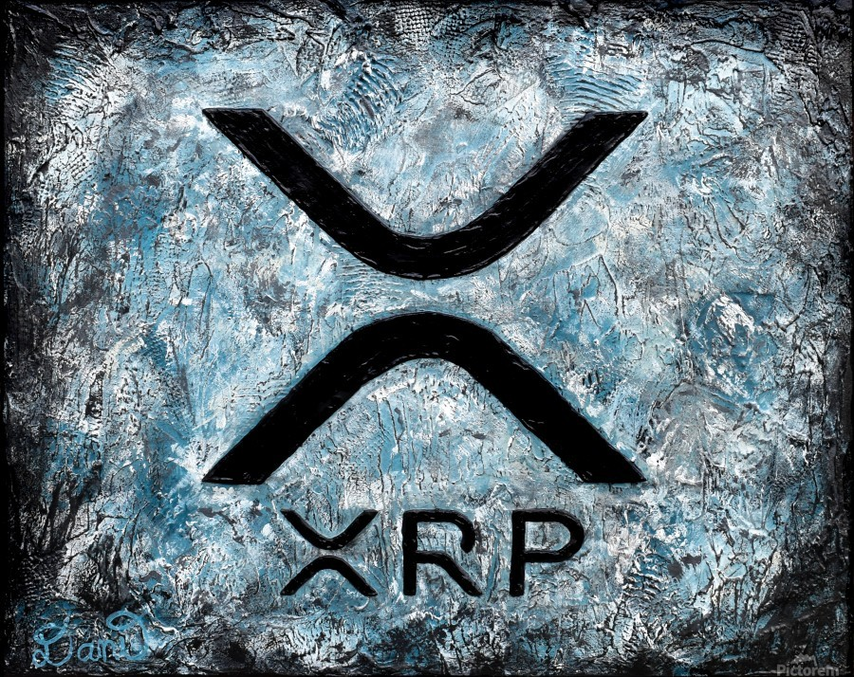](https://forum.mt5.com/customavatars/32434194.jpg)

XRP is a crypto asset that was created by OpenCoin, Inc. in January 2013 and then became Ripple Labs, a company we all know today. Under the original arrangement, Ripple Labs is responsible for creating Ripple applications, marketing the network, and distributing and selling XRP. XRP is designed to reduce congestion, expense and transaction time for current cross-border payment processes. The proponents of Ripple and XRP aim to add interoperability to the current financial system, making it more functional, secure, cost-effective and interconnected. Payments made with XRP settle in 4 seconds and transaction performance is calculated to be about 1,500 transactions per second with very low transaction fees, making XRP one of the fastest, cheapest and most scalable crypto properties. For contrast, Bitcoin settles the contract in about 10 minutes, has a capacity of 7 transactions per second and is comparatively more costly to use.  
  
The presence of XRP and Ripple eliminates the need for foreign banks and payment processors to keep nostro and vostro accounts in exotic markets. In mature markets, such as currency flows between the dollar and the yen, currency fluctuations are efficient, liquid and simple. However, currency movements between financial institutions in developed economies, such as Mexico and the Philippines, have poor reliability, reduced liquidity and are more costly. Ripple Labs reports that financial firms seeking to deliver transfers to hard-to - reach areas in the global payment system will save up to 70% by using Ripple 's tools in combination with XRP instead of nostro or vostro accounts.  
  
**Keep in charge of your own XRP wallet**  
  
Ripple (XRP) is a completely digitized currency, much like Bitcoin and other cryptocurrencies. The cool thing about cryptocurrencies like XRP is that you can handle it differently from third parties. There is no need for a bank to digitally handle your savings. Through your pocket, you're in full charge of your own money. This is one of the fundamental principles behind the Blockchain Movement. It's very important to get your own Ripple wallet. The wallet allows you full ownership of your private XRP funds. What's amusing about cryptocurrencies is that you're playing a bank. Think about it: legally, the money on your checking account is not yours. The number indicated is simply a receivable sum. As soon as the bank sinks, the loans will become worthless. It's a chance you don't face while you're juggling your own pockets. The content of your pocket really belongs to you.  
  
There are a number of Ripple wallets available on the internet. At first, it can seem difficult to determine what kind of wallet is appropriate for a start-up crypto trader. To help you out a little, here we list the various types of wallets and briefly explain the pros and cons of each. You can still go for a different wallet, but it is always important to do some research on this subject before you start buying cryptocurrencies. Make sure you pick the right cryptocurrency for your wallet. There are usually four types of wallets used for XRP storage: smartphone wallets, software wallets, hardware wallets, and online wallets. Each of these features has its own set of features which has some benefits and drawbacks. It depends on your tastes, which wallet is ideally suited to you. As far as Ripple wallets are concerned, it is much more important to make the right decision in advance, as Ripple needs you to deposit 20 XRPs before you can unlock a wallet. It is a step placed in order to discourage the needless production of new wallets. Think about it as a buffer for email.  
  
**1. Mobile Wallet**

[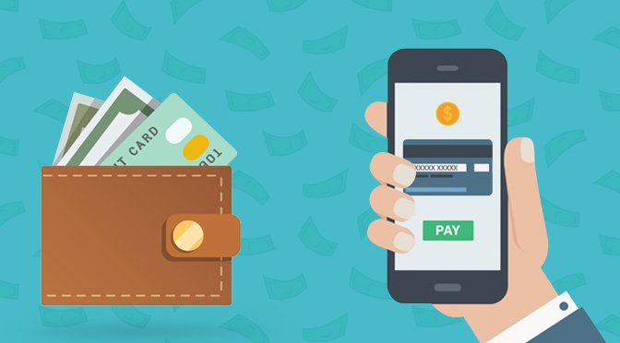](https://forum.mt5.com/customavatars/1282206894.jpg)

Do you really want to keep your cryptocurrencies close at hand? Then downloading a mobile wallet could be a good choice for you. Applications for mobile wallets are typically free of charge. They're easy to install and use, too. Have you just decided to invest in crypto? A mobile wallet is definitely going to suffice. But if you start making more serious investments, mobile wallets become vulnerable. After all, nobody would feel relaxed walking down the street with their whole resources.  
  
**2. Hardware Wallet**

See also: InstaForex offers cryptocurrency trading. [Join now](https://www.instaforex.com/cryptocurrency?x=MBZKY&uifd=657)!

The hardware wallet is the best option. It is a physical interface developed exclusively for the task of handling cryptocurrencies. A new redesign is going to set you back a little over a hundred euros. Are you planning to make major savings, or are you just a more seasoned trader? In that scenario, a hardware wallet could be the best choice for you.  
  
**3. Software Wallet**  
  
Were you going to spend a little more? A software wallet installed on your machine could suit you well! Managing your crypto inventory from a laptop or desktop computer is much better than putting it in a mobile wallet so you don't take your computer with you anywhere. In comparison, it is easier to protect your device with a decent virus scanner than to protect your cell. Do you need more security? Then you might consider buying a hardware wallet.  
  
**4. Web Wallet**  
  
The final choice we're looking at here is a mobile wallet. This is the least secure choice. We therefore prevent you from building a wallet for the network. Web wallets pass over their liability to third parties, which ensures that you do not have full power over the protection of your wallet. There are a few decent online wallets available, of course, but we encourage you to go for a smartphone, app or hardware wallet instead.  
  
**Where to Buy Ripple?**

[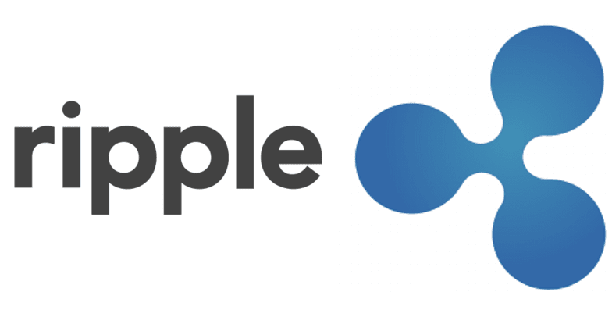](https://forum.mt5.com/customavatars/1697505482.png)

There are a number of cryptocurrency exchanges that let you buy the XRP. However, to the best of my knowledge, there are no options to buy XRP directly from a fiat currency. The best way to get an XRP is to buy a Bitcoin or Ethereum first. It's quick to buy Bitcoin. There are a number of different platforms that can trade it for local currency. The most famous is the Coinbase website. Other approaches include the acquisition of peer-to - peer platforms such as LocalBitcoins, or by websites such as Bitstamp. After acquiring Bitcoin, you can send it to one of the different exchanges of altcoin, where you can trade it for XRP. Examples of these are Binance, Bittrex, and Poloniex.  
  
**Where to hold Ripple (XRP)**  
  
You can keep it on the same exchange on which you bought Ripple coins, but this is not the popular way. Cryptocurrency exchanges seem to be dangerous in terms of cryptocurrency storage, and there have been several times where exchanges get compromised and their cryptocurrency assets robbed. For this reason, it is usually recommended that XRP be stored in the preferred Ripple wallet. In reality, there are lots of different types of cryptocurrency wallets to choose from: you may store Ripple in your hardware wallet, desktop wallet, app wallet or mobile wallet. -- of these forms has its own pros and cons, so it can often be overwhelming.

See also: Explore the infinite possibilities of online trading with a reliable broker. [Join now](https://www.instaforex.com/real_account_whiterabbit?x=MBZKY&uifd=657)!

**Ripple Mining**

[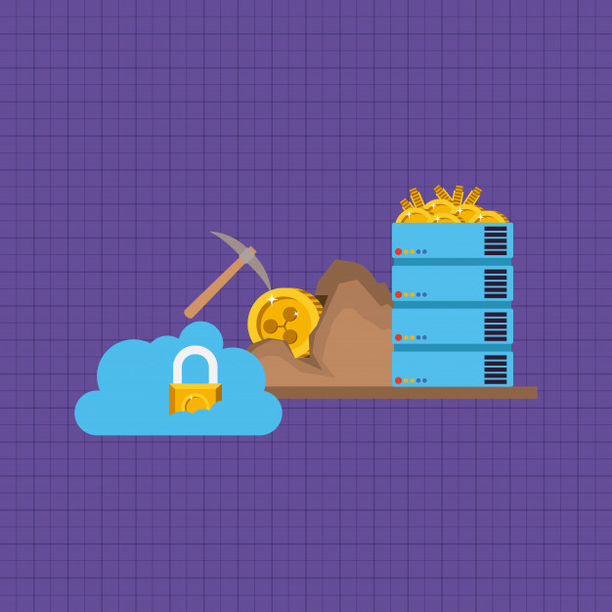](https://forum.mt5.com/customavatars/1180569164.jpg)

Unlike Bitcoin, all of the XRP coins have already been produced. Without the production of new coins, we can't tell you how to mine the Ripple. A lot of people believe that XRP can be mined. They're mistaken here. So, if your Ripple mining or XRP mining is more fitting, it's unlikely. If you're a miner, you might be more interested in figuring out how to mine Ripple instead of where to buy Ripple. The Ripple team is responsible for keeping billions of XRPs. Any of these will finally be published onto the free market, but 20% of the overall stock is retained by the protocol's developers. Apart from the numerous centralisation questions, this is one of the main challenges with the Ripple programme. Like bitcoin and other blockchain projects that focus on "miners" to verify network transfers, the Ripple protocol uses validator nodes. These validator nodes prohibit XRP from spending twice. Unlike Bitcoin mines, Ripple validator nodes are not paid for validating transactions. They do, however, gain voting rights on the network. These validator nodes are picked by the organization behind Ripple. As a result, Ripple is considered to be more organized than other blockchain ventures.