**Transfer Bitcoin in Effectively Trading**

[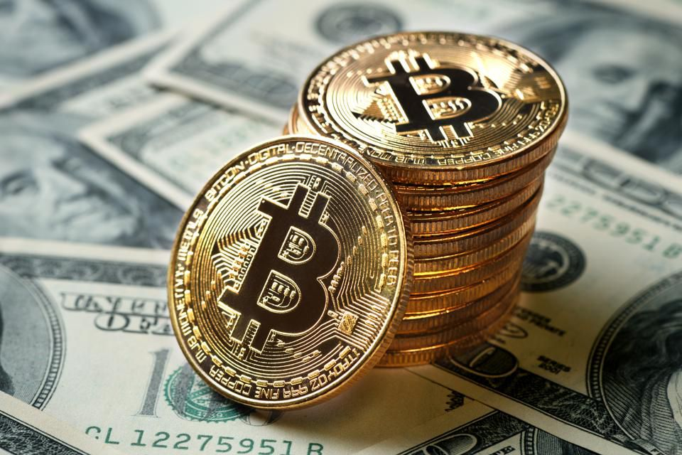](https://forum.mt5.com/customavatars/439800241.jpg)

Bitcoin transfers are more complicated than you would imagine behind the scenes. You hardly submit a bitcoin in one go. Instead, the Bitcoin wallet and the Bitcoin network need to go through a series of measures to guarantee the receiver receives the correct sum of electronic currency. It's important to understand what a bitcoin is, to begin with. It's not a single account of a coin, as you could see on the billboard or on your bank statement. Instead, it is essentially a file (referred to as money hereafter) with a value that registers as a purchase anytime you make a deposit or receipt. There are three components involved in a bitcoin transaction: a transaction input, a transaction destination, and a quantity. The transaction input is the Bitcoin address from which the money has been paid, and the result of the exchange is the Bitcoin address from which the money was issued. If the bitcoin is in your wallet, that would be the address of the bitcoin under your power.  
  
**How Bitcoin Transaction Works**  
  
The bitcoins you give to someone else have been sent by someone else to you. When they sent it to you, the address from which they sent it was recorded on the bitcoin blockchain (encrypted and unaccessible register) as the transaction entry, and your address — the address they sent it to — was recorded on the bitcoin network as the transaction exit. When you send the bitcoin to someone else, your wallet produces a transaction output, which is the address of the person you give the coin to. This transaction would then be recorded on the bitcoin network using your bitcoin address as the transaction input. If the person moves the bitcoins to someone else, their address will, in effect, become an input transaction, and the other person's bitcoin address will be the output of the exchange.  
  
**Sending Small Amounts of Bitcoin**

[](https://forum.mt5.com/customavatars/2099950536.jpg)

What if you like to submit a tiny bitcoin? Luckily, you can simply cut bitcoins very finely. The smallest divisible element of a bitcoin is called a satoshi, because it's just one 100 millionth of a bitcoin. You can't send a single satoshi across the network, though — that's too thin, and it's going to close the network with tiny transactions. The smallest transaction size is 546 satoshis, which is also very small. To confuse matters more, many bitcoin transfers require exchange fees, which means that you have to add a certain amount of bitcoin to the money you're attempting to submit. If you don't, then the bitcoin exchange is likely to crash. So, when you open your bitcoin wallet after a couple of transfers and start seeing several addresses containing loads of tiny numbers, you now know what's going on. It's not especially easy to read and makes accounting a little annoying, but it makes it easier to track bitcoin transactions through the whole network which is important , considering bitcoin's slogan of openness and immutability.  
  
**How to Send and Receive Bitcoin**  
  
If you submit and receive bitcoins, you're going to need a bitcoin wallet. The exact method can vary from wallet to wallet, but it should be exactly the same overall. It seems almost as simple as using Venmo or some other money transfer software. You can use your Bitcoin wallet to pick the type of currency you wish to transfer (in this case, Bitcoin), enter the address of the receiver, enter the sum you want to submit, pay any transaction fees, and then press transfer. Now in order to send bitcoin first you need to open your Bitcoin.com wallet app and select Send. Copy and paste the address of the recipient wallet into your own wallet program. Or, if you're in person, pick the Scan QR code and scan it with your smartphone. Choose the wallet from which you want to transfer Bitcoin. Make sure you pick a BCH wallet if you want to send a Bitcoin Cash or a BTC wallet if you want to send a Bitcoin wallet. Enter how many you want to submit, and then pick Next. Carefully verify if you're pleased with the specifics and then slide to send. Or, if you want to switch money between your own wallets, choose Transfer between wallets in the Send section of your account.  
  
Next is on how to Receive Bitcoin first you need to open your Bitcoin.com wallet app and select Receive. Choose the wallet you want to get from Bitcoin. If you get a wallet, make sure you choose a BCH wallet. Bitcoin Cash or a BTC wallet if you have a Bitcoin wallet. Your preferred wallet will create an address that will allow you to receive coins. Copy this by pressing the QR code if you're on a handheld computer, or by clicking it if you're on a laptop. Provide this address to an exchange in cryptocurrencies or to a person who gives you Bitcoin. Or, if you're in person, you can easily search your QR code wallet with your mobile.

**Sending Bitcoins from One Wallet To Another**  
  
Sending cryptocurrencies between wallets may be either a walk in the park or a tiring job based on the system used by the sender. For eg, a transaction can be done in a jiffy by merely scanning a QR code. However, some factors decide how seamless the execution of a transaction will be; these include the sort of wallet used and the amount of knowledge the consumer requires. In order to prevent problems during the conversion of Bitcoins, the following instructions should be helpful.  
  
**Sending Bitcoin Via Email or SMS**  
  
Sending bitcoin via the Short Message Service allows one to send bitcoin even without using the Internet, but sending by email requires an internet connection. You will need a cell phone number or email to use this form. The next thing you need to do is register your phone number with a program that facilitates transferring bitcoin via text messaging and emails. Examples of those sites like blockchain.com and Coinapult. These are the steps in sending bitcoin via SMS first you need to sign in to the suitable platform. Create a profile and add your phone number or email address to your profile tab. Click “Send Via” to select your desired means of transferring BTC: SMS or Email. Simply enter the phone number or email address of the receiver and the requested amount of BTC and press "Send Payment". You can also transfer Bitcoin by following this SMS command: "send" + phone number of the receiver + number of bitcoins.  
  
**Bitcoin Wallet**

[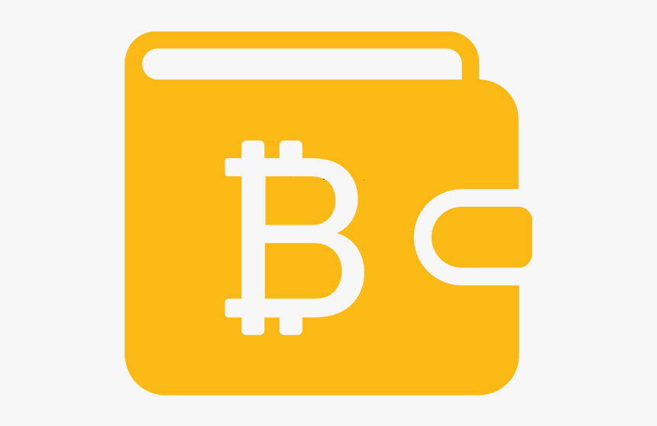](https://forum.mt5.com/customavatars/1685314598.png)

Bitcoin wallet is a software application that keeps bitcoins in. Technically, bitcoins are never kept anywhere. For someone who has a Bitcoin wallet balance, there is a private key that correlates to the Bitcoin wallet address. Bitcoin wallets make it easy to send and receive Bitcoins and grant the user control of the Bitcoin balance. The wallet of Bitcoin comes with a variety of ways. The four big categories are personal, computer, web, and hardware. Bitcoin wallets are also referred to as bitcoin wallets. To trade in Bitcoins, a dealer must set up a digital wallet. Bitcoin wallets are comparable to electronic wallets. However, instead of holding physical currency, the wallet holds relevant information such as the protected private key used to enter Bitcoin addresses and execute transactions. Bitcoin wallet types are laptop, tablet, network, and hardware.