**The Essence of Smart Contracts: Things You Need To Know!**

[](https://forum.mt5.com/customavatars/415272831.jpg)

The principle of smart contract predates the invention of Bitcoin in 2010. However, it was the introduction of Ethereum in 2014, with the possibility of programming blockchain logic that brought the concept to life. Today, this programmable logic commonly referred to as “smart contracts” allows blockchain technologies across a multitude of implementations across various business sectors. In this post, we will clarify what a smart contract is, how smart contracts have come about, and when and how they can be used. Smart contracts are generally ideally suited for the automated execution of two forms of “transactions” present in many contracts: guaranteeing reimbursement of funds for certain triggering events and enforcing financial penalties if certain contractual requirements are not fulfilled. In any case, human interference whether by the holder of the trust, or also through the legal system, is not needed until the smart contracts has been enforced and is operational, thus reducing the implementation and compliance costs of the contracting process.  
  
**What is a Smart Contract?**

[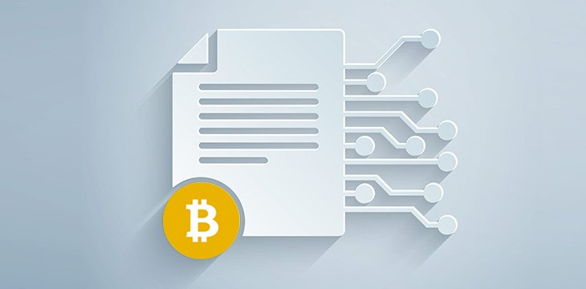](https://forum.mt5.com/customavatars/2108798931.jpg)

A smart contract is a piece of code built on a blockchain that specifies the terms of a given transaction. Upon receipt of a signal or feedback, the Smart Contract may execute and fulfill its assigned tasks. Any common assets are owned by all smart contracts. Since they operate on a blockchain, they have a state like RAM on a computer, and this state is spread throughout the whole network. So, any node operating this blockchain has a snapshot of the state of the smart contracts. They can’t be changed. Although there are ways to extend or replace parts if such action has been envisaged by the developers there is no way to covertly manipulate their content without drawing the attention of the network. The meaning of a smart contract cannot be skewed, so there is no space for confusion. That’s why they’re referred to as a “contract.” They function as an arrangement between the parties, but one that does not require a judge, since the outcome is decided by the data.  
  
Smart contracts gave us the ability to build some sort of token without the need to introduce a brand new blockchain. With the advent of Ethereum, the token is only a piece of code, a smart contract with some features, including the ability to “move” digital assets and the ability to “read” the contents of the token holders’ accounts. Escrow deals or futures can be formed on the grounds of the existence of such conditions in order to be issued. For example, a smart contract may be designed to release funds for someone’s birthday every year. Pay can also be set for payment until someone declares delivery of the product shipped. It may be used to implement preferential protections for digital asset holders. Any of these proposals will be discussed in the later portion of this article of this article on smart contract implementations.  
  
**Benefits of Smart Contracts**  
  
Smart contracts provide a range of advantages when properly implemented. They will encourage people from across the globe to communicate with each other without the need for an intermediary, reducing the costs of middlemen and brokers because there is no third party involved there is no chance of manipulation. Smart contracts will simplify management and save time. They offer complete autonomy, and because everything is backed up to the blockchain, smart contracts are completely secure against data loss. A big obstacle for smart contracts is that they are permanent. If the code has glitches, it may be that unauthorized transfers are going on and there is actually no way to reverse them.  
  
**Evolution of Smart Contracts**  
  
Nich Szabo set forth the concept of smart contracts in a 1997 article. Szabo acknowledged that smart contracts could be built on a distributed ledger, which would be managed by computers running the network. Bitcoin, as the very first blockchain implementation, provided simple features to perform certain logic, although it was not capable of running complex algorithms. Therefore, at the time, one did not refer to it as a “good deal.” What Bitcoin is basically doing is accounting. When anyone makes a bitcoin transfer, their wallet address will be changed with the current balance and the money will be credited to the payee. It was only in 2014, though, that smart contracts really began to take shape. When Ethereum was introduced, anybody with a decent knowledge of coding might learn the Solidity programming language and start writing smart contracts for the Ethereum Virtual Machine, which is the core component that interprets them. Today, five years later, after the concept was embraced by many other blockchain ventures and also Bitcoin released its own variant of smart contract interpreters, developers already have a range of blockchain platforms on which to write smart contracts, create distributed applications (dApps) and issue digital tokens.

**Smart Contracts Practical Applications**

[](https://forum.mt5.com/customavatars/599242230.png)

**Insurance**  
  
Smart contracts provide tremendous opportunities for improving and streamlining the compensation process in the insurance market. A basic definition might be life insurance. The policy words will be embedded in the Smart Contract. In the event of passing, the Notarized Death Certificate will be issued as an input mechanism for the Smart Contract to transfer the payout to the designated beneficiary. Which can be applied across various forms of policy, so that the insured can find an acceptable oracle for inputting external data in the case of lawsuit. For example, in the event of a travel interruption, the insurer may use the flight data given by the airlines to serve as a smart contract catalyst.  
  
**Supply Chain and Logistics**  
  
The use of smart contracts revolutionizes the supply chain and logistics business. By itself, blockchain can provide a clear and permanent record of the transit of goods between multiple handlers. With smart contracts in effect, transfers can be made instantly upon receipt of supply, and the inventory amount changed automatically in real time. There are more advantages to be gained from the convergence of blockchain and smart contracts with other technologies. For example, quality assessments may be carried out by artificial intelligence robotics, and then decisions could be made on the basis of the result. The Internet of Things (IoT) allowed smart containers to submit data instructing the smart contract to hold back payments. This might happen, for example, if temperatures were not controlled during the shipment of perishable goods, or if containers were opened by an unauthorized person.  
  
**Rights for Digital Token Holders**  
  
Tokenization of real world assets can mean that individual token holders will have special privileges. These privileges can be configured on a smart contract. For example, if the shares of the company are tokenized, the shareholders have the right to vote. In a smart contract, a person’s right to vote is guaranteed when a given ballot is opened. The smart contract helps them to cast their votes and record it in a straightforward manner. It also requires online voting, relieves owners of the need to be physically present or appoints a power of attorney.

.