**Purchasing Bitcoins: Why Do Bitcoins Have Value?**

[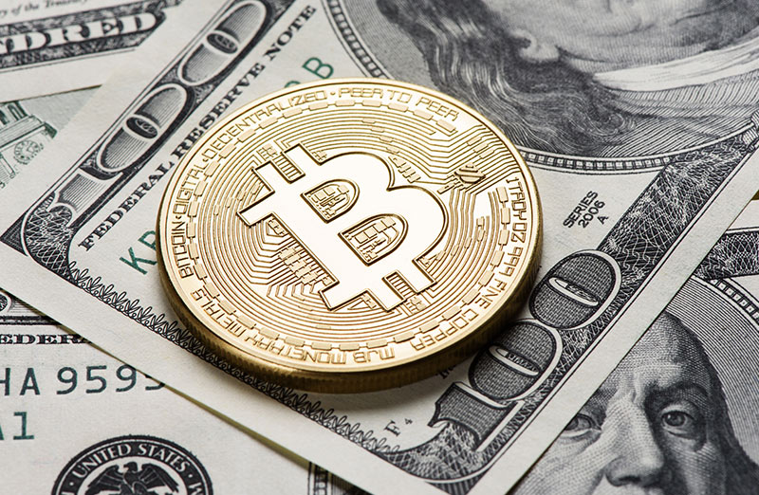](https://forum.mt5.com/customavatars/900841883.jpg)

Bitcoin is the most effective way of exchanging money over the Internet, regulated by a decentralized network with a straightforward set of laws, providing an alternative to bank-run fiat currency. There seems to be a lot of talk on how to price Bitcoin and we’re going to set out here to explore what the price of cryptocurrency could look like in the event of further widespread change. However, it is useful to back up a step first. Bitcoin and other digital currencies have been proclaimed as alternatives to fiat money. But what gives value to and kind of currency? Currency is usable whether it is a store of value or, to put it better, if it can be relied on to retain its relative value over time and without depreciating it. In certain cultures throughout history, goods or precious metals have been used as payment instruments, since they have been shown to have a relatively safe value. Rather than forcing individuals to cart around bulky amounts of cocoa beans, gold or other early types of money, however, cultures gradually switched to minted money as an alternative. Still, many examples of minted currency were usable because they were durable stores of money, made of metals with long shelf life and little chance of depreciation.  
  
In modern times, minted currencies mostly take the form of paper currency, which does not have the same inherent value as coins made from precious metals. Even more likely, though, people are using electronic currencies and payment systems. Some types of currencies depend on the assumption that they are “representatives'', which ensures that each coin or note may be traded directly for a given quantity of a product. However, as nations have abandoned the gold standard in an attempt to alleviate fears over the federal availability of gold, many world currencies are now known as fiat. Fiat money is issued by the government and not backed by any asset, but rather by the expectation that the people and governments of the parties will recognize the money. Currently, most of the world’s big currencies are money. Many governments and cultures have observed that the fiat money is the most stable, less likely to deteriorate or lose value over time. Apart from the question of whether it is a store of value, a good currency must also account for volatility, divisibility, usefulness, transportability, longevity and forgery. Let’s take a look at these attributes one at a time.  
  
**1. Scarcity**  
  
The key to preserving the value of a currency is its availability. Too big a supply of capital may raise the price of commodities, resulting in economic instability. Too limited an amount of capital will also cause economic difficulties. Monetarism is a macro-economic ideology that seeks to resolve the role of money supply in (or lack of) health and development in the economy. In the case of fiat currencies, most countries around the world prefer to print currency as a way to regulate inflation. Many governments work with a predetermined level of inflation that is used to lower the value of the fiat currency. In the U.S. for example, this figure has traditionally been about 2%. This is distinct from bitcoin, which has a variable problem rate that varies over time.  
  
**2. Utility**  
  
The currency must have the power to be successful. Individuals must be able to exchange currency units efficiently for products and services. This is the primary explanation why currencies formed in the first place so that market players could stop have to exchange commodities directly. Utility also demands that currencies be transferred quickly from one place to another. Burdens of precious metals and resources do not readily comply with this stipulation.  
  
**3. Divisibility**  
  
Efficient currencies may be separated into smaller cumulative units. In order for the single currency structure to act as a means of trade for all types of commodities and values within the economy, it must provide the stability associated with the divisibility. The currency must be properly divisible to correctly represent the worth of any goods or services provided in the economy.  
  
**4. Transportability and Durability**  
  
Currencies must be conveniently exchanged between economic actors in order to be useful. In fiat currency terminology, this means that currency units must be transferable by trade within the economy of a given counter as well as within nations. Also, to be successful, the currency must be at least relatively sustainable. Coins or notes made from items that can easily be mutilated, altered or lost, or eroded to the extent of becoming unusable over time, are not adequate.  
  
**5. Counterfeitability**  
  
Just as a currency must be long-lasting, it must also be difficult to counterfeit in order to remain successful. If not, the malicious parties could effectively damage the currency system by flooding it with bogus notes, adversely affecting the value of the currency. To determine the worth of Bitcoin as currency, we’re going to compare it to flat currencies in each of the aforementioned categories.