**Overview on best momentum indicator in mt4**

**What is the Best Momentum Indicator?**  
  
**The best momentum indicator for forex traders**  
  
Forex traders use a range of methods to assess market dynamics and make decisions. Traders use momentum measures to consider how quickly the price of a currency shift. Since they only consider the timeframe for the price shift and not the direction of movement, these metrics should be used in combination with other methods. Moving averages and trend lines are two other technical measures that are used in conjunction with momentum indicators to determine the direction of market change and price patterns.  
  
The best momentum indicators seem to be the most commonly been using trading indicators, including the Relative Strength Index (RSI), Moving average convergence divergence (MACD), Stochastics, and the Commodity Channel Index are all examples of technical indicators (CCI). Momentum measures calculate the pace at which a security's price moves. Using these metrics, traders can make better decisions, find the edge more easily, evaluate the effect, and get a better look at the map.  
  
**Here are some of the best momentum indicators:**

* Relative Strength Index (RSI)
* Moving Average Convergence Divergence (MACD)
* Stochastics
* Commodity Channel Index is the best momentum measures (CCI)

The bulk of indicators are oscillators. They do not forecast market prices; rather, they clarify better price charts, and technical indicators will assist traders in determining the best entry and exit points.  
  
**Advantages of momentum indicators**  
  
The momentum indicators would display the change of the forex rates over time, as well as the frequency of these movements as the rates rise or fall. These metrics are useful because they assist analysts and traders in determining when the market is about to reverse. There is a divergence between momentum and forex rate movement at the reversal stage.  
  
**Divergence**  
  
Divergence happens when the forex rate shifts in one direction and the momentum, which was previously moving in the same direction, no longer follows the forex rate downwards. This means that the momentum measure has deviated from the movement of the forex rate. and the new price trend is gaining traction. Divergence is observed when momentum is stalled, indicating that the current trend in exchange rates is likely to end soon and reverse rapidly. If both the momentum and the forex prices are diverging upward, the divergence is called bullish. If the momentum indicator and exchange rates were both heading upward when the indicator began to move downward, this is referred to as a bearish divergence.  
  
**Indicators of Popular Momentum**  
  
While there are many momentum indicators available, some of the most common are mentioned below so that a trader can choose the Best momentum indicator.  
  
**The Moving Average Convergence Divergence MACD**

A common momentum indicator is the Moving Average Convergence Divergence (abbreviated as MACD - see analysis). The MACD creates an oscillator by subtracting the longer moving average from the shorter moving average. These averages will overlap, converge, and shift away from each other, suggesting momentum. While the trader or analyst may use any time, they usually use the exponential moving average (EMA) for 26 and 12 days. The resulting MACD line is plotted against a 9-day exponential moving average (EMA), which is used to predict when the price change will reverse. If the histogram is positive but heading downward, it indicates a declining uptrend or a downtrend. Similarly, the histogram is negative but heading upward.  
  
**Relative Strength Index**  
  
Another common momentum measure is the Relative Strength Index (RSI). It is an oscillator that, like the MACD, calculates the rate at which the forex rate shifts. The RSI ranges from zero to one hundred. A rising RSI value over 50 indicates positive momentum, but a value above 70 can imply that traders have overinvested in the currency. Similarly, if the RSI value falls below 50, it indicates negative momentum or a downtrend. However, a drop in the RSI reading below 30 could mean that traders and investors have oversold the currency. When the RSI reaches the centerline, traders use it to track the divergence. The RSI indicator can be used to measure the currency pair's power.  
  
**Here's an example of RSI bearish divergence:**

[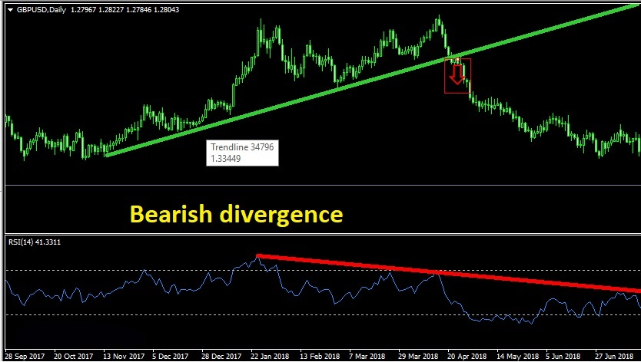](https://forum.mt5.com/attachment.php?attachmentid=347153&d=1616120274)

**Here's an example of RSI bullish divergence:**

[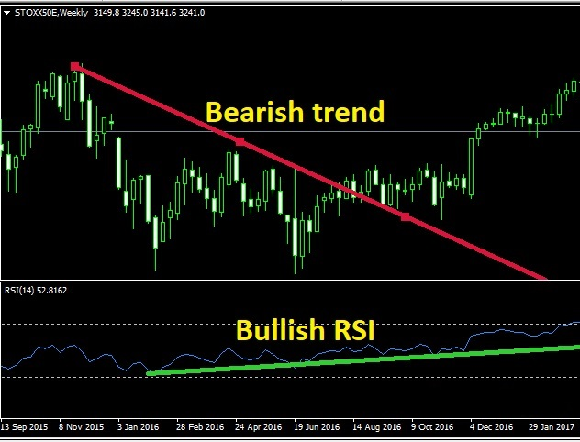](https://forum.mt5.com/attachment.php?attachmentid=347154&d=1616120293)

**The Average Directional Index**  
  
The Average Directional Index (ADX) was developed by Welles Wilder as part of his Directional Movement scheme. It is made up of a Minus (-DI) and (+DI) directional indicator, as well as ADX, which calculates the direction and momentum of price change. The -DI and +DI are calculated by contrasting consecutive lows and peaks. The smoothed average of the +DI and -DI is used to measure the ADX. If the ADX value reaches twenty, It denotes a business trend, and if ADX is less than 20, the market is regarded as directionless. The ADX only tests trend power, not trend direction.

**In conclusion**  
  
Forex traders and analysts make heavy use of momentum measures, which are critical in determining when to buy or sell forex. However, most traders use these metrics in conjunction with other instruments that show trend direction. After assessing the direction of the shift in the forex rate, these measures may help provide information on market movement patterns and whether these trends are shifting or reversing.  
  
The Momentum indicator is a versatile tool with numerous applications. Because of the indicator's versatility, you can easily create momentum trading systems that work in both the short and long term. As a general rule, the more sensitive the performance will be, the shorter the time-frame used. This comes with the caveat that it is more likely to generate false signals than a longer time-frame. Because of its broad applicability, the MT5 Momentum indicator could be the ideal tool for you, whether you're a day trader or a position player looking for the best indicator. So, how do you know which momentum indicator is best for day trading or long-term trading? One option is to open a demo trading account and experiment with it. For this reason, you could even determine which path to take is the best for you.