**What Is the Heikin-Ashi Indicator**

**What is the Heikin-Ashi Indicator?**  
  
The Heikin-Ashi method is a Japanese candlestick-based technical trading tool that represents and visualizes market value statistics using candlestick charts. It's used to spot market trends and forecast price movements. The Heikin-Ashi method employs average price data to help classify out the noise in the market  
  
The absence of market noise results in a clear depiction of market trends and direction, which aids in predicting potential price movements. The trading technique assists traders in determining when to hold a trade, pause a trade, or identify if a reversal is imminent.

[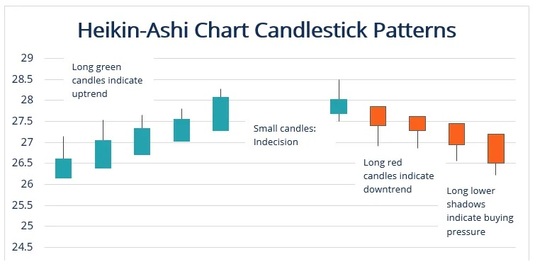](https://forum.mt5.com/attachment.php?attachmentid=397360&d=1627537289)

Munehisa Homma invented the Heikin-Ashi trading technique in the 1700s. The technique is similar to traditional candlestick charts used in trading, but it differs in how the candlestick values are computed. Heikin means average or balance, and Ashi tends to mean bar or foot.  
  
The primary distinction between such a traditional candlestick chart as well as a Heikin-Ashi chart is that both employ a customized formula based on the two-time frame moving averages rather than open, high, low and close prices. As a result, the technique produces a smoother chart, making it easier to identify trends and reversals. Gaps and some price data are also obscured by the Heikin-Ashi charts.  
  
Heiken Ashi is designed to make it easier to identify trends. A smoothing technique is one of the more commonly used tools for seeing past volatility. In either case, these price fluctuations obscure the true nature of the market. Averages are used to construct Heiken Ashi candlesticks.  
  
Averaging aids in smoothing out short-term price fluctuations. Let's compare a standard candlestick chart to a Heiken Ashi chart.  
  
A daily candlestick chart for USD/JPY:

[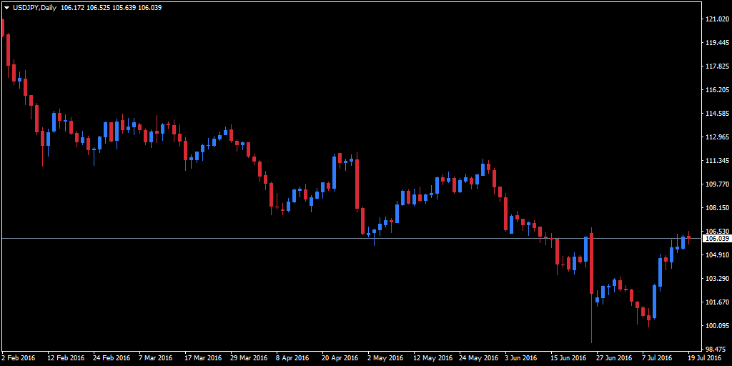](https://forum.mt5.com/attachment.php?attachmentid=397361&d=1627537332)

**Making the Heikin-Ashi Chart**  
  
The Heikin-Ashi chart candles are usually red, but during an uptrend, they are green during the downtrend. However, various color variants have been observed to be used. A change in the color of the HA candle indicates a potential change in the trend.  
  
The Heikin-Ashi chart below was generated using stock data for a publicly-traded entity from February 2020 to June 2020.

[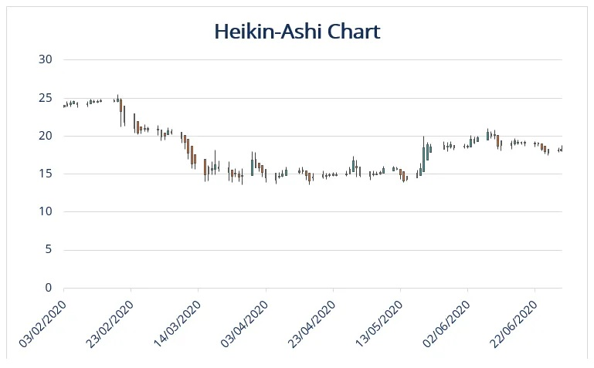](https://forum.mt5.com/attachment.php?attachmentid=397362&d=1627537369)

The Heikin-Ashi chart providing a clearer understanding of price changes. It will have smooth directional movements and much more consecutive bars of a certain color. The Heikin-Ashi chart differs from the traditional candlestick chart in a few ways.  
  
The traditional candlestick chart pattern is making it more difficult for traders to perceive and identify trends, making it more difficult for traders to perceive and identify trends. Alternates between red and green colors. The Heikin-Ashi chart making it possible to perceive and define leading up price swings and current trends by eliminating noise and displays consecutive colored candles.  
  
**Signals from the Heikin-Ashi Indicator**

Through indicator signals, the Heikin-Ashi technique reflects the market trend. The Heikin-Ashi indicator signals have two main components: trend strength and trend reversal.  
  
**Trend Strength**  
  
The first consideration in determining the strength of the trend. Due to the smoothing effect of the indicator, small consolidations and corrections may not be visible on the chart. It is best to be using a trailing stop to increase the benefits of trading within the trend when using the Heikin-Ashi technique to trade in the trend. If the trend is strong, it is recommended that a trader stays in it to profit from it.  
  
Different kinds of Heikin-Ashi trends:

* Bullish trend: Is indicated by presence of multiple of back to back green candlesticks with no reduced shadows.
* Bearish trend: A series of consecutive red candlesticks with no upper wicks indicates a strong downtrend.
* Triangles: Heikin-Ashi triangles are classified into three types: ascending, descending, and symmetrical. If the indicator breaks above the upper boundary of an asymmetrical or ascending triangle, the uptrend is very likely to continue. The bearish trend will continue and strengthen if candles fall below the bottom line of the descending triangle.

**Trend Reversals**  
  
A trend reversal signal can be used to determine when to exit a previous trend-following trade and enter a new trend. A trader can avoid losses by identifying a reversal signal and entering a new trade instead.

* A candlestick with a small body and long shadows is known as a Doji candlestick. It always indicates the presence of market insecurity. The Heikin-Ashi indicator indicates a trend reversal.
* Wedges are categorized into two categories: rising wedges and falling wedges. Wedges are also more similar to triangles. A rising wedge indicator requires a trader to wait until the candlestick breaks below the bottom line of the indicator. If a falling wedge is present, a trader should wait for the price to break above the upper line, which will reverse the downtrend.

**Heikin-Ashi Techniques**

1. **The emergence of a significant bullish or bearish trend**  
     
   The Heikin-Ashi technique is most commonly used to identify the start of a strong uptrend or downward trend. Heikin-Ashi signal indicators are generally regarded as being very dependable and thus are rarely incorrect.  
     
   As a result, traders can profitably ride the trend of the Heikin-Ashi trend signal's credibility. When a bullish trend emerges, traders with short positions should exit, while those with long positions should increase and consolidate their positions.
2. **Recognize Candlesticks Without Shadows**

Finding candlesticks without any shadows has become a very reliable indicator that even a strong bullish trend is about to start. Because of its track record of success and performance, this strategy is one of the top Heikin-Ashi strategies.  
  
The greater the number of consecutive candlesticks with no tails, the stronger the expected trend. Similarly, traders should expect a new stable downward bearish trend to continue if they identify candlesticks with no upper shadows.

1. **Small-bodied candlesticks indicate trend pauses or reversals.**  
     
   The appearance of candles with small bodies is a signal that traders should be aware of and pay attention to. These candles indicate when a trend is just about to stop or start reversing. As a result, when traders notice this, they move to open new positions in response to a trend that is ending.  
     
   However, traders should exercise caution because the trend may be stalling rather than reversing. In that case, the trader must use judgment to determine whether a reversal is imminent or merely a trend pause.

Here's a chart for the same period with Heiken Ashi candlesticks on top:

[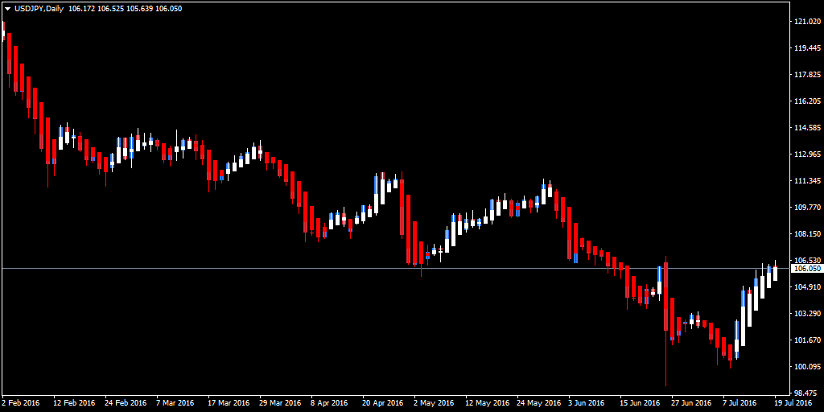](https://forum.mt5.com/attachment.php?attachmentid=397363&d=1627537410)

With Heiken Ashi, the indications of bullishness and bearishness are much more consistent. For example, there's an upward trend in USD/JPY all across May, which appears as a series of red bearish candles on the standard candlestick chart. On the other hand, Heiken Ashi shows far fewer bearish candles over the entire period (i.e. a clearer trend.)  
  
It's a similar story for the June downward trend. When compared to the Heiken Ashi, the normal candlestick chart shows more than twice as many bullish candles. Whenever the Heiken Ashi had only bearish candles this would be especially visible in the first half of June.  
  
The regular chart, on the other hand, had a couple of bullish candles in this stretch. A Heiken Ashi trader looks for two specific signals, which include a:

* A hollow (white in the above charts) candle with no lower shadow is a particularly bullish signal.
* A filled (red in the above charts) candle with no upper shadow, which is a particularly bearish signal

To verify a trend, a few traders use Heiken Ashi in conjunction with momentum indicators.  
  
As an entry signal, the Heiken Ashi moving average method may pause if candles cross over a 50-period moving average.  
  
**The Advantages of the Heikin-Ashi Technique**

1. Availability: Heikin-Ashi does not need installation and can also be discovered on any trading platform because of its one of the most widely available indicators.
2. High chart readability: It is simple to interpret because any trader can recognize the candlestick patterns. Heikin-Ashi candlestick charts are easier to understand, unlike traditional candlestick charts, making it much easier to recognize trends and movements in the market.
3. Reliability: Heikin-Ashi is indeed a highly dependable indicator that produces reliable results. It makes use of historical data, which is also quite reliable.
4. Market noise filtering: The indicator helps to filter out market noise and lessens minor changes, attempting to make the signals more clear. The smoothing effect aids in trend identification. Today's markets are filled with noise; thus, the Heikin-Ashi technique helps traders plan one's entry and exit more effectively by reducing noise.
5. Capability to combine with many other indicators: It could be merged to provide even larger market movement signals with several other technical indicators.
6. Timeframe tolerant: The method can be applied to any time frame, such as hourly, daily, monthly, and so on. Larger time frames, on the other hand, are more accurate.

**The Heikin-Ashi Technique's Limitations**

1. Time lag: Because the Heikin-Ashi indicator's base signals are based on historical prices, there is a time lag involved.
2. A lack of price gaps: Price gaps are commonly used by traders to analyze price momentum, trigger entries, or position stop-loss orders. Even if Heikin-Ashi doesn't have any price gaps, traders could even compensate for this restriction throughout a trading period by momentarily shifting to traditional candlesticks.
3. There is no full price information: Because Heikin-Ashi data is averaged, it does not show exact open and close prices. With more active securities, this may not work well for day traders or scalpers.