**What Is the BW Mfi Strategy**

**Market Facilitation Index (MFI)**  
  
Dr. Bill Williams' Market Facilitation Index (MFI) is a volatility indicator that focuses on determining the market's desire to move the market value. The absolute values of the indicators are useless to traders because they do not provide trading signals. Instead, its significance stems from its application as a tool for analyzing the efficiency of price movements by combining price and volume.  
  
The BW MFI can help you determine whenever a trend is solid enough to trade securely, whenever a new trend is constructing, and when to avoid hitting the market by computing price movement per volume unit. It enables you to determine whether the market is liquid and whether the various types of market participants are active. If the market activity falls, market participants who use the MFI will notice a decrease in volume and price movement efficiency.  
  
**How is it Calculated and Visualized?**  
  
**Calculation**  
  
The Market Facilitation Index is a simple calculation which some experts believe is an improved measurement action than that of the RSI and the Stochastic Oscillator.  
  
**The following formula is used to calculate it:**  
  
*(High – Low) / Volume = MFI*  
**Where:**  
  
*High = the current bar's highest price.  
Low = the current bar's lowest price.  
  
Volume = the current bar's volume*  
  
**Results**  
  
As shown in the screenshot below, the calculation results are visualized using a histogram made up of bars of four different colors.

[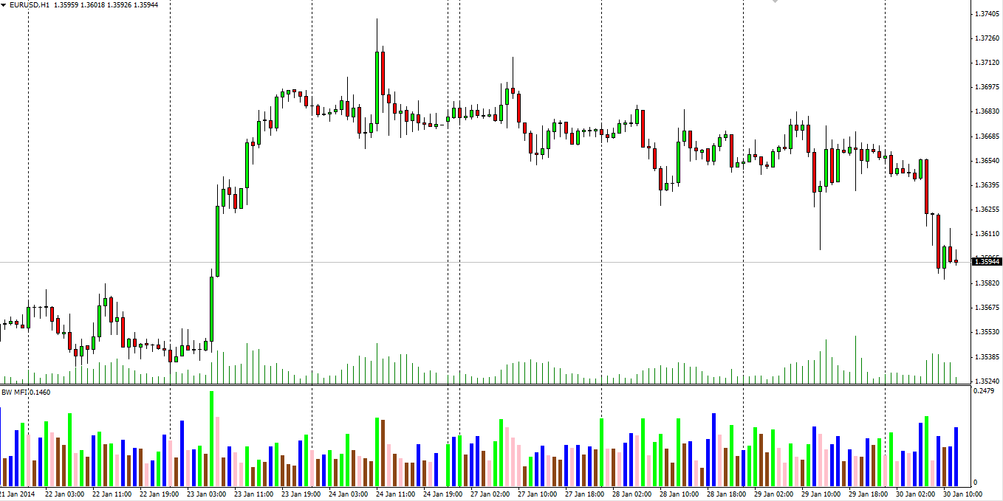](https://forum.mt5.com/attachment.php?attachmentid=399329&d=1628071108)

The absolute values of the indexes are represented by the bars, while the comparison between the index and volume changes is represented by four different colors, which are essential for reading the signals generated by the MFI.  
  
**What does MFI shows us and How to use it?**  
  
**The Green Market (green bar) indicates that price movements are increasing and volume is increasing.**  
  
The green bar in the histogram indicates that both the MFI and the volume are increasing. This indicates that the market is already moving, and traders should enter a position in the same direction as the market is trending. Contrary trades should be closed. A green phase happens whenever a growing volume of trading comes into the market and mentality supports the current market movements, causing it to move more in that way.

[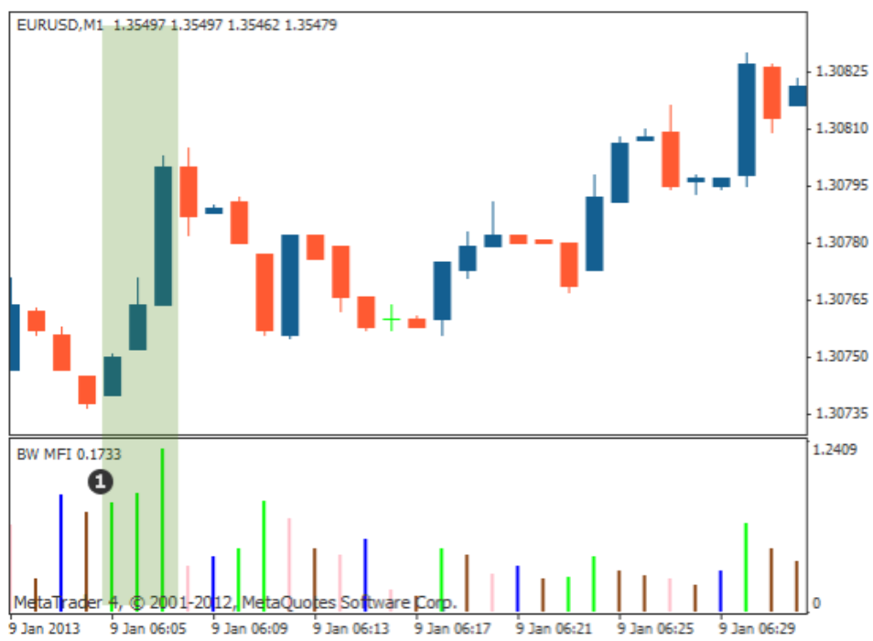](https://forum.mt5.com/attachment.php?attachmentid=399336&d=1628071608)

**The Fade The brown bar indicates a loss of momentum.**  
  
A brown bar represents this condition. It denotes the exit of a trend, since both MFI and volume drop because as the market starts to lose interest in the new price movement and looks for symbols of future growth. Investors are currently uninterested, but this bar is a precursor to a significant move. Williams advises market participants to keep an eye out for any signs of gaining momentum which in this case, can be detected early by the formation of several consecutive brown bars

[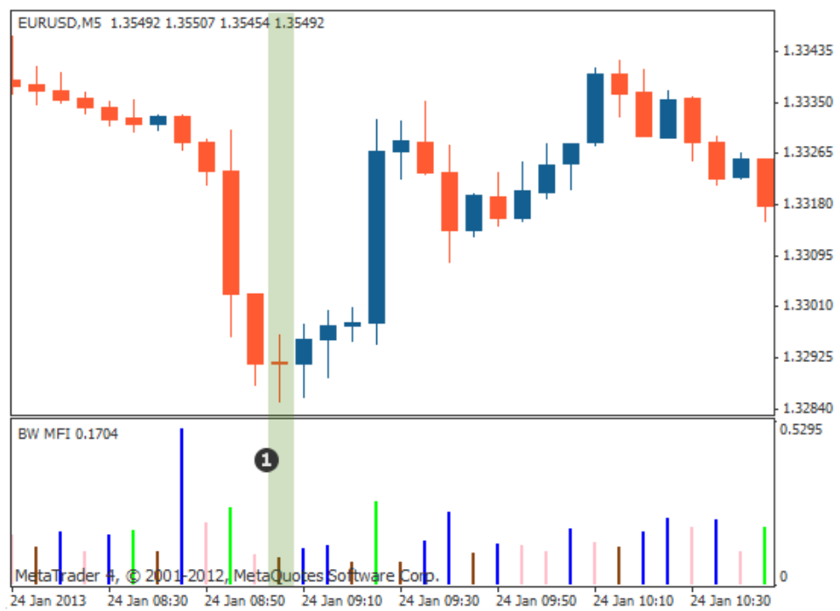](https://forum.mt5.com/attachment.php?attachmentid=399337&d=1628071629)

**The Fake (blue bar) price movements are increasing while volume is decreasing.**  
  
A blue bar represents this situation. It denotes a period in which the MFI is increasing while volume is decreasing. It implies that the market is moving forward, but it is not supported by volume. Traders are not supporting the current price movement by opening new positions due to a lack of interest.  
  
This indicates that the price is moving as a result of a specific group of market participants (brokers) attempting to control and manipulate the market to their advantage. A price reversal is common when such a condition exists.

[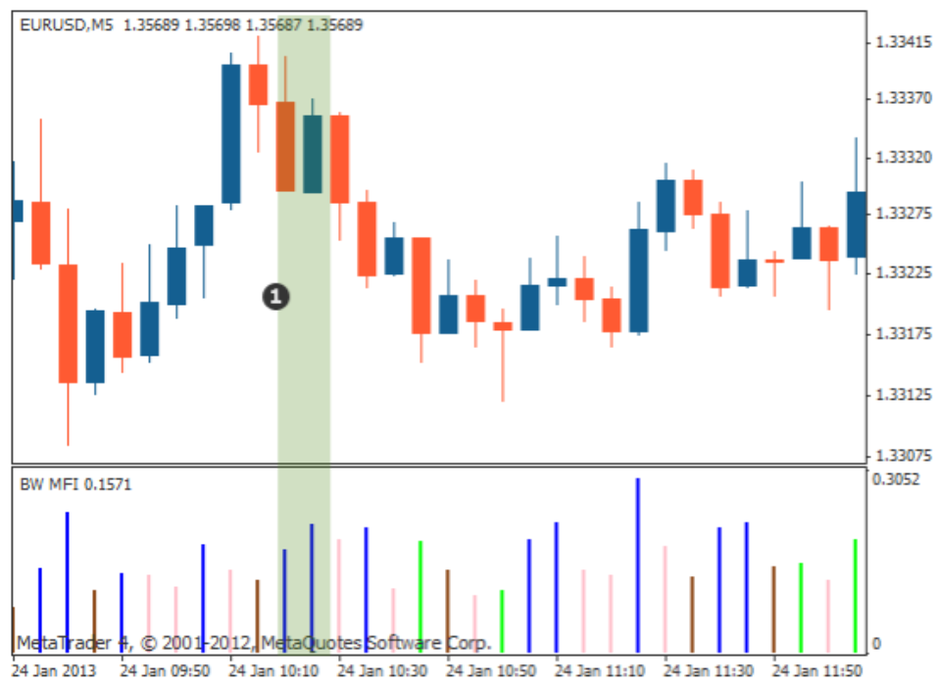](https://forum.mt5.com/attachment.php?attachmentid=399338&d=1628071652)

**The Squat (pink bar) indicates that price movements are decreasing while volume is increasing**  
  
A pink bar illuminates the situation. It represents a situation in which the MFI falls while volume rises. During this time, a battle between bulls and bears takes place to determine who will be in control during the next trend. Volume increases as more traders enter the market, but because the two counterparts are relatively evenly matched, the price does not change significantly.  
  
Eventually, one of the competing factions will triumph over the other. Because this situation usually occurs before a major move, You should keep a close eye on the price once it has broken out of this slowdown.

[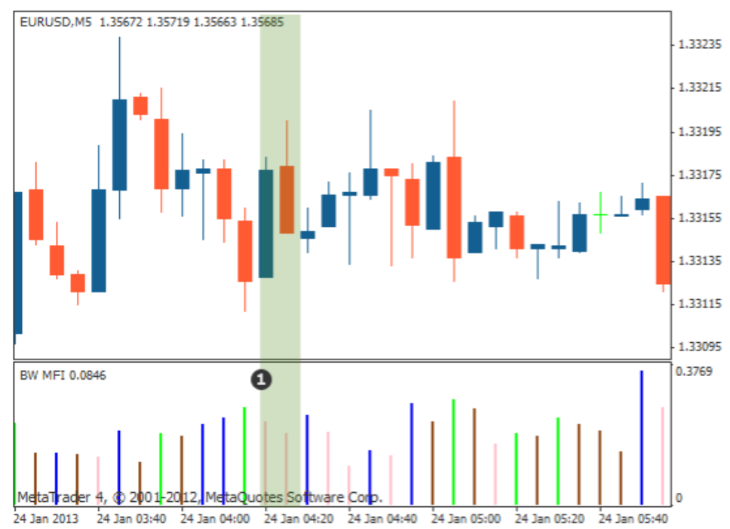](https://forum.mt5.com/attachment.php?attachmentid=399339&d=1628071679)

According to Bill Williams, it is the most profitable of the four components because a breakout can happen, whether continuing the current trend or starting a new one. As a result, someone who makes the right decision will benefit from a longer price movement and achieve better results.  
  
**Summary of Bill Williams MFI Strategy**

* In this article, the market facilitation index is defined as an indicator which helps to measure the strength and weaknesses of existing price movements in an investment. It assists you in determining when a trend is strong enough to warrant trading when a new trend is about to begin and when it is best to avoid trading It does this by examining the relationship between changes in the size of price moves and changes in trading volume and then provides trading signals via a system of color-coded bars.
* When a green bar appears, it indicates that price movements are increasing and trading volume is increasing, indicating that price movements are gaining strength as more traders enter the market. This suggests that it may be best to enter trades in the direction of current price movements. When a brown (fade) bar appears when price moves are shrinking and volume is low, it indicates that traders are losing interest in the current price move, which may be coming to an end.
* This suggests that it may be best to avoid entering trades in the direction of currency moves. When price moves are increasing and volume is decreasing, a blue (fake) bar appears. Powerful movements are the reason for low volume and it may not after that long. This suggests that it may be best to refrain from engaging in any new trades.
* When price moves are shrinking and volume is increasing, a battle between enthusiastic bulls and bears may result in a large price move once one side has won. The pink bar indicates that a large price move is on the way, but it will not determine the direction for you. The MFI indicator applies to all time frames and market conditions.