**What Is Gator Forex**

**What Is Gator Forex?**  
  
The Gator indicator, like the Alligator, aids in detecting price trend changes in an asset. The main distinction between the two is that the Alligator employs moving average lines, whereas the Gator employs a histogram.  
  
Because Gator oscillators rely on moving average readings, they will logically be most effective in trending market conditions. Positions are typically opened as the Gator awakens and maintained through the trend exhaustion phase until both sides of the indicator turn red. A more conservative approach is to lock in profits and exit positions when one of the sides turns red in the third phase (gator is sated). This, of course, reduces the level of return, but it also reduces risk.  
  
**The Gator indicator is based on the idea that trends, like living (alligators), go through four distinct stages:**

* **Sleeping phase**  
    
  The sleeping phase occurs when both bars on each side of the oscillator's zero lines are red. This indicates that the alligator is sleeping, or that there is no trend. That's the same as using the Alligator Indicator, as well as the moving averages are all going to cross and getting tighter, indicating a lack of proper path loss.
* **Awakening phase**  
    
  The awakening phase occurs when different colors appear on each side of the oscillator. The awakening phase corresponds to when the moving averages within Alligator Indicator begin to expand slightly. The Gator Oscillator eliminates the need for moving averages by simply plotting what the moving averages would do in this window. The awakening of the alligator indicates the beginning of a trend.
* **Eating phase**  
    
  The eating phase is when the oscillator has green bars on both sides. This indicates that the alligator is trending, which means that it is eating. In this case, you should do everything possible to keep your position open to attract as many prophets as possible. In other words, the Alligator Indicator's moving averages would be spread wide open and on a nice trending slope.
* **Sated phase**

The sated phase indicates that the market is beginning to slow down as the alligator fills up and becomes sated. In other words, the trend may be slowing or even coming to an end. This is the point at which you transition from a couple of green bars above and below the zero lines to a color mix once more. At this point, the indicators suggest that it is possible to make a profit.

**Green bars indicate that a trend is strengthening, while red bars indicate that it is weakening.**  
  
The Gator oscillator appears as a histogram of green and red bars in a separate box beneath the asset's price chart. Each period is represented by two bars that are stacked on top of each other. They are sometimes both green, sometimes both red, and sometimes both colors.  
  
A green bar implies that a trend is greater than previous price movements, while a red bar indicates that it is relatively weak.  
  
**The following image depicts how the Gator oscillator appears on a chart:**

[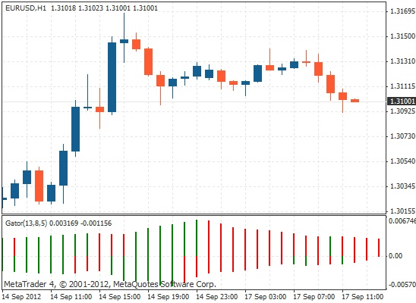](https://forum.mt5.com/attachment.php?attachmentid=398921&d=1627977369)

A green bar indicates that the trend is becoming stronger than the previous price action, whereas a red bar indicates that it is weakening.  
  
**The four phase of the gator forex**  
  
**Sleeping Phase**  
  
Both bars are red during the Gator sleeps phase.

[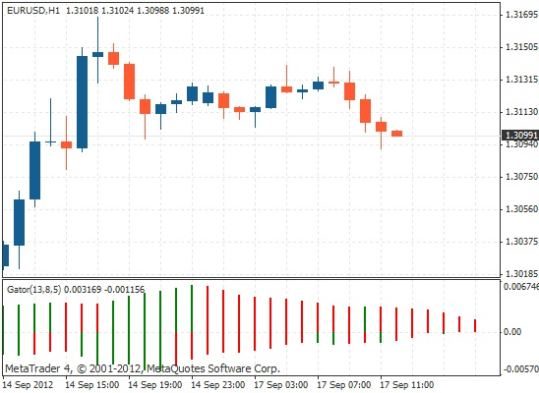](https://forum.mt5.com/attachment.php?attachmentid=398922&d=1627977415)

**Awakening Phase**

The Gator awakens phase occurs after the Gator sleeps phase and can be identified by one of the red bars turning green. It makes no difference whether the red or green bar is above or below the zero lines, as long as one of each is present.

[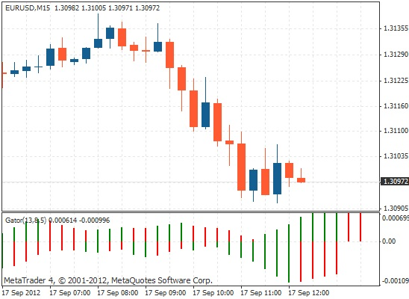](https://forum.mt5.com/attachment.php?attachmentid=398926&d=1627977582)

**Eating Phase**  
  
Both bars turn green again during the Gator eats phase.

[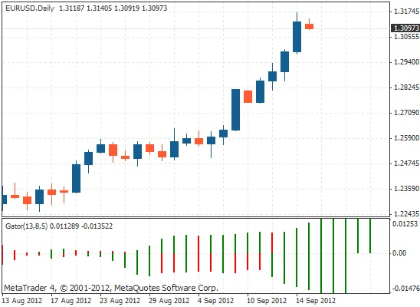](https://forum.mt5.com/attachment.php?attachmentid=398928&d=1627977625)

**Sated Phase**  
  
The Gator's sated phase occurs after the Gator eats phase and is indicated by one of the green bars turning red. Again, whether the green or red bar is above or below zero is irrelevant as long as there is one of each.

[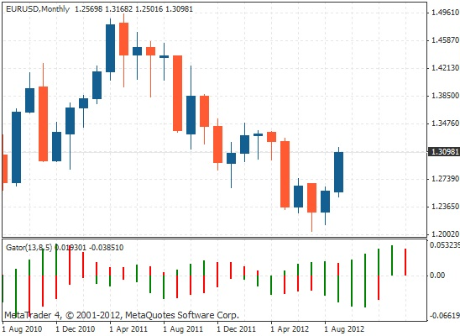](https://forum.mt5.com/attachment.php?attachmentid=398929&d=1627977673)

**As Gator awakens, enter trades.**  
  
While using the Gator oscillator, users can generally look to gain entry into a spot mostly during the awakening phase, retain this through the eating phase, and instead exit their game and take profit as the trend draws nearer during the sated phase. Because the Gator oscillator is focused on a moving average system, perhaps there is a time delay among price movements and the indicator entering its different phases.  
  
Also, keep in mind that the Gator oscillator only indicates how strong or weak a trend is. It does not indicate which way prices are likely to move. As a result, it should be combined with other indicators or a set of rules to determine the trend's direction.  
  
Best used on medium to long time scales. Because it is designed to identify each phase of the market's cycles, the Gator oscillator works well in all market conditions. However, it is best used over medium to long periods.

**Conclusion**

* Because the Alligator's three moving averages can clog your screen, the Gator oscillator can be used as a standalone indicator, but the two together provide a more complete picture of market conditions.
* The Gator oscillator is a price trend indicator that can help detect price changes in an asset. It is based on the idea that trends go through four stages: awakening (formation), eating (strengthening), sated (running out of momentum), and sleeping (exhausted). On charts, it did appear as a histogram of red and green bars, with each time frame characterized by two bars that can be all red, both green, or maybe one of each color.
* The Gator's sated phase occurs after the Gator eats phase and is indicated by one of the green bars turning red. Traders tend to look to enter a position during the awakening phase, keep it through the eating phase, and exit it during the sated phase; however, there could be a time delay between price changes and the indicator transitioning through its different phases.
* The Gator oscillator only informs users how weak or strong a trend is not whether the position price increases have been moving; it appears to work well for all market conditions because it is developed to recognize almost every phase of the market's cycles, and it is better used for the moderate to longer period frames and lower time frames may produce false signals.