**Overview on Lot Size in Forex Trading**

**Overview on Lot Size in Forex Trading**  
  
You'll learn about trading lots when you first start your forex training. A lot is a batch of currency that the trader controls in the context of forex trading. The lot size is adjustable. Standard lots, mini lots, and micro lots are common lot size designations. It is critical to understand that the lot size has a direct impact on and indicates the amount of risk you are taking.  
  
**The Lot Size is Important**  
  
Picking the ideal lot size with a method such as a risk management calculator and something related to an expected outcome can assist you in determining the best lot size based on your current trading account assets, whether you're making a practice trade or trading live, as well as assist you in determining the amount of risk you are willing to take.  
  
The size of your trading lot has a direct impact on how much a market move affects your accounts. A 100-pip move on a small trade, for example, will never be looked at equally as often as the same 100-pip move on such a large trade size.  
  
Various lot sizes would be encountered during your trading career, but they can be stated using a useful comparison appropriated with one of the most admired trading books.  
  
**PIP Value per Lot Size Formula**

[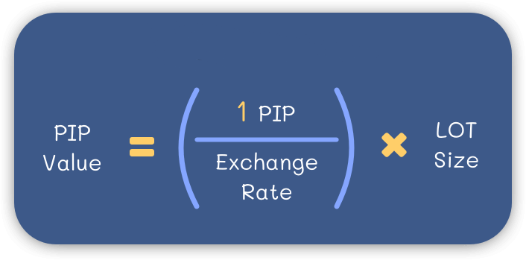](https://forum.mt5.com/attachment.php?attachmentid=398522&d=1627880916)

* The first step in the formula is to perform a simple currency conversion by dividing the PIP value (0.0001 or 0.01) by the current rate in trading. Traders will then know how much that PIP is worth in terms of the currency being traded.
* The second step is to expand that outcome by the LOT size to trade (100.000, 10.000, 1.000, 100) to know the implications of the previous result in the entire value of currency units traded.

**Trading in Nano Lot**

The nano lot is the smallest trading lot size available. This trading lot is made up of 100 currency units worth a total of $100. The nano lot is becoming increasingly rare, but it is still available through many top forex trading brokers. This is an excellent starting lot size for those who want to try their hand at forex trading for the first time. It provides real money trading in addition to a demo trading account, but with a much lower level of risk.

[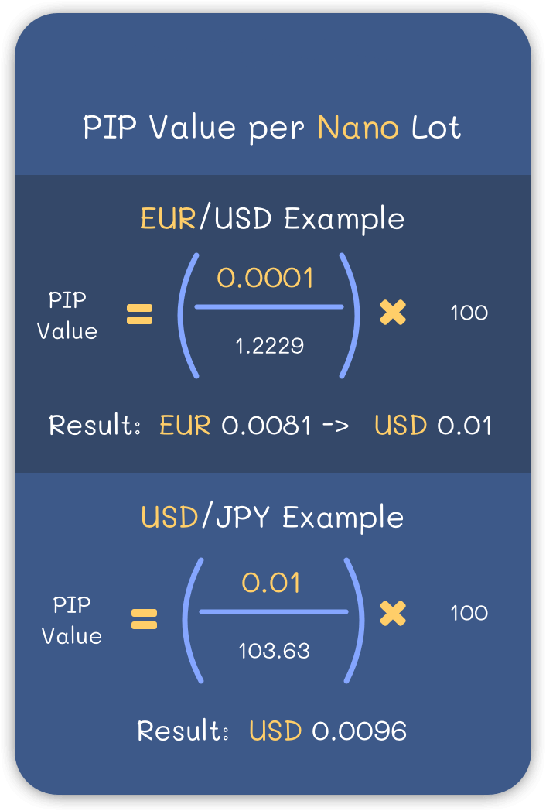](https://forum.mt5.com/attachment.php?attachmentid=398523&d=1627880965)

**Trading in Micro Lot**  
  
Most brokers offer lots as the smallest tradeable micro lots. A micro lot is a lot of 1,000 units of the currency used to fund your account. If users fund your account in US dollars, a micro lot is $1,000 worth of the main currency you would like to trade. In the case of a dollar-based set, 1 pip is equivalent to 10 cents. 2 Micro lots are ideal for beginners who want to keep risk to a minimum while learning to trade.  
  
**PIP Value per Micro Lot**

[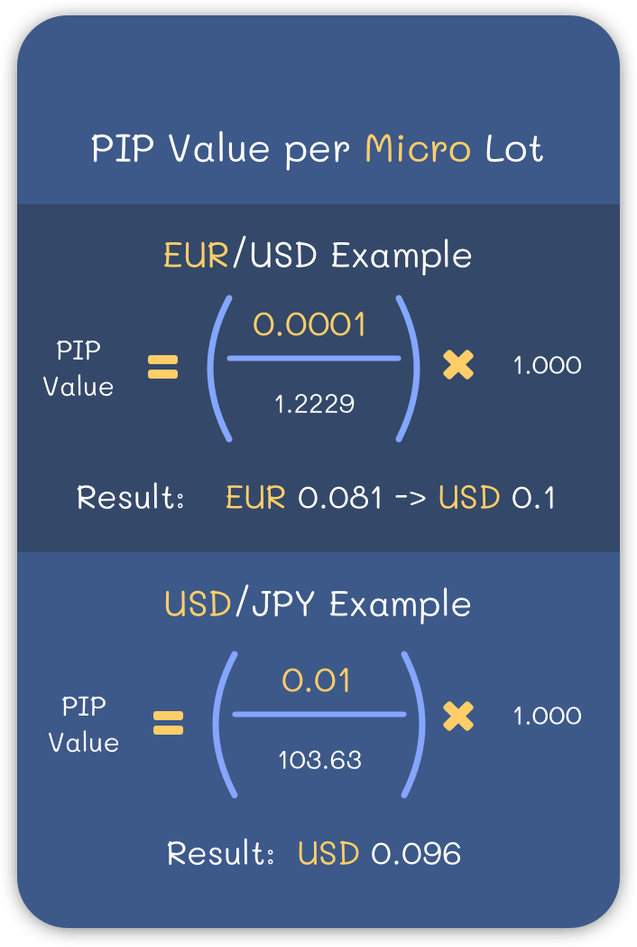](https://forum.mt5.com/attachment.php?attachmentid=398524&d=1627881021)

The PIP value per Micro lot is $0.1 in any currency pair where the USD is the quote (the second currency).  
  
**Trading with Mini Lot**  
  
There were mini lots before micro lots. A mini lot is 10,000 units of the currency used to fund your account. If you are a beginner and want to start trading with mini lots, make sure you are adequately capitalized.  
  
**PIP Value per Mini Lot**

[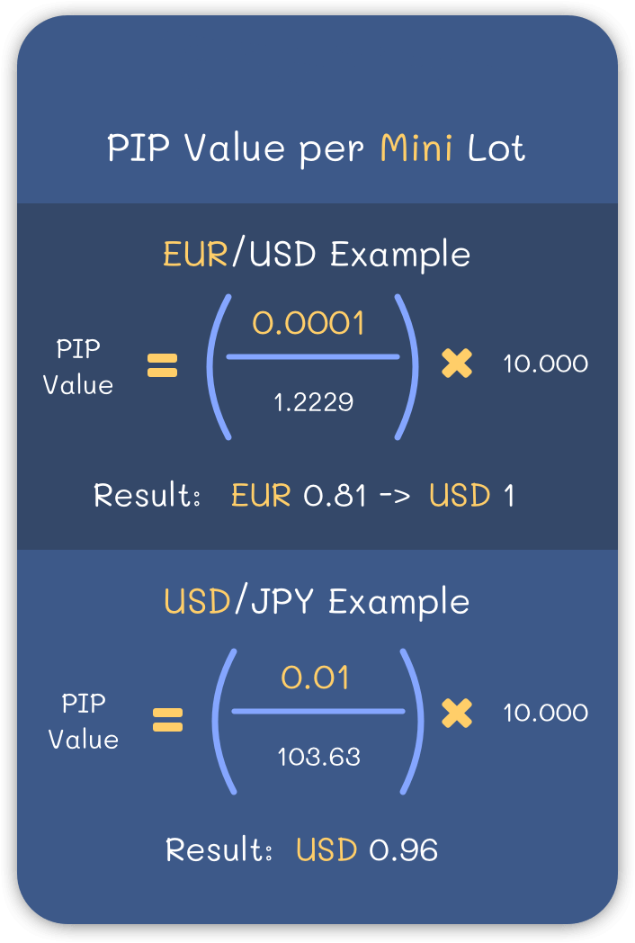](https://forum.mt5.com/attachment.php?attachmentid=398525&d=1627881088)

The PIP value per Mini lot is $1 in any currency pair in which the USD seems to be the quote.

While $1.00 per pip may appear to be a small amount, the market in trading could perhaps start moving 100 pips per day, and even in an hour. If the market moves, this equates to a $100 loss. It is entirely important to decide the ultimate tolerance for risk. However, if you want to trade a mini account, you might also begin from at least $2,000 to feel secure.  
  
**Making Use of The Standard Lot**  
  
A standard lot is one with 100,000 units. If you're trading in dollars, that's a $100,000 trade. Trading with this situation size means that perhaps the trader's account balance will vary by $10 for every pip move. For a trader with only $2,000 in their account (the minimum required to trade a standard lot), a 20-pip move can result in a 10% change in account balance. As a result, the majority of retail traders with small accounts do not trade in standard lots.  
  
**PIP Value per Standard Lot**

[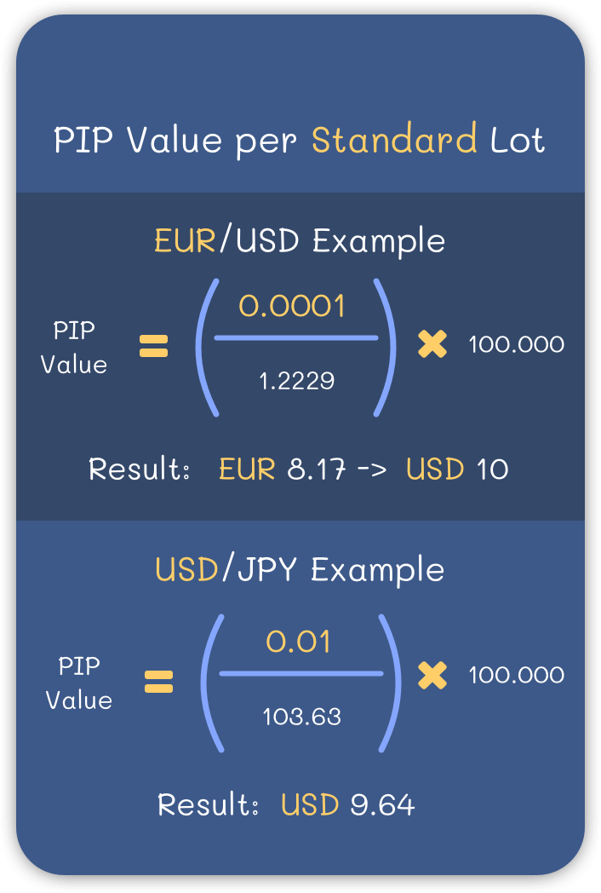](https://forum.mt5.com/attachment.php?attachmentid=398526&d=1627881153)

The PIP value per Standard lot is $10 in any currency pair where the USD is the quote (the second currency).  
  
The majority of forex traders you will come across will be trading mini lots or micro-lots. It may not be best utilized, but maintaining your lot size reasonable about your account size will assist you to retain your trading capital so that you can trade in the longer term.  
  
**A Useful Visualization in Lot Size**  
  
If you've read Mark Douglas' Trading In The Zone, you may recall the analogy he uses with traders he's coached, which he shares in the book. In short, Douglas suggests comparing the lot size you trade and how market movements affect you. to the amount of support you have beneath you while walking over a valley when something unexpected occurs  
  
To use an analogy, a very small trade size relative to your account capital would be like walking across a valley on a very wide, stable bridge where nothing would bother you even if there was a storm or heavy rains. Consider that the larger the trade, the smaller and riskier the support or bridge beneath you becomes.

See also: Explore the infinite possibilities of online trading with a reliable broker. [Join now](https://www.instaforex.com/real_account_whiterabbit?x=MBZKY&uifd=657)!

When users place an exceptionally large trade size about your account balance, the bridge becomes as smaller as a narrow line wire, and any slight movement in the market is compared to a wind gust in the instance and may send a trader past the point of no return  
  
**Conclusion**  
  
Knowing the various lot sizes available and how to calculate the pip ver lot size value will enable you to develop effective risk management strategies when trading.  
  
If you know that perhaps a currency varies 100 PIPS per day and their risk management plan allows for the highest allowable loss of $100, you would also not open a Standard lot trade. Outside of your risk management plan, this would expose you to a large profit/loss potential.  
  
This is a mistake that several new traders end up making as a result of brokers enabling better leverage aspects to all of their clients; when a newbie trader recognizes that he might secure a position worth $100.000 (1 standard lot) using $100 as margin requirement, he does so simply because he can, and this could not be more incorrect; remember to always fit every single trade into your risk management plan.