**How to Use RSI for Trading?**

**How to Use RSI for Trading?**

[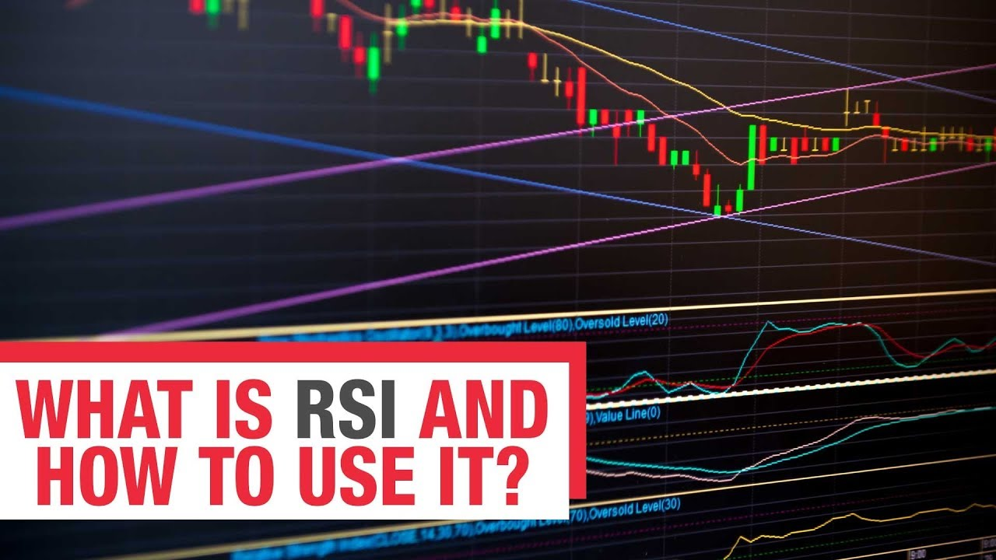](https://forum.mt5.com/attachment.php?attachmentid=398221&d=1627797157)

The RSI or Relative Strength Index is the most dependable and well-known momentum indicator, Among the various useful oscillators available to traders. Day traders use this to make money intraday, however, some find it very difficult to read due to the unavailability of its trading signals. It's indeed common knowledge that most intraday traders use RSI to achieve the best outcomes with a risk success ratio.  
  
It has become quite popular to generate technical trader signals for bullish or bearish price momentum since it was first introduced in the book New Concepts of Technical Trading System back in 1978. The RSI aids in determining if the same financial asset is oversold or overbought. Then primarily indicates the primary trend of a stock or asset.  
  
**Levels of RSI OBOS**  
  
It aims to predict when the price will bounce off the trendline, indicating a good time to enter a trade. It indicates that the market has been oversold and that the price may eventually rise if the RSI is less than 30. A buy trade can be placed once the reversal is confirmed. If the RSI is greater than 70, it indicates that the market is overbought and that the price may soon fall. A sell trade can be placed once the reversal has been confirmed.

[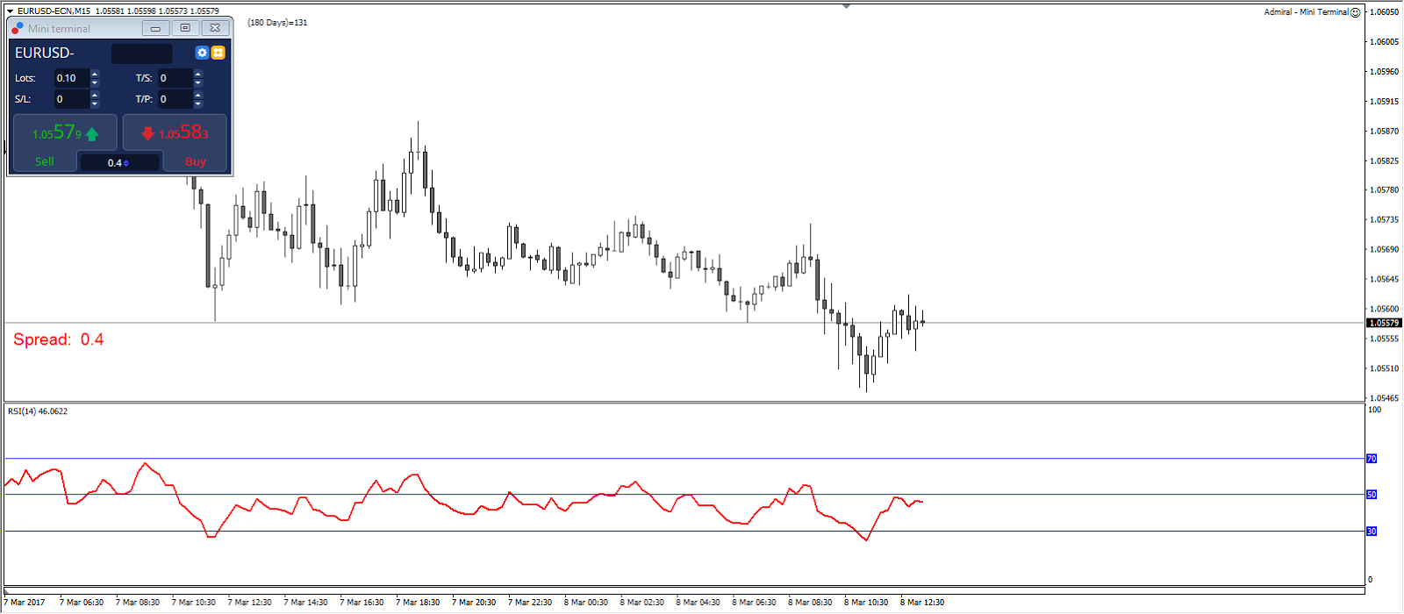](https://forum.mt5.com/attachment.php?attachmentid=398223&d=1627797203)

The RSI 50 level represents the midpoint between the upper (Bullish) and lower (Bearish) territories. In an uptrend, the RSI is commonly above 50, while being in a downtrend, it is normally below 50.  
  
**The RSI's Place in Day Trading**  
  
Beginners who do not understand how its parameters work undervalue the Relative Strength Index. You must be able to read RSI indicators on the charts for them to assist you in making intraday profits. The RSI is a reliable tool for all traders, but especially for day traders. It is not a problem to receive infrequent trades generated by RSI if they are of high quality. It all comes down to finding quality trades to compensate for infrequent intraday trades.

Trading the obvious won't bring in much money but once you start trading different stocks and assets every day. And that is why day traders must depend on dynamic RSI indicators to obtain good trading setups.  
  
**Divergence in RSI**  
  
RSI bearish divergence occurs when an investor makes a higher high while the RSI falls and makes a lower high. RSI divergence typically appears at the top of a bullish market. When the RSI Divergence forms, traders anticipate a reversal. It is an early reversal warning because it appears in several candlesticks before the uptrend reverses and breaks below its support line.  
  
When the price makes a lower low and the RSI makes a higher low, the RSI will form a bullish divergence. This is a warning sign that the trend may shift from a downtrend to an uptrend. Some traders try to trade RSI divergence on higher time frames. Using these methods, you can generate a variety of RSI indicator buy and sell signals.

[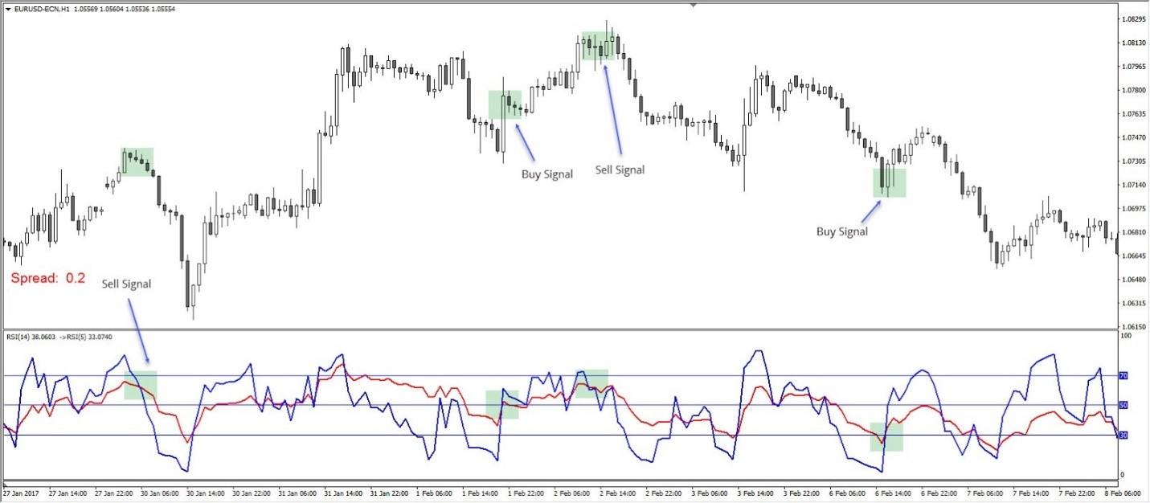](https://forum.mt5.com/attachment.php?attachmentid=398225&d=1627797259)

**Useful RSI Strategies for Day Traders**  
  
As previously stated, the standard default setting for RSI on technical charts is 14. However, experts believe that the best timeframe for RSI is between 2 and 6. Intermediate and expert day traders prefer this last timeframe because they can adjust the values based on everyone's situation. The key to profiting from RSI indicators is to learn how to use RSI for day trading by selecting the appropriate timeframe for one's trading strategy.  
  
As a result, focusing on the RSI timeframe is crucial. When looking for short-term trading in up-trending markets, short periods prove to be more reliable.  
  
**The following are some helpful for RSI Day Trading:**

* Practice reading RSI indicators and understanding market trends based on the information provided by RSI indicators and technical trading charts.
* Combine the RSI indicator using the moving average indicator to eliminate the weak ones and then identify the best stocks and assets in an up-trending market.
* Keep an eye on the stocks as closely as possible using scanner software, which helps traders focus on valuable assets.
* Traders can easily buy and sell to determine which one to trade using RSI is to determine a stock's high/low bidding condition. Instead of relying on higher or lower period settings, figure out which one works best for you.
* If you trade stocks or forex, RSI determines whether you should follow a market trend or not. When it comes to stock trading, following the market is beneficial, but when it comes to forex, you must remain vigilant to protect your account from losses.

**Divergence of the RSI Over two periods**  
  
This strategy is also known as an RSI 14 trading strategy. Look for crossovers then you can apply a 5-period RSI over a 14-period RSI. When using the RSI 14 trading strategy, the market may not reach the oversold or overbought levels before shifting direction. A shorter period RSI is far more sensitive to the latest price increases and can detect early warning signs of reversals. Whenever the RSI 5 crosses above the RSI 14, it indicates that the latest prices are increasing.  
  
When the 5 periods (blue) are oversold, a buy signal is generated, and a 5 vs. 14 cross should occur (below 30). When the RSI 5 crosses below it indicate that the latest prices are dropping and fall below the RSI 14. This indicates a sell signal. When the overbought is 5 period, a 5 vs. 14 cross should occur. Experienced traders may find that combining an RSI trading strategy with Pivot Points improves their trading performance significantly.

[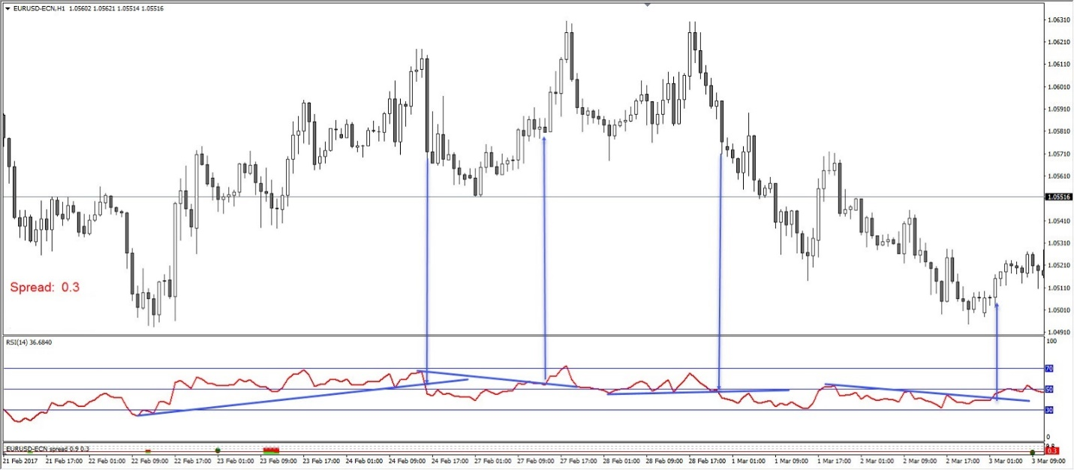](https://forum.mt5.com/attachment.php?attachmentid=398235&d=1627798432)

The best RSI settings for intraday swing traders who short sell rapidly and aim for smaller profits set their RSI timeframe to 14 periods, but that's not proven to work for the day trader. Traders can achieve the best RSI settings for intraday that are suitable for them after researching the impact of changing timeframes on RSI. The data assists day traders in obtaining and determining when to exit a market to profit from proper RSI signals.

**Trendlines of the RSI**  
  
Connect tops and bottoms on the RSI chart and trade the break of the trendline. Connect three or more points on the RSI line as it rises to draw an RSI uptrend line. A break of an RSI trendline could indicate a price continuation or reversal. Remember that the break of an RSI trendline usually precedes the break of a price chart trendline, providing a warning and a very early opportunity to trade.

[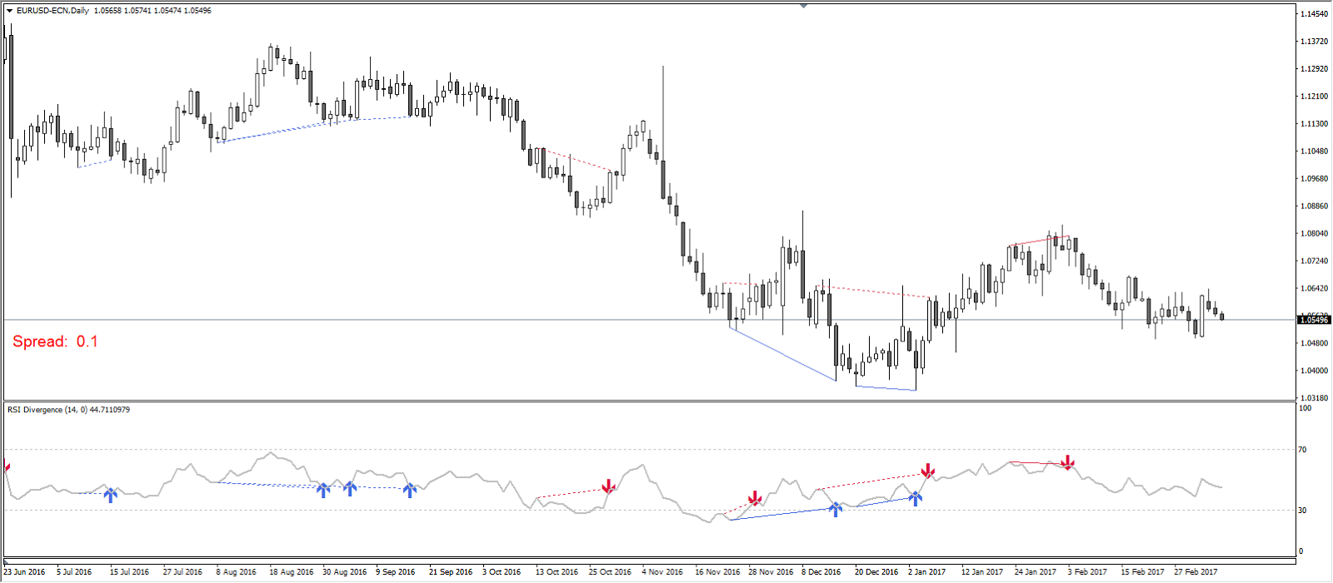](https://forum.mt5.com/attachment.php?attachmentid=398236&d=1627798471)

**Conclusion**  
  
Since the Forex RSI indicator is so simple to use for day trading, new traders frequently begin without testing different parameters or trying to educate themselves on the correct understanding of an indicator, to make money quickly.  
  
Using the RSI indicator for day trading, once understood and correctly applied, will help you develop the ability to determine, and the best price to enter or exit a trade is whether prices are trending when a market is overbought or oversold.