**ETF Trading Strategies for Beginners**

**ETF Trading Strategies for Beginners**

[](https://forum.mt5.com/attachment.php?attachmentid=397969&d=1627712763)

Unlike mutual funds, exchange-traded funds (ETFs) are easily traded while stock exchanges are open and offering live pricing. As a result, on the surface, they appear to function similarly to stocks. Because of the accessibility and utility of ETFs in general, there are a variety of strategies for trading them. Some of these are intended for more advanced, experienced traders, while others are intended for beginners.  
  
**What Are Exchange Traded Funds (ETFs)?**  
  
An ETF is a type of security that is traded on the stock exchange. They were first introduced in Canada in 1990 and have since grown in popularity as listed securities around the world.  
  
**Traded Common Stock**  
  
Instead of purchasing a mutual fund, which requires a period to complete a new buy or a sell of a position in that fund, ETFs are buy and sold in the same way that common stocks are acquired or divested. This makes them ideal for trading, whether as a long-term investment or as a very short-term trading strategy that includes day trading at the faster end of the process.

[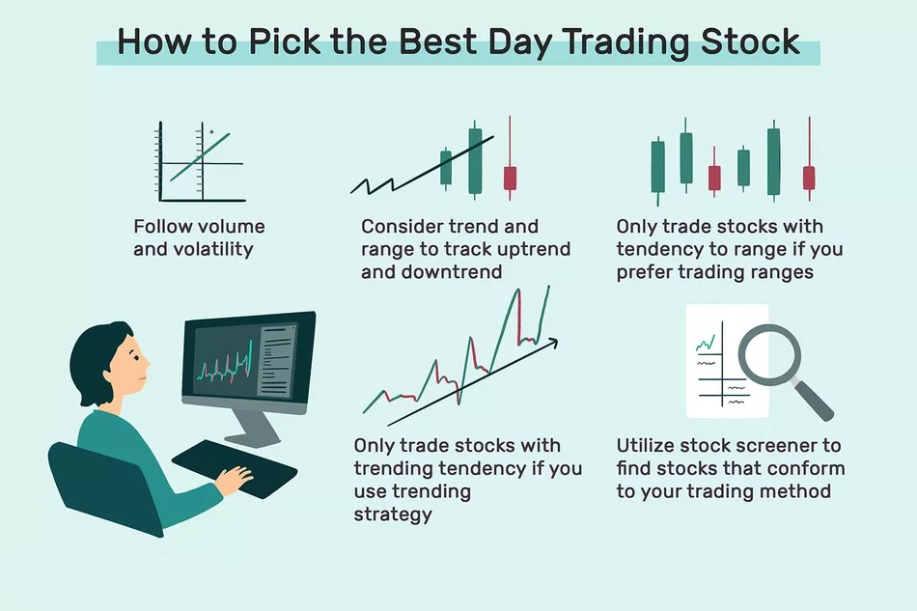](https://forum.mt5.com/attachment.php?attachmentid=397970&d=1627712877)

In the sense that they own a collection of investments or securities, ETFs are similar to mutual funds. If it's an S&P 500 index fund, it likely owns every stock in the index or something close to it.  
  
**Markets and More**  
  
Specific ETFs contain entire markets, sectors, categories, and styles, among other options. As a result, investors who have a strong preference for the retail or premium office sectors can choose an ETF that focuses solely on those sectors and invest their money there.

As a result, ETFs are not only more liquid because they can be traded quickly, but they also allow traders to bet or take positions for the short, medium, or long term on indices, sectors, or styles such as large-cap value or growth investing, rather than being limited to trading common stocks, bonds, or dabbling in other tradable investments.  
  
**Investing in the Sector**  
  
Investing in sector funds is appealing to new investors. It can provide a sense of security that is absent when investing in the far broader Wilshire 5000 index or the S&P 500 index.  
  
There are now a plethora of industry-related ETFs that narrow the field down to a handful or a hundred companies in a specific sector. This is an excellent way to invest with your heart or to strike when you see a profitable opportunity when it makes sense for you. Be aware that sector index funds typically have higher expense ratios (TERs) than broader indexing options such as the S&P/TSX Composite Index in Canada or the S&P 500 index in the United States.  
  
When there is no reputable index to use as a composite, some ETFs are actively managed, and the fees are significantly higher on average. As a result, an investment thesis must account for these increased holding costs. Sectors and industries can and do fall out of favor, and occasionally die out completely, leaving investors empty-handed.

[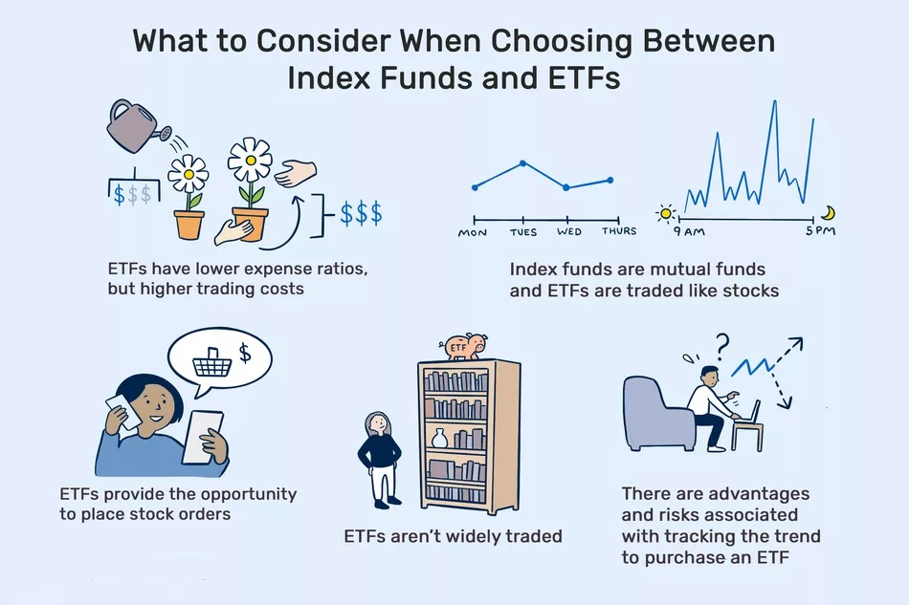](https://forum.mt5.com/attachment.php?attachmentid=397971&d=1627712942)

**Choosing an Investing Style**  
  
Instead of looking at sectors, you can look at investing styles and use that as a trading strategy. There are numerous styles to choose from. The most common are growth or value systems, but some ETFs focus on momentum and other strategies.  
  
**Investing for Growth**  
  
Growth investing is typically centered on an ETF that owns companies that are growing at a faster rate than the market average. Another growth-oriented strategy is dividend growth investing, in which companies not only grow faster than the average but also pass some of these extra earnings on to investors by increasing their cash dividend at a rate significantly faster than the rate of inflation.

See also: Explore the infinite possibilities of online trading with a reliable broker. [Join now](https://www.instaforex.com/real_account_whiterabbit?x=MBZKY&uifd=657)!

Typically, the income or dividend component of growth investing is as small as or less than the market's average yield. The goal is to buy companies that will increase in value over time and can then be sold for a healthy profit by the ETF. Income is not a top priority.  
  
Growth works well with larger companies, but the small-cap growth style underperforms the market. Most businesses do not grow to become large-cap stocks. Furthermore, excess profits are frequently wrung out of start-ups by venture capitalists, resulting in unimpressive post-IPO growth. There are, however, low-returning small-cap growth periods that are frequently followed by those with excess returns, which is something to keep an eye out for as a trading option for beginners.  
  
**Investing for Value**  
  
Value investing is the concept of purchasing something worth $1 for 50 cents, i.e., purchasing businesses when they are on sale. They may be discounted as a result of recent bad news, such as a legal judgment (or one that is expected in the future), a poor trading period, or simply a period of poor returns.  
  
Long-term investments are sometimes made by value investors. Other times, they look for periods of poor performance for the value style and choose when to dive in. Value stocks perform worse in difficult economies when companies are on the shakier economic ground and better in good economies overall.  
  
There is what is known as a “value premium” above the general market return due to an increase in the depressed prices of value stocks, which are traded for the newly cheap stocks of other companies after returning to their fair value. This process, at least, helps to maintain a value premium overtime – at least, that is the hope.

[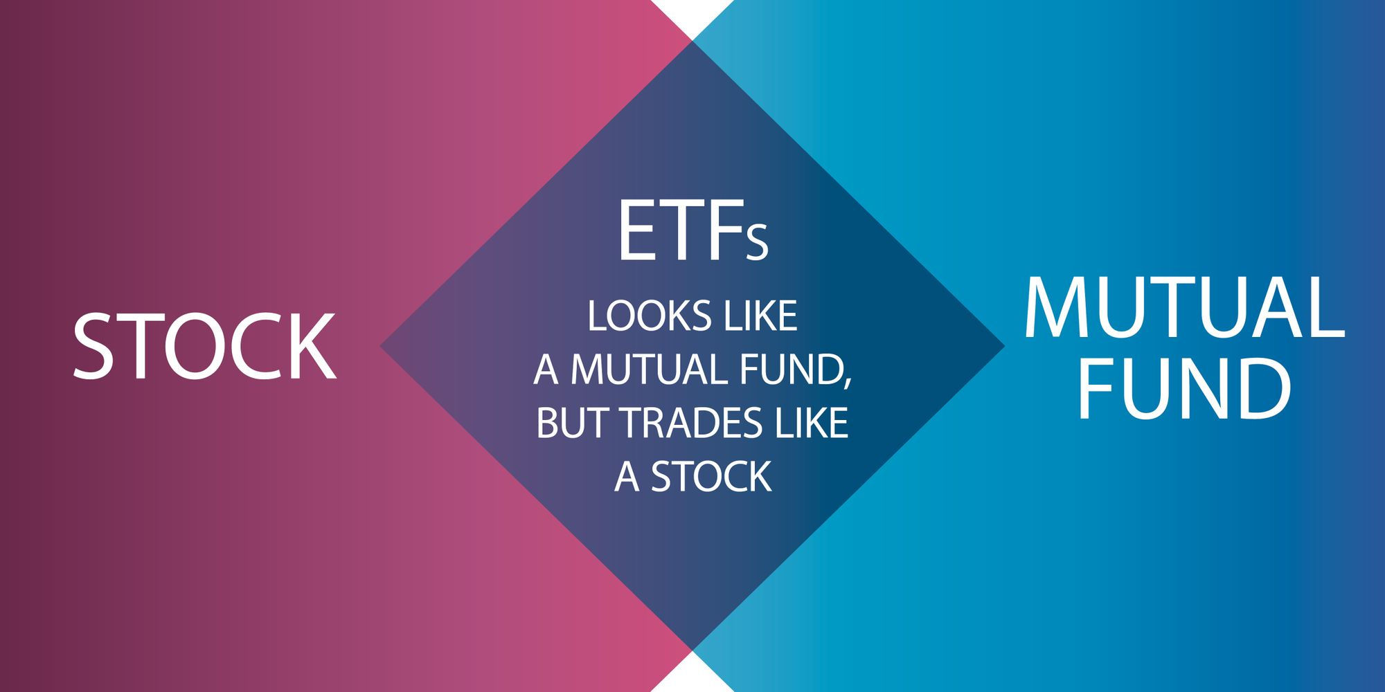](https://forum.mt5.com/attachment.php?attachmentid=397972&d=1627713028)

**Other Styles**  
  
The momentum style is also popular. This is typically on the actively managed side of ETFs, but there are plenty to choose from. Momentum occurs when a stock or ETF has been rapidly rising in comparison to either its recent past or to other similar stocks or ETFs. These investors hope to ride the wave while it is still going on and exit when it appears to be coming to an end.  
  
**Leveraged ETFs**  
There are leveraged ETFs that multiply your initial investment several times. The ETFs will claim to be 2X or 3X that sector or market. There is an additional risk factor at work here. If the market moves against you, the value of your investment may decrease several times faster. On the other hand, if you have a strong belief that the market or sector is trending upwards, this is a simple way to capitalize on that in the short term.  
  
**Inverse ETFs**  
  
In addition to leveraged ETFs, there are inverse ETFs, which include multiplying the effect. Inverse ETFs, as the name implies, seeks to produce results that are roughly the inverse of those produced by a given index. As a result, it is betting against something. Some of the inverse ETFs are also used to multiply the inverse effect.

[](https://forum.mt5.com/attachment.php?attachmentid=397975&d=1627713102)

**Conclusion**  
  
There are numerous ETF trading strategies, but only a few are appropriate for beginners. While certain industries can be extremely profitable Cloud Computing ETFs have done particularly well in 2020 it is not all sunshine and rainbows. Many trading strategies require you to pick your moment and be extremely selective.