**What Is the Best Dax Trading Strategy?**

**What is the DAX?**

[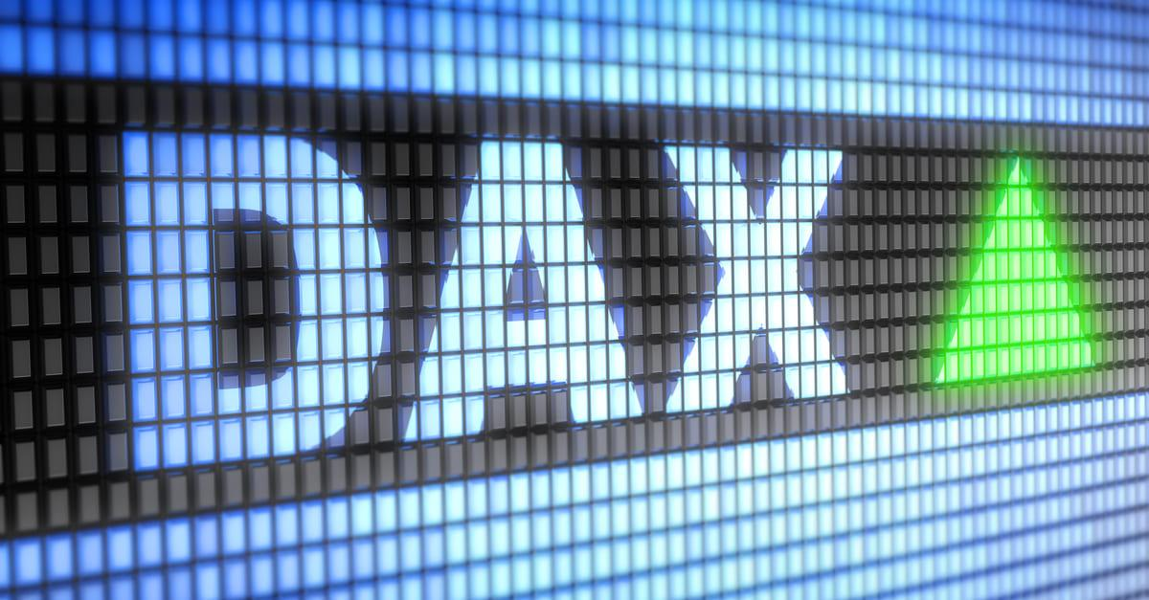](https://forum.mt5.com/attachment.php?attachmentid=397616&d=1627616280)

The DAX 30 is the premier index of the Frankfurt Trading Stock in Germany. The index is comprised of the stock prices of the top 30 companies, which include well-known global brands such as BMW, Allianz, and Adidas. On spread betting and CFD brokers, the DAX is also known as the Germany 30, GER30, or DE30.  
  
**Trading strategies for the DAX 30**  
  
**There are two general market types for which DAX 30 trading strategies are required:**

* Trending markets
* Sideways markets

The DAX 30 goes through phases of sideways and trending markets, and even when it does, it provides us with a wide range of market opportunities. Three trading strategies are consistently used on the DAX 30. Swing trading strategies, breakout trading strategies, and scalping are examples of these.

[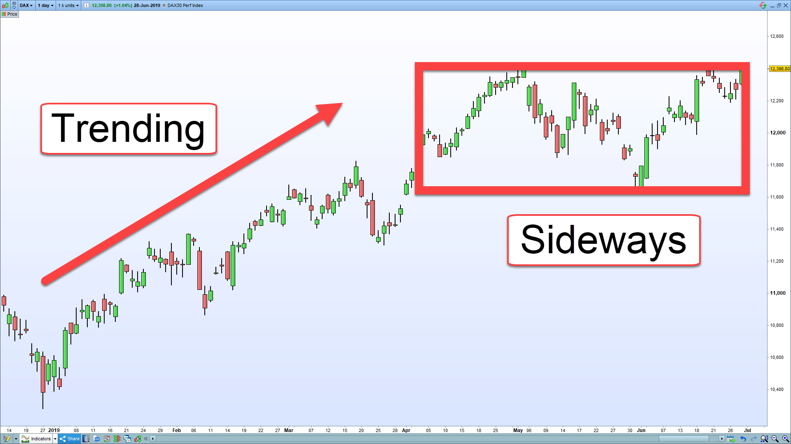](https://forum.mt5.com/attachment.php?attachmentid=397622&d=1627617849)

**Swing trading on the DAX 30**  
  
**The first DAX 30 trading strategies are as follows:**  
  
Many people believe that swing trading strategies work very well on the DAX and that there are several monster trades available every year that can generate thousands of dollars in profit while also providing a solid financial foundation for your trading. This is especially true when the market has been down-trending / risk-off because, with indices, any sell-off usually precedes a rally.  
  
Look at the chart above; the market had sold off at the end of December. In January, the market began to recover, and there were technical signs that the market would recover and rally.  
  
**Breakout trading on the DAX 30**

See also: Explore the infinite possibilities of online trading with a reliable broker. [Join now](https://www.instaforex.com/real_account_whiterabbit?x=MBZKY&uifd=657)!

**The second DAX 30 trading strategy is as follows:**  
  
The DAX 30 is ideal for breakout trading. In this regard, it is similar to the Dow Jones Industrial Average perhaps because they both contain 30 companies helps. Breakouts are more difficult to predict in Forex. Forex is more prone to fake-outs (where the level enters a new zone and then fades back in) than indices. This is one of the reasons why many Forex traders dislike breakouts.  
  
If you don't trade indices, you should start doing so and look for breakouts. There are numerous occasions when the market will enter a new trading zone and simply lift off. The same is true if the breakout is brief. In a downtrending, risk-off environment, indices tend to move faster and with greater momentum.  
  
**Scalping strategy for the DAX 30**  
  
**The third DAX 30 trading strategy is:**  
  
The DAX 30 is one of the best trading instruments to the scalp if you have the time, availability, and focus. This is due, in part, to the high index value and generally low spreads available. As a result, it is ideal for scalping. The cost of trading is only one consideration. The market must still be scalpable.  
  
Fortunately, even with small moves suitable for scalping, the DAX 30 is extremely technical. It works extremely well with support and resistance, pivots, and round numbers.  
  
**Why should you trade the DAX 30 index?**  
  
So, why should you think about trading the DAX? Why does the German stock market deserve your attention and trading effort when there are so many other markets to trade-in?  
  
**It is highly technical**  
  
By technical, it refers to the ability to repeat predictable and consistent patterns that can be used to trade and profit from. This is necessary for any market that wishes to trade. Swing trades, breakout trades, scalping, and other strategies can all be executed using the DAX 30 as a platform. A dependable technical trading instrument allows for a consistent source of income and promotes risk-free trading.

**It has a high index value as well as low volatility**  
  
The DAX 30 has excellent, manageable volatility consistently. Naturally, it can reach extremes, either where nothing happens or where the volatility is so high that the market becomes too risky to trade.  
  
**On indices, Black Swan events are less likely**  
  
A black swan is onset or occasion that diverges from what is generally known of a condition and is difficult to predict. A good example is when the Swiss Central Bank ‘unpegged' their currency, the Swiss Franc, from the Euro.

[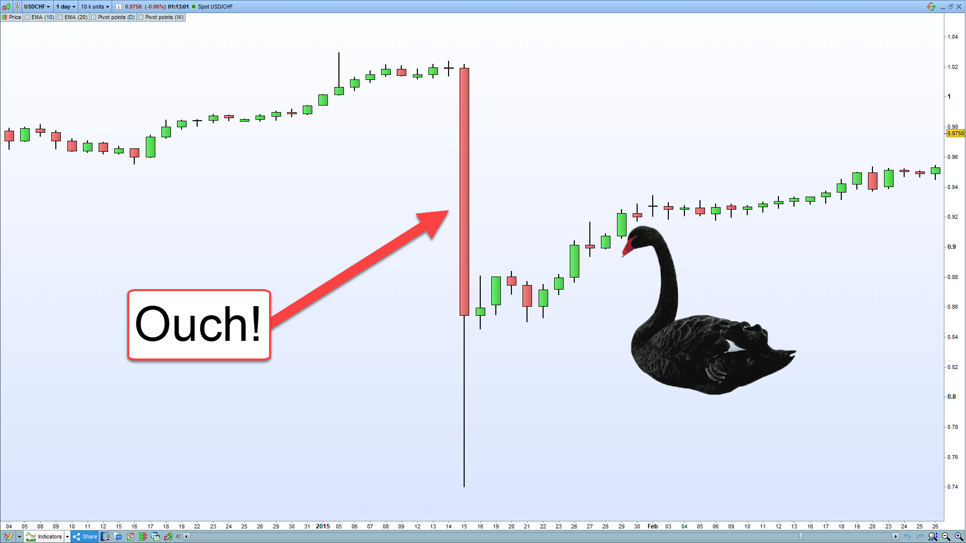](https://forum.mt5.com/attachment.php?attachmentid=397623&d=1627617874)

The point here is that indices are less vulnerable to such horrific, unpredictable moves because the index value you are trading is comprised of many companies. As a result, if one company experiences a "black swan" event, it is absorbed by the others.  
  
**It enjoys both support and resistance**  
  
Consider support and resistance to be the pillars on which trading is built. The DAX 30 establishes extremely strong support and resistance levels that can be used in a variety of ways. They can be used to trade directly off reversal and breakout strategies, as well as to set profit targets and place stop losses above and below to give a trade the best chance of success.  
  
**Swing trades for a long time**  
  
In the past, indices have risen more than they have fallen.

[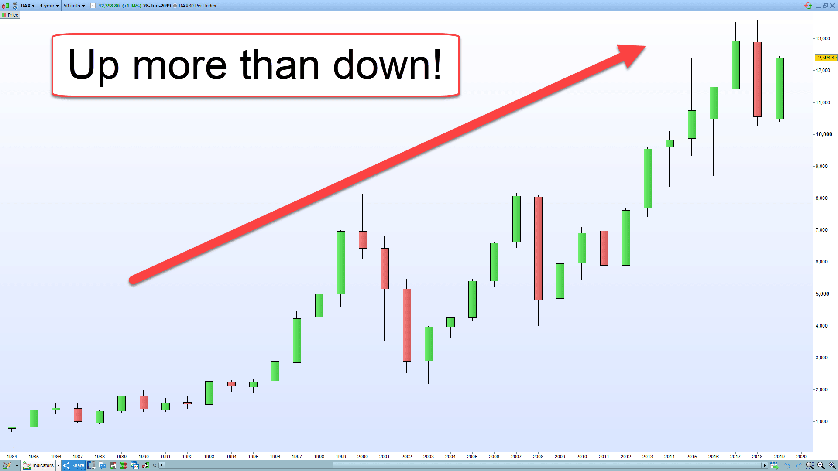](https://forum.mt5.com/attachment.php?attachmentid=397624&d=1627617903)

This is since indices are composed of stocks. What do the people in charge of these businesses hope to achieve? They want to make money and be successful. What would happen if they did this? The index's value rises.

Investors who buy stocks expect their value to rise. They want the value of their holdings to rise and to be able to receive dividends. This is not the case with forex, commodities, or other asset classes. This means that indices rise more than they fall, and whenever there is a sell-off / risk-off period in the market, it is a great time to go long. All of the DAX 30 trading strategies discussed above allow for long entries.  
  
**Other things to consider**  
  
Here are some other things you should be aware of if you trade or intend to trade the DAX 30.

[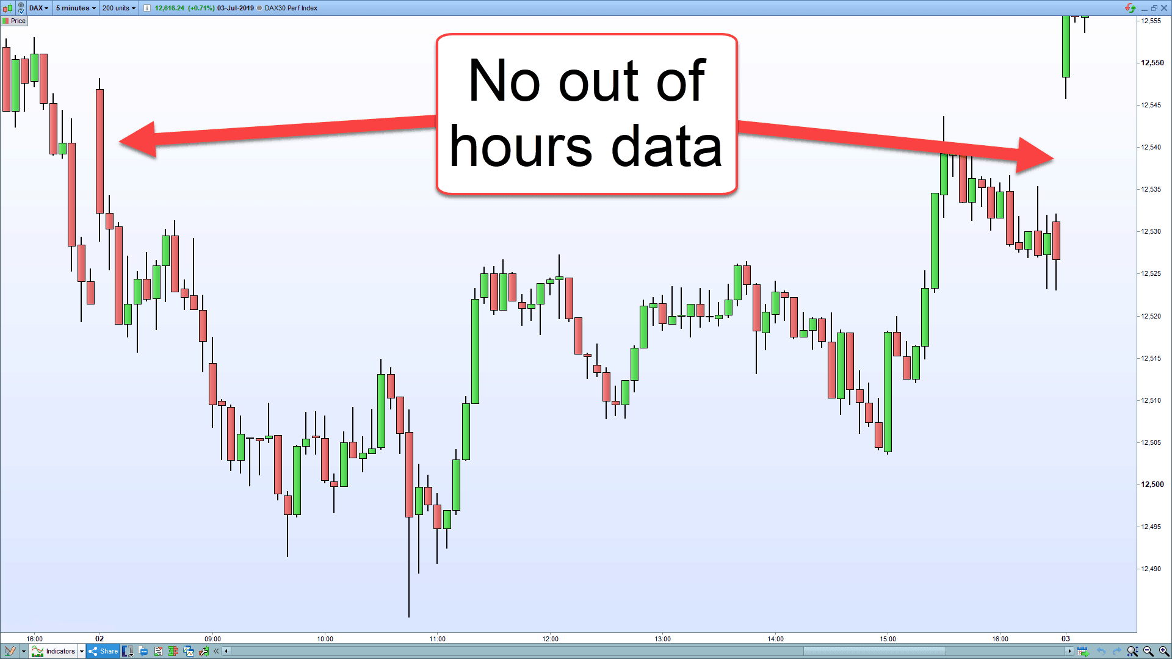](https://forum.mt5.com/attachment.php?attachmentid=397625&d=1627617919)

**Different types of DAX 30**  
  
You should be aware that the DAX comes in two flavors. The first is the performance index, and the second is the price index. The distinction between the two is whether dividends are counted. The quoted number is usually the performance index.  
  
The reason for this is that if a broker has an unusually high price, it could be due to a different version of the German stock market being quoted, rather than an error that presents an arbitrage opportunity (where there is a 'risk-free' opportunity with pricing disparity).