**Overview of MACD Stock**

**Who created MACD?**  
  
Gerald Appel created Moving Average Convergence Divergence (MACD) in the late 1970s trading indicator used in technical analysis of stock prices which is a trading indicator. Its purpose is to reveal shifts in the strength, direction, momentum, and timeframe of a stock's trading price.  
  
**What is MACD?**  
  
As a general rule, the MACD indicator is determined by three-time parameters: the time constants of the three EMAs. The indicator is commonly denoted as MACD(a,b,c), where a MACD series is the difference of EMAs with distinctive times a and b and the average series is an EMA of the MACD series with characteristic time c. These variables are typically measured in days.  
  
The most commonly used are 12, 26, and 9 days (12,26,9) MACD values, like most technical indicators, derives its period settings from the days when the technical analysis was primarily based on daily charts.  
  
**Horizontal lines are visible on the Macd indicator.**  
  
A fast EMA reacts to recent changes in a stock's price faster than a slow EMA. The MACD series can detect changes in a stock's trend by comparing EMAs from different periods. The divergence series is said to be capable of detecting subtle shifts in the stock's trend.  
  
The MACD is a slow and lagging indicator because it is based on moving averages. The MACD is trading with unpredictable price action, less useful as a future indicator of price trends for stocks that are not trending (trading in a range). As a result, by the time MACD shows the trend, it will be completed or nearly completed.  
  
This is the most basic technical tool that analysts use to forecast stock trends. This technique has gained popularity among traders due to its consistency in predicting the broad direction or state of the market; however, it does not provide exact entry or exit points as other indicators do, but it does provide the direction of the stock quite consistently.  
  
**Constructing the MACD Stock**  
  
The chart that appears when you draw the MACD of any stock are as follows.

* MACD is calculated by subtracting the stock's Long Term Moving Average from its Short Term Moving Average. Typically, the Long term is taken to be the most recent 26 days, and the Short Term is taken to be the most recent 13 days.  
    
  Because the Short term Moving Average is more responsive than its longer sibling, the difference is shown as a line chart. The plot will oscillate between being above and below zero, with no upper or lower bounds. It is usually drawn in blue.
* The Signal Line, which is drawn in red, is the MACD's Moving Average.
* There is a bar chart to show the difference between a signal line and the MACD oscillator.

Fast MACD is typically built by combining moving averages of 10 and 5 days to show recent developments. It is more responsive but prone to false signals. The Slow MACD is created by combining the 26 and 12 days MA, and while it is less responsive to the latest improvements, it is more accurate in estimation.  
  
**Recognizing the Signs**  
  
**MACD Indicators (Positive & Negative)**  
  
Using EMA instead of simple MA because EMA emphasizes recent prices, and using (26, 12) day EMA in the example to better understand the signal.  
  
When the MACD is favorable and going up through value, it indicates that the short-term price is rising faster than the long-term rate and the stock is gaining momentum. When the 12 days EMA is relatively low than the 26 days EMA, The Negative MACD occurs, and the trajectory is downward, indicating a bearish trend.  
  
In the case of Mcleod Russell, notice how MACD provides both bullish and bearish signals two to three days before the actual trend begins.

[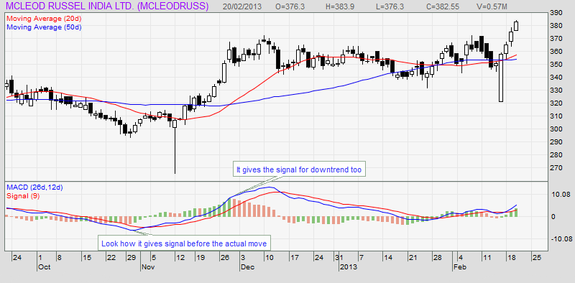](https://forum.mt5.com/attachment.php?attachmentid=396647&d=1627356093)

**Crossover**  
  
Crossovers are classified into two types:

* Signal Line Cross: A bullish signal is indicated when the MACD crosses the Signal Line (9 days EMA of MACD) from below and moves above.
* Center Line Crossover: A common indicator is the bullish crossover of the center line, which occurs when the MACD crosses the zero line and moves above it. Take a look at the chart above.

**Divergence in technical terms**  
  
Divergence occurs when the MACD begins to move higher or lower and stock prices do not. It indicates that price action in the direction of the MACD is imminent. It is difficult to carve out these patterns, but they are very accurate in predicting the direction of the move.  
  
In the chart below of JP Associates, notice how the stock price is rising while the MACD is falling; eventually, the stock price just breaks down following the MACD.

[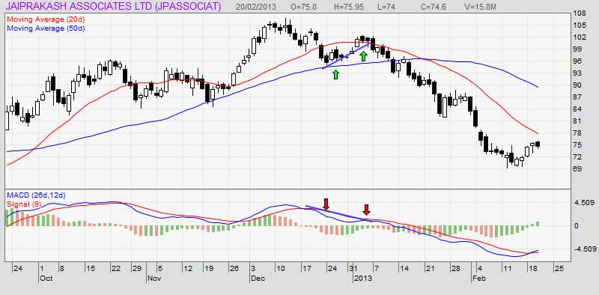](https://forum.mt5.com/attachment.php?attachmentid=396648&d=1627356112)

Negative divergences are extremely rare, but they represent the most reliable prediction. This occurs when security remains sideways while the MACD moves downwards and shows a peaking-off.

Moving Average Convergence/Divergence is a momentum oscillator that is primarily used to trade trends. Even though it is an oscillator, it is not typically used to detect overbought or oversold conditions. On the chart, it appears as two lines that oscillate without boundaries. The intersection of the two lines generates trading signals similar to a two-moving-average system.

[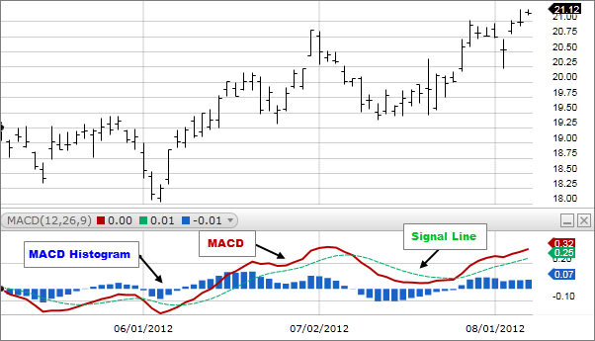](https://forum.mt5.com/attachment.php?attachmentid=396666&d=1627358618)

* MACD crossing above zero is considered bullish while crossing below zero is considered bearish. Second, when the MACD rises from a low of zero, it is considered bullish trend and when it falls from above zero, It is considered bearish trend.

[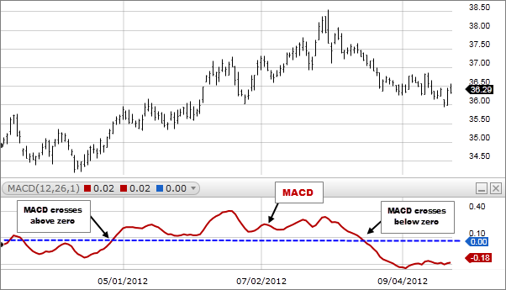](https://forum.mt5.com/attachment.php?attachmentid=396668&d=1627358686)

* When it crosses from below to above the signal line it is considered bullish. The greater the distance below the zero line, the stronger the signal.
* The indicator is considered bearish when the MACD line crosses from above to below the signal line. The greater the distance above the zero line, the stronger the signal.

The main features of a MACD indicator are as follows:

* Period or interval - defined by the user. The following are some examples of commonly used periods:
  + Short-term intervals - 3, 5, 7, 9, 11, 12, 14, 15-day intervals, though 9-day and 12-day intervals are more popular.
  + Long-term intervals include 21, 26, 30, 45, 50, 90, and 200-day intervals; the 26-day and 50-day intervals are the most common.
* Momentum oscillator line or divergence or MACD line - The two interval moving averages which can be as simple as a plot of divergence.
* Signal Line - an exponential moving average of divergence data, such as the 9-day EMA
* A combination of 12-day and 26-day EMAs of prices and 9-day EMAs of divergence data is typically used but based on the trading objective and aspects and these values can be adjusted

[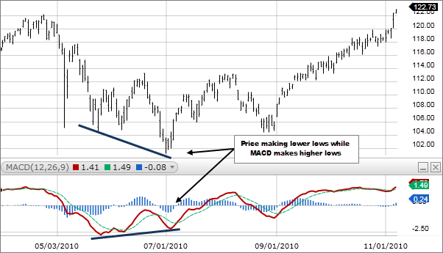](https://forum.mt5.com/attachment.php?attachmentid=396670&d=1627358786)

**Calculation**  
  
An approximation of the MACD can be computed by deducting the value of a 26 period EMA from a 12 period EMA. The shorter EMA is always converging toward and diverging from the longer EMA. As a result, the MACD oscillates around zero. The MACD line's 9-period EMA is used to create a signal line.  
  
To indicate a trend, such as overbought or oversold conditions, the MACD and signal line move above and below the zero axis or centerline. When the EMA points are close to one another, this is referred to as convergence; because they're far apart, this is referred to as divergence. The MACD line reacts more strongly when the moving average is shorter.  
  
**Everything revolves around timing**

Choosing a time frame is critical because it affects the appearance of the MACD chart as well as the interpretation and timing of signals.  
  
Other important points to consider:

* When there is a proper trend, the MACD indicator should be used. It is ineffective in a rangebound market.
* Long bars in a histogram indicate divergence, whereas short bars indicate convergence of the moving averages.
* When a relatively short EMA moves above the relatively long one, MACD has good growth; when it moves well below longer EMA, it has negative momentum.
* When the MACD rises significantly and the short EMA pulls away from the longer one, it indicates that the market is overbought.
* Fake signals from the MACD are also possible. For example, there could be a bullish signal line crossover but a sharp drop in the price of a security.

Similarly, there could be a negative crossover but just a steep increase in the current stock. As a result, an event must be examined for a longer period to be confirmed.