**Overview of Stochastic Settings**

**What Is the Stochastic Oscillator?**  
  
Dr. Gorge Lane invented the Stochastic Oscillator indicator in the 1950s. It was created to determine the market's buying and selling pressure. It can also identify the cycle rotation that allows bulls and bears to conserve power. This dependable indicator is used by many traders.  
  
A momentum indicator is a Stochastic Oscillator. By default, it is between 100 and o. It displays the close's position about the high-low range on a set of parameters. The Stochastic Oscillator has two lines: the slow Oscillator (percent k) and the moving average (percent D). Slowing is typically applied as a period of three to the indicator's default setting.  
  
**Stochastic Oscillator Settings That Work**  
  
You must first decide how much data noise you are willing to accept for your trading method. The more familiar you are with the indicator, the better your chances of sustaining probable signals will be.  
  
For short-term trading or scalping, some professional traders prefer the low setting. For long-term trading, some traders prefer a high setting. Because a highly smoothed outcome only responds to the most significant changes in price action.

[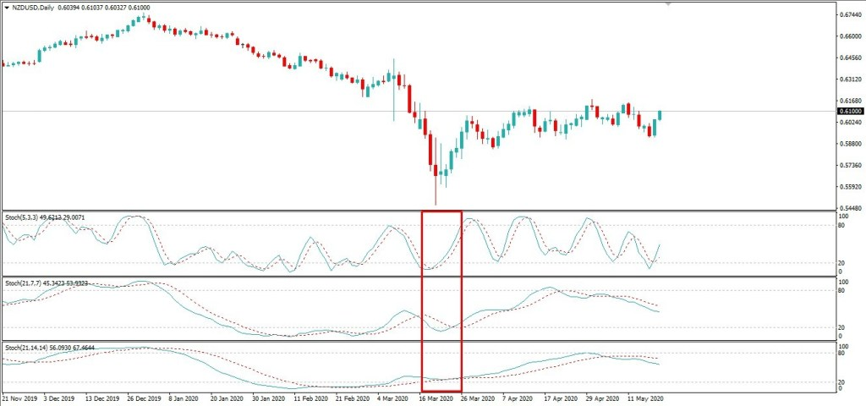](https://forum.mt5.com/attachment.php?attachmentid=396988&d=1627443829)

NZDUSD exhibits various Stochastic Oscillator parameters based on variants. The fast line intersects the slow line when it reaches the overbought and oversold levels, and Cycle then turns over.  
  
Furthermore, the 5, 3, 3 parameters constantly loop through buy and sell cycles without approaching the overbought and oversold levels. Furthermore, the 21, 7, 7 parameters operate over a longer period. However, it continues to ease at a relatively low level and provides fewer buy and sell signals. Furthermore, the 21, 14, 14 parameters operate on a massive dataset, produce few signals, and are mostly located near the key level.  
  
**Stochastic Oscillator Applications**  
  
The following are the basic applications of the Stochastic Oscillator indicator:  
  
**Levels of Overbought and Oversold**  
  
It indicates that the market is overbought when the Stochastic reading exceeds 80. And a reading of less than 20 indicates that the market is oversold. The market usually gives a sell signal when Stochastic lines are above 80 and return to below 80.  
  
In contrast, the market signals a buy when the Stochastic lines fall below 20 and then rise above 20. Furthermore, the Stochastic signals of overbought and oversold by staying within the time frame's range whenever the security price is close to the top or bottom level.

[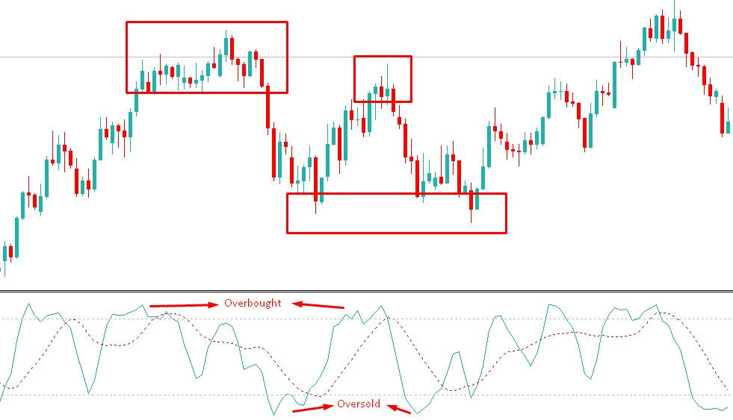](https://forum.mt5.com/attachment.php?attachmentid=396985&d=1627443599)

**Divergence**  
  
Divergence occurs when the asset price creates a good high or low without being detected by the Stochastic Oscillator. The price reaches a new high as an example. Nonetheless, the Stochastic may not rise to a high reading. It is known as bearish divergence. Bearish Divergence can indicate that the market is about to shift from a bullish to a bearish trend.  
  
The inability of the Stochastic Oscillator to indicate the latest high reading in tandem with the price indicates that the momentum of the bearish trend is beginning to rise. Similarly, when the price makes a new low, the Stochastic does not move to the low reading, which is known as bullish divergence. Bullish Divergence indicates that the market is likely to move to the upside shortly.  
  
However, the price may rise for a few trading sessions before falling. It is worth noting that the oscillator can sometimes indicate a divergence signal before the price changes direction. A stochastic Oscillator, for instance, offers a divergence signal. For example, A stochastic Oscillator provides a divergence signal. As a result, Dr. Gorge Lane advised waiting for verification of the market shift without first engaging in any trade. As a result, you should not trade solely on divergence.

[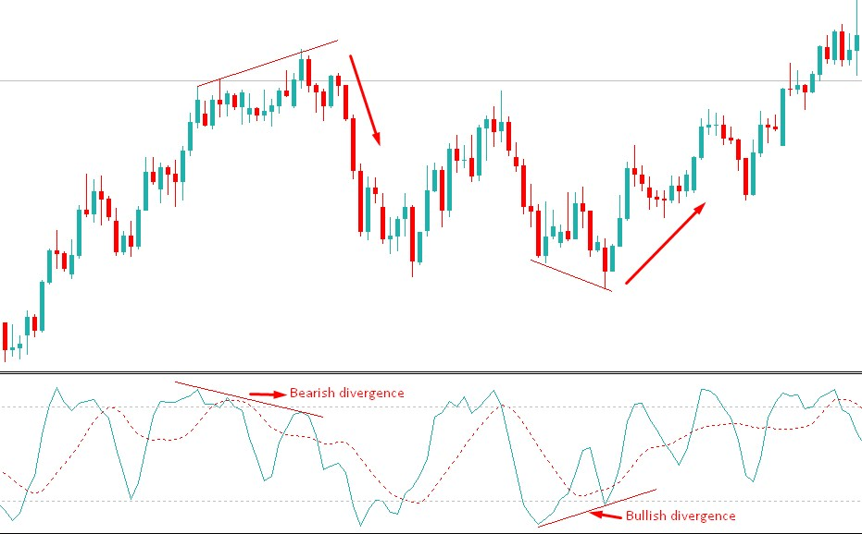](https://forum.mt5.com/attachment.php?attachmentid=396986&d=1627443714)

**Crossovers**  
  
When the rapid stochastic line and the slow stochastic line collide, a crossover is imposed. The fast Stochastic line is the percent K line, and the slow Stochastic line is the percent D line. The bullish crossover occurs when the percent K line intersects and follows the percent D line. Furthermore, the intersection of the percent K line and the percent D line from the upper to lower Stochastic line indicates a bearish sell signal.

[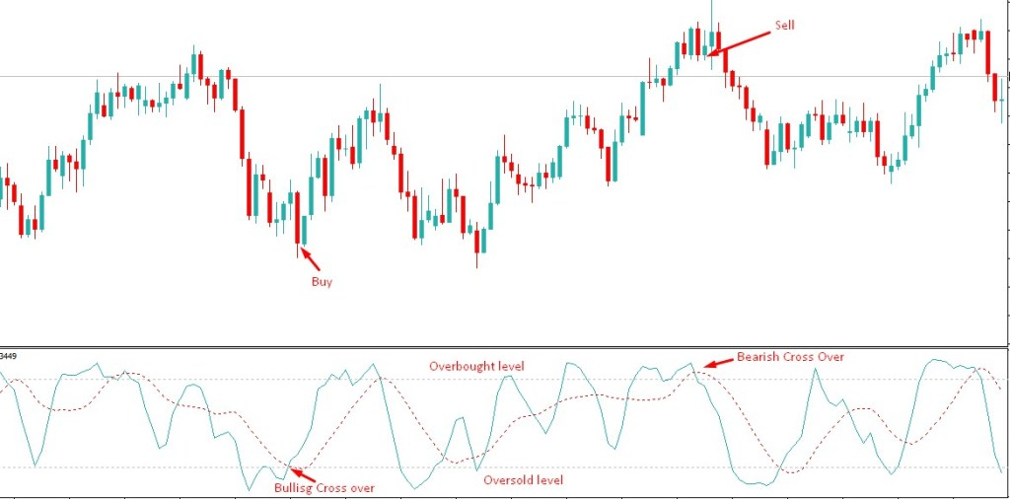](https://forum.mt5.com/attachment.php?attachmentid=396987&d=1627443735)

**Limitations of the Stochastic Oscillator**  
  
The Stochastic Oscillator's major weakness is its proclivity to produce incorrect signals. Especially during difficult and volatile trading conditions. As a result, it is critical to wait for confirmation of the signal from the Stochastic Oscillator as well as other technical indicators.  
  
Also make sure that the Stochastic Oscillator was developed to test strengths, not trends. Some traders aim to reduce the oscillator's tendency to give false signals by using the highest readings from the Stochastic Oscillator indicating an overbought or oversold situation in the market.  
  
**Pattern Analysis and Stochastic Oscillator**  
  
Stochastic does not need to obtain the required amount to provide reliable signals because the price pattern has standard barriers. Whereas the deepest switches are predicted at the overbought and oversold levels and cross in the center of the panel may depend on, then well-known support and resistance levels line.

[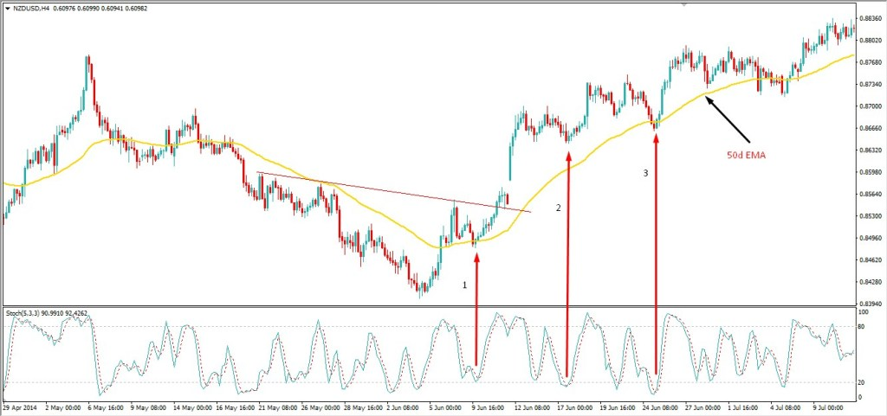](https://forum.mt5.com/attachment.php?attachmentid=396989&d=1627443887)

NZDUSD has risen above the 50-day moving average (EMA) as volatility has decreased, creating new support. It is causing the Stochastic line to rise before it reaches the oversold level.

It also broke just above the dropping trend line as well as pulled back, resulting in a bullish crossover just at the panel's midpoint. Furthermore, the bullish rally retraced to find support at the 50-day EMA (3), triggering a third bullish move above the oversold level.  
  
**Stochastic Scalping Methodology**  
  
This scalping system employs a different set of Stochastic indicator settings than the day trading strategy described above. The purpose of using the Stochastic in this manner is to capture momentum bounces, which are reflected by a unique Admiral Pivot set on hourly time frames.

* **Indicators:**

Stochastic (13,8,8) with 80, 50, and 20 levels  
  
Admiral Pivot is an abbreviation for Admiral Pivot's (set on H1)

* **Timetable:**

M5 for entry, M30 for trend direction

* **Pairs:**

EUR/USD (of particular interest), GBP/USD, GBP/JPY, USD/JPY, AUD/USD, EUR/JPY, USD/CHF

* **Long Entry:**

On the M30 time frame, the Stochastic should be just above 20 or just above 50, indicating an uptrend.  
  
Switch to the M5 time frame.  
  
The Stochastic should cross 20 or 50 from below, at which point you should place your long entry.

* **Short Entry:**

On the M30 time frame, the Stochastic should be just below 80 or just below 50, indicating a downtrend.

Switch to the M5 time frame.  
  
When the Stochastic crosses 20 or 50 from above, place your short entry.

* **Stop-loss:**

Long entries should be 5 pips below the previous M30 candle.  
  
For short entries, 5 pips above the previous M30 candle.

* **Target:**

Admiral Pivot points on an H1 chart are used as targets. H1 pivots will change every hour, so it's critical to keep an eye on the charts. This is a scalping system only.  
  
**Conclusion**  
  
Most traders are perplexed by the influence of Stochastic since they are unsure of which parameter can use. Different traders approach Stochastic in different ways. Some of them only use the default settings. And some of them use it in conjunction with other indicators such as RSI, MACD, MA, EMA, and so on. You must determine which Stochastic Oscillator settings are best for your psychology and trading style.